**Assignment 6**

**Assignment 1:**

Declare an integer array of size 10 and print the array elements using pointer.

Code:

#include <iostream>

using namespace std;

int main()

{

int arr[5];

cout << "Enter elements: ";

for(int i = 0; i < 5; ++i)

cin >> arr[i];

cout << "You entered: ";

for(int i = 0; i < 5; ++i)

cout << endl << *(arr + i);

return 0;

}

Output:

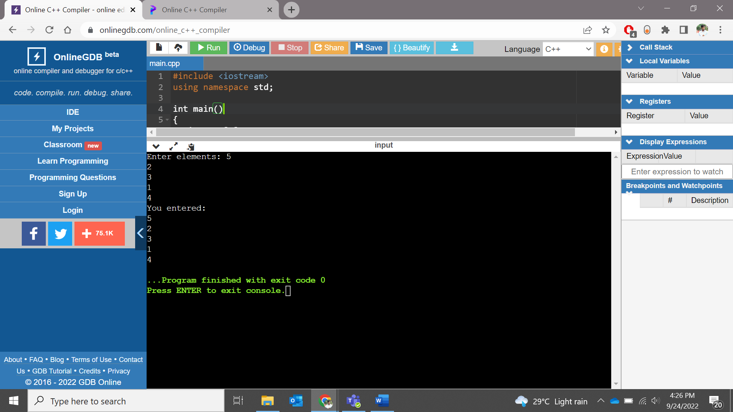

**Assignment 2:**

1. const int a = 10;   
   const int* ptr = &a;

     What is the output for the following?   
 1. *ptr = 5;

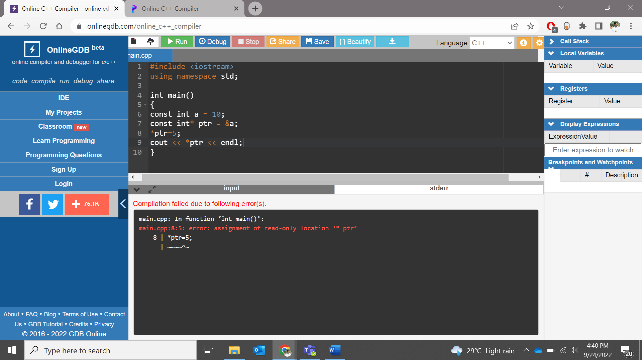

2. ptr++;

1. int a = 10;   
   int* const ptr = &a;

     What is the output for the following?   
 1. *ptr = 5;

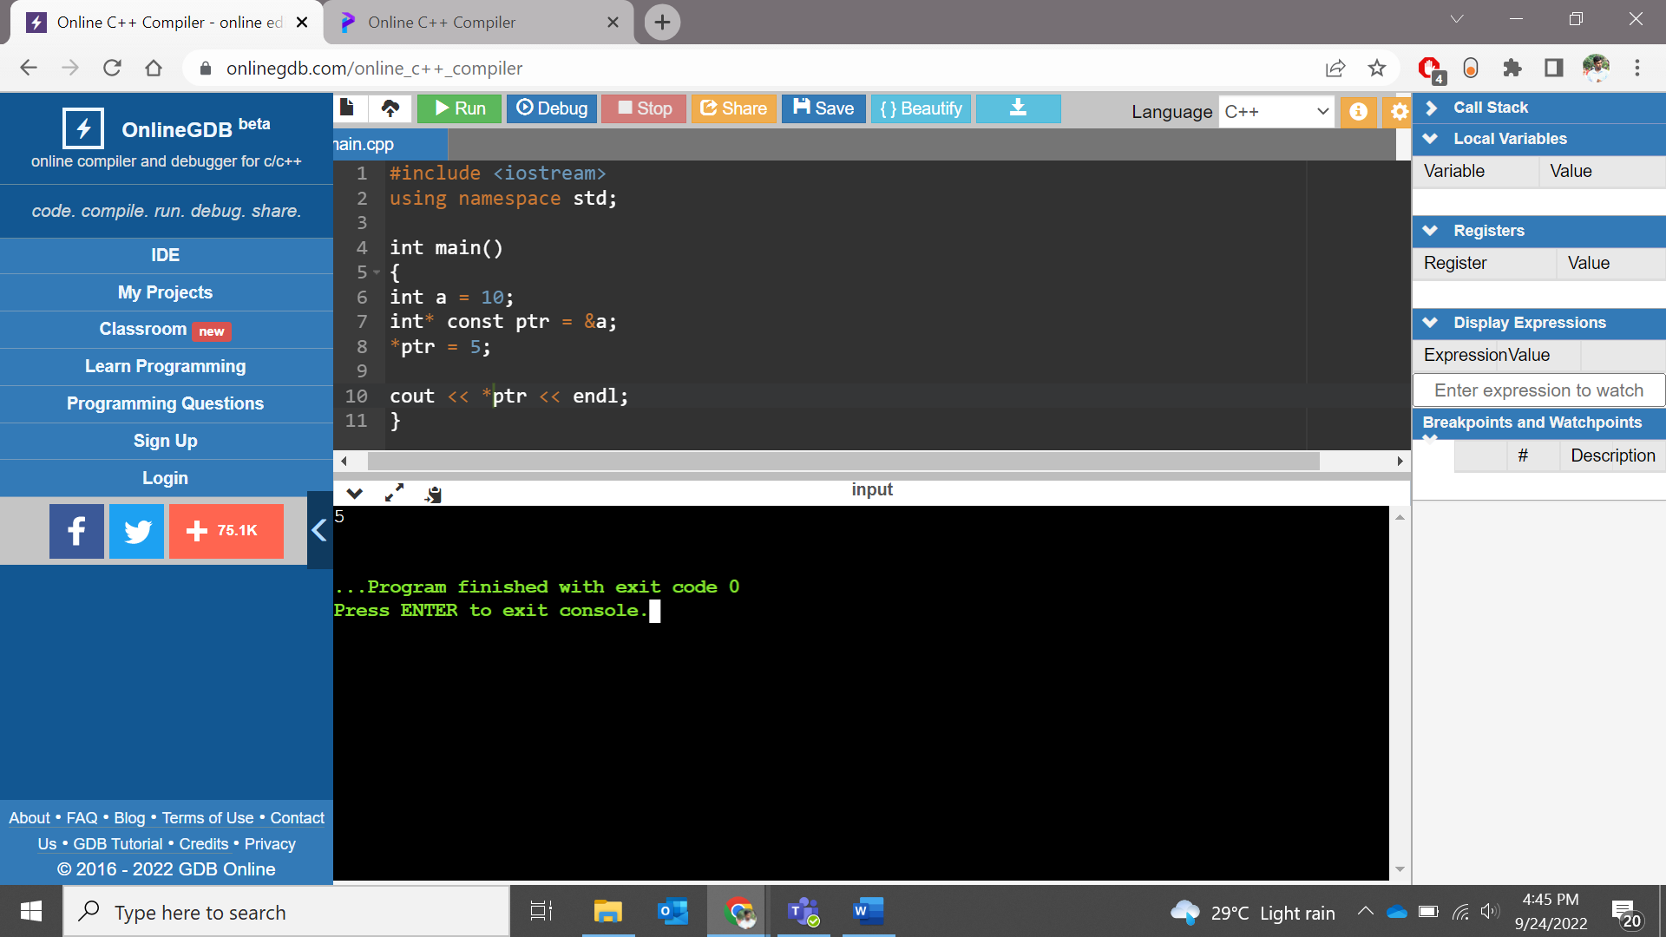

      2. ptr++;

**Assignment 3:**

Swap 2 numbers using call by value, call by reference.

Code:

Call By Reference

#include<iostream>

using namespace std;

void swap(int *x, int *y)

{

int swap;

swap=*x;

*x=*y;

*y=swap;

}

int main()

{

int x=500, y=100;

cout << "Value Before Swap" << endl;

cout<< "Value of x is: "<< x <<endl;

cout<< "Value of y is: "<< y <<endl;

swap(&x, &y);

cout << "Value After Swap" << endl;

cout << "Value of x is: " << x << endl;

cout << "Value of y is: "<< y << endl;

return 0;

}

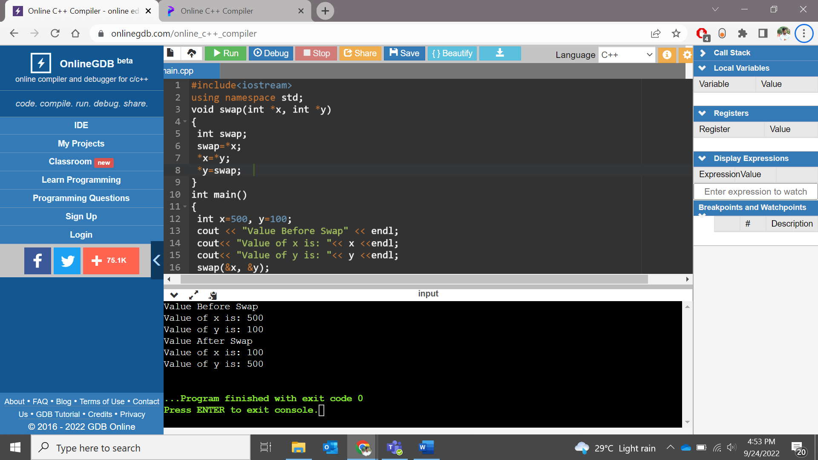

Call by Value:

#include<iostream>

using namespace std;

void swap(int,int);

int main()

{

int num1,num2;

cout<<"\n Enter First Number : ";

cin>>num1;

cout<<"\n Enter Second Number : ";

cin>>num2;

cout<<"\n Before Swapping the Value : \n"<<" "<<num1<<"\t"<<num2<<"\n";

swap(num1,num2);

}

void swap(int num1,int num2)

{

int num3;

num3=num1;

num1=num2;

num2=num3;

cout<<"\n After Swapping the Value : \n"<<" "<<num1<<"\t"<<num2;

}

**Output:**

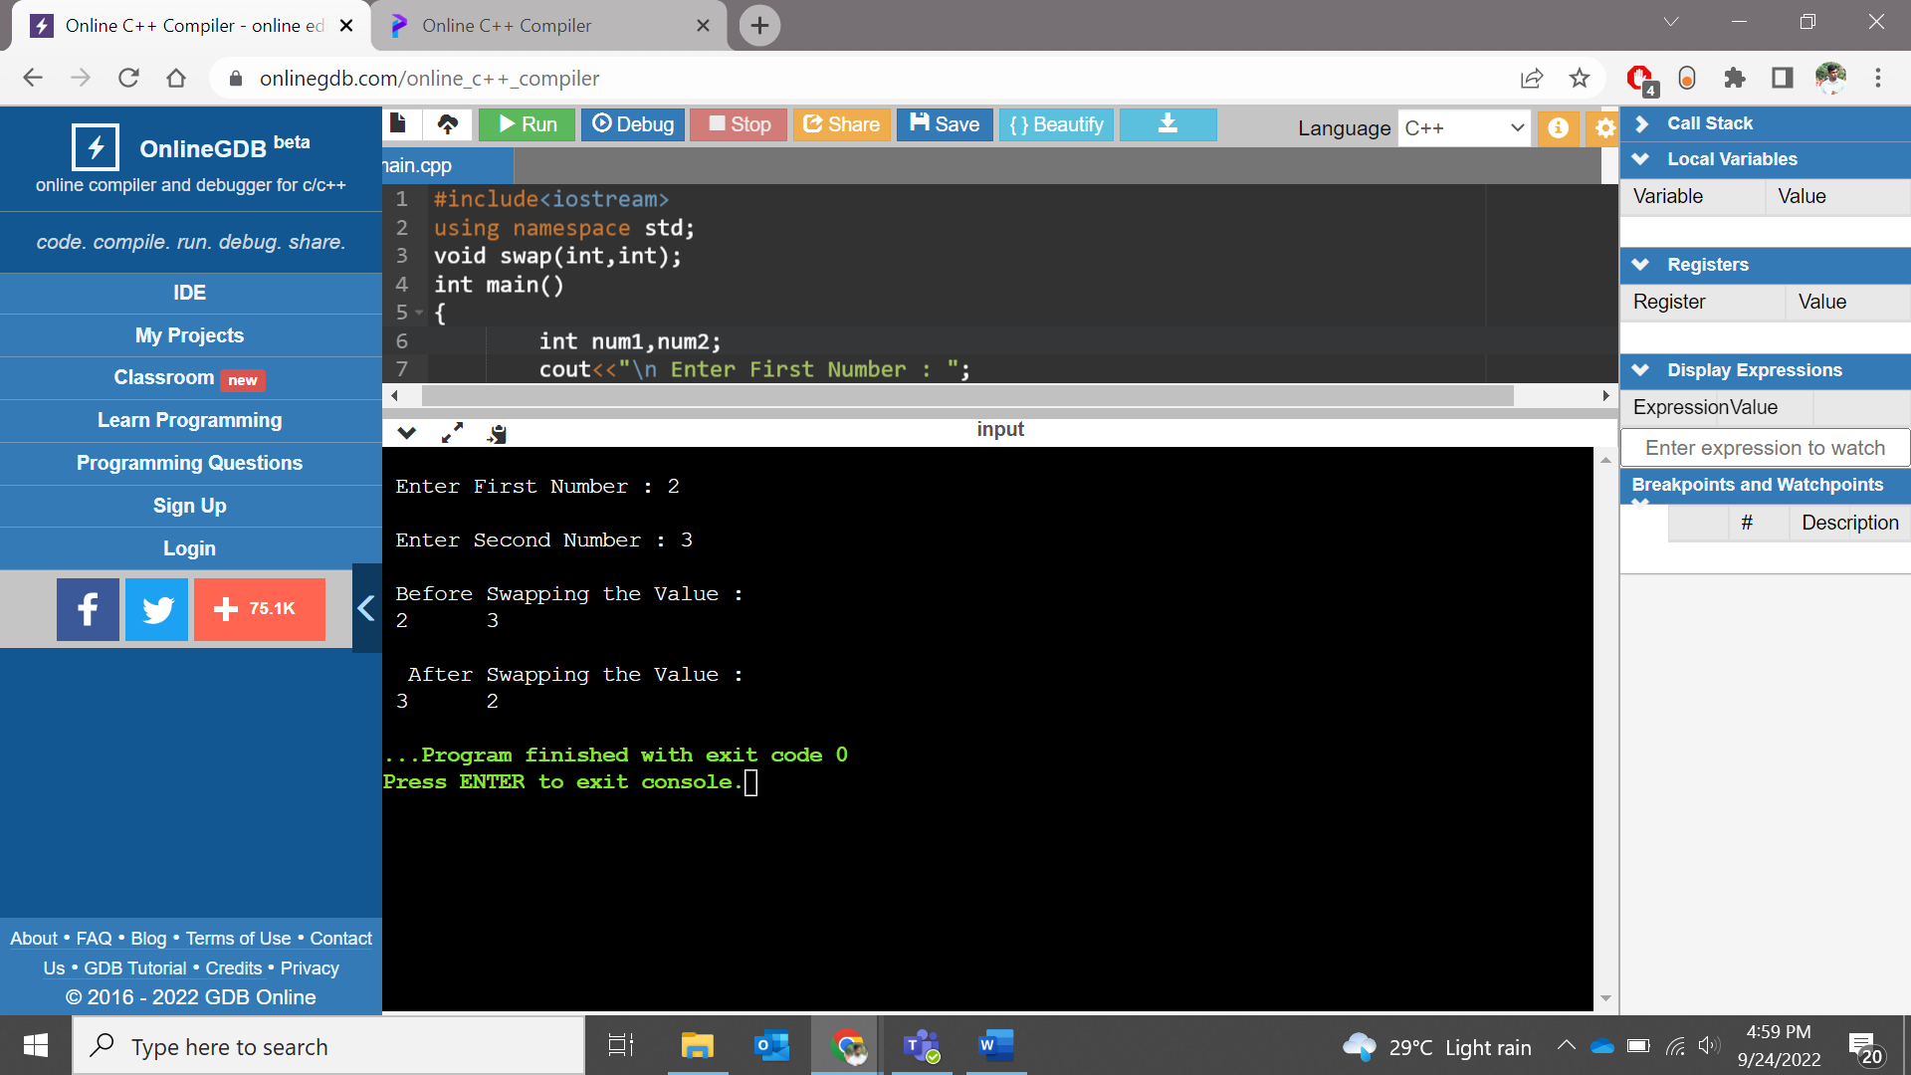

**Assignment 4:**

Write a program to add two numbers using pointers as function returns

**Code:**

**#include<iostream>**

**#include<string>**

**using namespace std;**

**int addpt(int *p, int *q){**

**return *p + *q;**

**}**

**int main(){**

**int m = 46;**

**int n =69;**

**int *p, *q;**

**p = &m;**

**q = &n;**

**cout<< addpt(p,q)<< endl;**

**return 0;**

**}**

**Output:**

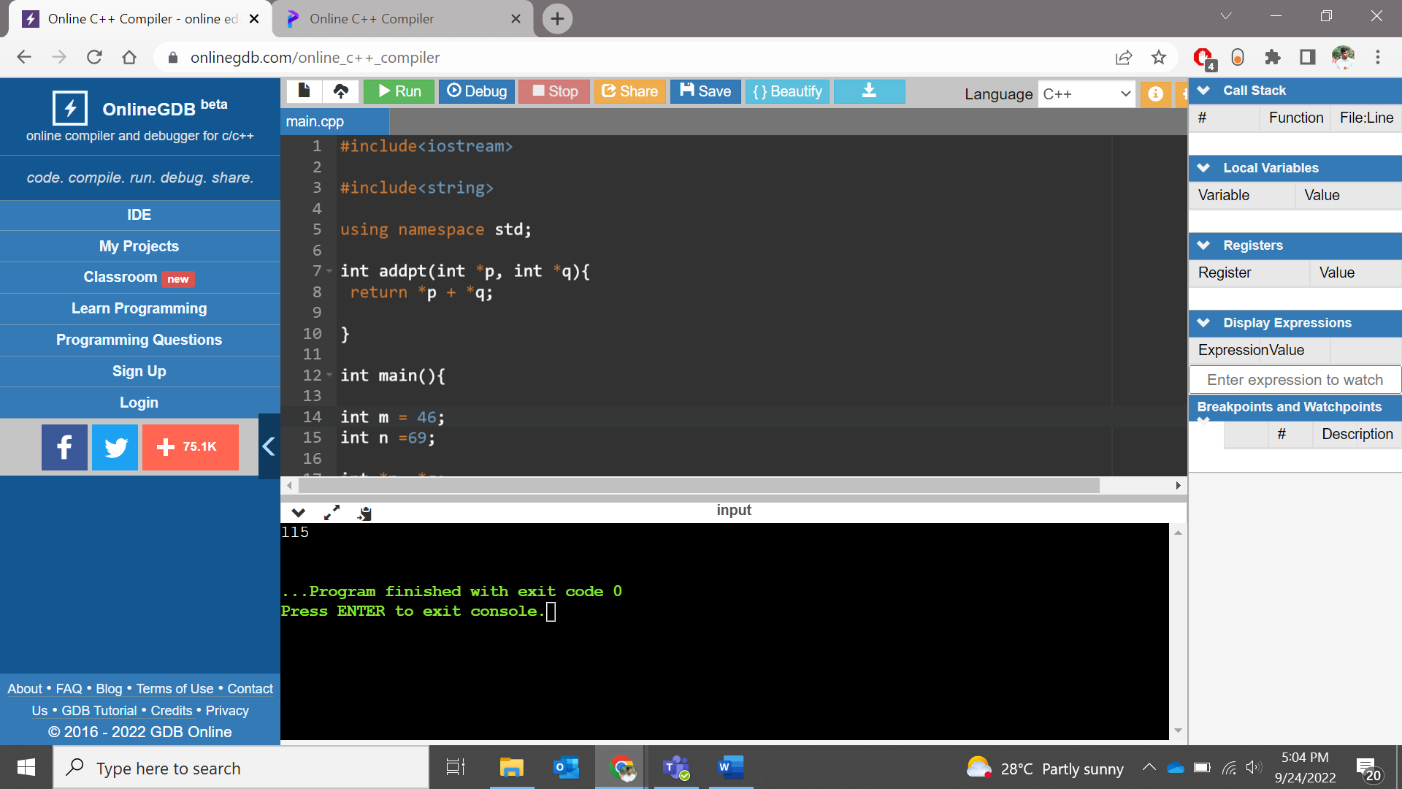

**Assignment 5:**

Please find the below structure:

struct student {

string name;

int Id;

int age;

};

And write a program to modify the structure using passing structure as a pointer in function

**Code:**

**#include<iostream>**

**#include<string>**

**using namespace std;**

**struct student {**

**string name;**

**int Id;**

**int age;**

**};**

**void change(struct student *st){**

**struct student newst;**

**st->name = st->name + " Das";**

**st->Id = st->Id + 0005;**

**st->age = st->age + 3;**

**}**

**int main() {**

**student st = {"Kabir", 001,24};**

**student *ptr =&st;**

**cout<<" The details are " << endl;**

**cout<<"Name: "<<ptr->name<<endl<<"ID: "<<ptr->Id<<endl<<"Age : "<<ptr->age<<endl;**

**change(ptr);**

**cout<<"After modification " << endl;**

**cout<<"Name: "<<ptr->name<<endl<<"ID: "<<ptr->Id<<endl<<"Age : "<<ptr->age<<endl;**

**return 0;**

**}**

**Output:**

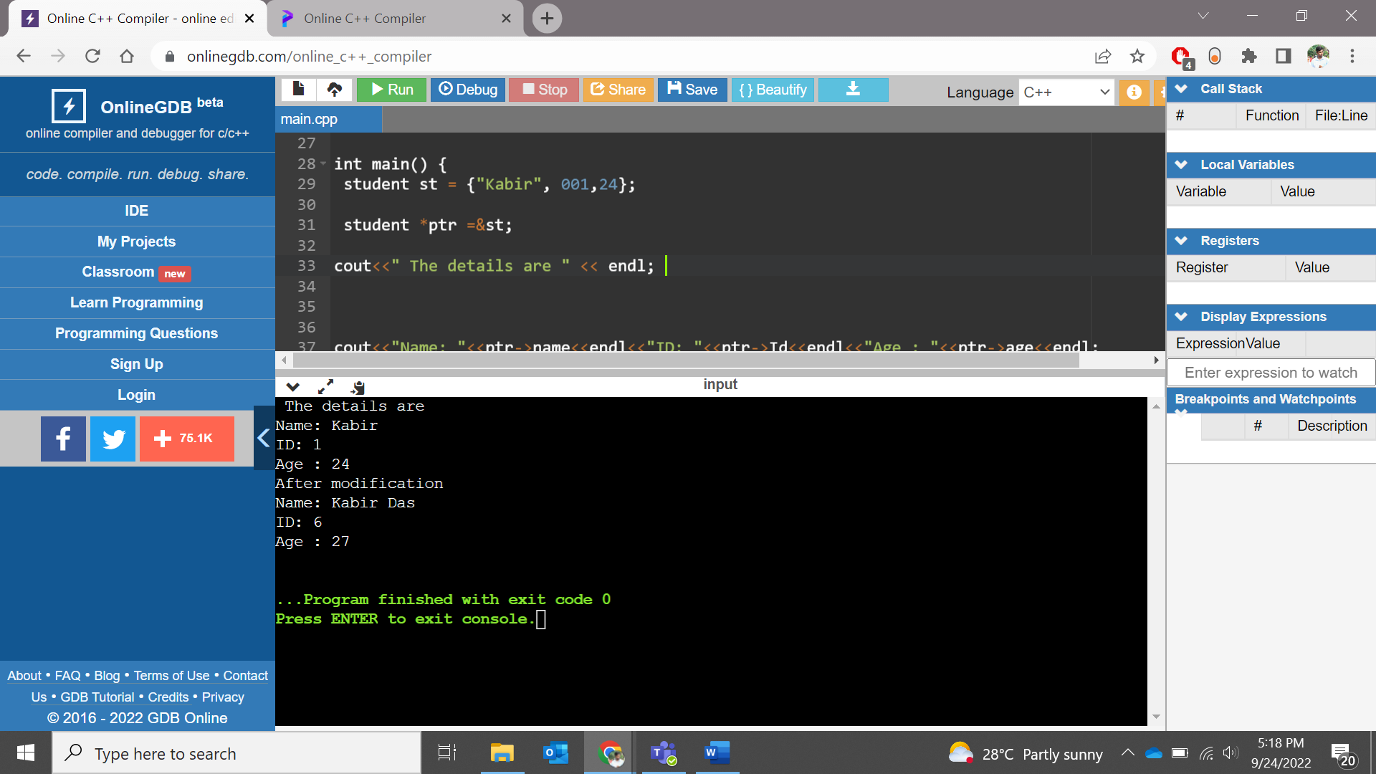

**Assignment 6:**

Try to do atleast 4 arithmetic operations on pointer and print the results.

**Code:**

**#include<iostream>**

**using namespace std;**

**int main(){**

**int a = 7;**

**int b = 21;**

**int *p1, *p2;**

**p1 = &a;**

**p2 = &b;**

**int sum = 0;**

**cout<<"sum = "<< *p1 + *p2 <<endl;**

**cout<<"sub = "<< *p1 - *p2 <<endl;**

**cout<<"Multiplication = "<< *p1 * *p2 <<endl;**

**cout<<"Division = "<< *p1 / *p2 <<endl;**

**return 0;**

**}**

**Output:**

