OLS by hand

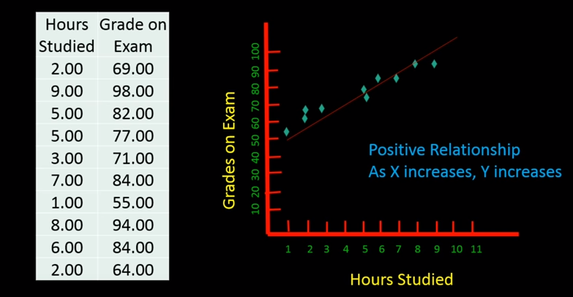

| Hours | Grade |
| --- | --- |
| 2 | 69 |
| 9 | 98 |
| 5 | 82 |
| 5 | 77 |
| 3 | 71 |
| 7 | 84 |
| 1 | 55 |
| 8 | 94 |
| 6 | 84 |
| 2 | 64 |

Here Input variable is : Hours (x)

Output variable is : Grade (y )

$y=b_{0}+b_{1}*x_{1}$

$Grade=b_{0}+b_{1}*Hours$

$b_{1}=\frac{\sum_{i}^{n}{}\left(\underline{y_{a}}- y_{ai}\right)* \left(\underline{x}-x_{i}\right)}{\sum_{i}^{n}{}{\left(\underline{x}-x_{i}\right)}^{2}}$

$what we need is:$

$\underline{x}$

$\underline{y}$

$\underline{y}-y_{i}$

$\underline{x}-x_{i}$

${\left(\underline{x}-x_{i}\right)}^{2}$

| Hours(X) | Grade(y) | $\underline{x}-x_{i}$ | ${\left(\underline{x}-x_{i}\right)}^{2}$ | $\underline{y}-y_{i}$ | $\underline{(x}-x_{i})*(\underline{y}-y_{i)}$ |
| --- | --- | --- | --- | --- | --- |
| 2 | 69 | 2.8 | 7.84 | 8.8 | 24.64 |
| 9 | 98 | -4.2 | 17.64 | -20.2 | 84.8 |
| 5 | 82 | -0.2 | 0.04 | -4.2 | 0.84 |
| 5 | 77 | -0.2 | 0.04 | 0.8 | -0.16 |
| 3 | 71 | 1.8 | 3.24 | 6.8 | 12.24 |
| 7 | 84 | -2.2 | 4.84 | -6.2 | 13.64 |
| 1 | 55 | 3.8 | 14.44 | 22.8 | 86.64 |
| 8 | 94 | -3.2 | 10.24 | -16.2 | 51.84 |
| 6 | 84 | -1.2 | 1.44 | -6.2 | 7.44 |
| 2 | 64 | 2.8 | 7.84 | 13.8 | 38.64 |
| $\underline{x}=4.8$ | $\underline{y}=77.8$ |  | $\sum_{i}^{n}{}{\left(\underline{x}-x_{i}\right)}^{2}=67.24$ |  | $\sum_{i}^{n}{}\left(\underline{y_{a}}- y_{ai}\right)* \left(\underline{x}-x_{i}\right)=320.6$ |

$b_{1}=\frac{\sum_{i}^{n}{}\left(\underline{y_{a}}- y_{ai}\right)* \left(\underline{x}-x_{i}\right)}{\sum_{i}^{n}{}{\left(\underline{x}-x_{i}\right)}^{2}}=\frac{320.6}{67.24}=4.76$

$b_{o}=\underline{y_{a}}-b_{1}*\underline{x}=77.8-4.76*4.8=54.95$

$Grade=b_{0}+b_{1}*Hours$

$Grade=54.95+4.76*Hours$

$GrE=200+4.76*Good ans$