

**HOSPITAL MANAGEMENT DATABASE**

**TEAM MEMBERS**

1. **CHILUKURI VISHAL SAI DUTT B 21CSB0B11**

**2. SATHWIK CHINTHA B 21CSB0B51**

**PROBLEM STATEMENT:**

Our aim is to create a hospital database management system to keep records of all the patients' medical records, doctors, tests, medicines, appointments, rooms, other employees, etc. The main goal is to computerize all the details regarding the patient and the hospital. This model helps the hospital management system to use their database efficiently.

The hospital management system is essential for all healthcare establishments, like hospitals, nursing homes, health clinics, dispensaries, or clinics. The use of this database management system will result in the improvement in administrative functions and hence better patient care.

**OUR THOUGHT PROCESS:**

Patient enters a hospital and takes an appointment. Patient waits for his turn and then undergoes diagnosis by the doctor. Then, patient gets treated by the doctor and is provided with a prescription. Then patient takes some tests. According to prescription, patient buys medicine and pays the bill and completes their treatment. And if it is mentioned in prescription that patient needs to get admitted, and they are also expected to pay the room bill. All the payment is done at bill-counter where patient gives his patient_id and gets the details of his payment.

Patient exits

Bill payment

Buys medicine

No room

Gets room

Admits?

Takes tests

Treatment

Diagnosis

Takes appointment

Patient enters

**ER DIAGRAM:**

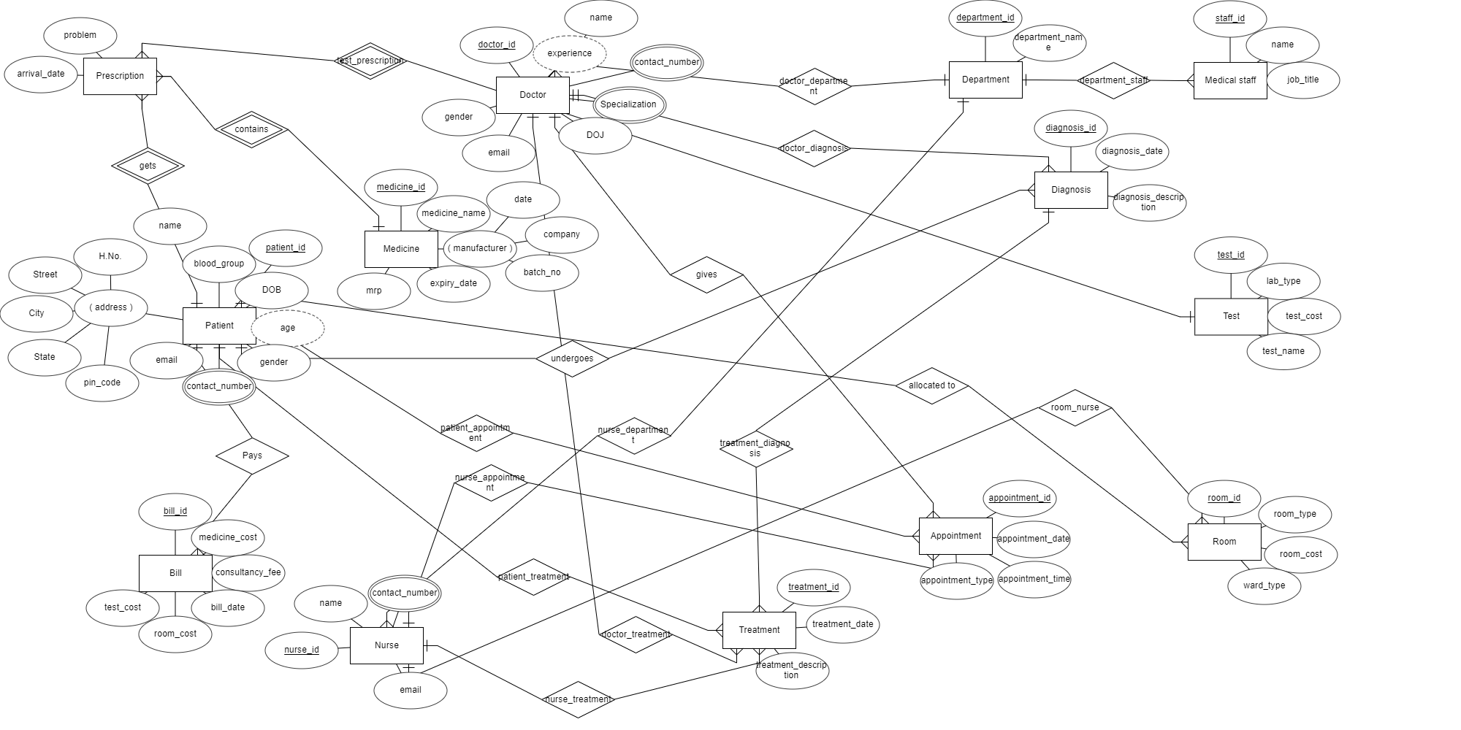

**RELATIONAL SCHEMA**

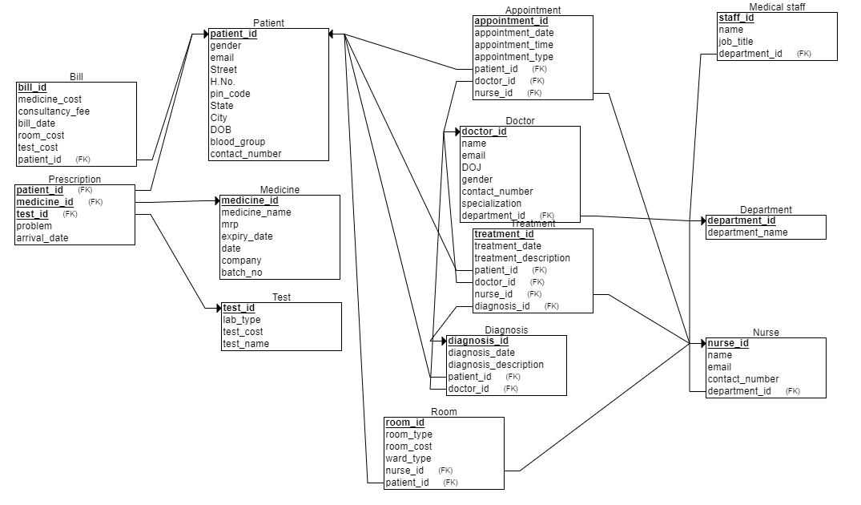

**AFTER FIRST NORMAL FORM**

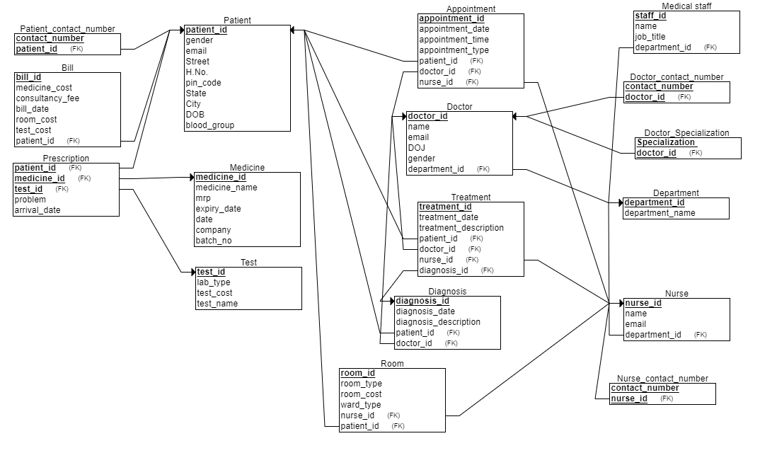

**Functional Dependencies:**

Functional dependencies in each relation define the relationship between attributes in a relation. Here are the functional dependencies in each of the relations mentioned in the hospital database system:

**Test:**

test_id → lab_type, test_cost, test_name

**Medicine:**

medicine_id → medicine_name, mrp, expiry_date, date, company, batch_no

**Patient:**

patient_id → gender, email, street, H_No, pincode, city, street, state, DOB, blood_group, contact_number

**Prescription:**

(patient_id, medicine_id, test_id) → problem,arrival_date

**Bill:**

bill_id → medicine_cost, consultancy_fee, bill_date, room_cost, test_cost, patient_id

**Department:**

department_id → department_name

**Doctor:**

doctor_id → name, email, DOJ, gender, department_id

**Nurse:**

nurse_id → name, email, contact_number, department_id

**Appointment:**

appointment_id → patient_id, doctor_id, n urse_id, appointment_date, appointment_time, appointment_type

**Diagnosis:**

diagnosis_id → patient_id, doctor_id, diagnosis_date, diagnosis_description

**Treatment:**

treatment_id → patient_id, doctor_id, nurse_id, treatment_date, treatment_description

**Medical_staff:**

staff_id → department_id, name, job_title

**Room:**

room_id → nurse_id, patient_id, room_type, room_cost, ward_type

**NORMAL FORMS:**

**1st NF:**

Atomic attributes: To ensure that all attributes are atomic, for composite attributes, all it’s components are included in the table. (address attribute in *Patient* table) and for multivalued attributes, we maintained a separate table referencing to the main table(patient_contact_no with patient_id referencing to patient, doctor_contact_no with doctor_id referencing to doctor, specialization with doctor_id referencing to doctor and nurse_contact_no with nurse_id referencing to nurse).

Uniqueness: We made sure that every attribute in a table has a unique name and there are no repeated tuples.

Thus, 1st NF is achieved.

**2nd NF:**

Partial dependency: There is no relation with one of the proper subsets of the candidate keys functionally dependent on the non- prime attributes. Hence, there is no partial dependency in any of the relations.

As all relations are in 1st NF and there is no partial dependency, we can say that the relational schema is already in 2nd NF.

**3rd NF:**

Transitive dependency: Except for *patient* relation, there is no relation where there is a functional dependency between two non-prime attributes. I.e. only *patient* relation is transitively dependent. So, all relations except *patient* are in 3rd NF. In *patient* relation, we have a FD *pincode->(state, city).* To convert it into 3rd normal form, we are creating a relation with *pincode* as primary key and  *state* and *city* as the other two attributes. In the main table we referenced pincode attribute to the pincode from this table.

**BCNF:**

Here, after converting the schema into 3rd NF there are no relations with functional dependencies without their left hand side being a super key. So, the relational schema is in BCNF.

**NOTE:**

Before conversion into 1st NF, there are 13 relations in the schema. After conversion into 1st NF there are 17 relations. After conversion BCNF there are 18 relations.

**AFTER BCNF:**

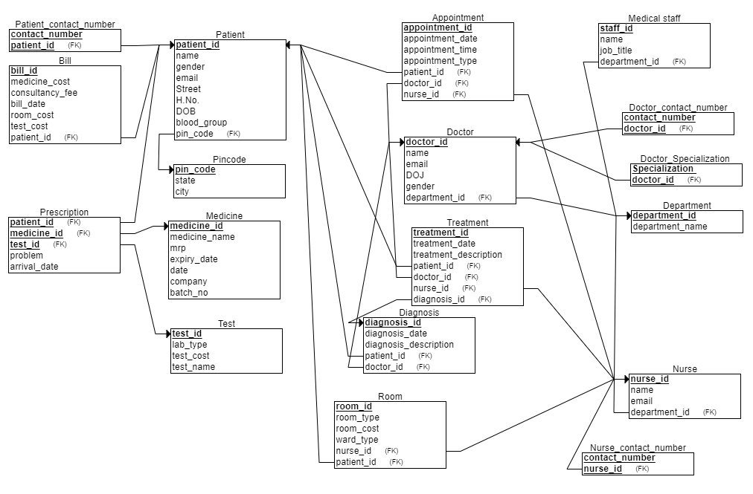

**SQL PART:**

CREATE TABLE Pincode

(

pin_code INT NOT NULL,

state VARCHAR2(30) NOT NULL,

city VARCHAR2(30) NOT NULL,

PRIMARY KEY (pin_code)

);

INSERT INTO Pincode VALUES (123456, 'California', 'Los Angeles');

INSERT INTO Pincode VALUES (234567, 'New York', 'New York City');

INSERT INTO Pincode VALUES (345678, 'Texas', 'Houston');

INSERT INTO Pincode VALUES (456789, 'Florida', 'Miami');

INSERT INTO Pincode VALUES (567890, 'Illinois', 'Chicago');

select *from pincode;

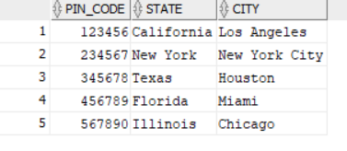

CREATE TABLE Test

(

test_id INT NOT NULL,

lab_type VARCHAR2(30) NOT NULL,

test_cost INT NOT NULL,

test_name VARCHAR2(30) NOT NULL,

PRIMARY KEY (test_id)

);

INSERT INTO Test VALUES (1, 'Blood', 100, 'Complete Blood Count');

INSERT INTO Test VALUES (2, 'Urine', 50, 'Urinalysis');

INSERT INTO Test VALUES (3, 'X-ray', 200, 'Chest X-ray');

INSERT INTO Test VALUES (4, 'MRI', 500, 'Brain MRI');

INSERT INTO Test VALUES (5, 'Ultrasound', 300, 'Abdominal Ultrasound');

INSERT INTO Test VALUES (6, 'EKG', 150, 'Electrocardiogram');

INSERT INTO Test VALUES (7, 'Colonoscopy', 400, 'Colonoscopy');

INSERT INTO Test VALUES (8, 'Endoscopy', 350, 'Upper Endoscopy');

INSERT INTO Test VALUES (9, 'CT Scan', 450, 'Head CT Scan');

INSERT INTO Test VALUES (10, 'Biopsy', 250, 'Skin Biopsy');

select *from test;

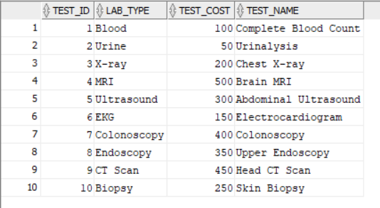

CREATE TABLE Medicine

(

medicine_id INT NOT NULL,

medicine_name VARCHAR2(30) NOT NULL,

mrp INT NOT NULL,

expiry_date DATE NOT NULL,

manufactory_date DATE NOT NULL,

company VARCHAR2(30) NOT NULL,

batch_no INT NOT NULL,

PRIMARY KEY (medicine_id)

);

INSERT INTO Medicine VALUES (1, 'Paracetamol', 10, DATE '2023-12-31', DATE '2021-01-01', 'ABC Pharmaceuticals', 123);

INSERT INTO Medicine VALUES (2, 'Ibuprofen', 15, DATE '2024-06-30', DATE '2021-02-01', 'XYZ Pharmaceuticals', 456);

INSERT INTO Medicine VALUES (3, 'Amoxicillin', 20, DATE '2023-09-30', DATE '2021-03-01', 'PQR Pharmaceuticals', 789);

INSERT INTO Medicine VALUES (4, 'Lisinopril', 25, DATE '2024-02-29', DATE '2021-04-01', 'LMN Pharmaceuticals', 101);

INSERT INTO Medicine VALUES (5, 'Simvastatin', 30, DATE '2023-11-30', DATE '2021-05-01', 'JKL Pharmaceuticals', 112);

INSERT INTO Medicine VALUES (6, 'Omeprazole', 35, DATE '2024-08-31', DATE '2021-06-01', 'DEF Pharmaceuticals', 223);

INSERT INTO Medicine VALUES (7, 'Metformin', 40, DATE '2023-10-31', DATE '2021-07-01', 'GHI Pharmaceuticals', 334);

INSERT INTO Medicine VALUES (8, 'Atorvastatin', 45, DATE '2024-03-31', DATE '2021-08-01', 'STU Pharmaceuticals', 445);

INSERT INTO Medicine VALUES (9, 'Prednisone', 50, DATE '2023-07-31', DATE '2021-09-01', 'VWX Pharmaceuticals', 556);

INSERT INTO Medicine VALUES (10, 'Levothyroxine', 55, DATE '2024-01-31', DATE '2021-10-01', 'YZA Pharmaceuticals', 667);

select *from Medicine;

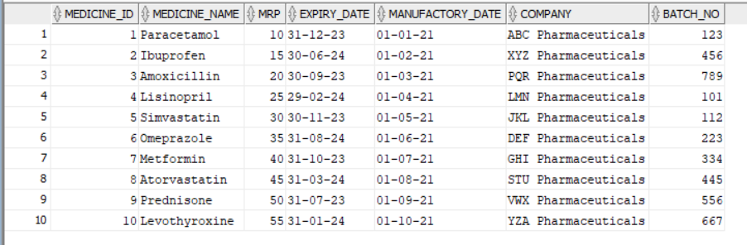

CREATE TABLE Patient

(

patient_id INT NOT NULL,

name VARCHAR2(30) NOT NULL,

gender VARCHAR2(30) NOT NULL,

email VARCHAR2(30) NOT NULL,

Street VARCHAR2(30) NOT NULL,

H_No VARCHAR2(30) NOT NULL,

DOB DATE NOT NULL,

blood_group VARCHAR2(30) NOT NULL,

pin_code INT NOT NULL,

PRIMARY KEY (patient_id),

FOREIGN KEY (pin_code) REFERENCES Pincode(pin_code)

);

INSERT INTO Patient VALUES (1, 'John Doe', 'Male', 'johndoe@gmail.com', 'Main Street', '123', TO_DATE('1990-01-01', 'YYYY-MM-DD'), 'A+', 123456);

INSERT INTO Patient VALUES (2, 'Jane Smith', 'Female', 'janesmith@yahoo.com', 'Broadway', '456', TO_DATE('1985-02-02', 'YYYY-MM-DD'), 'B-', 234567);

INSERT INTO Patient VALUES (3, 'David Johnson', 'Male', 'davidjohnson@hotmail.com', 'Oak Avenue', '789', TO_DATE('1978-03-03', 'YYYY-MM-DD'), 'O+', 345678);

INSERT INTO Patient VALUES (4, 'Sarah Lee', 'Female', 'sarahlee@gmail.com', 'Maple Drive', '456', TO_DATE('1995-04-04', 'YYYY-MM-DD'), 'AB+', 456789);

INSERT INTO Patient VALUES (5, 'Michael Brown', 'Male', 'michaelbrown@yahoo.com', 'Pine Street', '123', TO_DATE('1980-05-05', 'YYYY-MM-DD'), 'A-', 567890);

select *from patient;

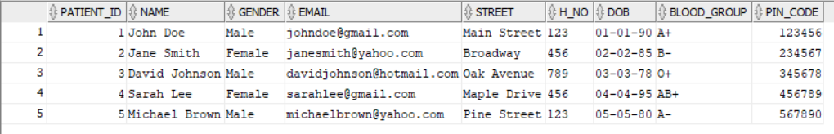

CREATE TABLE Prescription

(

problem VARCHAR2(30) NOT NULL,

arrival_date DATE NOT NULL,

patient_id INT NOT NULL,

medicine_id INT NOT NULL,

test_id INT NOT NULL,

PRIMARY KEY (patient_id, medicine_id, test_id),

FOREIGN KEY (patient_id) REFERENCES Patient(patient_id),

FOREIGN KEY (medicine_id) REFERENCES Medicine(medicine_id),

FOREIGN KEY (test_id) REFERENCES Test(test_id)

);

INSERT INTO Prescription VALUES ('Fever', DATE '2023-01-01', 1, 1, 1);

INSERT INTO Prescription VALUES ('Headache', DATE '2023-02-02', 2, 2, 2);

INSERT INTO Prescription VALUES ('Cough', DATE '2023-03-03', 3, 3, 3);

INSERT INTO Prescription VALUES ('Allergies', DATE '2023-04-04', 4, 4, 4);

INSERT INTO Prescription VALUES ('Stomachache', DATE '2023-05-05', 5, 5, 5);

INSERT INTO Prescription VALUES ('Back Pain', DATE '2023-06-06', 1, 6, 6);

INSERT INTO Prescription VALUES ('Sore Throat', DATE '2023-07-07', 2, 7, 7);

INSERT INTO Prescription VALUES ('Insomnia', DATE '2023-08-08', 3, 8, 8);

INSERT INTO Prescription VALUES ('Depression', DATE '2023-09-09', 4, 9, 9);

INSERT INTO Prescription VALUES ('Anxiety', DATE '2023-10-10', 5, 10, 10);

select *from Prescription;

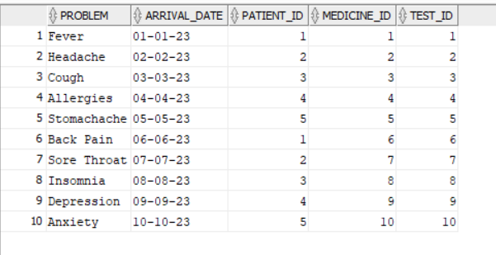

CREATE TABLE Bill

(

bill_id INT NOT NULL,

medicine_cost INT NOT NULL,

consultancy_fee INT NOT NULL,

bill_date DATE NOT NULL,

room_cost INT NOT NULL,

test_cost INT NOT NULL,

patient_id INT NOT NULL,

PRIMARY KEY (bill_id),

FOREIGN KEY (patient_id) REFERENCES Patient(patient_id)

);

INSERT INTO Bill VALUES (1, 50, 100, DATE '2023-01-01', 500, 200, 1);

INSERT INTO Bill VALUES (2, 30, 80, DATE '2023-02-02', 400, 150, 2);

INSERT INTO Bill VALUES (3, 40, 120, DATE '2023-03-03', 600, 250, 3);

INSERT INTO Bill VALUES (4, 20, 70, DATE '2023-04-04', 300, 100, 4);

INSERT INTO Bill VALUES (5, 60, 150, DATE '2023-05-05', 700, 300, 5);

select *from bill;

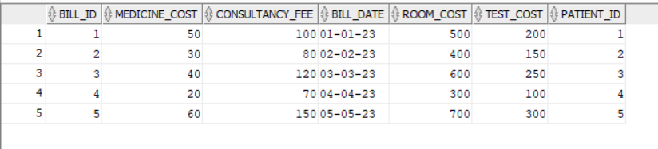

CREATE TABLE Patient_contact_number

(

contact_number INT NOT NULL,

patient_id INT NOT NULL,

PRIMARY KEY (contact_number, patient_id),

FOREIGN KEY (patient_id) REFERENCES Patient(patient_id)

);

INSERT INTO Patient_contact_number VALUES (1234567890, 1);

INSERT INTO Patient_contact_number VALUES (2345678901, 2);

INSERT INTO Patient_contact_number VALUES (3456789012, 3);

INSERT INTO Patient_contact_number VALUES (4567890123, 4);

INSERT INTO Patient_contact_number VALUES (5678901234, 5);

INSERT INTO Patient_contact_number VALUES (6789012345, 1);

INSERT INTO Patient_contact_number VALUES (7890123456, 2);

INSERT INTO Patient_contact_number VALUES (8901234567, 3);

INSERT INTO Patient_contact_number VALUES (9012345678, 4);

INSERT INTO Patient_contact_number VALUES (0123456789, 5);

select *from patient_contact_number;

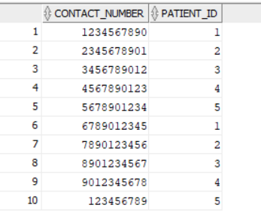

CREATE TABLE Department

(

department_id INT NOT NULL,

department_name VARCHAR2(30) NOT NULL,

PRIMARY KEY (department_id)

);

INSERT INTO Department VALUES (1, 'Cardiology');

INSERT INTO Department VALUES (2, 'Orthopedics');

INSERT INTO Department VALUES (3, 'Neurology');

select *from department;

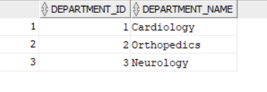

CREATE TABLE Doctor

(

doctor_id INT NOT NULL,

name VARCHAR2(30) NOT NULL,

email VARCHAR2(30) NOT NULL,

DOJ DATE NOT NULL,

gender VARCHAR2(30) NOT NULL,

department_id INT NOT NULL,

PRIMARY KEY (doctor_id),

FOREIGN KEY (department_id) REFERENCES Department(department_id)

);

INSERT INTO Doctor VALUES (1, 'Dr. John Smith', 'johnsmith@gmail.com', DATE'2023-01-01', 'Male', 1);

INSERT INTO Doctor VALUES (2, 'Dr. Emily Johnson', 'emilyjohnson@yahoo.com', DATE '2023-02-02', 'Female', 2);

INSERT INTO Doctor VALUES (3, 'Dr. Michael Brown', 'michaelbrown@hotmail.com', DATE '2023-03-03', 'Male', 1);

INSERT INTO Doctor VALUES (4, 'Dr. Sarah Lee', 'sarahlee@gmail.com', DATE '2023-04-04', 'Female', 3);

INSERT INTO Doctor VALUES (5, 'Dr. David Wilson', 'davidwilson@yahoo.com', DATE '2023-05-05', 'Male', 2);

select *from doctor;

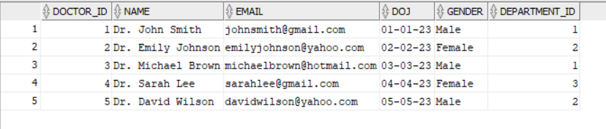

CREATE TABLE Nurse

(

nurse_id INT NOT NULL,

name VARCHAR2(30) NOT NULL,

email VARCHAR2(30) NOT NULL,

department_id INT NOT NULL,

PRIMARY KEY (nurse_id),

FOREIGN KEY (department_id) REFERENCES Department(department_id)

);

INSERT INTO Nurse VALUES (1, 'Nurse 1', 'nurse1@example.com', 1);

INSERT INTO Nurse VALUES (2, 'Nurse 2', 'nurse2@example.com', 2);

INSERT INTO Nurse VALUES (3, 'Nurse 3', 'nurse3@example.com', 1);

INSERT INTO Nurse VALUES (4, 'Nurse 4', 'nurse4@example.com', 3);

INSERT INTO Nurse VALUES (5, 'Nurse 5', 'nurse5@example.com', 2);

INSERT INTO Nurse VALUES (6, 'Nurse 6', 'nurse6@example.com', 1);

INSERT INTO Nurse VALUES (7, 'Nurse 7', 'nurse7@example.com', 2);

INSERT INTO Nurse VALUES (8, 'Nurse 8', 'nurse8@example.com', 3);

INSERT INTO Nurse VALUES (9, 'Nurse 9', 'nurse9@example.com', 1);

INSERT INTO Nurse VALUES (10, 'Nurse 10', 'nurse10@example.com', 2);

select *from nurse;

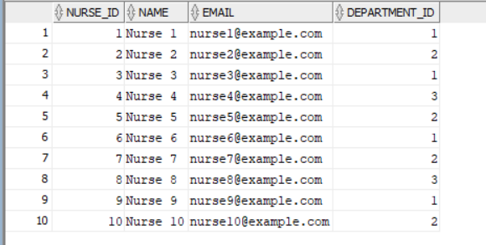

CREATE TABLE Appointment

(

appointment_id INT NOT NULL,

appointment_date DATE NOT NULL,

appointment_time TIMESTAMP NOT NULL,

appointment_type VARCHAR2(30) NOT NULL,

patient_id INT NOT NULL,

doctor_id INT NOT NULL,

nurse_id INT NOT NULL,

PRIMARY KEY (appointment_id),

FOREIGN KEY (patient_id) REFERENCES Patient(patient_id),

FOREIGN KEY (doctor_id) REFERENCES Doctor(doctor_id),

FOREIGN KEY (nurse_id) REFERENCES Nurse(nurse_id)

);

INSERT INTO Appointment VALUES (1, DATE '2023-01-01', TIMESTAMP '2023-01-01 10:00:00', 'Check-up', 1, 1, 1);

INSERT INTO Appointment VALUES (2, DATE '2023-02-02', TIMESTAMP '2023-02-02 11:00:00', 'Follow-up', 2, 2, 2);

INSERT INTO Appointment VALUES (3, DATE '2023-03-03', TIMESTAMP '2023-03-03 12:00:00', 'Check-up', 3, 3, 3);

INSERT INTO Appointment VALUES (4, DATE '2023-04-04', TIMESTAMP '2023-04-04 13:00:00', 'Follow-up', 4, 4, 4);

INSERT INTO Appointment VALUES (5, DATE '2023-05-05', TIMESTAMP '2023-05-05 14:00:00', 'Check-up', 5, 5, 5);

select *from appointment;

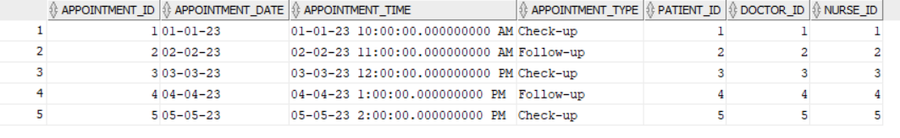

CREATE TABLE Diagnosis

(

diagnosis_id INT NOT NULL,

diagnosis_date DATE NOT NULL,

diagnosis_description VARCHAR2(30) NOT NULL,

patient_id INT NOT NULL,

doctor_id INT NOT NULL,

PRIMARY KEY (diagnosis_id),

FOREIGN KEY (patient_id) REFERENCES Patient(patient_id),

FOREIGN KEY (doctor_id) REFERENCES Doctor(doctor_id)

);

INSERT INTO Diagnosis VALUES (1, DATE '2023-01-01', 'Fever', 1, 1);

INSERT INTO Diagnosis VALUES (2, DATE '2023-02-02', 'Sprained ankle', 2, 2);

INSERT INTO Diagnosis VALUES (3, DATE '2023-03-03', 'Migraine', 3, 3);

INSERT INTO Diagnosis VALUES (4, DATE '2023-04-04', 'Stomach infection', 4, 4);

INSERT INTO Diagnosis VALUES (5, DATE '2023-05-05', 'High blood pressure', 5, 5);

select *from diagnosis;

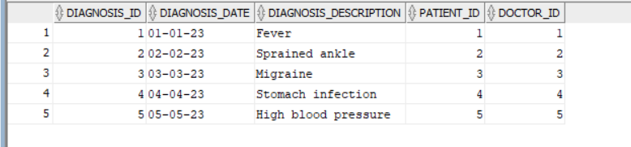

CREATE TABLE Treatment

(

treatment_id INT NOT NULL,

treatment_date DATE NOT NULL,

treatment_description VARCHAR2(30) NOT NULL,

patient_id INT NOT NULL,

doctor_id INT NOT NULL,

nurse_id INT NOT NULL,

diagnosis_id INT NOT NULL,

PRIMARY KEY (treatment_id),

FOREIGN KEY (patient_id) REFERENCES Patient(patient_id),

FOREIGN KEY (doctor_id) REFERENCES Doctor(doctor_id),

FOREIGN KEY (nurse_id) REFERENCES Nurse(nurse_id),

FOREIGN KEY (diagnosis_id) REFERENCES Diagnosis(diagnosis_id)

);

INSERT INTO Treatment VALUES (1, '2023-01-01', 'Prescribed medication', 1, 1, 1, 1);

INSERT INTO Treatment VALUES (2, '2023-02-02', 'Physical therapy', 2, 2, 2, 2);

INSERT INTO Treatment VALUES (3, '2023-03-03', 'Counseling session', 3, 3, 3, 3);

INSERT INTO Treatment VALUES (4, '2023-04-04', 'Surgery', 4, 4, 4, 4);

INSERT INTO Treatment VALUES (5, '2023-05-05', 'Lifestyle changes', 5, 5, 5, 5);

select * from treatment;

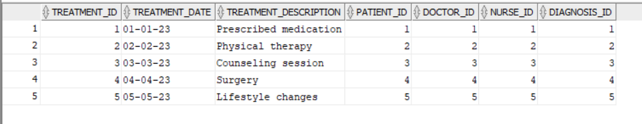

CREATE TABLE Medical_staff

(

staff_id INT NOT NULL,

name VARCHAR2(30) NOT NULL,

job_title VARCHAR2(30) NOT NULL,

department_id INT NOT NULL,

PRIMARY KEY (staff_id),

FOREIGN KEY (department_id) REFERENCES Department(department_id)

);

INSERT INTO Medical_staff VALUES (1, 'John Doe', 'Doctor', 1);

INSERT INTO Medical_staff VALUES (2, 'Jane Smith', 'Nurse', 2);

INSERT INTO Medical_staff VALUES (3, 'David Johnson', 'Doctor', 1);

INSERT INTO Medical_staff VALUES (4, 'Emily Davis', 'Nurse', 2);

INSERT INTO Medical_staff VALUES (5, 'Michael Brown', 'Doctor', 1);

select *from medical_staff;

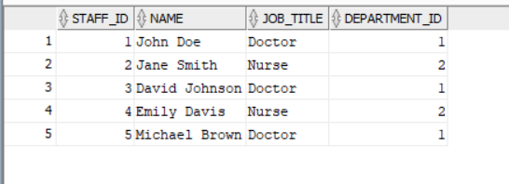

CREATE TABLE Room

(

room_id INT NOT NULL,

room_type VARCHAR2(30) NOT NULL,

room_cost INT NOT NULL,

ward_type VARCHAR2(30) NOT NULL,

nurse_id INT NOT NULL,

patient_id INT NOT NULL,

PRIMARY KEY (room_id),

FOREIGN KEY (nurse_id) REFERENCES Nurse(nurse_id),

FOREIGN KEY (patient_id) REFERENCES Patient(patient_id)

);

INSERT INTO Room VALUES (1, 'Private', 1000, 'General', 1, 1);

INSERT INTO Room VALUES (2, 'Shared', 500, 'Pediatric', 2, 2);

INSERT INTO Room VALUES (3, 'Private', 1200, 'ICU', 3, 3);

select *from room;

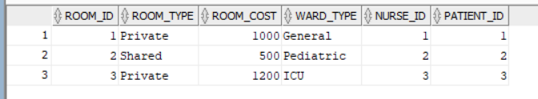

CREATE TABLE Doctor_Specialization_

(

Specialization_ VARCHAR2(30) NOT NULL,

doctor_id INT NOT NULL,

PRIMARY KEY (Specialization_, doctor_id),

FOREIGN KEY (doctor_id) REFERENCES Doctor(doctor_id)

);

INSERT INTO Doctor_Specialization_ VALUES ('Cardiology', 1);

INSERT INTO Doctor_Specialization_ VALUES ('Pediatrics', 2);

INSERT INTO Doctor_Specialization_ VALUES ('Orthopedics', 3);

INSERT INTO Doctor_Specialization_ VALUES ('Dermatology', 4);

INSERT INTO Doctor_Specialization_ VALUES ('Ophthalmology', 5);

INSERT INTO Doctor_Specialization_ VALUES ('Gynecology', 1);

INSERT INTO Doctor_Specialization_ VALUES ('Neurology', 2);

INSERT INTO Doctor_Specialization_ VALUES ('ENT', 3);

select *from Doctor_Specialization_;

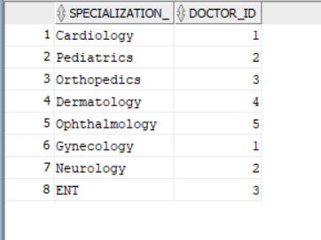

CREATE TABLE Doctor_contact_number

(

contact_number INT NOT NULL,

doctor_id INT NOT NULL,

PRIMARY KEY (contact_number, doctor_id),

FOREIGN KEY (doctor_id) REFERENCES Doctor(doctor_id)

);

INSERT INTO Doctor_contact_number VALUES (1234567890, 1);

INSERT INTO Doctor_contact_number VALUES (9876543210, 2);

INSERT INTO Doctor_contact_number VALUES (1112223333, 3);

INSERT INTO Doctor_contact_number VALUES (4445556666, 4);

INSERT INTO Doctor_contact_number VALUES (7778889999, 5);

INSERT INTO Doctor_contact_number VALUES (2223334444, 1);

INSERT INTO Doctor_contact_number VALUES (5556667777, 2);

INSERT INTO Doctor_contact_number VALUES (8889990000, 3);

select * from doctor_contact_number;

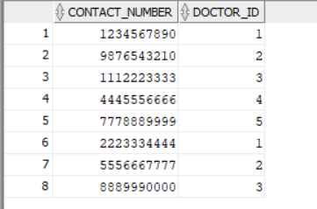

CREATE TABLE Nurse_contact_number

(

contact_number INT NOT NULL,

nurse_id INT NOT NULL,

PRIMARY KEY (contact_number, nurse_id),

FOREIGN KEY (nurse_id) REFERENCES Nurse(nurse_id)

);

INSERT INTO Nurse_contact_number VALUES (1111111111, 1);

INSERT INTO Nurse_contact_number VALUES (2222222222, 2);

INSERT INTO Nurse_contact_number VALUES (3333333333, 3);

INSERT INTO Nurse_contact_number VALUES (4444444444, 4);

INSERT INTO Nurse_contact_number VALUES (5555555555, 5);

INSERT INTO Nurse_contact_number VALUES (6666666666, 1);

select *from nurse_contact_number;

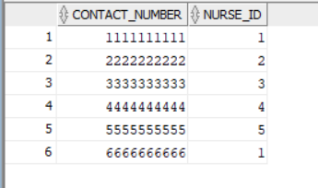

SELECT d.name

FROM Doctor d

JOIN Doctor_Specialization_ ds ON d.doctor_id = ds.doctor_id

WHERE ds.Specialization_ = 'Cardiology';

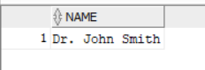

SELECT d.name, COUNT(a.appointment_id) AS appointment_count

FROM Doctor d

LEFT JOIN Appointment a ON d.doctor_id = a.doctor_id

GROUP BY d.name;

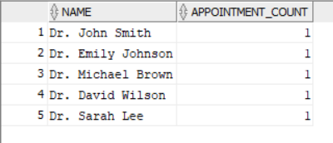

SELECT p.name

FROM Patient p

JOIN Treatment t ON p.patient_id = t.patient_id

WHERE t.treatment_description = 'Physical therapy';

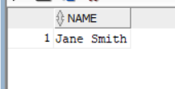

SELECT m.medicine_name

FROM Medicine m

JOIN Prescription p ON m.medicine_id = p.medicine_id

JOIN Patient pat ON p.patient_id = pat.patient_id

WHERE pat.name = 'John Doe';

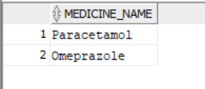

SELECT a.appointment_id, a.appointment_date, a.appointment_time

FROM Appointment a

JOIN Patient p ON a.patient_id = p.patient_id

WHERE p.name = 'Jane Smith';

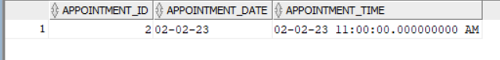

SELECT p.name, b.bill_id, (b.medicine_cost + b.consultancy_fee + b.room_cost + b.test_cost) AS total_cost

FROM Patient p

JOIN Bill b ON p.patient_id = b.patient_id

WHERE (b.medicine_cost + b.consultancy_fee + b.room_cost + b.test_cost) > 500;

