Unit-1
Basic Terminology
Data: The term data means a value or set of values. It specifies either the value of a variable or a constant (e.g., marks of students, name of an employee, address of a customer, value of pi, etc.).
While a data item that does not have subordinate data items is categorized as an elementary item, the one that is composed of one or more subordinate data items is called a group item. For example, a student’s name may be divided into three sub-items—first name, middle name, and last name—but his roll number would normally be treated as a single item.
Record: A record is a collection of data items. For example, the name, address, course, and marks obtained are individual data items. But all these data items can be grouped together to form a record.
File: A file is a collection of related records. For example, if there are 60 students in a class, then there are 60 records of the students. All these related records are stored in a file.
Data Structure: A data structure is basically a group of data elements that are put together under one name, and which defines a particular way of storing and organizing data in a computer so that it can be used efficiently. Some common examples of data structures are arrays, linked lists, queues, stacks, binary trees, and hash tables.
Applications of data structure: Data structures are widely applied in the following areas: 1. Compiler design 2. Operating system 3. Statistical analysis package 4. DBMS 5. Numerical analysis 6. Simulation 7. Artificial intelligence 8. Graphics.
How to select a data structure: When selecting a data structure to solve a problem, the following steps must be performed. 1. Analysis of the problem to determine the basic operations that must be supported. For example, basic operation may include inserting/deleting/searching a data item from the data structure. 2. Quantify the resource constraints for each operation. 3. Select the data structure that best meets these requirements.
Classification of Data Structures
Data structures are generally categorized into two classes: primitive and non-primitive data structures.
Primitive and Non-primitive Data Structures
Primitive data structures are the fundamental data types which are supported by a programming language. Some basic data types are integer, real, character, and boolean. The terms ‘data type’, ‘basic data type’, and ‘primitive data type’ are often used interchangeably.
Non-primitive data structures are those data structures which are created using primitive data structures. Examples of such data structures include linked lists, stacks, trees, and graphs. Non-primitive data structures can further be classified into two categories: linear and non-linear data structures.
Linear and Non-linear Structures
If the elements of a data structure are stored in a linear or sequential order, then it is a linear data structure. Examples include arrays, linked lists, stacks, and queues. Linear data structures can be represented in memory in two different ways. One way is to have a linear relationship between elements by means of sequential memory locations. The other way is to have a linear relationship between elements by means of links.
Operations on Data Structures
This section discusses the different operations that can be performed on the various data structures previously mentioned.
- Traversing: It means to access each data item exactly once so that it can be processed. For example, to print the names of all the students in a class.
- Searching: It is used to find the location of one or more data items that satisfy the given constraint. Such a data item may or may not be present in the given collection of data items. For example, to find the names of all the students who secured 100 marks in mathematics.
- Inserting: It is used to add new data items to the given list of data items. For example, to add the details of a new student who has recently joined the course.
- Deleting: It means to remove (delete) a particular data item from the given collection of data items. For example, to delete the name of a student who has left the course.
- Sorting: Data items can be arranged in some order like ascending order or descending order depending on the type of application. For example, arranging the names of students in a class in an alphabetical order, or calculating the top three winners by arranging the participants’ scores in descending order and then extracting the top three.
- Merging: Lists of two sorted data items can be combined to form a single list of sorted data items.
Abstract Data Type
An abstract data type (ADT) is the way we look at a data structure, focusing on what it does and ignoring how it does its job. For example, stacks and queues are perfect examples of an ADT. We can implement both these ADTs using an array or a linked list. This demonstrates the ‘abstract’ nature of stacks and queues.
Data type: Data type of a variable is the set of values that the variable can take. We have already read the basic data types in C include int, char, float, and double.
When we talk about a primitive type (built-in data type), we actually consider two things: a data item with certain characteristics and the permissible operations on that data. For example, an int variable can contain any whole-number value from –32768 to 32767 and can be operated with the operators +, –, *, and /. In other words, the operations that can be performed on a data type are an inseparable part of its identity. Therefore, when we declare a variable of an abstract data type (e.g., stack or a queue), we also need to specify the operations that can be performed on it.
Abstract: The word ‘abstract’ in the context of data structures means considered apart from the detailed specifications or implementation.
In C, an abstract data type can be a structure considered without regard to its implementation. It can be thought of as a ‘description’ of the data in the structure with a list of operations that can be performed on the data within that structure.
The end-user is not concerned about the details of how the methods carry out their tasks. They are only aware of the methods that are available to them and are only concerned about calling those methods and getting the results. They are not concerned about how they work.
For example, when we use a stack or a queue, the user is concerned only with the type of data and the operations that can be performed on it. Therefore, the fundamentals of how the data is stored should be invisible to the user. They should not be concerned with how the methods work or what structures are being used to store the data. They should just know that to work with stacks, they have push() and pop() functions available to them. Using these functions, they can manipulate the data (insertion or deletion) stored in the stack.
Advantage of using ADTs: In the real world, programs evolve as a result of new requirements or constraints, so a modification to a program commonly requires a change in one or more of its data structures. For example, if you want to add a new field to a student’s record to keep track of more information about each student, then it will be better to replace an array with a linked structure to improve the program’s efficiency. In such a scenario, rewriting every procedure that uses the changed structure is not desirable. Therefore, a better alternative is to separate the use of a data structure from the details of its implementation. This is the principle underlying the use of abstract data types.
Linked List
Definition: A linked list is a very flexible, dynamic data structure in which elements (called nodes) form a
sequential list. In contrast to static arrays, a programmer need not worry about how many elements
will be stored in the linked list. This feature enables the programmers to write robust programs
which require less maintenance. In a linked list, each node is allocated space as it is added to the list. Every node in the list
points to the next node in the list. Therefore, in a linked list, every node contains the following two types of data:
1. The value of the node or any other data that corresponds to that node
2. A pointer or link to the next node in the list
The last node in the list contains a NULL pointer to indicate that it is the end or tail of the list. Since the memory for a node is dynamically allocated when it is added to the list, the total number of nodes that may be added to a list is limited only by the amount of memory available.
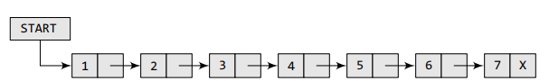
In the Figure, we can see a linked list in which every node contains two parts, an integer and a pointer to the next node. The left part of the node which contains data may include a simple data type, an array, or a structure. The right part of the node contains a pointer to the next node (or address of the next node in sequence). The last node will have no next node connected to it, so it will store a special value called NULL. In the Figure, the NULL pointer is represented by X. While programming, we usually define NULL as –1. Hence, a NULL pointer denotes the end of the list. Since in a linked list, every node contains a pointer to another node which is of the same type, it is also called a self-referential data type.
Creation of single link list
#include<stdio.h>
#include<stdlib.h>
struct node{
int data;
struct node *next;
};
struct node *head, *fnode, *temp;
void creat_head();
void creat_lst();
void display();
int main()
{
int option;
while(1)
{
printf("\n press 1 for creation of head");
printf("\n press 2 for creation of nodes");
printf("\n press 3 for display");
printf("\n press 4 to exit");
printf("\n enter option");
scanf("%d",&option);
switch(option)
{
case 1: creat_head();
break;
case 2: creat_lst();
break;
case 3: display();
break;
case 4: exit(0);
break;
}
}

return 0;
}
void creat_head()
{
int value;
head=(struct node *)malloc(sizeof(struct node));
if(head==NULL)
printf("\nmemory allocation unsuccessful");
else
{
printf("\n enter data for the head");
scanf("%d",&value);
head->data=value;
head->next=NULL;
temp=head;
}
}

void creat_lst()
{
int value;
fnode=(struct node *)malloc(sizeof(struct node));
if(fnode==NULL)
printf("\nmemory allocation unsuccessful");
else
{
printf("\n enter data for the node");
scanf("%d",&value);
fnode->data=value;
fnode->next=NULL;
temp->next=fnode;
temp=temp->next;

}
}
void display()
{
if(head==NULL)
printf("\nlist is empty");
else
{
temp=head;
while(temp!=NULL)
{
printf("%d->",temp->data);
temp=temp->next;
}
}
}
O/P:
press 1 for creation of head
press 2 for creation of nodes
press 3 for display
press 4 to exit
enter option1

enter data for the head24
press 1 for creation of head
press 2 for creation of nodes
press 3 for display
press 4 to exit
enter option2
enter data for the node45
press 1 for creation of head
press 2 for creation of nodes
press 3 for display
press 4 to exit
enter option2
enter data for the node36
press 1 for creation of head
press 2 for creation of nodes
press 3 for display
press 4 to exit
enter option2
enter data for the node18
press 1 for creation of head
press 2 for creation of nodes
press 3 for display
press 4 to exit
enter option3
24->45->36->18->
press 1 for creation of head
press 2 for creation of nodes
press 3 for display
press 4 to exit
enter option4
--------------------------------
Process exited after 50.78 seconds with return value 0
Press any key to continue . . .

Insertion at three different positions
#include<stdio.h>
#include<stdlib.h>
struct node{
int data;
struct node *next;
};
struct node *head,*fnode,*temp, *newnode, *lnode, *mnode;
void creat_head();
void creat_node();
void display();
void insert_beg();
void insert_last();
void insert_middle();
int main()
{
int option;
while(1)
{
printf("\n press 1 to create head");
printf("\n press 2 to create node");
printf("\n press 3 to display");
printf("\n press 4 to create node at the begining");
printf("\n press 5 to create node at the end");
printf("\n press 6 to create node at the middle");
printf("\n press 7 to exit");
printf("\nenter option");
scanf("%d",&option);
switch(option)
{
case 1:creat_head();
break;
case 2:creat_node();
break;
case 3:display();
break;
case 4:insert_beg();
break;
case 5:insert_last();
break;
case 6:insert_middle();
break;
case 7:exit(0);
break;
}
}
return 0;
}
void creat_head()
{
int val;
head=(struct node *)malloc(sizeof(struct node));
if(head==NULL)
printf("\n memory allocation unsuccessful");
else
{
printf("\n enter the data");
scanf("%d",&val);
head->data=val;
head->next= NULL;
temp=head;
}
}
void creat_node()
{
int val;
fnode=(struct node *)malloc(sizeof(struct node));
if(fnode==NULL)
printf("\n memory allocation unsuccessful");
else
{
printf("\n enter the data");
scanf("%d",&val);
fnode->data=val;
fnode->next=NULL;
temp->next=fnode;
temp=temp->next;
}

}
void display()
{
if (head==NULL)
printf("\n the linked list is empty");
else
{
temp=head;
while(temp!=NULL)
{
printf("%d->",temp->data);
temp=temp->next;
}
}
}

void insert_beg()
{
int val;
newnode=(struct node *)malloc(sizeof(struct node));
if(newnode==NULL)
printf("\n memory allocation unsuccessful");
else
{
printf("\n enter the data");
scanf("%d",&val);
newnode->data=val;
newnode->next=head;
head=newnode;
}
}
void insert_last()
{
int val;
lnode=(struct node *)malloc(sizeof(struct node));
if(lnode==NULL)
printf("\n memory allocation unsuccessful");
else
{
printf("\n enter the data");
scanf("%d",&val);
lnode->data=val;
lnode->next=NULL;
temp=head;
while(temp->next!=NULL)
{
temp=temp->next;
}
temp->next=lnode;

}
}

void insert_middle()
{
int val,pos;
mnode=(struct node *)malloc(sizeof(struct node));
if(mnode==NULL)
printf("\n memory allocation unsuccessful");
else
{
printf("\n enter the data and position");
scanf("%d%d",&val,&pos);
mnode->data=val;
temp=head;
for(int i=1;i<pos-1 && temp->next!=NULL;i++)
{
temp=temp->next;
}
mnode->next=temp->next;
temp->next=mnode;

}
}
O/P:
press 1 to create head
press 2 to create node
press 3 to display
press 4 to create node at the begining
press 5 to create node at the end
press 6 to create node at the middle
press 7 to exit
enter option1
enter the data600
press 1 to create head
press 2 to create node
press 3 to display
press 4 to create node at the begining
press 5 to create node at the end
press 6 to create node at the middle
press 7 to exit
enter option2
enter the data500
press 1 to create head
press 2 to create node
press 3 to display
press 4 to create node at the begining
press 5 to create node at the end
press 6 to create node at the middle
press 7 to exit
enter option2
enter the data400
press 1 to create head
press 2 to create node
press 3 to display
press 4 to create node at the begining
press 5 to create node at the end
press 6 to create node at the middle
press 7 to exit
enter option3
600->500->400->
press 1 to create head
press 2 to create node
press 3 to display
press 4 to create node at the begining
press 5 to create node at the end
press 6 to create node at the middle
press 7 to exit
enter option6
enter the data and position100 2
press 1 to create head
press 2 to create node
press 3 to display
press 4 to create node at the begining
press 5 to create node at the end
press 6 to create node at the middle
press 7 to exit
enter option3
600->500->100->400->
press 1 to create head
press 2 to create node
press 3 to display
press 4 to create node at the begining
press 5 to create node at the end
press 6 to create node at the middle
press 7 to exit
enter option4
enter the data20
press 1 to create head
press 2 to create node
press 3 to display
press 4 to create node at the begining
press 5 to create node at the end
press 6 to create node at the middle
press 7 to exit
enter option3
20->600->500->100->400->
press 1 to create head
press 2 to create node
press 3 to display
press 4 to create node at the begining
press 5 to create node at the end
press 6 to create node at the middle
press 7 to exit
enter option5
enter the data30
press 1 to create head
press 2 to create node
press 3 to display
press 4 to create node at the begining
press 5 to create node at the end
press 6 to create node at the middle
press 7 to exit
enter option3
20->600->500->100->400->30->
press 1 to create head
press 2 to create node
press 3 to display
press 4 to create node at the begining
press 5 to create node at the end
press 6 to create node at the middle
press 7 to exit
enter option6
enter the data and position5 3
press 1 to create head
press 2 to create node
press 3 to display
press 4 to create node at the begining
press 5 to create node at the end
press 6 to create node at the middle
press 7 to exit
enter option3
20->600->500->5->100->400->30->
press 1 to create head
press 2 to create node
press 3 to display
press 4 to create node at the begining
press 5 to create node at the end
press 6 to create node at the middle
press 7 to exit
enter option
Deletion at three different positions
#include<stdio.h>
#include<stdlib.h>
struct node{
int data;
struct node *next;
};
struct node *head,*fnode,*temp, *newnode, *lnode, *mnode, *prev;
void creat_head();
void creat_node();
void display();
void creat_beg();
void creat_last();
void creat_middle();
void del_head();
void del_last();
void del_middle();
int main()
{
int option;
while(1)
{
printf("\n press 1 to create head");
printf("\n press 2 to create node");
printf("\n press 3 to display");
printf("\n press 4 to insert at beg");
printf("\n press 5 to insert at last");
printf("\n press 6 to insert at middle");
printf("\n press 7 to delete head");
printf("\n press 8 to delete last");
printf("\n press 9 to delete middle");
printf("\n press 10 to exit");
printf("\nenter option");
scanf("%d",&option);
switch(option)
{
case 1:creat_head();
break;
case 2:creat_node();
break;
case 3:display();
break;
case 4:creat_beg();
break;
case 5:creat_last();
break;
case 6:creat_middle();
break;
case 7:del_head();
break;
case 8:del_last();
break;
case 9:del_middle();
break;
case 10:exit(0);
break;
}
}
return 0;
}
void creat_head()
{
int val;
head=(struct node *)malloc(sizeof(struct node));
if(head==NULL)
printf("\n memory allocation unsuccessful");
else
{
printf("\n enter the data");
scanf("%d",&val);
head->data=val;
head->next= NULL;
temp=head;
}
}
void creat_node()
{
int val;
fnode=(struct node *)malloc(sizeof(struct node));
if(fnode==NULL)
printf("\n memory allocation unsuccessful");
else
{
printf("\n enter the data");
scanf("%d",&val);
fnode->data=val;
fnode->next=NULL;
temp->next=fnode;
temp=temp->next;
}

}
void display()
{
if (head==NULL)
printf("\n the linked list is empty");
else
{
temp=head;
while(temp!=NULL)
{
printf("%d->",temp->data);
temp=temp->next;
}
}
}
void creat_beg()
{
int val;
newnode=(struct node *)malloc(sizeof(struct node));
if(newnode==NULL)
printf("\n memory allocation unsuccessful");
else
{
printf("\n enter the data");
scanf("%d",&val);
newnode->data=val;
newnode->next=head;
head=newnode;
}
}
void creat_last()
{
int val;
lnode=(struct node *)malloc(sizeof(struct node));
if(lnode==NULL)
printf("\n memory allocation unsuccessful");
else
{
printf("\n enter the data");
scanf("%d",&val);
lnode->data=val;
lnode->next=NULL;
temp=head;
while (temp->next!=NULL)
{
temp=temp->next;
}
temp->next=lnode;
}
}

void creat_middle()
{
int val, pos;
mnode=(struct node *)malloc(sizeof(struct node));
if(mnode==NULL)
printf("\n memory allocation unsuccessful");
else
{
printf("\n enter the data and the position");
scanf("%d%d",&val,&pos);
mnode->data=val;
temp=head;
for(int i=1;i<pos-1&&temp->next!=NULL;i++)
{
temp=temp->next;
}
mnode->next=temp->next;
temp->next=mnode;
}
}
void del_head()
{
if(head==NULL)
printf("\n Linked list is empty");
else
{
temp=head;
head=head->next;
free(temp);
}
}

void del_last()
{
if (head==NULL)
printf("Linked list is empty");
else if(head->next==NULL)
{
free(head);
head=NULL;
}
else
{
temp=head;
while(temp->next!=NULL)
{
prev=temp;
temp=temp->next;
}
prev->next =NULL;
free(temp);
}
}

void del_middle()
{
int pos;
if (head==NULL)
printf("Linked list is empty");
else if(head->next==NULL)
{
free(head);
head=NULL;
}
else
{
temp=head;
printf("\n enter position");
scanf("%d",&pos);
for(int i=1;i<pos-1&&temp->next!=NULL;i++)
{
temp=temp->next;
}
prev=temp->next;
temp->next=prev->next;
free(prev);
}
}
Circular Linked List
A circular linked list is a linear data structure in which the last node points back to the first node, creating a continuous loop. Unlike a regular linked list which terminates with a NULL pointer, every node in a circular list has a successor, allowing for endless traversal.
Circular Singly Linked List
Each node has a single pointer (next) to the subsequent node in the sequence. The next pointer of the last node points back to the first node (head).
Key Operations
Common operations on a circular linked list include:
- Insertion: Adding a new node at the beginning, end, or after a specific node. Careful pointer management is crucial to maintain the list's circular structure.
- Deletion: Removing a node from various positions (beginning, end, specific position). This requires adjusting pointers to ensure the remaining nodes form a continuous loop.
- Traversal: Visiting each node in the list starting from a given point and continuing until the starting node is reached again. A do-while loop is often used to ensure the head is processed exactly once.
- Searching: Locating a node with a specific value by traversing the list until the value is found or the traversal returns to the starting node.
Advantages and Disadvantages

Advantages | Disadvantages
Allows for continuous, efficient traversal from any node without checking for NULL. | More complex to implement and debug due to the pointer logic and the risk of infinite loops if the stopping condition is mishandled.
Insertion and deletion at the beginning or end can be efficient (O(1) time) if a pointer to the last node (tail) is maintained. | Requires more memory overhead per node in a doubly linked variant due to the extra pointer(s).
Useful in applications that require data to be processed in a repeating cycle. | Lacks a natural end, which makes standard list boundary detection logic more involved.
Applications
Circular linked lists are well-suited for applications that involve looping or cyclic processing:
- Operating Systems: Used in round-robin scheduling algorithms to give each process a fixed time slice in a cyclic manner.
- Media Players: Manage playlists in "repeat" mode, so the last song seamlessly loops back to the first.
- Networking: Implements algorithms for token ring networks.
- Game Development: Manages player turns in multiplayer games in a loop.
- Data Buffering: Used in circular buffers for managing data in applications like networking.

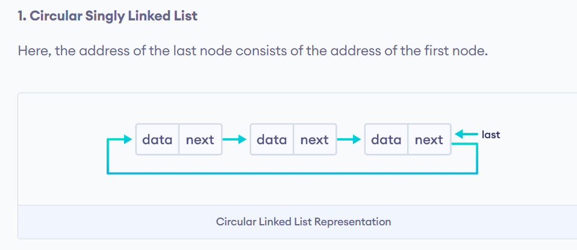

Creation, insertion and deletion
#include<stdio.h>
#include<stdlib.h>
struct node{
int data;
struct node *next;
};
struct node *head,*fnode,*temp, *newnode, *lnode, *mnode, *prev;
void creat_head();
void creat_node();
void display();
void insert_beg();
void insert_last();
void insert_middle();
void del_beg();
void del_last();
void del_middle();
int main()
{
int option;
while(1)
{
printf("\n press 1 to create head");
printf("\n press 2 to display");
printf("\n press 3 to create node");
printf("\n press 4 to insert at begining");
printf("\n press 5 to insert at last");
printf("\n press 6 to insert at middle");
printf("\n press 7 to delete at begining");
printf("\n press 8 to delete at last");
printf("\n press 9 to delete at middle");
printf("\n press 10 to exit");
printf("\nenter option");
scanf("%d",&option);
switch(option)
{
case 1:creat_head();
break;
case 2:display();
break;
case 3:creat_node();
break;
case 4:insert_beg();
break;
case 5:insert_last();
break;
case 6:insert_middle();
break;
case 7:del_beg();
break;
case 8:del_last();
break;
case 9:del_middle();
break;
case 10:exit(0);
break;
}
}
return 0;
}
void creat_head()
{
int val;
head=(struct node *)malloc(sizeof(struct node));
if(head==NULL)
printf("\n Memory allocation unsuccesful");
else
{
printf("\n enter value");
scanf("%d",&val);
head->data=val;
head->next=head;
temp=head;
}
}

void display()
{
if(head==NULL)
printf("\n linked list empty");
else
{
struct node *curr=head;
do
{
printf("%d->",curr->data);
curr=curr->next;
}while(curr!=head);
}
}
void creat_node()
{
int val;
fnode=(struct node *)malloc(sizeof(struct node));
if(fnode==NULL)
printf("\n memory allocation unsuccessful");
else
{
printf("\n enter value");
scanf("%d",&val);
fnode->data=val;
temp->next=fnode;
fnode->next=head;
temp=temp->next;
}

}

void insert_beg()
{
int val;
newnode=(struct node *)malloc(sizeof(struct node));
if(newnode==NULL)
printf("\n memory allocation unsuccessful");
else
{
printf("\n enter the data");
scanf("%d",&val);
newnode->data=val;
newnode->next=head;
// find last node
temp = head;
while(temp->next != head)
{
temp = temp->next;
}
temp->next = newnode; // last points to new head
head = newnode;
}
}

void insert_last()
{
int val;
lnode=(struct node *)malloc(sizeof(struct node));
if(lnode==NULL)
printf("\n memory allocation unsuccessful");
else
{
printf("\n enter the data");
scanf("%d",&val);
lnode->data=val;
lnode->next=head;
// find last node
temp = head;
while(temp->next != head)
{
temp = temp->next;
}
temp->next = lnode; // last points to new head

}
}

void insert_middle()
{
int val, pos;
mnode=(struct node *)malloc(sizeof(struct node));
if(mnode==NULL)
printf("\n memory allocation unsuccessful");
else
{
printf("\n enter the data and position");
scanf("%d%d",&val,&pos);
mnode->data=val;
temp=head;
for(int i=1; i<pos-1&&temp->next!=head;i++)
{
temp=temp->next;
}
mnode->next=temp->next;
temp->next=mnode;
}
}

void del_beg()
{
if (head==NULL)
printf("\n linked list is empty");
else if(head->next==head)
{
free(head);
head=NULL;
}
else
{
temp=head;
while(temp->next!=head)
{
temp=temp->next;
}
struct node *begnode=head;
head=head->next;
temp->next=head;
free(begnode);
}
}
void del_last()
{
if (head==NULL)
printf("\n linked list is empty");
else if(head->next==head)
{
free(head);
head=NULL;
}
else
{
temp=head;
while(temp->next!=head)
{
prev=temp;
temp=temp->next;
}
prev->next=head;
free(temp);
}
}
void del_middle()
{
int pos;
if (head==NULL)
printf("Linked list is empty");
else if(head->next==head)
{
free(head);
head=NULL;
}
else
{
temp=head;
printf("\n enter position");
scanf("%d",&pos);
for(int i=1;i<pos-1&&temp->next!=head;i++)
{
temp=temp->next;
}
prev=temp->next;
temp->next=prev->next;
free(prev);
}
}
Doubly Linked List
A doubly linked list is a type of linked list in which each node consists of 3 components:
*prev - address of the previous node
data - data item
*next - address of next node
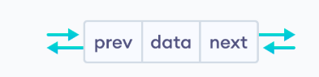

Representation of Doubly Linked List
Let's see how we can represent a doubly linked list on an algorithm/code. Suppose we have a doubly linked list:
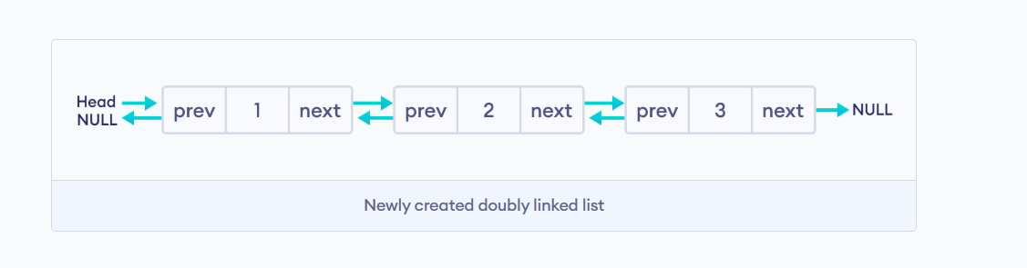
Here, the single node is represented as
struct node {
int data;
struct node *next;
struct node *prev;
}
Each struct node has a data item, a pointer to the previous struct node, and a pointer to the next struct node.
Creation, Insertion, Deletion
#include<stdio.h>
#include<stdlib.h>
struct node{
int data;
struct node *next;
struct node *prev;
};
struct node *head,*fnode,*temp, *newnode, *prev;
void creat_head();
void creat_node();
void display();
void insert_beg();
void delete_last();
int main()
{
int option;
while(1)
{
printf("\n press 1 to create head");
printf("\n press 2 to display");
printf("\n press 3 to create node");
printf("\n press 4 to insert at beg");
printf("\n press 5 to delete at last");
printf("\n press 6 to exit");
printf("\nenter option");
scanf("%d",&option);
switch(option)
{
case 1:creat_head();
break;
case 2:display();
break;
case 3:creat_node();
break;
case 4:insert_beg();
break;
case 5:delete_last();
break;
case 6:exit(0);
break;
}
}
return 0;
}
void creat_head()
{
int val;
head=(struct node *)malloc(sizeof(struct node));
if(head==NULL)
printf("\n Memory allocation unsuccesful");
else
{
printf("\n enter value");
scanf("%d",&val);
head->data=val;
head->prev=NULL;
head->next=NULL;
temp=head;
}
}

void creat_node()
{
int val;
fnode=(struct node *)malloc(sizeof(struct node));
if(fnode==NULL)
printf("\n Memory allocation unsuccesful");
else
{
printf("\n enter value");
scanf("%d",&val);
fnode->data=val;
fnode->next=NULL;
fnode->prev=temp;
temp->next=fnode;
temp=temp->next;
}
}

void display()
{

if (head == NULL) {
printf("\nList is empty");
return;
}

struct node *curr = head;
printf("\nDoubly Linked List (Forward): ");

while (curr != NULL) {
printf("%d->", curr->data);
curr = curr->next;
}
}

void insert_beg()
{
int val;
newnode=(struct node *)malloc(sizeof(struct node));
if(newnode==NULL)
printf("\n Memory allocation unsuccesful");
else
{
printf("\n enter value");
scanf("%d",&val);
newnode->data=val;
newnode->prev=NULL;
newnode->next=head;
head->prev=newnode;
head=newnode;
}

}
void delete_last()
{
if (head==NULL)
printf("\n the linked list does not exist");
else if(head->next==NULL)
{
free(head);
head=NULL;
}
else
{
temp=head;
while(temp->next!=NULL)
{
prev=temp;
temp=temp->next;
}
//temp->prev->next=NULL;
prev->next=NULL;
free(temp);
}
}
Queue
A queue is a linear data structure that follows the First-In-First-Out (FIFO) principle which means the elements added first in a queue will be removed first from the queue. In this article, we will learn how to implement a Queue using Array in C.
Approach:
- Define a structure consisting of an array and two pointers front and rear.
- Initialize the array with MAX_SIZE.
- Initialize both the front and rear pointers to -1.
- The insertion of elements will take place through the rear pointer and the deletion of elements will take place through the front pointer.
- Implement isFull, isEmpty, Enqueue, and Dequeue functions to manipulate the elements of the queue easily.
Algorithm for Enqueue Function
1. Check if the queue is full
2. If the queue is empty, set front pointer to 0.
3. Increment rear pointer and add the element at the rear position in the queue array.
Algorithm for Dequeue Function
- Check if the queue is empty.
- If not, store the data at the front position of the queue.
- If front pointer is equal to rear, reset both pointers to -1, indicating an empty queue.
- Otherwise, increment the front pointer to point to the next element.
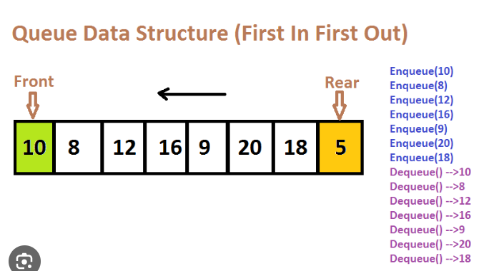

#include<stdio.h>
#include<stdlib.h>
#define MAX 5
int queue[MAX];
int front=-1;
int rear=-1;
void enqueue();
void dequeue();
void display();
int main()
{

int option;
while(1)
{
printf("\npress 1 for enqueue");
printf("\npress 2 for dequeue");
printf("\npress 3 for display");
printf("\npress 4 to exit");
printf("\n enter option ");
scanf("%d",&option);
switch(option)
{
case 1: enqueue();
break;
case 2: dequeue();
break;
case 3: display();
break;
case 4: exit(0);
break;
}
}
return 0;
}

void enqueue()
{
int data;
if(rear==MAX-1)
{
printf("\n Queue is full");
return;
}

if(front==-1)
{
front=0;
}
rear++;
printf("\n enter data");
scanf("%d",&data);
queue[rear]=data;
printf("Enqueued %d in queue\n", data);
}

void dequeue()
{
int data;
if(front==-1)
{
printf("\n Queue is empty");
return;
}
data=queue[front];
if(front==rear)
{
front=-1;
rear=-1;
}
else
{
front++;
}
printf("Deleted element: %d\n", data);
}

void display()
{
int i;

if (front == -1) {
printf("\nQueue is empty");
return;
}
printf("\nQueue elements: ");
for (i = front; i <= rear; i++) {
printf("%d ", queue[i]);
}
}
Circular Queue

Basic idea (one line)
A circular queue treats the array as circular, so when the last index is reached, it wraps around to the beginning using modulo (%).

Variables Used
- queue[MAX] → array
- front → index of first element
- rear → index of last element
- Initially:
front = -1
rear = -1

ENQUEUE(x)
1. If ( (rear + 1) % MAX == front )
Print "Queue is Full"
Return
2. If (front == -1)
front = 0

Else
rear = (rear + 1) % MAX
3. queue[rear] = x
4. End
DEQUEUE(x)
1. If (front == -1)
Print "Queue is Empty"
Return

2. item = queue[front]

3. If (front == rear)
front = -1
rear = -1
Else
front = (front + 1) % MAX

4. Return item

DISPLAY(x)
1. i = front
2. while (1)
3.PRINT queue[i]
4. if (i == rear)
5 break
6. i = (i + 1) % MAX
Application of Queue
Round Robin Scheduling Algorithm
Round Robin scheduling is a CPU scheduling algorithm that uses a queue to allocate CPU time fairly among processes. Each process is given a fixed time quantum, and if it does not complete execution within that time, it is placed at the rear of the queue. This continues in a circular manner until all processes finish execution, ensuring fairness and preventing starvation.

What problem does Round Robin solve?
In a multitasking operating system:
- Many processes want the CPU
- CPU must be shared fairly
- No process should wait forever (no starvation)
👉 Round Robin scheduling solves this using a queue.

Core idea (in one line)
Each process gets the CPU for a fixed time slice (time quantum) and is then placed at the back of the queue if it is not finished.
Sounds familiar?
That’s exactly enqueue at rear, dequeue from front.

How queue is used
- Ready Queue → implemented using a circular queue
- Processes are stored in FIFO order
- CPU always picks from the front
- Unfinished processes go back to the rear
Queue using linked list
#include<stdio.h>
#include<stdlib.h>
struct node
{
int data;
struct node *next;
};
struct node *front =NULL;
struct node *rear =NULL;
struct node *newnode, *temp;
void enqueue();
void dequeue();
void display();
int main()
{
int option;
while(1)
{
printf("\npress 1 to enqueue");
printf("\npress 2 to dequeue");
printf("\npress 3 to display");
printf("\npress 4 to exit");
printf("\nenter option");
scanf("%d",&option);
switch(option)
{
case 1: enqueue();
break;
case 2: dequeue();
break;
case 3: display();
break;
case 4: exit(0);
break;
}
}
return 0;
}
void enqueue()
{
int val;
newnode=(struct node *)malloc(sizeof(struct node));
if(newnode==NULL)
printf("\nmemory allocation failed");
else
{
printf("\n enter data");
scanf("%d",&val);
newnode->data=val;
newnode->next=NULL;
if(rear==NULL)
front=rear=newnode;
else
{
rear->next=newnode;
rear=rear->next;
}
}
}

void dequeue()
{
if(front==NULL)
printf("\nlink list empty");
else
{
temp=front;
printf("\ndequeued data =%d",temp->data);
front=front->next;
if(front==NULL)
{
rear=NULL;
}
free(temp);
}

}
void display()
{
struct node *ptr=front;
if(front==NULL)
printf("\nlink list empty");
else
{
while(ptr!=NULL)
{
printf("%d->",ptr->data);
ptr=ptr->next;
}
}

}
Stack
What is a stack?
Stack is a linear data structure which follows LIFO principle. There are two operations in stack:
- Push-add elements in a stack. The top pointer which is initialized to -1, will be incremented by plus 1. If stack is full and still elements are added, causes STACK OVERFLOW error.
- pop-remove elements from the top of the stack. This follows the LIFO principle. The top pointer is decremented by -1. If stack is empty and still elements are tried to be removed, causes STACK UNDERFLOW error.
- Peek- This displays the top most element of a stack. If stack is empty and still elements are tried to be displayed, causes STACK UNDERFLOW error.
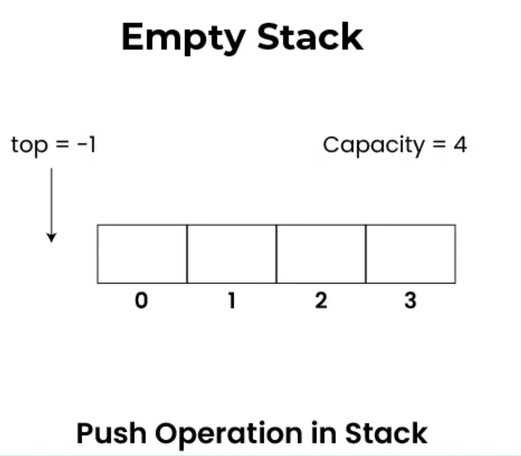

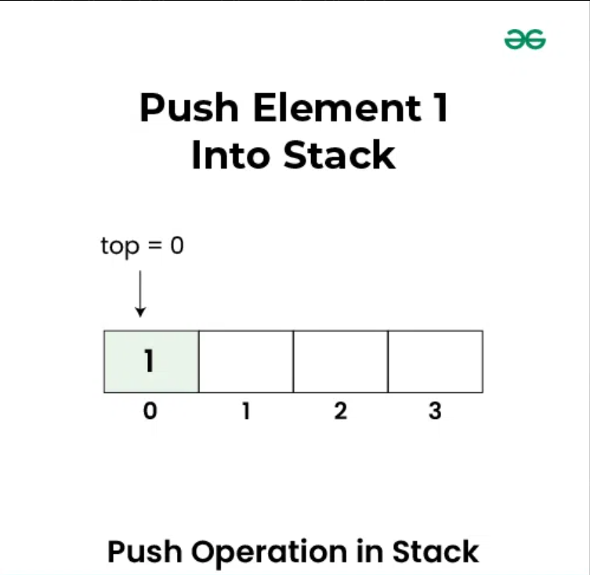
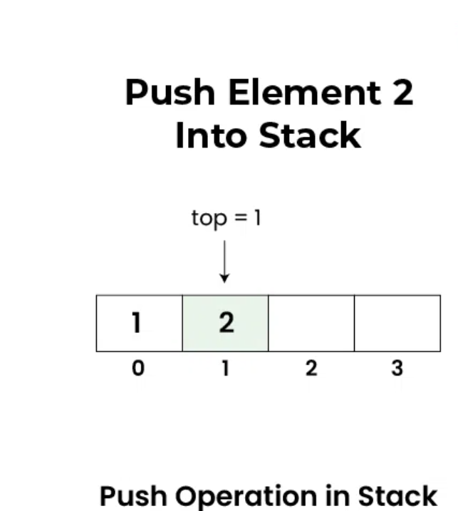
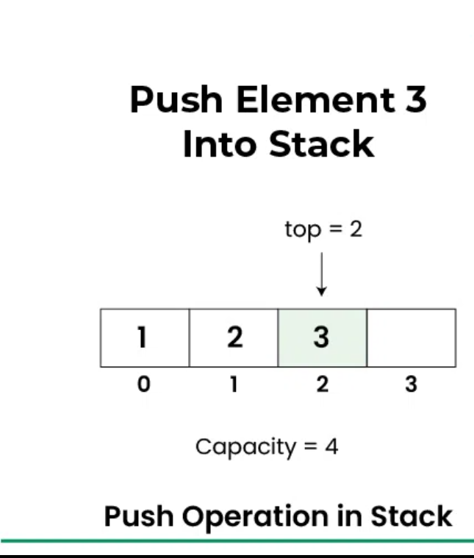
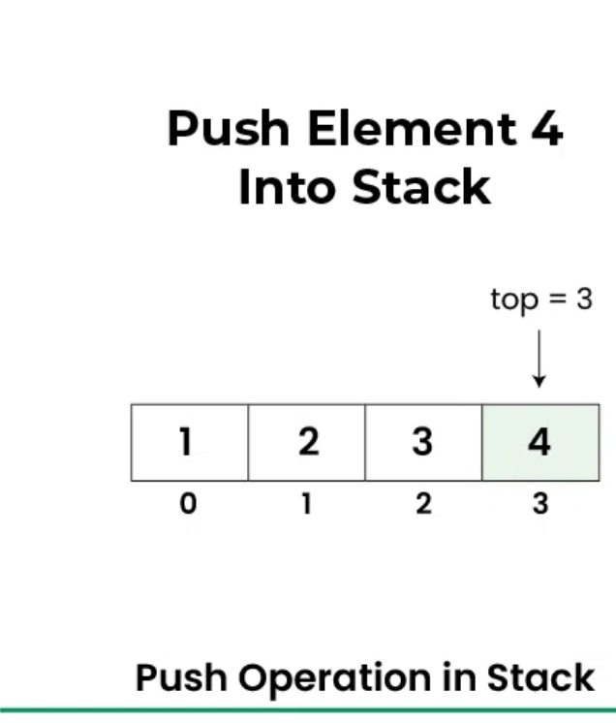
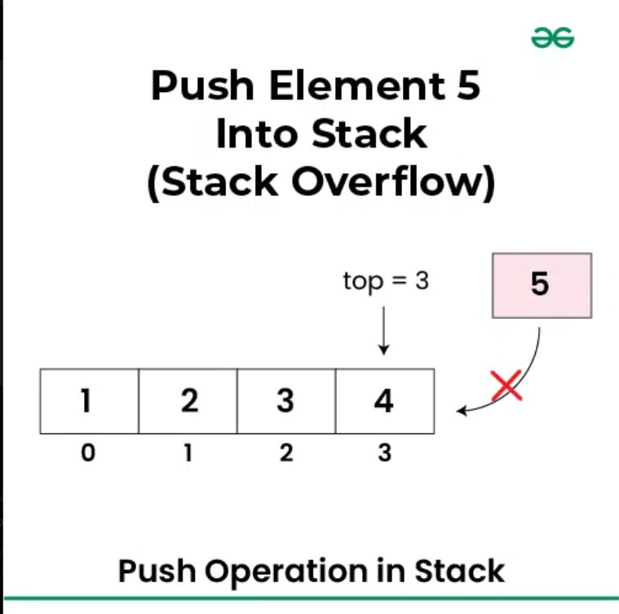

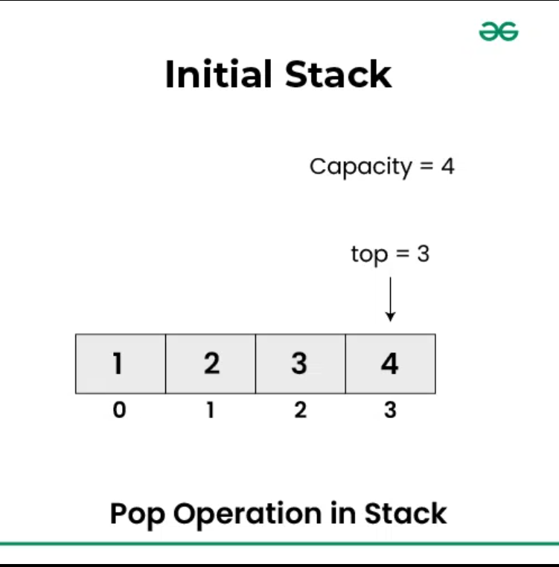
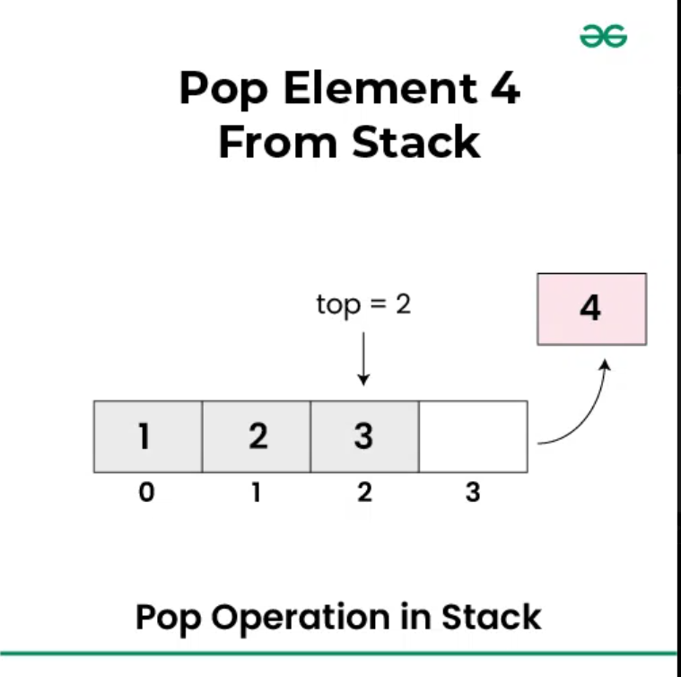
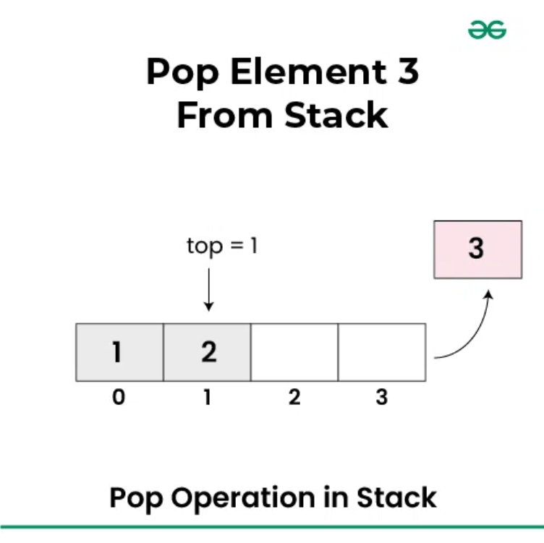
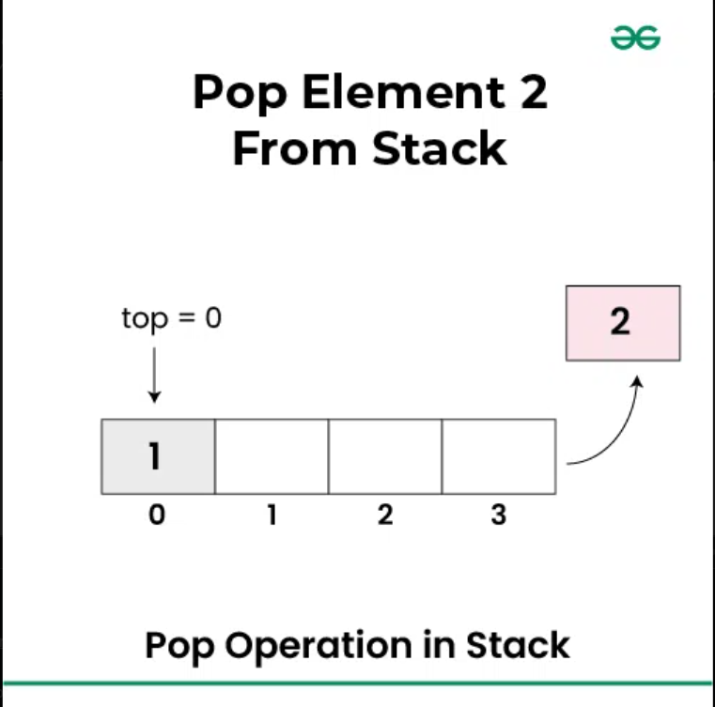
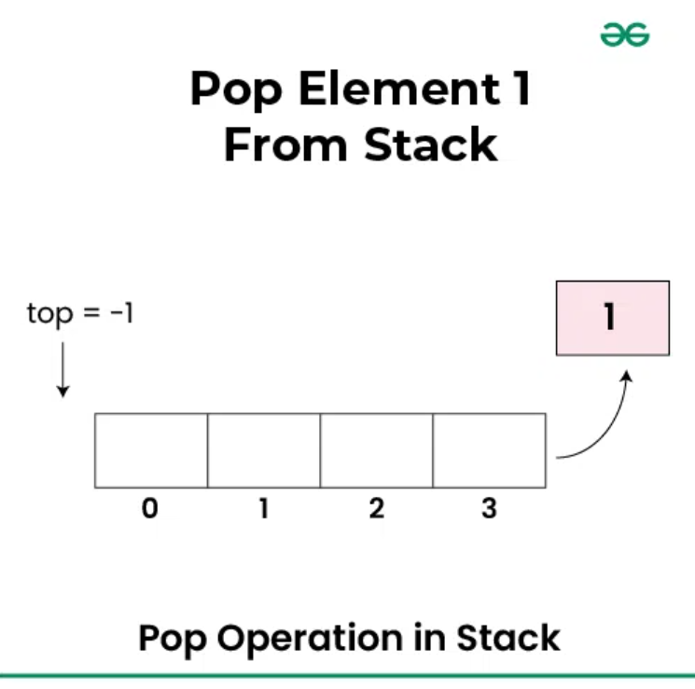
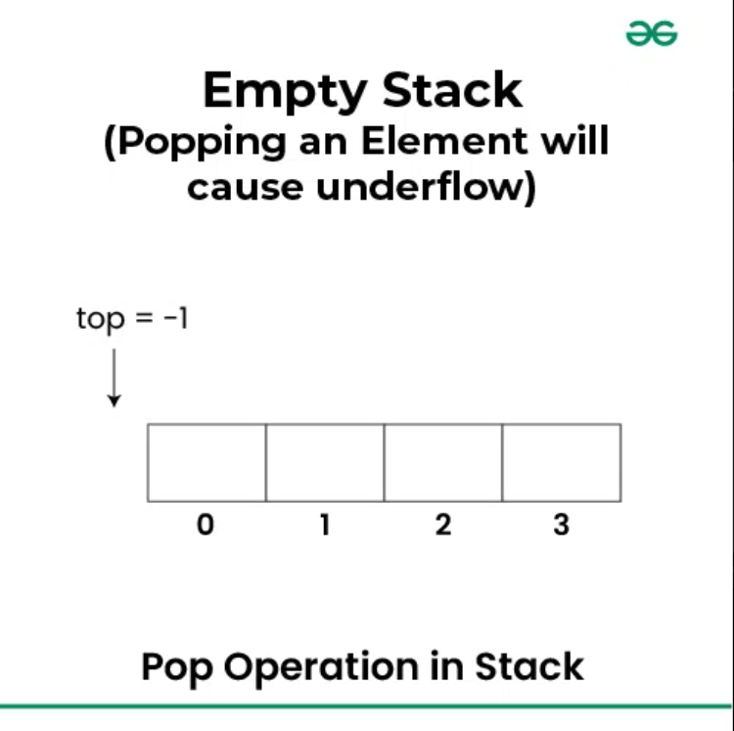

Stack Using Array
#include<stdio.h>
#include<stdlib.h>
#define MAX 5
int arr[MAX];
int top=-1;
void push();
void pop();
void peek();
int main()
{
int option;
while(1)
{
printf("\npress 1 for push");
printf("\npress 2 for pop");
printf("\npress 3 for peek");
printf("\npress 4 to exit");
printf("\n enter option ");
scanf("%d",&option);
switch(option)
{
case 1: push();
break;
case 2: pop();
break;
case 3: peek();
break;
case 4: exit(0);
break;
}
}
return 0;
}
void push()
{

int ele;
if (top==MAX-1)
printf("\n stack overflow");
else
{
top++;
printf("\n enter the element to be pushed");
scanf("%d",&ele);
arr[top]=ele;
}
}

void pop()
{
int val;

if(top==-1)
printf("\n stack underflow");
else
{
val=arr[top];
printf("%d\n",val);
top--;
}
}
void peek()
{
if(top==-1)
printf("\n stack underflow");
else
{
printf("%d\n",arr[top]);
}
}
Stack Using Linked List
#include<stdio.h>
#include<stdlib.h>
struct node
{
int data;
struct node *next;
};
struct node *top =NULL;
struct node *newnode, *temp;
void push();
void pop();
void peek();
int main()
{
int option;
while(1)
{
printf("\npress 1 to push");
printf("\npress 2 to pop");
printf("\npress 3 to peek");
printf("\npress 4 to exit");
printf("\nenter option");
scanf("%d",&option);
switch(option)
{
case 1: push();
break;
case 2: pop();
break;
case 3: peek();
break;
case 4: exit(0);
break;
}
}
return 0;
}
void push()
{
int val;
newnode = malloc(sizeof *newnode);

if(newnode == NULL)
printf("\nMemory allocation failed");
else
{
printf("\nEnter data: ");
scanf("%d", &val);
newnode->data = val;
newnode->next = top; // point to old top
top = newnode; // ✅ update top correctly
}
}
void pop()
{
if(top == NULL)
printf("\nStack is empty");
else
{
temp = top;
printf("\nPopped data = %d", temp->data);
top = top->next; // move top down
free(temp);
}
}
void peek()
{
struct node *ptr=top;
if(top==NULL)
printf("\nlink list empty");
else
{
printf("\n top data =%d",ptr->data);
}

}
Application of Stack
1. Post Value Evaluation Using Stack
Algorithm for Postfix Evaluation using a Stack
- Create an empty stack to store the operands.
- Scan the postfix expression from left to right, character by character (or token by token).
- For each character/token:
  - If the character is an operand (a number): Convert it to an integer (if necessary, handling multi-digit numbers) and push its value onto the stack.
  - If the character is an operator (+, -, *, /, ^):
    - Pop the top two operands from the stack. The first popped element is the second operand (operand2), and the second popped element is the first operand (operand1).
    - Perform the arithmetic operation: result = operand1 operator operand2.
    - Push the calculated result back onto the stack.
- After the entire expression has been processed, the final result will be the only item remaining in the stack. Pop this final value, which is the result of the expression.
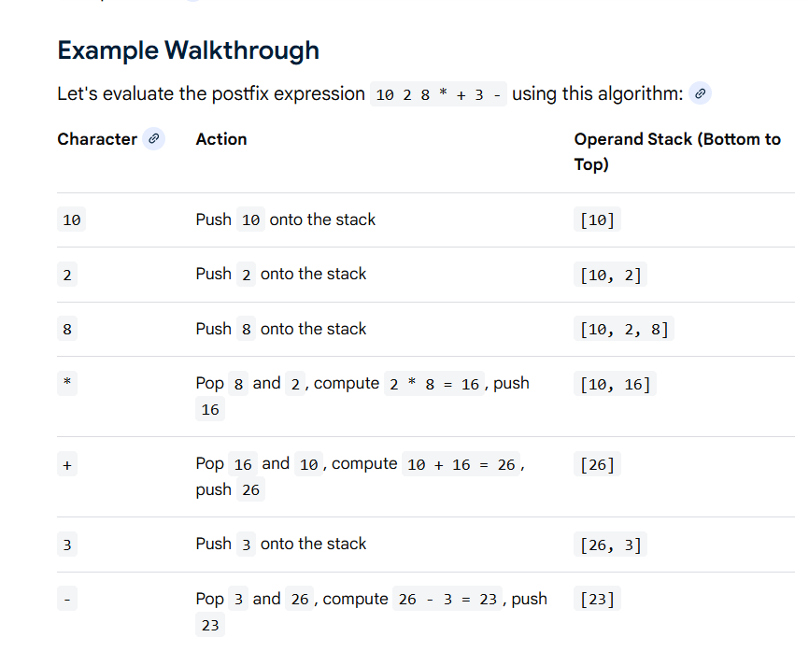
2. Infix to postfix conversion
If operator (^,+, -, *, /, %) is present between two operands (A, B, C..), it is called an infix expression.
Example: A+B
If operator is present after the operands, it is called a postfix expression (AB+)
Rules of conversion
- Priorities of operators
Exponent (^)
Multiplication, Division (*, /) (same priority)
Addition, subtraction (+, -)
- No two operators of the same priority can stay in a stack. The operator on top of the stack has to be popped.
- Lowest priority cannot be placed before highest priority. (pop the higher priority and then place the lower priority)
- A high priority operator can be placed on top of low priority operator.
- Any operator between (and), pop out that operator
- Operands are coming from left to right scanning, put it in postfix expression and if operators are scanned then place them on top of stack.
Example1: (A+B/C*(D+C)-F)
Symbol | Stack | Postfix Expression
( | (
A | ( | A
+ | (+ | A
B | (+ | AB
/ (high on low) | (+/ | AB
C | (+/ | ABC
*(same priority as division) | (+* | ABC/
( | (+*( | ABC/
D | (+*( | ABC/D
+ | (+*(+ | ABC/D
C | (+*(+ | ABC/DC
) Pop out | (+* | ABC/DC+
-(low priority cannot stay over high) | (- | ABC/DC+*+
F | (- | ABC/DC+*+F
) Pop out |  | ABC/DC+*+F-

Example2: m*n+(p-q)+r
Answer: mn*pq-+r+

