Unit-5
Hashing and Collision
HASH TABLE
There are two solutions to this problem. Let us take an example to explain the first solution. In a small company of 100 employees, each employee is assigned an Emp_ID in the range 0–99. To store the records in an array, each employee’s Emp_ID acts as an index into the array where the employee’s record will be stored as shown in Fig. 15.1. In this case, we can directly access the record of any employee, once we know his Emp_ID, because the array index is the same as the Emp_ID number. But practically, this implementation is hardly feasible. Let us assume that the same company uses a five-digit Emp_ID as the primary key. In this case, key values will range from 00000 to 99999. If we want to use the same technique as above, we need an array of size 100,000, of which only 100 elements will be used. It is impractical to waste so much storage space just to ensure that each employee’s record is in a unique and predictable location. Whether we use a two-digit primary key (Emp_ID) or a five-digit key, there are just 100 employees in the company. Thus, we will be using only 100 locations in the array. Therefore, in order to keep the array size down to the size that we will actually be using (100 elements), another good option is to use just the last two digits of the key to identify each employee. For example, the employee with Emp_ID 79439 will be stored in the element of the array with index 39. Similarly, the employee with Emp_ID 12345 will have his record stored in the array at the 45th location. In the second solution, the elements are not stored according to the value of the key. So, in this case, we need a way to convert a five-digit key number to a two-digit array index. We need a function which will do the transformation. In this case, we will use the term hash table for an array and the function that will carry out the transformation will be called a hash function.
Hash table is a data structure in which keys are mapped to array positions by a hash function. In the example discussed here we will use a hash function that extracts the last two digits of the key. Therefore, we map the keys to array locations or array indices. A value stored in a hash table can be searched in O (1) time by using a hash function which generates an address from the key (by producing the index of the array where the value is stored).
HASH FUNCTION
A hash function is a mathematical formula which, when applied to a key, produces an integer which can be used as an index for the key in the hash table. The main aim of a hash function is that elements should be relatively, randomly, and uniformly distributed. It produces a unique set of integers within some suitable range in order to reduce the number of collisions.
Properties of a Good Hash Function
Low cost: The cost of executing a hash function must be small, so that using the hashing technique becomes preferable over other approaches. For example, if binary search algorithm can search an element from a sorted table of n items with log2 n key comparisons, then the hash function must cost less than performing log2 n key comparisons.
Determinism: A hash procedure must be deterministic. This means that the same hash value must be generated for a given input value. However, this criterion excludes hash functions that depend on external variable parameters (such as the time of day) and on the memory address of the object being hashed (because address of the object may change during processing).
Uniformity: A good hash function must map the keys as evenly as possible over its output range. This means that the probability of generating every hash value in the output range should roughly be the same. The property of uniformity also minimizes the number of collisions.
Different Hashing Functions
1. Division Method: It is the simplest method of hashing an integer x. This method divides x by M and then uses the remainder obtained. In this case, the hash function can be given as h(x) = x mod M The division method is quite good for just about any value of M and since it requires only a single division operation, the method works very fast. However, extra care should be taken to select a suitable value for M.
Example 15.1 Calculate the hash values of keys 1234 and 5462. Solution Setting M = 97, hash values can be calculated as: h (1234) = 1234 % 97 = 70 h (5642) = 5642 % 97 = 16
2. Multiplication Method: The steps involved in the multiplication method are as follows:
Step 1: Choose a constant A such that 0 < A < 1
Step 2: Multiply the key k by A.
Step 3: Extract the fractional part of kA.
Step 4: Multiply the result of Step 3 by the size of hash table (m). Hence, the hash function can be given as:
where (kA mod 1) gives the fractional part of kA and m is the total number of indices in the hash table. The greatest advantage of this method is that it works practically with any value of A.
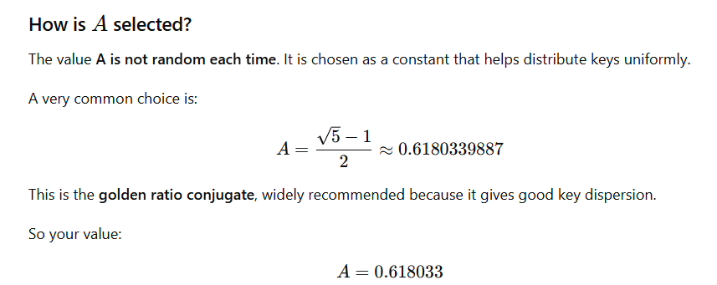
Example 15.2 Given a hash table of size 1000, map the key 12345 to an appropriate location in the hash table.
Solution We will use A = 0.618033, m = 1000, and k = 12345
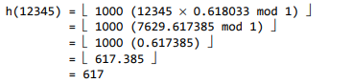
3. Mid-Square Method: The mid-square method is a good hash function which works in two steps:
Step 1: Square the value of the key. That is, find k².
Step 2: Extract the middle r digits of the result obtained in Step 1.
The algorithm works well because most or all digits of the key value contribute to the result. This is because all the digits in the original key value contribute to produce the middle digits of the squared value. Therefore, the result is not dominated by the distribution of the bottom digit or the top digit of the original key value. In the mid-square method, the same r digits must be chosen from all the keys. Therefore, the hash function can be given as: h(k) = s where s is obtained by selecting r digits from k^{2.}
Example 15.3 Calculate the hash value for keys 1234 and 5642 using the mid-square method. The hash table has 100 memory locations.
Solution Note that the hash table has 100 memory locations whose indices vary from 0 to 99. This means that only two digits are needed to map the key to a location in the hash table, so r = 2.
When k = 1234, k² = 1522756, h (1234) = 27
When k = 5642, k² = 31832164, h (5642) = 21
Observe that the 3rd and 4th digits starting from the right are chosen.

Example 1
1234= k² = 1522756
Digits: 1 5 2 2 7 5 6 (7 digits)
Middle 3 digits = 2 2 7
So:
h(1234)=227

Example 2
56422= k² = 31832164
Digits: 3 1 8 3 2 1 6 4 (8 digits)
Middle 3 digits = 3 2 1
So:
h(5642)=321
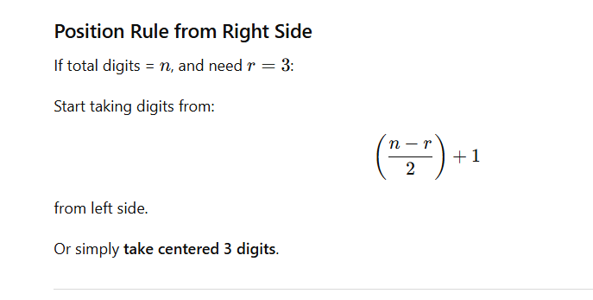
4. Folding Method
The folding method works in the following two steps:
Step 1: Divide the key value into a number of parts. That is, divide k into parts k₁, k₂, ..., k_{n}, where each part has the same number of digits except the last part which may have lesser digits than the other parts.
Step 2: Add the individual parts. That is, obtain the sum of k₁ + k₂ + ... + k_{n}. The hash value is produced by ignoring the last carry, if any.
Note that the number of digits in each part of the key will vary depending upon the size of the hash table. For example, if the hash table has a size of 1000, then there are 1000 locations in the hash table. To address these 1000 locations, we need at least three digits; therefore, each part of the key must have three digits except the last part which may have lesser digits.
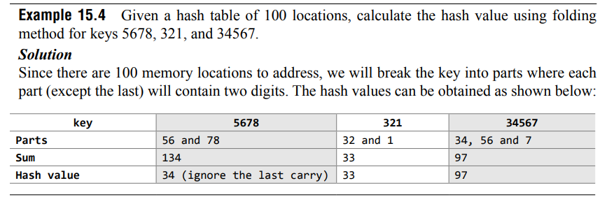
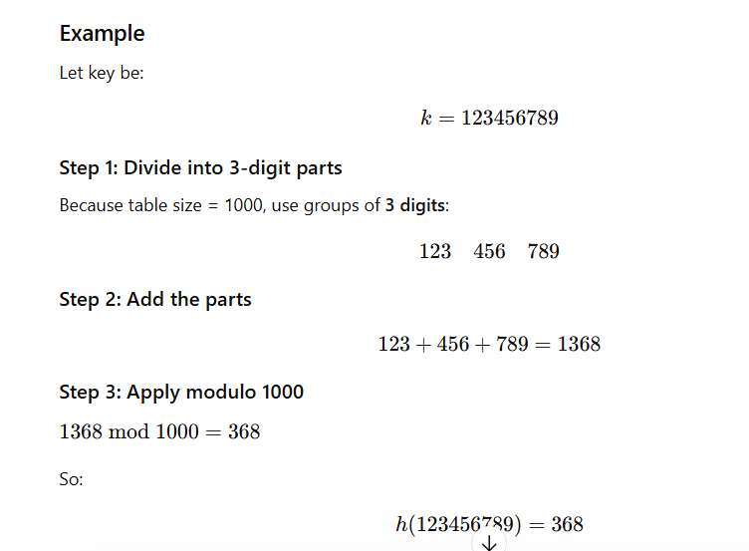
Collisions
collisions occur when the hash function maps two different keys to the same location. Obviously, two records cannot be stored in the same location. Therefore, a method used to solve the problem of collision, also called collision resolution technique, is applied. The two most popular methods of resolving collisions are:
1. Open addressing
2. Chaining
1. Collision Resolution by Open Addressing
Once a collision takes place, open addressing or closed hashing computes new positions using a probe sequence and the next record is stored in that position. In this technique, all the values are stored in the hash table. The hash table contains two types of values: sentinel values (e.g., –1) and data values. The presence of a sentinel value indicates that the location contains no data value at present but can be used to hold a value. When a key is mapped to a particular memory location, then the value it holds is checked. If it contains a sentinel value, then the location is free and the data value can be stored in it. However, if the location already has some data value stored in it, then other slots are examined systematically in the forward direction to find a free slot. If even a single free location is not found, then we have an OVERFLOW condition. The process of examining memory locations in the hash table is called probing. Open addressing technique can be implemented using linear probing, quadratic probing, double hashing, and rehashing.
1. Linear Probing: The simplest approach to resolve a collision is linear probing. In this technique, if a value is already stored at a location generated by h(k), then the following hash function is used to resolve the collision:
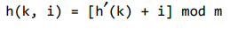
Where m is the size of the hash table, 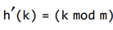 and i is the probe number that varies from 0 to m–1.
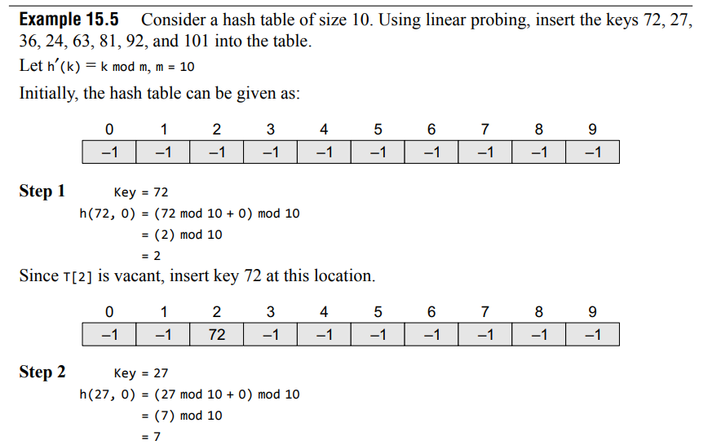
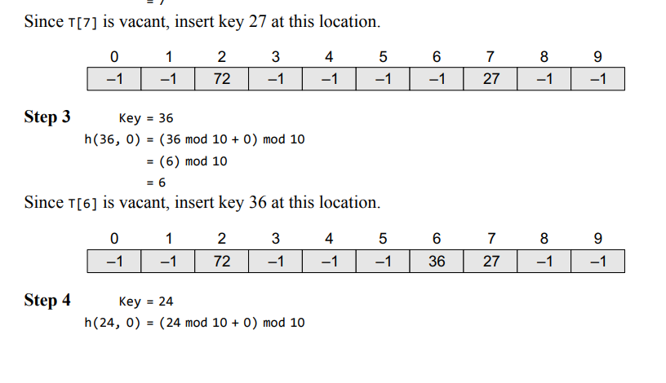
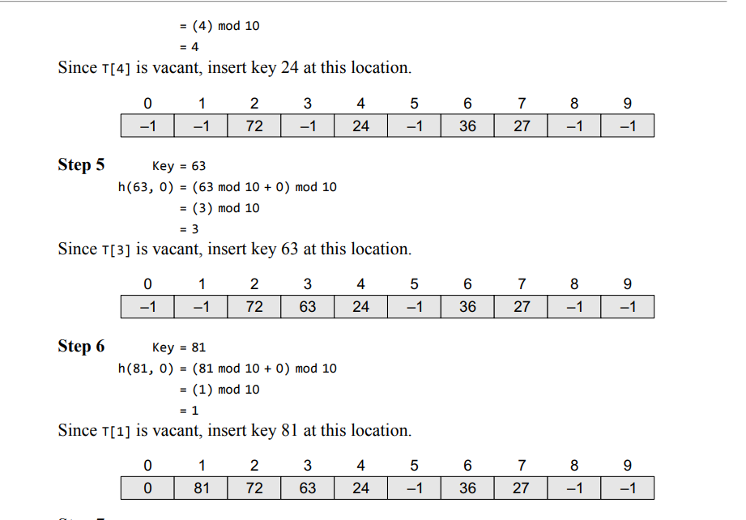
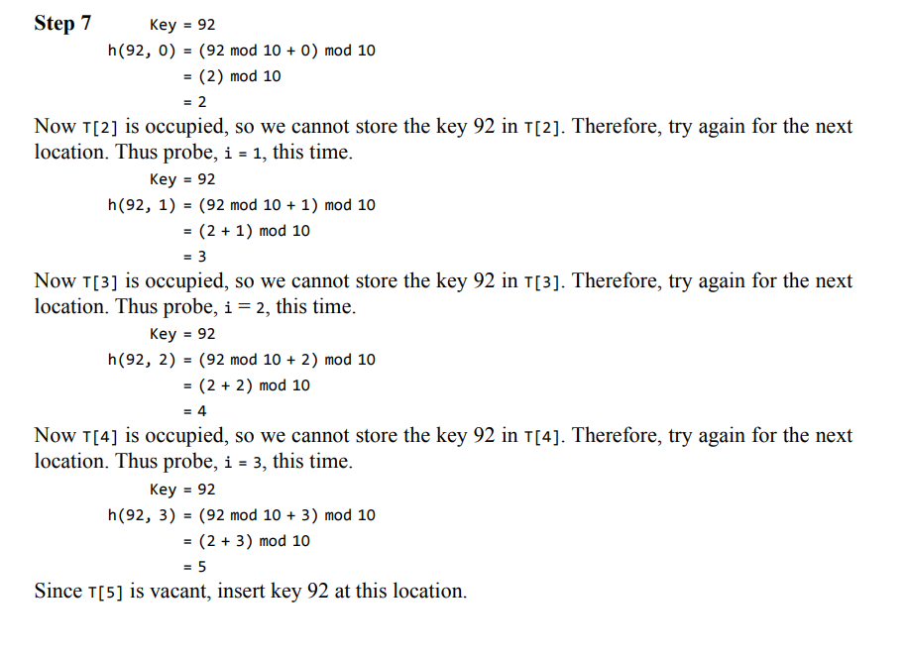
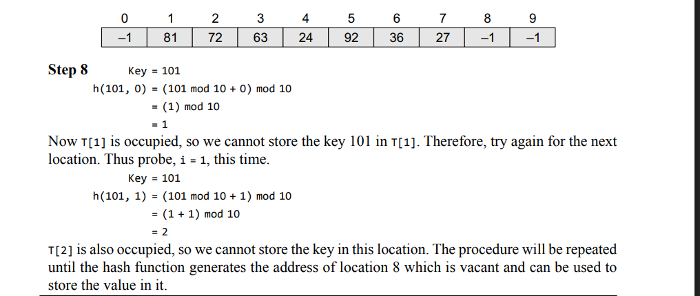
2. Quadratic Probing In this technique, if a value is already stored at a location generated by h(k), then the following hash function is used to resolve the collision: h(k, i) = [h¢(k) + c₁ i + c₂ i² ] mod m where m is the size of the hash table, 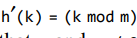, i is the probe number that varies from 0 to m–1, and c₁ and c₂ are constants such that c₁ and c₂ $≠$ 0. Quadratic probing eliminates the primary clustering phenomenon of linear probing because instead of doing a linear search, it does a quadratic search. For a given key k, first the location generated by is probed. If the location is free, the value is stored in it, else subsequent locations probed are offset by factors that depend in a quadratic manner on the probe number i. Although quadratic probing performs better than linear probing, in order to maximize the utilization of the hash table, the values of c₁ , c₂ , and m need to be constrained.
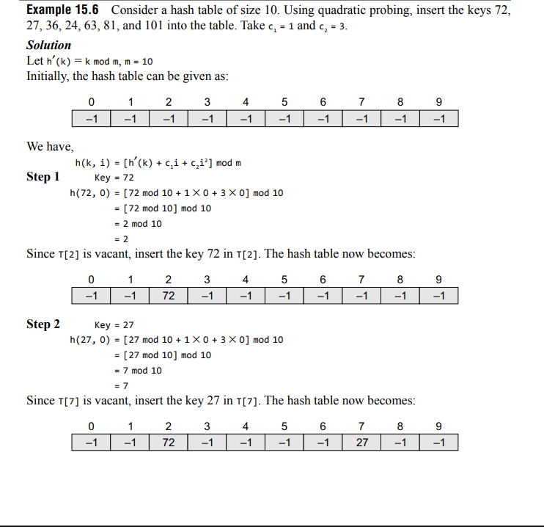
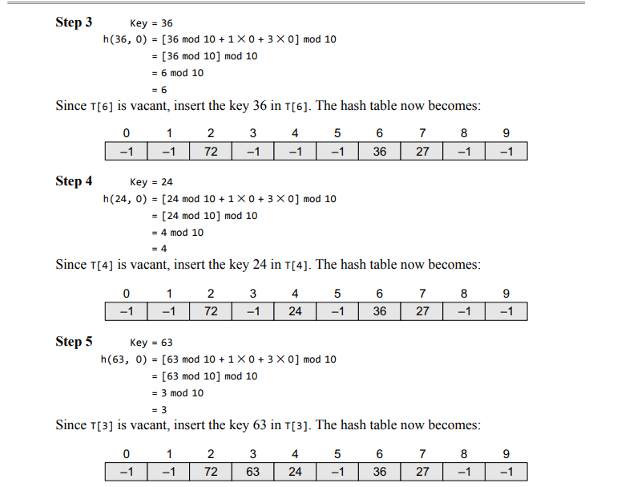
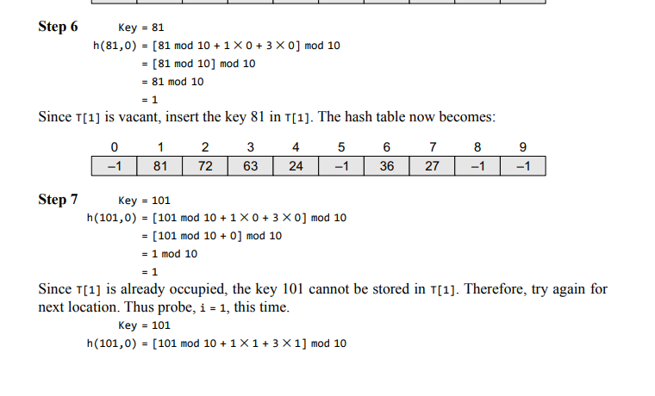
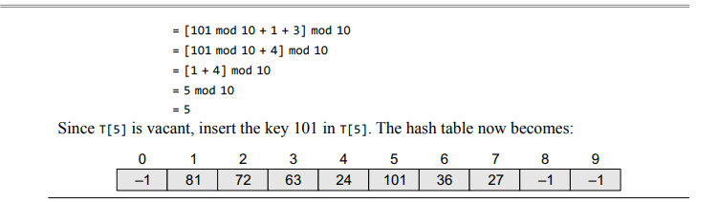
3. Double Hashing: To start with, double hashing uses one hash value and then repeatedly steps forward an interval until an empty location is reached. The interval is decided using a second, independent hash function, hence the name double hashing. In double hashing, we use two hash functions rather than a single function. The hash function in the case of double hashing can be given as:
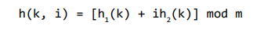
When we have to insert a key k in the hash table, we first probe the location given by applying [h₁ (k) mod m] because during the first probe, i = 0. If the location is vacant, the key is inserted into it, else subsequent probes generate locations that are at an offset of [h₂ (k) mod m] from the previous location. Since the offset may vary with every probe depending on the value generated by the second hash function, the performance of double hashing is very close to the performance of the ideal scheme of uniform hashing.
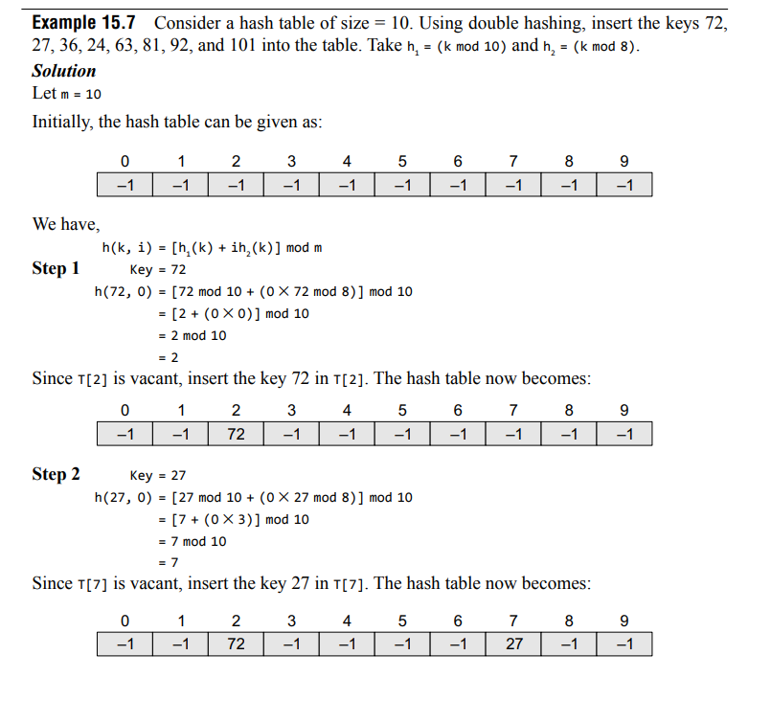
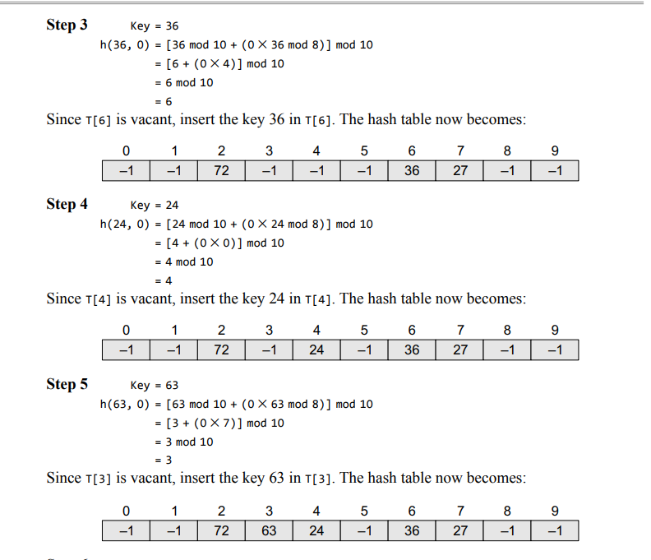
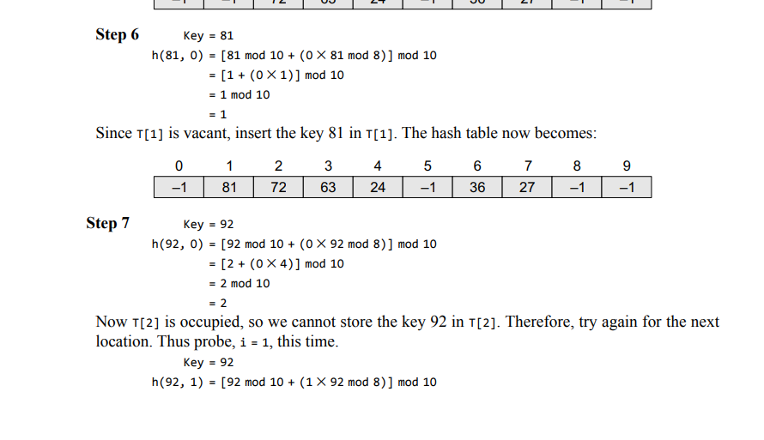
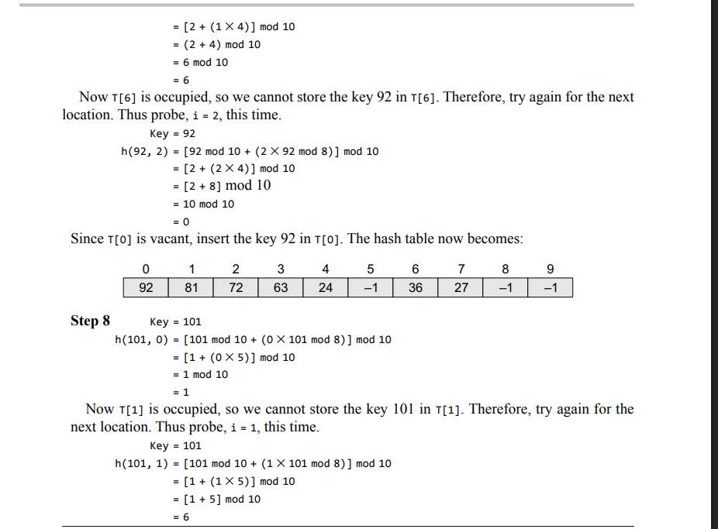
Now T[6] is occupied, so we cannot store the key 101 in T[6]. Therefore, try again for the next location with probe i = 2. Repeat the entire process until a vacant location is found. You will see that we have to probe many times to insert the key 101 in the hash table. Although double hashing is a very efficient algorithm, it always requires m to be a prime number. In our case m=10, which is not a prime number, hence, the degradation in performance. Had m been equal to 11, the algorithm would have worked very efficiently. Thus, we can say that the performance of the technique is sensitive to the value of m.
4. Rehashing: When the hash table becomes nearly full, the number of collisions increases, thereby degrading the performance of insertion and search operations. In such cases, a better option is to create a new hash table with size double of the original hash table. All the entries in the original hash table will then have to be moved to the new hash table. This is done by taking each entry, computing its new hash value, and then inserting it in the new hash table. Though rehashing seems to be a simple process, it is quite expensive and must therefore not be done frequently. Consider the hash table of size 5 given below. The hash function used is h(x) = x % 5. Rehash the entries into to a new hash table.
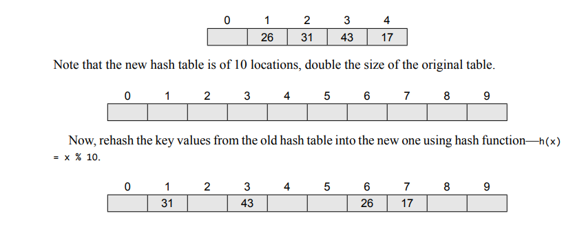
Chaining
In chaining, each location in a hash table stores a pointer to a linked list that contains all the key values that were hashed to that location. That is, location l in the hash table points to the head of the linked list of all the key values that hashed to l. However, if no key value hashes to l, then location l in the hash table contains NULL. Figure 15.5 shows how the key values are mapped to a location in the hash table and stored in a linked list that corresponds to that location.
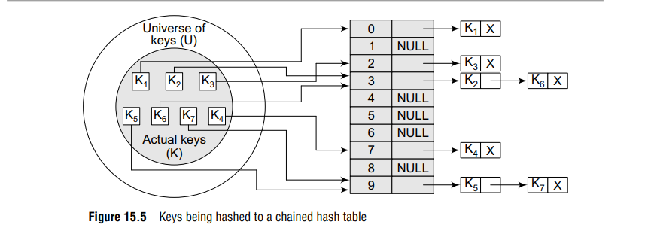
Example 15.8 Insert the keys 7, 24, 18, 52, 36, 54, 11, and 23 in a chained hash table of 9 memory locations. Use h(k) = k mod m.
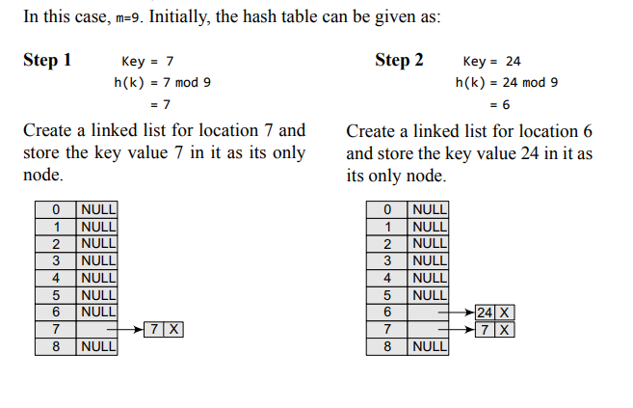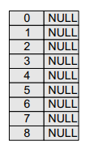
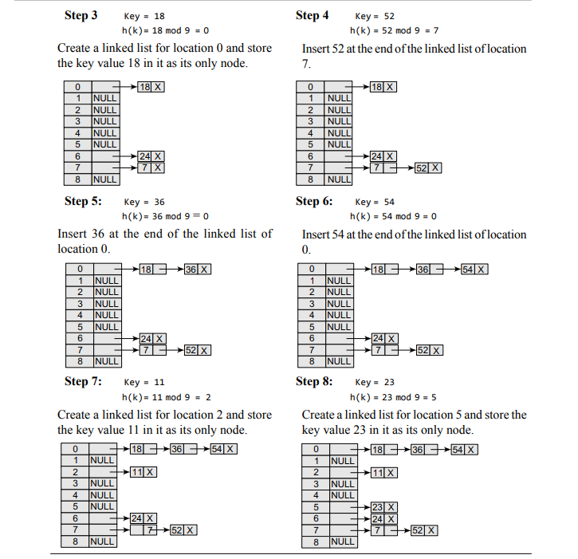
Bucket Hashing
In closed hashing, all the records are directly stored in the hash table. Each record with a key value k is stored in a location called its home position. The home position is calculated by applying some hash function. In case the home position of the record with key k is already occupied by another record then the record will be stored in some other location in the hash table. This other location will be determined by the technique that is used for resolving collisions. Once the records are inserted, the same algorithm is again applied to search for a specific record. One implementation of closed hashing groups the hash table into buckets where M slots of the hash table are divided into B buckets. Therefore, each bucket contains M/B slots. Now when a new record has to be inserted, the hash function computes the home position. If the slot is free, the record is inserted. Otherwise, the bucket’s slots are sequentially searched until an open slot is found. In case, the entire bucket is full, the record is inserted into an overflow bucket. The overflow bucket has infinite capacity at the end of the table and is shared by all the buckets. An efficient implementation of bucket hashing will be to use a hash function that evenly distributes the records amongst the buckets so that very few records have to be inserted in the overflow bucket. When searching a record, first the hash function is used to determine the bucket in which the record can be present. Then the bucket is sequentially searched to find the desired record. If the record is not found and the bucket still has some empty slots, then it means that the search is complete and the desired record is not present in the hash table. However, if the bucket is full and the record has not been found, then the overflow bucket is searched until the record is found or all the records in the overflow bucket have been checked. Obviously, searching the overflow bucket can be expensive if it has too many records.

Example
Suppose we have:
- 10 buckets (0 to 9)
- Each bucket can store 2 values
- Hash function:
h(key)=key mod 10
Insert these keys:
15, 25, 35, 42, 52, 62

Step-by-Step

1. Insert 15
15 mod 10 = 5 → Bucket 5

2. Insert 25
25 mod 10 = 5 → Bucket 5
Bucket 5 now full: [15, 25]

3. Insert 35
35 mod 10 = 5 → Bucket 5 full
So place in overflow bucket

4. Insert 42
42 mod 10 = 2 → Bucket 2

5. Insert 52
52 mod 10 = 2 → Bucket 2
Bucket 2 full: [42, 52]

6. Insert 62
62 mod 10 = 2 → Overflow

Final Table
Bucket | Values
0 | -
1 | -
2 | 42, 52
3 | -
4 | -
5 | 15, 25
6 | -
7 | -
8 | -

Overflow Area
Overflow
35
62
#include <stdio.h>
/* Function Prototypes */
void divisionMethod();
void foldingMethod();
void menu();
/* Main Function */
int main()
{
menu();
return 0;
}

/* Menu Function */
void menu()
{
int choice;
do
{
printf("\n===== HASHING MENU =====\n");
printf("1. Division Method\n");
printf("2. Folding Method\n");
printf("3. Exit\n");
printf("Enter your choice: ");
scanf("%d", &choice);
switch(choice)
{
case 1:
divisionMethod();
break;
case 2:
foldingMethod();
break;

case 3:
printf("Exiting Program...\n");
break;
default:
printf("Invalid Choice!\n");
}
} while(choice != 3);
}
/* Division Method */
void divisionMethod()
{
int key, size, hash;
printf("\n--- Division Method ---\n");
printf("Enter key value: ");
scanf("%d", &key);
printf("Enter hash table size: ");
scanf("%d", &size);
hash = key % size;
printf("Hash Address = %d\n", hash);
}
/* Folding Method */
void foldingMethod()
{
int key, size, digits = 0;
int temp, divisor = 1;
int part, sum = 0, hash;

printf("Enter key: ");
scanf("%d", &key);

printf("Enter hash table size: ");
scanf("%d", &size);

/* Count digits in table size-1 */
temp = size - 1;

while(temp > 0)
{
digits++;
temp = temp / 10;
}

/* divisor = 10^digits */
for(int i = 1; i <= digits; i++)
divisor = divisor * 10;

temp = key;

while(temp > 0)
{
part = temp % divisor;
sum = sum + part;
temp = temp / divisor;
}

hash = sum % size;

printf("Sum of parts = %d\n", sum);
printf("Hash Address = %d\n", hash);
}

Files and Their Organization
DATA HIERARCHY
Every file contains data which can be organized in a hierarchy to present a systematic organization. The data hierarchy includes data items such as fields, records, files, and database. These terms are defined below.
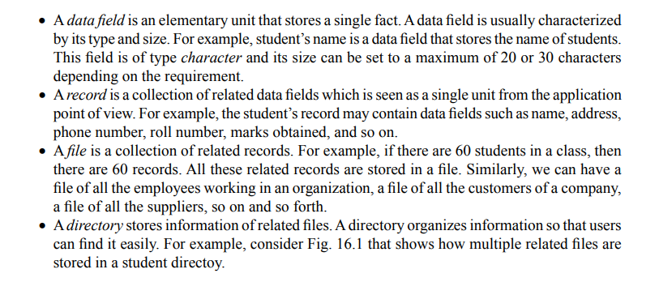
FILE ATTRIBUTES
Every file in a computer system is stored in a directory. Each file has a list of attributes associated with it that gives the operating system and the application software information about the file and how it is intended to be used. A software program which needs to access a file looks up the directory entry to discern the attributes of that file. For example, if a user attempts to write to a file that has been marked as a read-only file, then the program prints an appropriate message to notify the user that he is trying to write to a file that is meant only for reading. Similarly, there is an attribute called hidden. When you execute the DIR command in DOS, then the files whose hidden attribute is set will not be displayed. These attributes are explained in this section.
File name: It is a string of characters that stores the name of a file. File naming conventions vary from one operating system to the other.
File position: It is a pointer that points to the position at which the next read/write operation will be performed.
File structure: It indicates whether the file is a text file or a binary file. In the text file, the numbers (integer or floating point) are stored as a string of characters. A binary file, on the other hand, stores numbers in the same way as they are represented in the main memory.
File Access Method: It indicates whether the records in a file can be accessed sequentially or randomly. In sequential access mode, records are read one by one. That is, if 60 records of students are stored in the STUDENT file, then to read the record of 39th student, you have to go through the record of the first 38 students. However, in random access, records can be accessed in any order.
Attributes Flag
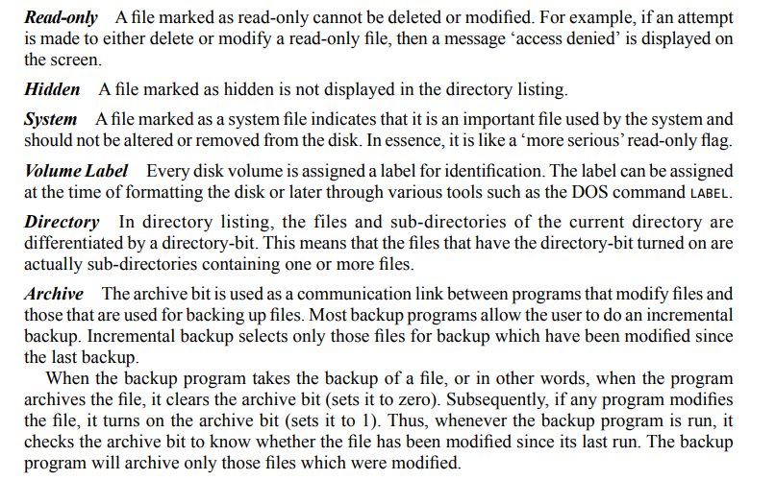
TEXT AND BINARY FILES
A text file, also known as a flat file or an ASCII file, is structured as a sequence of lines of alphabet, numerals, special characters, etc. However, the data in a text file, whether numeric or non-numeric, is stored using its corresponding ASCII code. The end of a text file is often denoted by placing a special character, called an end-of-file marker, after the last line in the text file. A binary file contains any type of data encoded in binary form for computer storage and processing purposes. A binary file can contain text that is not broken up into lines. A binary file stores data in a format that is similar to the format in which the data is stored in the main memory.
Therefore, a binary file is not readable by humans and it is up to the program reading the file to make sense of the data that is stored in the binary file and convert it into something meaningful (e.g., a fixed length of record). Binary files contain formatting information that only certain applications or processors can understand. It is possible for humans to read text files which contain only ASCII text, while binary files must be run on an appropriate software or processor so that the software or processor can transform the data in order to make it readable. For example, only Microsoft Word can interpret the formatting information in a Word document. Although text files can be manipulated by any text editor, they do not provide efficient storage. In contrast, binary files provide efficient storage of data, but they can be read only through an appropriate program.
BASIC FILE OPERATIONS
The basic operations that can be performed on a file are given in Fig.
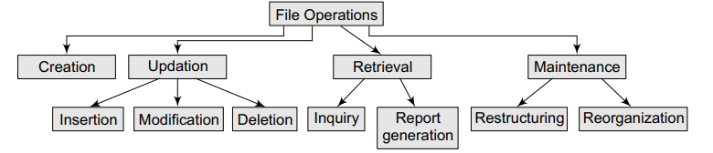
File operations
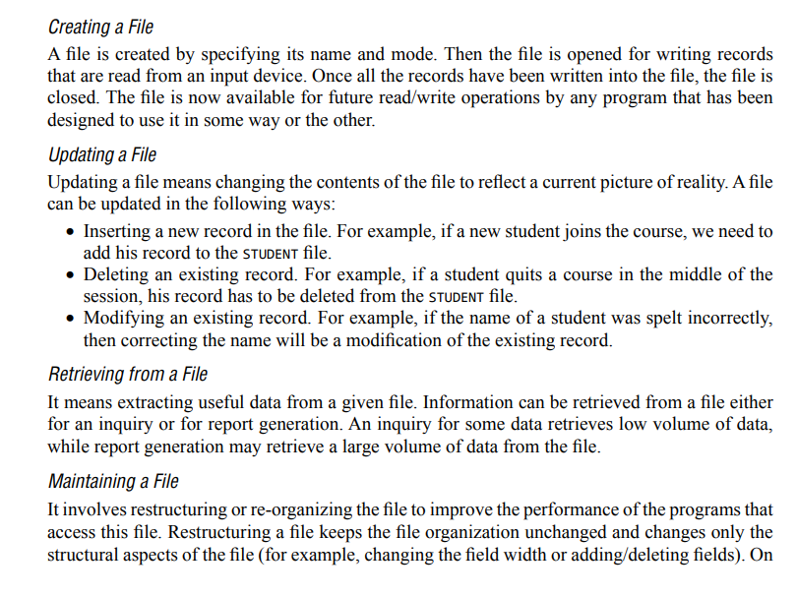
FILE ORGANIZATION
We know that a file is a collection of related records. The main issue in file management is the way in which the records are organized inside the file because it has a significant effect on the system performance. Organization of records means the logical arrangement of records in the file and not the physical layout of the file as stored on a storage media. Since choosing an appropriate file organization is a design decision, it must be done keeping the priority of achieving good performance with respect to the most likely usage of the file. Therefore, the following considerations should be kept in mind before selecting an appropriate file organization method:
- Rapid access to one or more records
- Ease of inserting/updating/deleting one or more records without disrupting the speed of accessing record(s)
- Efficient storage of records
- Using redundancy to ensure data integrity
Sequential Organization
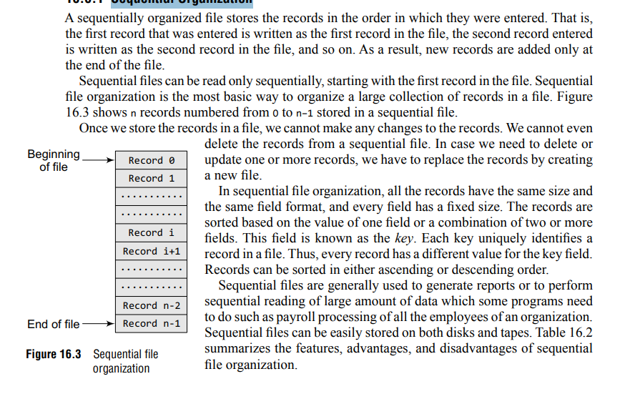
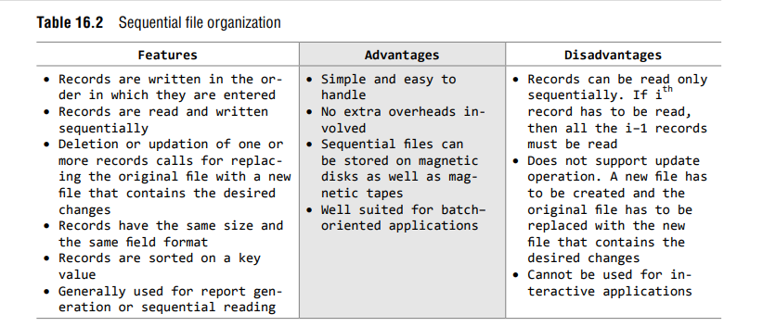
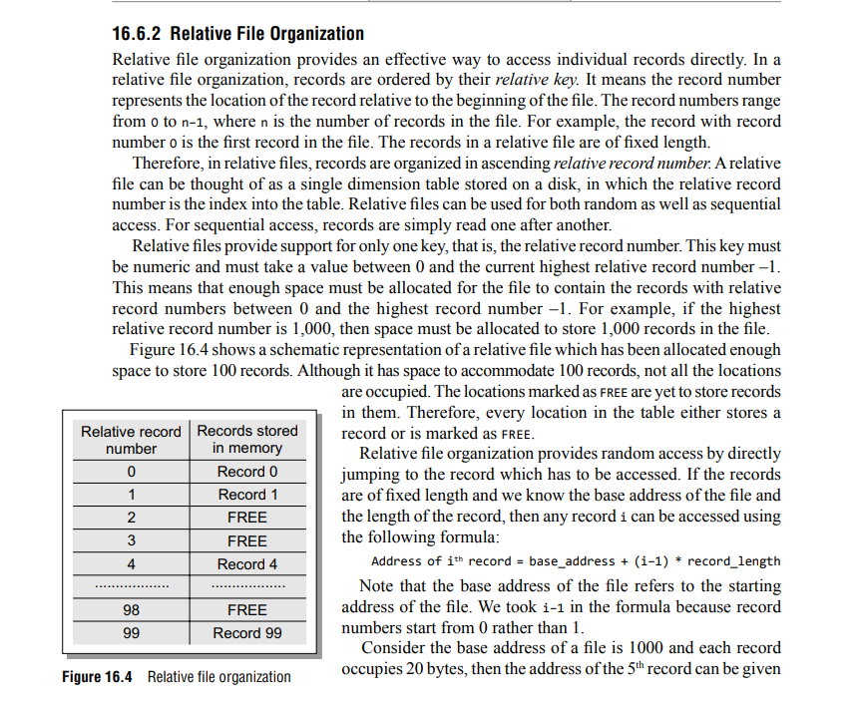

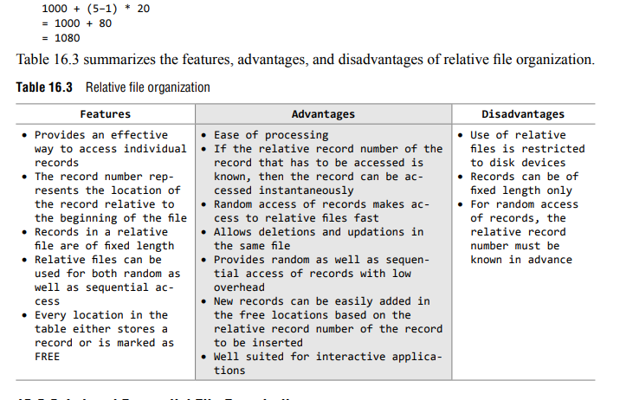
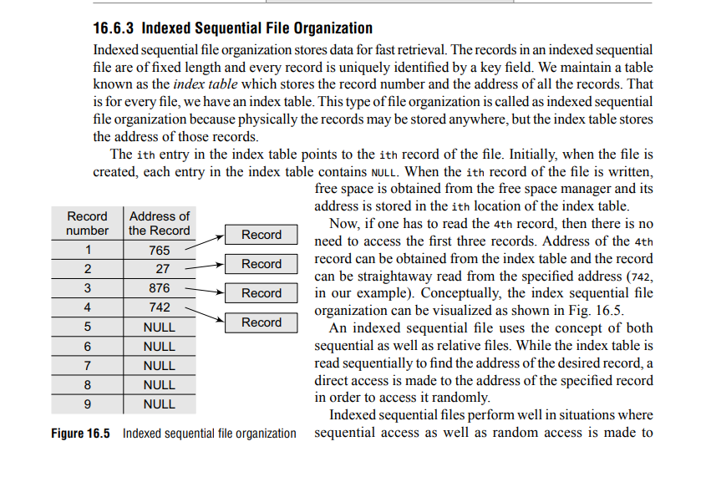
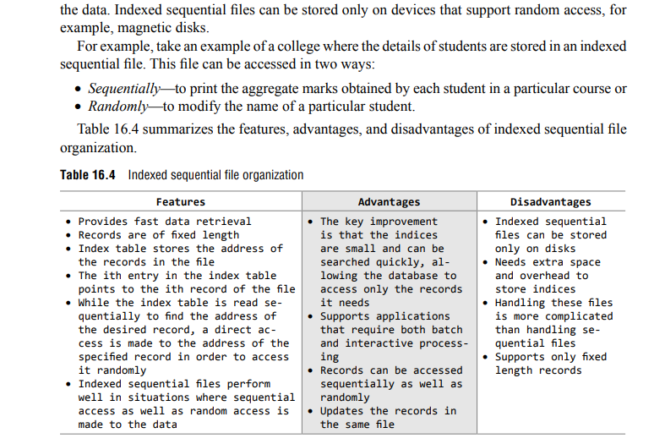
INDEXING: An index for a file can be compared with a catalogue in a library. Like a library has card catalogues based on authors, subjects, or titles, a file can also have one or more indices. There are two kinds of indices:
- Ordered indices that are sorted based on one or more key values
- Hash indices that are based on the values generated by applying a hash function
Ordered Indices
Indices are used to provide fast random access to records. As stated above, a file may have multiple indices based on different key fields. An index of a file may be a primary index or a secondary index.
Primary Index
In a sequentially ordered file, the index whose search key specifies the sequential order of the file is defined as the primary index. For example, suppose records of students are stored in a STUDENT file in a sequential order starting from roll number 1 to roll number 60. Now, if we want to search a record for, say, roll number 10, then the student’s roll number is the primary index. Indexed sequential files are a common example where a primary index is associated with the file.
Secondary Index
An index whose search key specifies an order different from the sequential order of the file is called as the secondary index. For example, if the record of a student is searched by his name, then the name is a secondary index.
Dense and Sparse Indices
In a dense index, the index table stores the address of every record in the file. However, in a sparse index, the index table stores the address of only some of the records in the file. Although sparse indices are easy to fit in the main memory, a dense index would be more efficient to use than a sparse index if it fits in the memory. Figure below shows a dense index and a sparse index for an indexed sequential file.
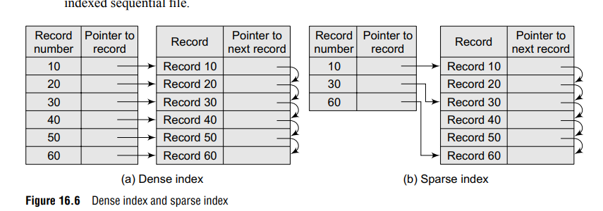
Note that the records need not be stored in consecutive memory locations. The pointer to the next record stores the address of the next record.
Cylinder Surface Indexing
Cylinder surface indexing is a very simple technique used only for the primary key index of a sequentially ordered file. In a sequentially ordered file, the records are stored sequentially in the increasing order of the primary key. The index file will contain two fields—cylinder index and several surface indices. Generally, there are multiple cylinders, and each cylinder has multiple surfaces. If the file needs m cylinders for storage then the cylinder index will contain m entries. Each cylinder will have an entry corresponding to the largest key value into that cylinder. If the disk has n usable surfaces, then each of the surface indices will have n entries. Therefore, the ith entry in the surface index for cylinder j is the largest key value on the jth track of the ith surface. Hence, the total number of surface index entries is m.n. The physical and logical organization of disk is shown in Fig.
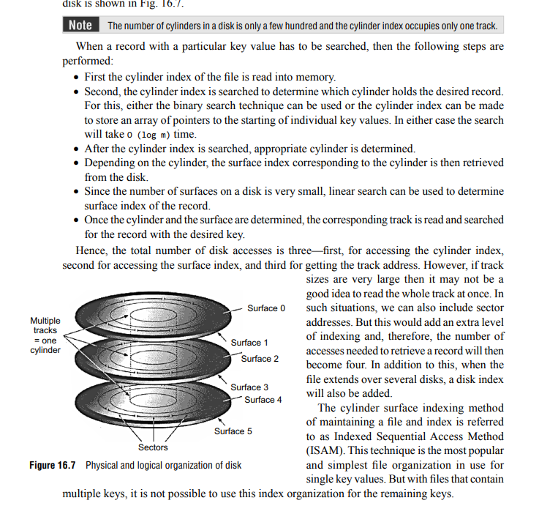
Multi-level Indices
In real-world applications, we have very large files that may contain millions of records. For such files, a simple indexing technique will not suffice. In such a situation, we use multi-level indices. To understand this concept, consider a file that has 10,000 records. If we use simple indexing, then we need an index table that can contain at least 10,000 entries to point to 10,000 records. If each entry in the index table occupies 4 bytes, then we need an index table of 4 × 10000 bytes = 40000 bytes. Finding such a big space consecutively is not always easy. So, a better scheme is to index the index table. Figure 16.8 shows a two-level multi-indexing. We can continue further by having a three-level indexing and so on. But practically, we use two-level indexing. Note that two and higher-level indexing must always be sparse, otherwise multi-level indexing will lose its effectiveness. In the figure, the main index table stores pointers to three inner index tables. The inner index tables are sparse index tables that in turn store pointers to the records.
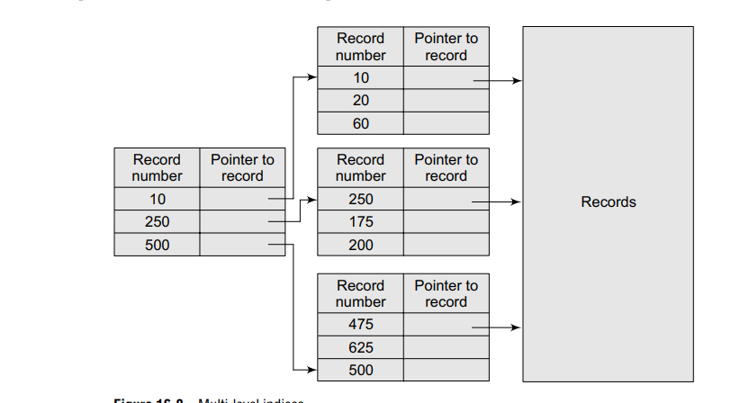
Inverted Indices
Inverted files are commonly used in document retrieval systems for large textual databases. An inverted file reorganizes the structure of an existing data file in order to provide fast access to all records having one field falling within the set limits. For example, inverted files are widely used by bibliographic databases that may store author names, title words, journal names, etc. When a term or keyword specified in the inverted file is identified, the record number is given and a set of records corresponding to the search criteria are created. Thus, for each keyword, an inverted file contains an inverted list that stores a list of pointers to all occurrences of that term in the main text. Therefore, given a keyword, the addresses of all the documents containing that keyword can easily be located. There are two main variants of inverted indices:
- A record-level inverted index (also known as inverted file index or inverted file) stores a list of references to documents for each word
- A word-level inverted index (also known as full inverted index or inverted list) in addition to a list of references to documents for each word also contains the positions of each word within a document. Although this technique needs more time and space, it offers more functionality (like phrase searches)
Therefore, the inverted file system consists of an index file in addition to a document file (also known as text file). It is this index file that contains all the keywords which may be used as search terms. For each keyword, an address or reference to each location in the document where that word occurs is stored. There is no restriction on the number of pointers associated with each word. For efficiently retrieving a word from the index file, the keywords are sorted in a specific order (usually alphabetically).

B-Tree Indices
A B-Tree is a balanced multi-level search tree used in databases and file systems for indexing.
B-Tree indexing is a balanced multiway tree indexing method where keys are stored in sorted order with multiple keys per node, providing efficient search, insertion, and deletion.
It stores keys in sorted order and allows:
- Fast search
- Fast insertion
- Fast deletion
- Few disk accesses

Structure of B-Tree
Each node contains:
- Multiple keys
- Child pointers
- Keys sorted ascending
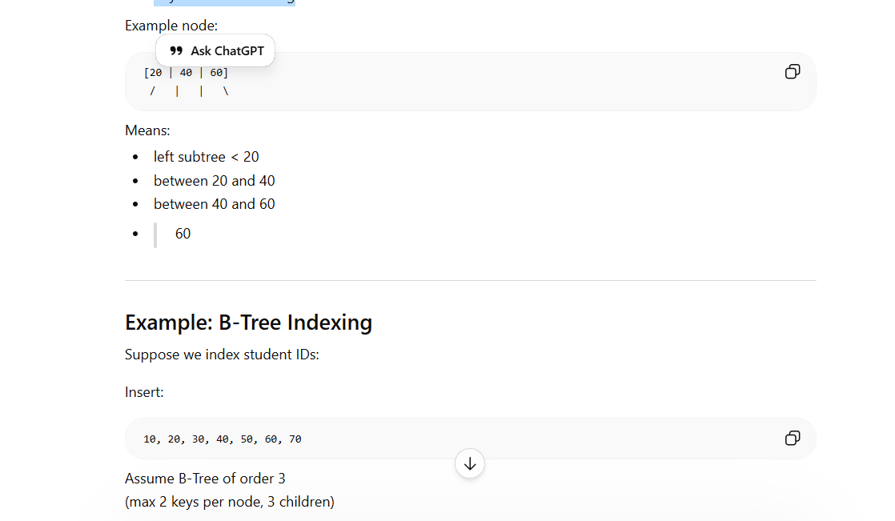
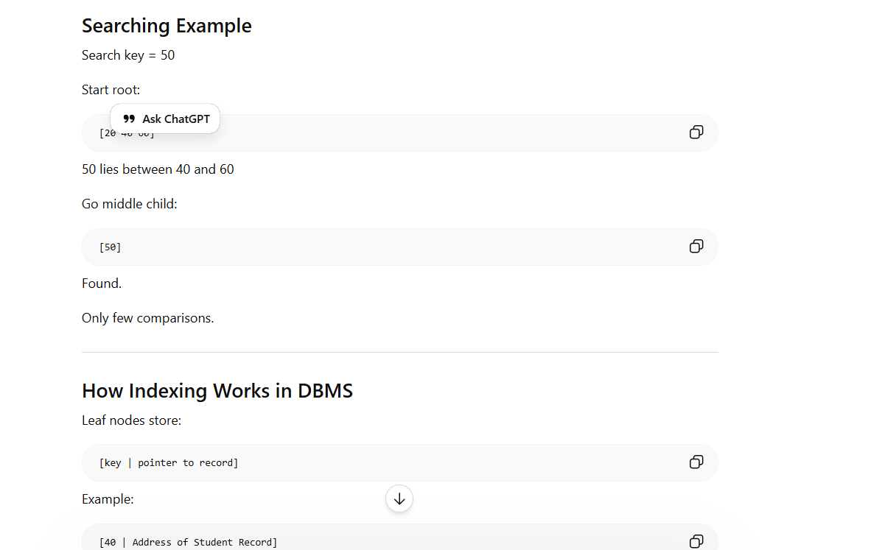
Hashed Indices
So far, we have studied that hashing is used to compute the address of a record by using a hash function on the search key value. If at any point of time, the hashed values map to the same address, then collision occurs and schemes to resolve these collisions are applied to generate a new address. Choosing a good hash function is critical to the success of this technique. By a good hash function, we mean two things. First, a good hash function, irrespective of the number of search keys, gives an average-case lookup that is a small constant. Second, the function distributes records uniformly and randomly among the buckets, where a bucket is defined as a unit of one or more records (typically a disk block). Correspondingly, the worst hash function is one that maps all the keys to the same bucket. However, the drawback of using hashed indices includes:
- Though the number of buckets is fixed, the number of files may grow with time.
- If the number of buckets is too large, storage space is wasted.
- If the number of buckets is too small, there may be too many collisions.
It is recommended to set the number of buckets to twice the number of the search key values in the file. This gives a good space–performance tradeoff. A hashed file organization uses hashed indices. Hashing is used to calculate the address of disk block where the desired record is stored. If K is the set of all search key values and B is the set of all bucket addresses, then a hash function H maps K to B. We can perform the following operations in a hashed file organization.
Insertion
To insert a record that has k_{i} as its search value, use the hash function h(k_{i} ) to compute the address of the bucket for that record. If the bucket is free, store the record else use chaining to store the record.
Search
To search a record having the key value k_{i,} use h (k_{i)} to compute the address of the bucket where the record is stored. The bucket may contain one or several records, so check for every record in the bucket (by comparing ki with the key of every record) to finally retrieve the desired record with the given key value.
Deletion
To delete a record with key value k_{i}, use h (k_{i}) to compute the address of the bucket where the record is stored. The bucket may contain one or several records so check for every record in the bucket (by comparing ki with the key of every record). Then delete the record as we delete a node from a linear linked list.

