ANALYSIS REPORT
Employee Attrition Analysis: The Impact of Workload and Commute Strain

Yuliia Chernysheva
Sinclair Community College
CIS 2266
Instructor: Todd Simpson
May 2, 2026

Executive Summary
This report identifies the primary drivers of employee turnover by analyzing the intersection of workplace stressors and demographic buffers. The findings indicate that attrition is most acute among young, single employees with long commutes and those in high-strain roles earning below a $5,000 monthly threshold. Strategic recommendations focus on targeted financial incentives and geographic flexibility to stabilize these high-risk segments.

Introduction
This report introduces the major findings of an investigation into employee attrition using the IBM HR Analytics dataset. The report outlines the methodology, data characteristics, and statistical inferences used to provide the HR department with actionable insights for improving workforce retention.

Background
This analysis was initiated as a final project for the Python Data Analytics course. The project was undertaken to demonstrate the application of data science techniques, specifically data cleaning, exploratory analysis, and visualization, to a complex organizational challenge. The study uses a synthetic dataset to simulate real-world HR scenarios and identify patterns that contribute to organizational instability.

Purposes
The primary purposes of this analysis are:
- To clarify the nature of perceived needs: To confirm whether stressors like overtime and travel are the direct causes of attrition or if they are moderated by other factors like income.
- To detect unmet needs: To identify specific demographic groups (e.g., young, single professionals) whose needs for work-life balance or geographic flexibility are not being met by current organizational policies.
- To support decision-making: To collect information directly related to workforce stability that can inform future HR policy development and interactive management tools.

Limitations
The analysis is based on a synthetic dataset; therefore, while the identified trends are highly probable, the specific financial thresholds ($5,000) and geographic cut-offs (10 miles) should be validated against actual internal company data before implementing large-scale policy changes.

Questions
The analysis addresses two specific research questions:
- Research Question 1: To what extent does Monthly Income mitigate the impact of high-stress work conditions (Overtime and Frequent Business Travel) on employee attrition?
- Research Question 2: How do Marital Status and Age moderate the relationship between Distance From Home and employee attrition rates?

Methods
A multi-step data analysis process was employed:
- Data Preprocessing: Cleaning, renaming columns for professional reporting, and binary encoding of the target variable (Attrition).
- Feature Categorization: Transforming continuous data (Age, Distance) into discrete groups to identify life-stage trends.
- Statistical Aggregation: Utilizing pivot tables to calculate attrition rates across segmented demographic and professional variables.
- Visualization: Applying faceted bar charts and heatmaps to reveal complex interactions between variables.

Sample
The analysis was performed on a sample of 1,470 employee records. The sample covers diverse demographics (Age 18-60, various Marital Statuses) and professional attributes across multiple departments (Sales, R&D, HR).

Instrumentation
The analysis was conducted using the Python programming language within a Jupyter Notebook environment. Specific libraries used include:
- Pandas & NumPy: For data manipulation and statistical aggregation.
- Matplotlib & Seaborn: For generating high-quality visualizations (Box plots, Bar charts, and Heatmaps).

Results
The following section presents the empirical findings of the study, focused on identifying the critical thresholds and demographic intersections that drive employee turnover.

Stress & Income Mitigation (Research Question 1)
The first phase of the analysis examined whether financial compensation serves as a buffer against workplace stressors. The data demonstrates that while high workload intensity (Overtime and Frequent Travel) increases the probability of departure, Monthly Income acts as a powerful moderating variable.
Figure 1
Income Mitigation Analysis: Overtime Employees
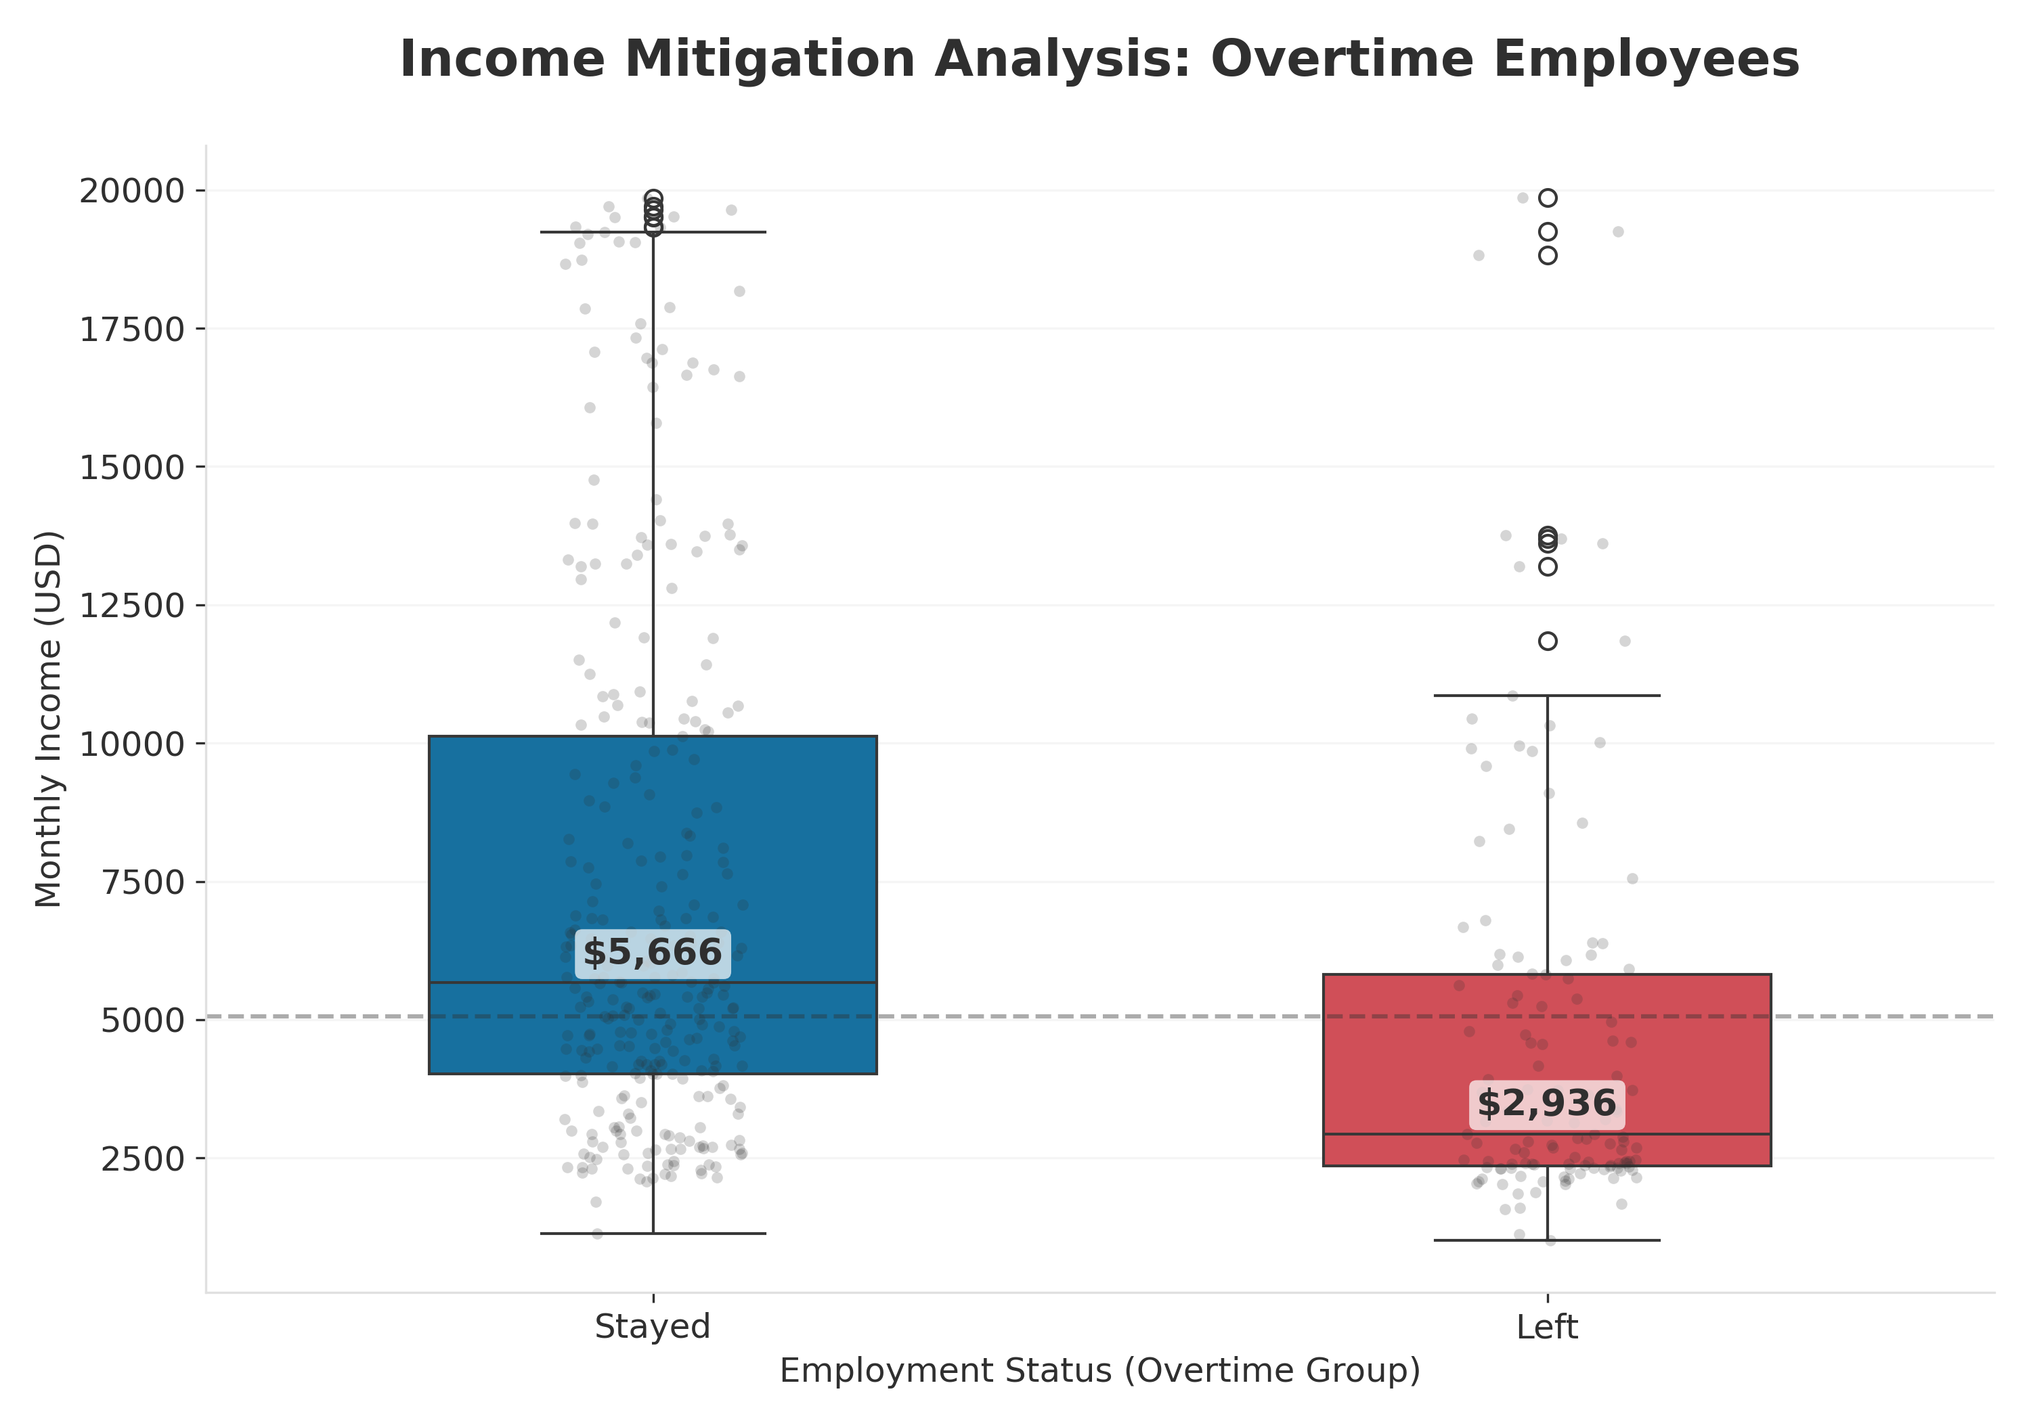
Analytical Observations from Figure 1:
- Median Income Disparity: A visible gap exists in the median monthly income between the two cohorts. Employees who remained with the organization (Stayed) consistently exhibit higher compensation levels compared to those who departed (Left), despite facing identical overtime requirements.
- The $5,000 Critical Threshold: The majority of attrition cases in the overtime-intensive group are concentrated in the lower-income brackets. Once monthly compensation exceeds the $5,000 mark, the interquartile range for retained employees stabilizes, suggesting that this income level serves as a "Retention Buffer."
- High-Income Resilience: The presence of high-income outliers in the "Stayed" group indicates that senior or specialized roles with premium compensation are highly resilient to the personal costs of extended work hours.
Key Finding: Retention is significantly higher when monthly compensation exceeds $5,000, even in high-stress roles. Attrition is most acute in the "low-pay, high-strain" segment, confirming that income acts as a significant mitigating factor.

Life Stages & Commute Strain (Research Question 2).
The second phase investigated the geographic dimension of employment, specifically how age and marital status moderate the impact of distance from home on attrition rates.
Analytical Observations:
- The Stability Zone: A "Stability Zone" was identified within 10 miles of the office. Employees residing within this radius demonstrate the highest retention rates across all demographic segments.
- The Attrition "Hot Zone": Beyond the 10-mile threshold, the data reveals a "Hot Zone" of maximum risk. This zone is characterized by the intersection of Single marital status and the Young (<30) age category. For this specific group, a long-distance commute acts as a primary catalyst for turnover, with attrition rates often doubling compared to their peers living closer to the office.
- Demographic Resilience: In contrast, Married and Senior (45+) employees demonstrate much higher resilience to long-distance commutes. This suggests that career maturity or household stability provides a buffer that allows these employees to tolerate geographic strain.
The interaction between these geographic and demographic factors is synthesized in the heatmap below (Figure 2).
Figure 2
Heatmap of Attrition Risk by Age and Marital Status for Long-Distance Commuters
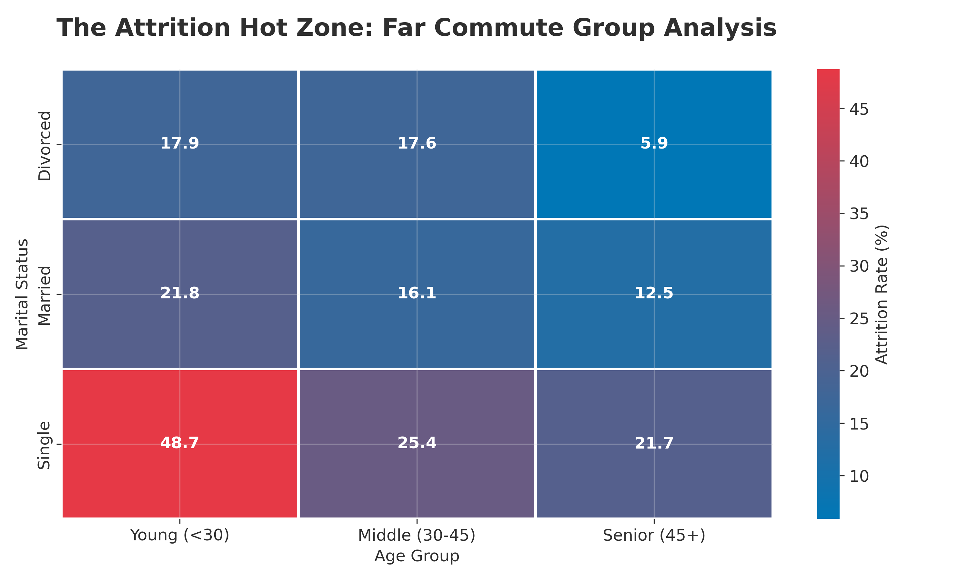
Key Finding: Commute distance is not a universal stressor; its impact is heavily moderated by an employee's life stage. The organization’s risk is most acute among young, single employees with commutes exceeding 10 miles.

Recommendations
- Compensation Adjustments: Introduce retention-based pay increases for high-travel/overtime roles, focusing on the under $5,000 income segment.
- Precision Flexibility: Prioritize remote work or “commute-offset” days for the single, early-career demographic living far from the office.
- Relocation Support: Develop incentives to encourage high-potential young talent to reside within the 10-mile “Stability Zone”.

Summary
The analysis concludes that employee attrition is a manageable risk when approached through the lens of moderation. By addressing the “Compensation Gap” in high-stress roles and providing geographic support to the most vulnerable demographic segments, the organization can significantly enhance its long-term retention rates.

References
Duke University. (2022). Research questions. https://twp.duke.edu/sites/twp.duke.edu/files/file-attachments/research-questions.original.pdf

IBM. (n.d.). IBM HR Analytics employee attrition & performance dataset. Kaggle. https://www.kaggle.com/datasets/pavansubhasht/ibm-hr-analytics-attrition-dataset

