Topic 10 Chapter 12 Worksheet
In the worksheets for this class, you are going to create MySQL statement for each task described below.
You are required to take a screen shot of the SQL statements and the output for each task.
Paste the screenshot of your results under the numbered question.
Save your work and upload the document to the assignment folder by the due date in the Syllabus.
Use the Oracle tutorial database.
Set AUTOCOMMIT to 0 so you can roll back all your changes.

1. Create a view of the employees table.
Limit the view to just employees whose first name starts with a S or T. Sort the results by last name, descending.
SELECT from the VIEW and display the results.
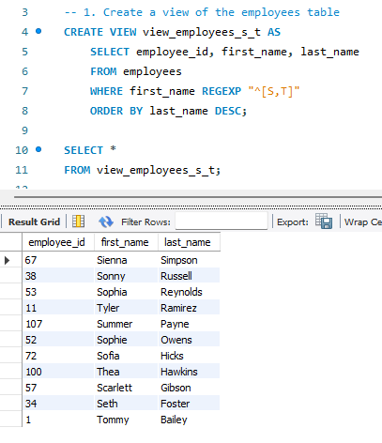

2. Create a view from the order_items table.
Multiply the quantity by the unit_price and name the column "total". Limit the output to the top 15 totals.
SELECT from the VIEW and display the results.
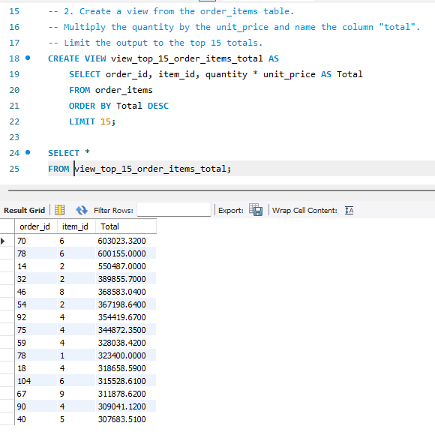

3. Create a view of joined tables.
Join warehouses to locations to countries to get the list of where the warehouses are.
SELECT from the VIEW and display the results.
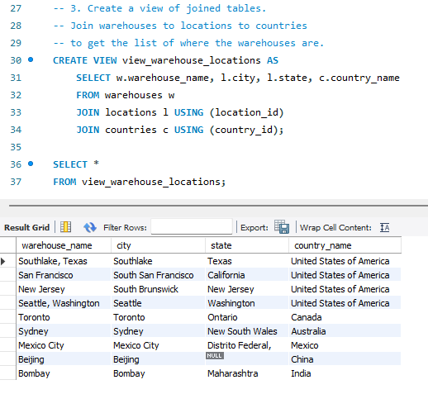

4. Using the view, update the city of the Bombay warehouse to "North Bombay".
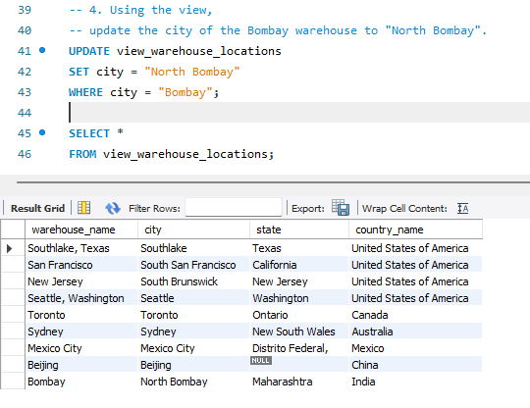

5. Create a view that calculates the profit by product name from the products table.
Profit is the list price minus the cost. Name the column "profit".
SELECT from the VIEW and display the results.
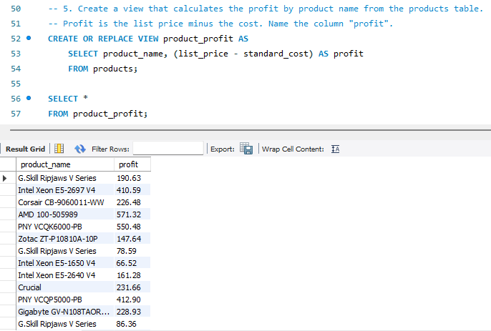

6. Using the view update the profit for the "Crucial" product to 1000.
What happened? Look up the error code and explain.
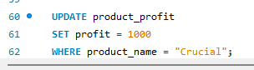

The update query failed and generated an error: Error Code: 1348. Column 'profit' is not updatable
The “profit” column in the “product_profit” view is a calculated expression, not a real physical column in the “products” base table. Because profit is derived from a calculation, MySQL cannot determine how to update the original columns (list_price or standard_cost), making this column read-only.

7. Create a view of the quantity in the warehouses.
Include the product_id, product_name, warehouse_id, quantity. Only show those quantities that are less than 5. Add a CHECK option.
SELECT from the VIEW and display the results.
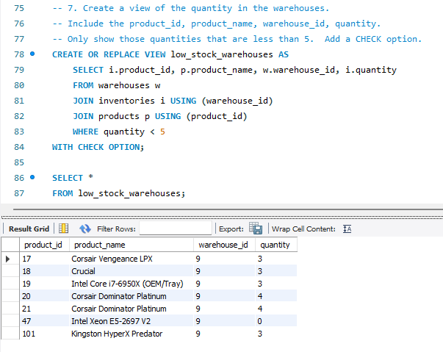

8. Using the above view, try to update the "Crucial" product by changing the quantity to 10.
What happened and why?
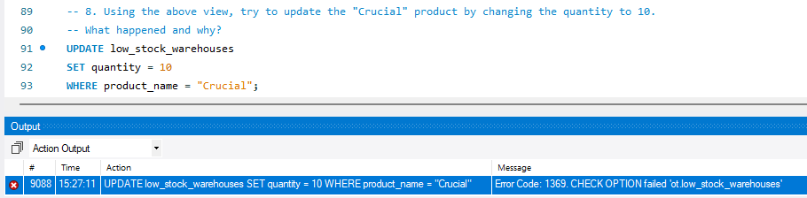
The UPDATE statement failed with Error Code: 1369. CHECK OPTION failed 'ot.low_stock_warehouses'
The view was defined with WHERE quantity < 5 and the WITH CHECK OPTION clause. The WITH CHECK OPTION ensures that any INSERT or UPDATE performed through the view must satisfy the view's WHERE condition. Updating the quantity to 10 violates this rule, so MySQL rejected the change.

9. Create a view that displays the region_id and region_name from the regions table.
Using the view, add Iceland, region_id=10 to the table.
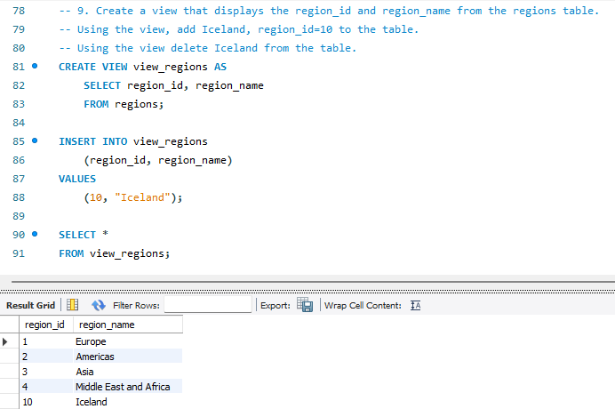
Using the view delete Iceland from the table.
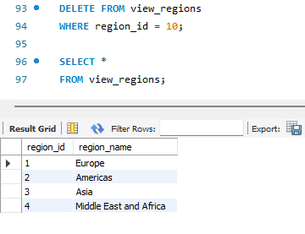

10. Clean up your database
Did your ROLLBACK work or did you have to reload the script to build the database?
I had to reload the script to rebuild the database because ROLLBACK did not undo the changes.
Even though AUTOCOMMIT was set to 0, DDL (Data Definition Language) statements such as CREATE VIEW trigger an implicit COMMIT in MySQL. Running CREATE VIEW in subsequent questions automatically committed all prior pending transactions (such as the UPDATE of the Bombay warehouse to "North Bombay"). Because the modifications were permanently committed to the base tables, ROLLBACK had no effect.

