Topic 4 Chapters 5 and 6 Worksheet
In the worksheets for this class, you are going to create MySQL statement for each task described below.
You are required to take a screen shot of the SQL statements and the output for each task.
Paste the screenshot of your results under the numbered question.
Save your work and upload the document to the assignment folder by the due date in the Syllabus.

Databases
- New database created during the steps below. (Use the CREATE DATABASE command, followed by USE to switch to that database.)
- Oracle Tutorial database from last week's assignment

Configuration
- The UPDATE and DELETE commands are potentially dangerous, allowing you to make huge database changes with a single command. MySQL helps you prevent this with "Safe Updates". Enable or disable this feature:
SET sql_safe_updates = 1; -- turn on safe updates
SET sql_safe_updates = 0; -- turn off safe updates

1. Create the following table:
CREATE TABLE Sinclair (
classID INT(10),
department VARCHAR(30),
deptShort VARCHAR(3),
class_number VARCHAR(4),
section_number CHAR(3),
class_type VARCHAR(10),
credit_hours DOUBLE(4, 2),
location VARCHAR(15),
instructor VARCHAR(20)
);

2. Populate the table with your classes, and then add the following classes:
INSERT INTO Sinclair VALUES (001,'REAL ESTATE', 'RES','1101','RA1','REMOTE',3,'REMOTE','Gagnon');
INSERT INTO Sinclair VALUES (002,'REAL ESTATE', 'RES','1201','RB1','REMOTE',3,'REMOTE','Davis');
INSERT INTO Sinclair VALUES (003,'REAL ESTATE', 'RES','1301','RA1','REMOTE',3,'REMOTE','Ashton');
INSERT INTO Sinclair VALUES (004,'CS', 'CIS','2268','RN1','REMOTE',3,'REMOTE', 'Taylor');
INSERT INTO Sinclair VALUES (005,'CS', 'CIS','1202','501','ONLINE',3,'ONLINE', 'Sommer');
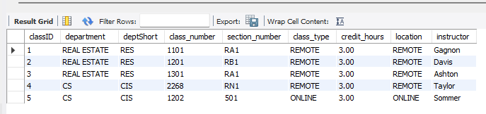

3. Update the table by changing the word "remote" to "virtual".
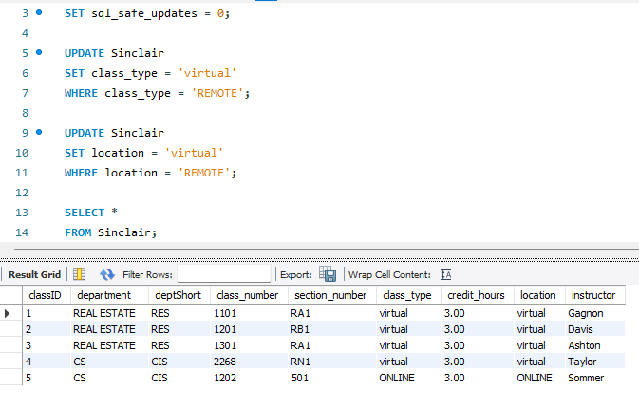

4. Update RES 1301 to be only 1.5 credit hours.
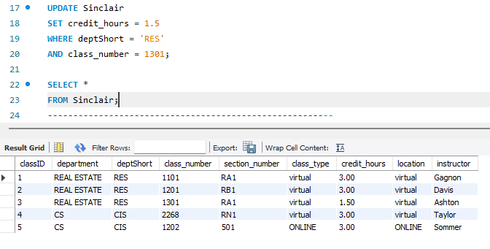

5. Create a new table called Sinclair_copy from the Sinclair table.
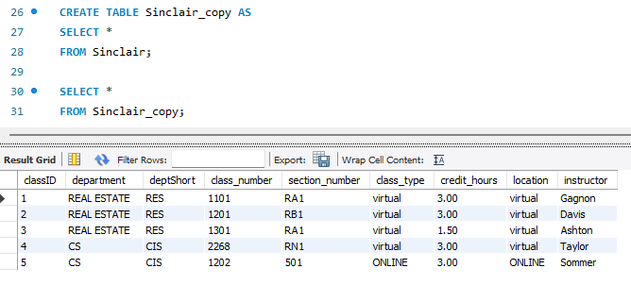
For the rest of the assignment you will use the Oracle Tutorial database.

6a. Sum the quantity of items in the inventories
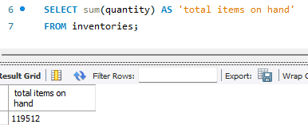

6b. Group the quantities by warehouse
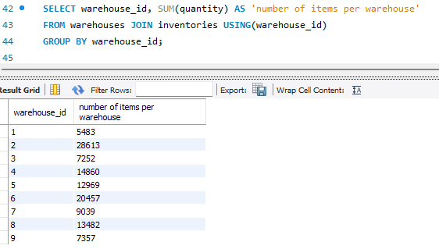

7. Are there any nulls in the manager_id column in the employees table?
Why?
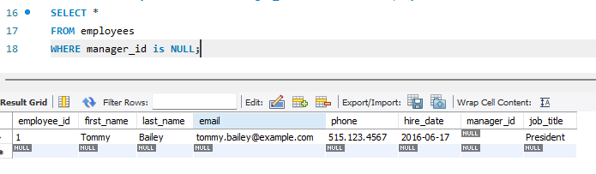
Yes, because he is the president of the company and sits at the very top of the organizational hierarchy. Since there is no higher-ranking employee above him, his manager_id cannot point to anyone and therefore remains NULL.

8. In the products table, what is the most expensive list item, the least expensive item, and what is the average list price?
Put all of the above in one statement.
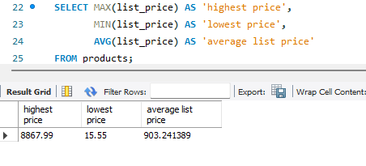

9. Take the results from above and group by category name (not id)
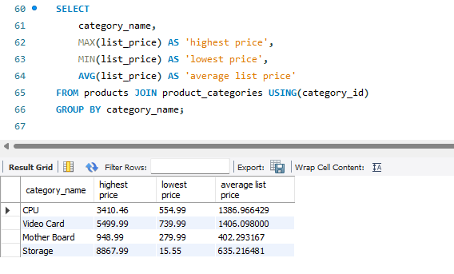

10. Use the statement above and add an average column for all items
Hint: see page 187 or 189 (Depends on your edition of the textbook. Look for the OVER() instruction and partitioning.)
