Topic 9 Chapter 7 Worksheet
In the worksheets for this class, you are going to create MySQL statement for each task described below.
You are required to take a screen shot of the SQL statements and the output for each task.
Paste the screenshot of your results under the numbered question.
Save your work and upload the document to the assignment folder by the due date in the Syllabus.
Use the Oracle tutorial database.

1. What is the average unit_price in order_items?
Next, go through the table and find all items whose unit_price is greater than the average. Group by item_id. Sort the output by item_id.
Note: grouping by the item_id without also grouping by the price may generate a MySQL error: "Error Code: 1055. Expression #2 of SELECT list is not in GROUP BY clause and contains nonaggregated column."
Issue this command to change the grouping rules, and then restart MySQL Workbench:
SET @@global.sql_mode := REPLACE(@@global.sql_mode, 'ONLY_FULL_GROUP_BY', '');
13 rows returned
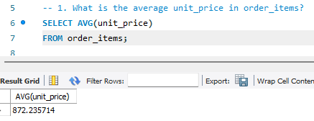
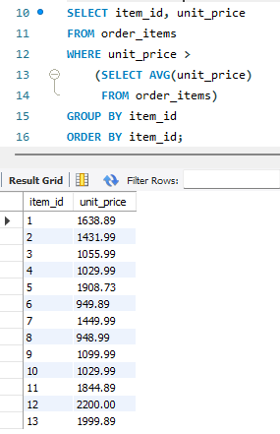

2. Join the above query with products to display the name of the item.
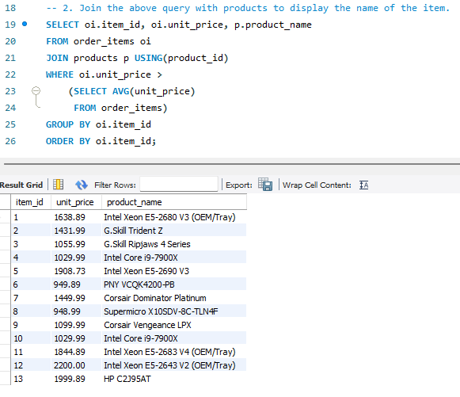

3. List all the inventory that is stored in Mexico.
You do not know how many warehouses are in Mexico. Use a subquery to first find the warehouse id.
106 rows returned
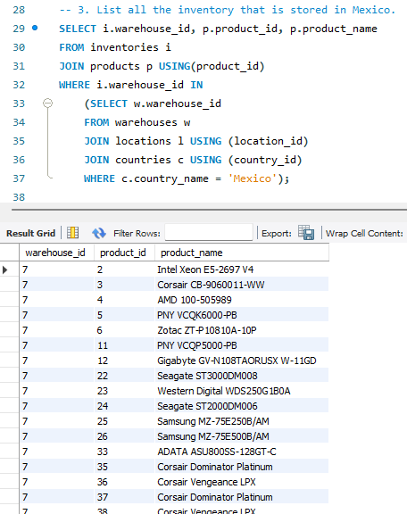

4. Rewrite the task above using a CTE.
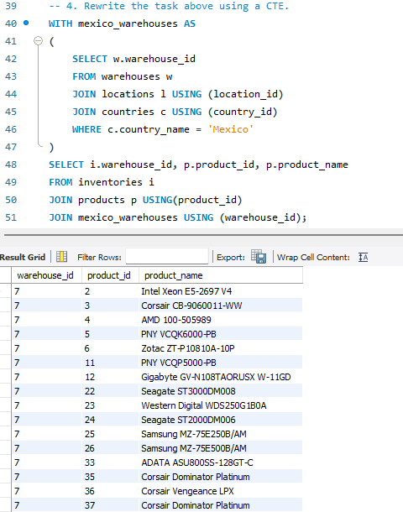

5. Count the number of orders_items that are higher than the average order_item amount.
You will need to take the average of quantity * unit_price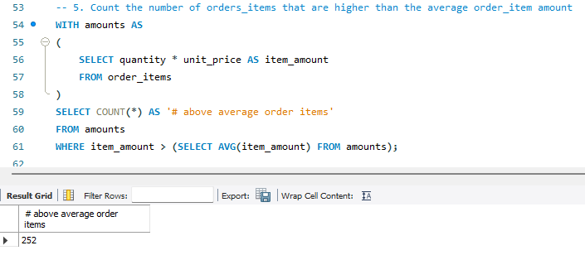

6. Calculate the average order amount.
- Use CTE and create a table that sums the quantity * unit_price for each order. 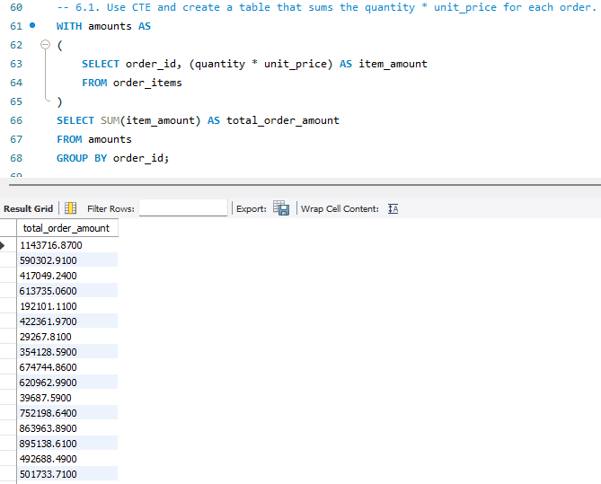
- Use the CTE to calculate the average for the orders 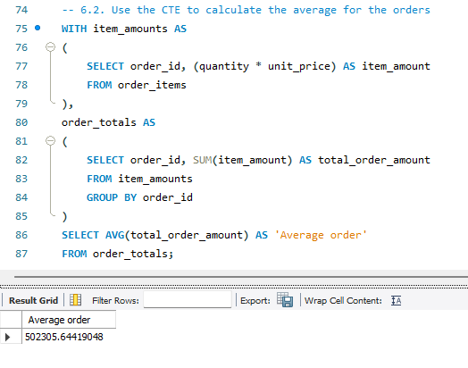

7. How many customers have a credit limit lower than the average?
