Topic 11 Chapter 13 Worksheet
In the worksheets for this class, you are going to create MySQL statement for each task described below.
You are required to take a screen shot of the SQL statements and the output for each task.
Paste the screenshot of your results under the numbered question.
Save your work and upload the document to the assignment folder by the due date in the Syllabus.
Use the Oracle database.

1. Write a procedure to display a simple statement.
Name the procedure "first_procedure". CALL the procedure.
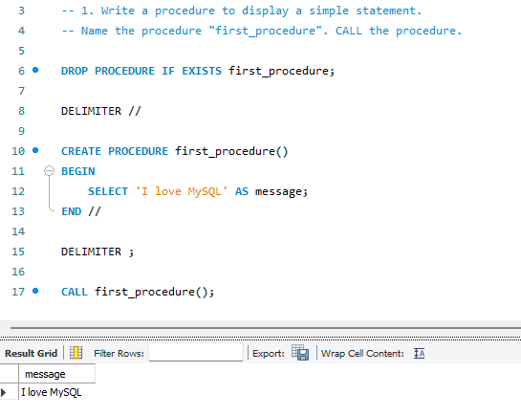

2. Create a procedure to calculate the margin for product_id 16.
Formula is (list_price - standard_cost) / list_price
If that amount is more than 0.2, then display "good margin". Otherwise, display "not good margin"
Follow the example for the lecture notes for balance due.
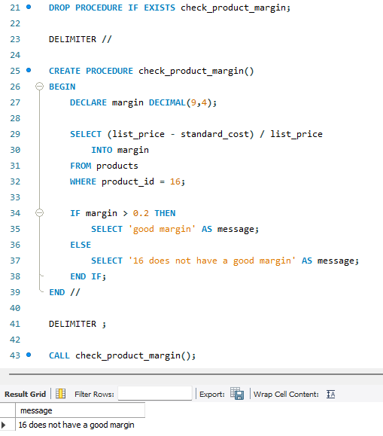

3. Rewrite the above procedure and send the product id to the procedure.
Run the procedure twice with product_id 10 and then 16.


