Topic 6 Chapter 9 Worksheet
In the worksheets for this class, you are going to create MySQL statement for each task described below.
You are required to take a screen shot of the SQL statements and the output for each task.
Paste the screenshot of your results under the numbered question.
Save your work and upload the document to the assignment folder by the due date in the Syllabus.

Database
Continue to use the Oracle tutorial database

1. Calculate the total for each order_item (quantity * unit_price) and format the total to two digits
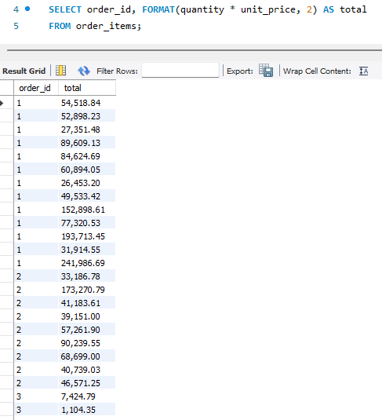

2. Using the employees table, concatenate the first to the last name with a comma, then the job_title
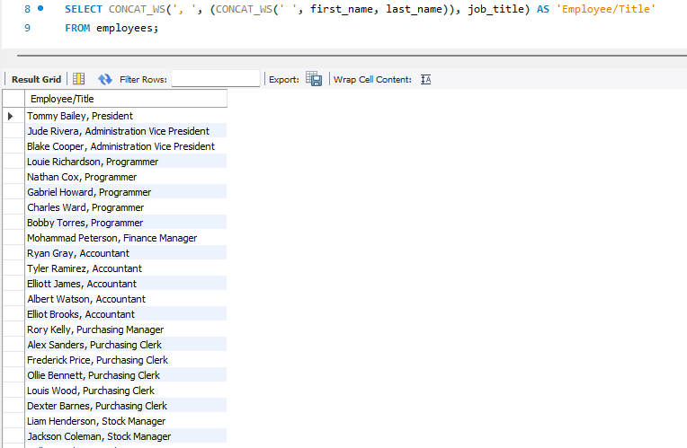

3. Using employees table, generate a login name according to these rules
Concatenate:
-first letter of the employee's first name
-to the last name
-to a random number that has been truncated to two digits
-and make the text upper case
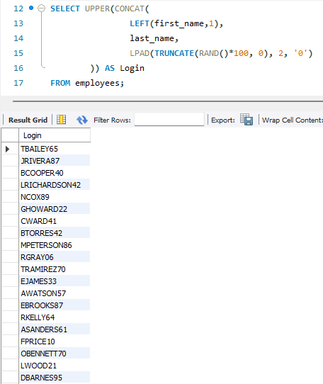

4. Using the customer table, what is the longest address?
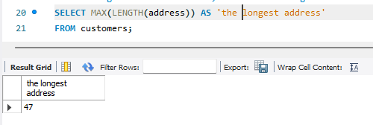

5. Using the customers table, locate the first comma in the address column whose name starts with a letter O
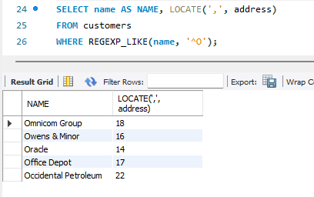

6. Using the products table, subtract standard cost from list price and round the total to zero decimal places
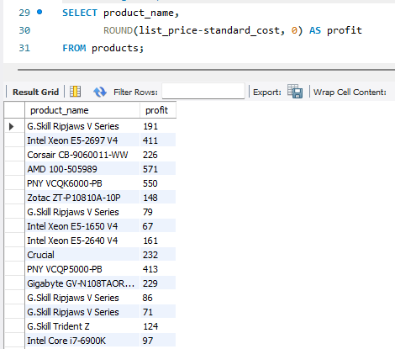

7. Take your birthdate and display the day of the week you were born
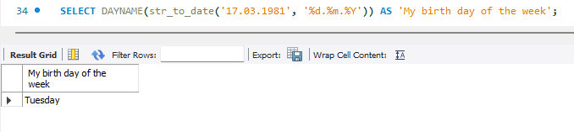

8. Use the CASE function to add an action item for each of the statuses in the order tables
If the status is shipped, then list the action item "send invoice"
If the status is pending, then the action item is "OK"
If the status is canceled, then the action item is "follow up"
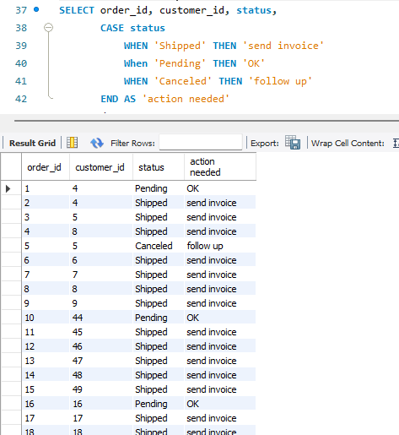

9. Use the IF statement to add a column to the query results showing whether a country is US or not
Show all locations
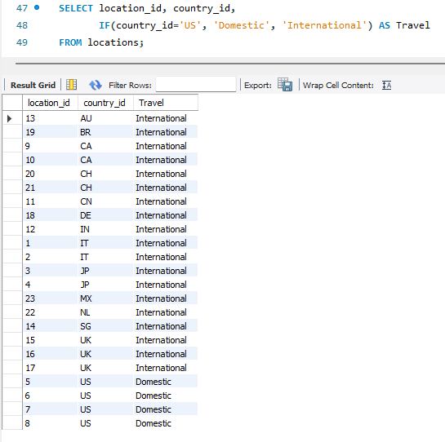

10. Using the employees table, calculate the number of years from hire date to now
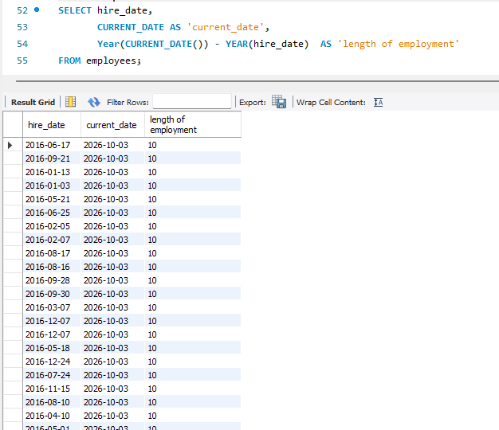

11. Create a query that displays the rank and dense rank for the credit limit of customers
Use the customer table
Order by credit limit
319 rows returned
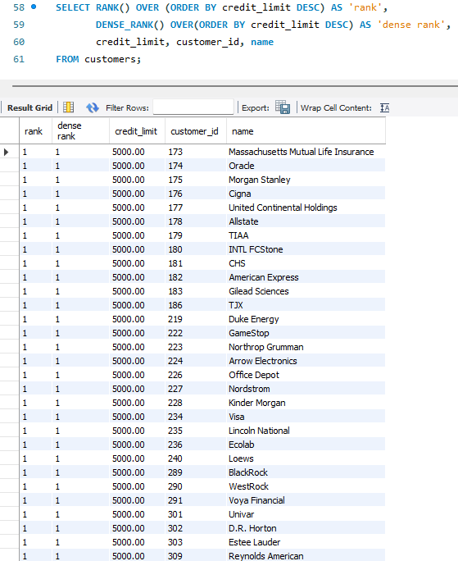
A little further down the list
