I.

Here is ZOC download address “ <http://www.emtec.com/zoc/> “ after you download and install, you have to copy two script file into below two directory.

1. C:\Users\xxxxx(your PC name)\Documents\
2. C:\Program Files\ZOC6\

Execute ZOC terminal and select com-port and baudrate as below.

Note : Current EVB with EEPROM mount version set baudrate to 921600, but in further EVB without EEPROM version, the default baudrate is 115200.

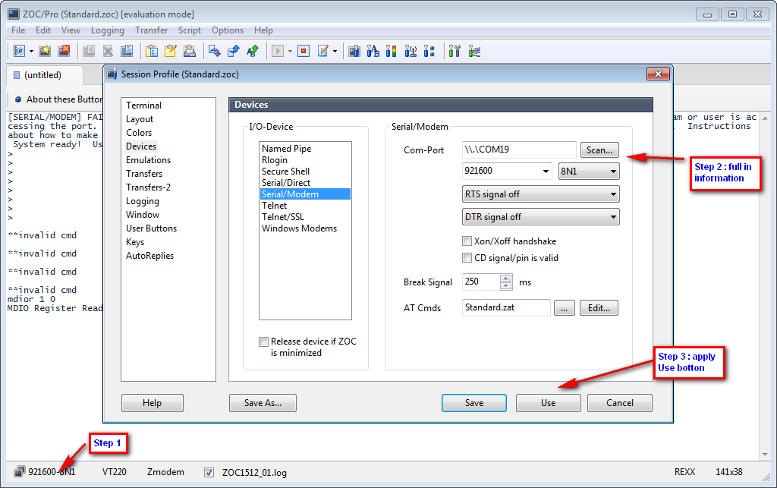

After click “Use” bottom, console should start the base command, please click esc in keyboard, customer should see “ > “ symbol in terminal.

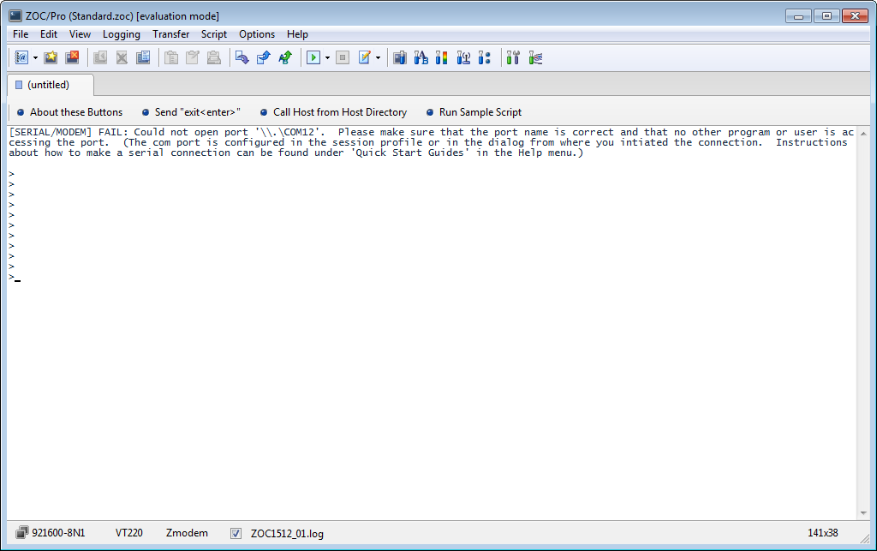

II.

Execute the script file to run the switch command line.

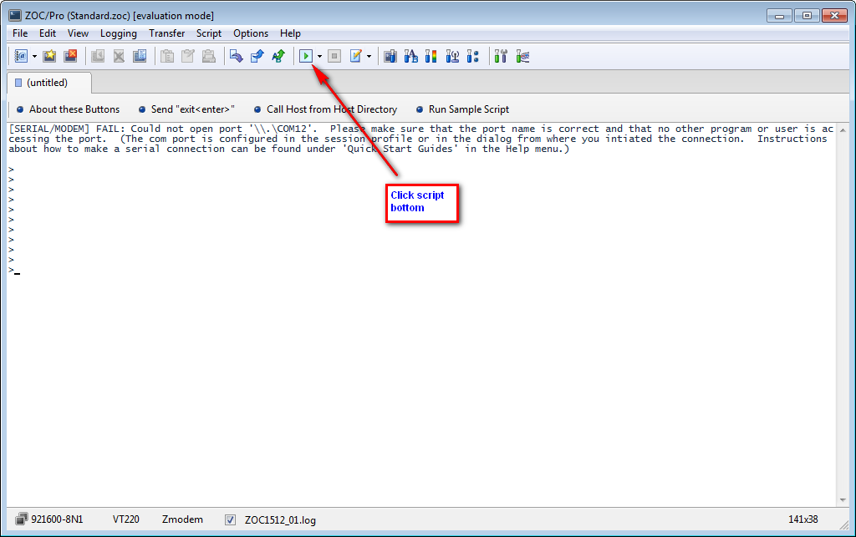

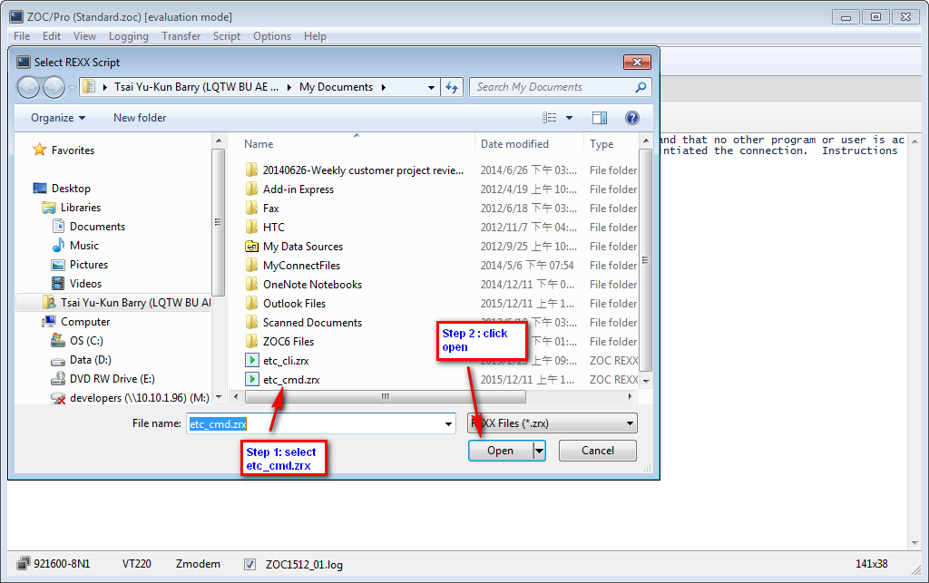

After click “Open”, now system should start to run the script file, below is example to read GPHY1 of MDIO reg0, return value 1040, more commands list in session III.

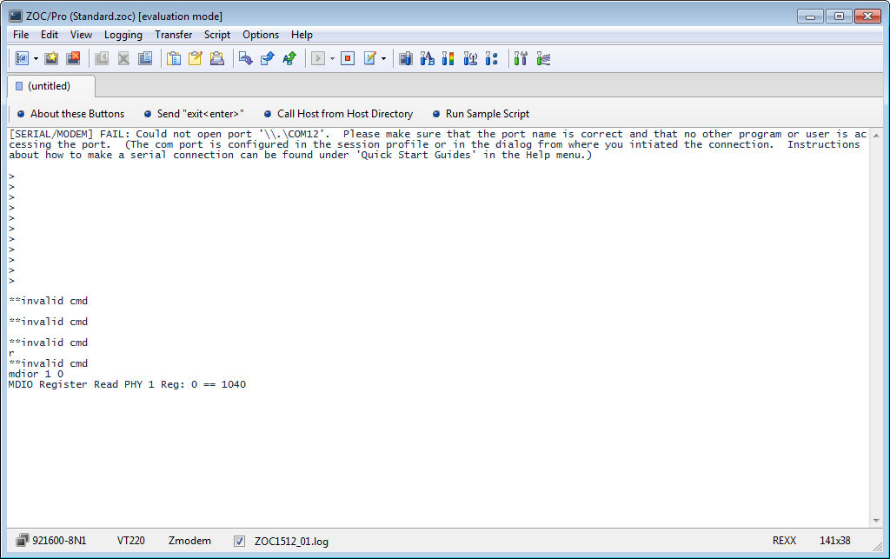

III.

Command Line

switch rmon read procedure.

- rmon clean 0 1 2 3 4

- rmon on 0 1 2 3 4

- rmon read 0 1 2 3 4

- mdior 1 0 --> MDIO PHY1 reg0 read command

- mdiow 1 0 1240 --> MDIO PHY1 reg0 write 1240

- mdiopd 0 --> MDIO PHY0 reg0 bit11=1 power down GPHY

- mmdr 3 1f 01e2 --> MMD PHY3 LED0H 1F.01E2 Read command

- mmdw 3 1f 01e2 70 --> MMD PHY3 LED0H 1F.01E2 write 70

- mr f400 --> Read switch register f400

- mw f400 8100 --> Write switch f400 bit8=1 disable port 0

Giga test mode

- mdiow 0 9 2300 --> test mode 1 voltage/template pick voltage

- mdiow 0 9 4300 --> test mode 2 jitter master

- mdiow 0 9 6300 --> test mode 3 jitter slave

- mdiow 0 9 8300 --> test mode 4 return loss (distortion)

100M eye pattern measurement

- mdiow 0 13 0 --> disable auto MDI / MDIX, set to MDI

- mdiow 0 13 4 --> disable auto MDI /MDIX, set to MDIX

- mdiow 0 0 2000 --> force 100M

10M Link pulse

- mdiow 0 13 0

- mdiow 0 0 0 --> force 10M