Scope:

Smart cards have become increasingly important in a number of sectors, such as mobile communications, banking, corporate uses and transport, globally.

All applications can benefit from the added features and security that smart cards provide.

The data can be password-protected, so users, at their discretion, can make the information embedded in the card available to potential providers in need of it.

Strong Authentication at centres of medical services,

Beneficial over Magnetic stripe cards,

Secured data assurance,

Medical Identity Theft in healthcare,

Providing secure access to emergency medical information.

Online portal needs to be available for the people to get registered on a valid government ID. For exception in patient registration is triggered on the very first visit of a patient to any health care facilities or at birth. The proposed system requires patients to register at a point of interest in any possible routes such as primary care practice, hospital facility, social services or emergency room. In emergency cases, healthcare takes precedence over recording patient information and in some cases the formalities are relaxed in an emergency situation. The prioritization of registration and healthcare support is largely dependent upon the individual patient circumstance. Therefore, the patient registration can take place before or after the treatment for first-time visitors. record for each patient is created in a database and stored on a portable electronic card. The next step of the process would be to encrypt the card with a secure password. Now the card is ready to be carried by the individual patient and presented at all health care facilities for data synchronization on each visit.

After the essential clinical and health care activities, the patient data is recorded in the information system and transferred over to the health care card. If the patient paid a visit to another health care facility and the card is holding new data, it is transferred over to the primary care information system. This will ensure completeness of patient data in all health care facilities. the patient may also choose only to have new reports downloaded and have their previous history be only viewable to the healthcare provider they are seeing. This method will prevent possible privacy leaks and also prevent a littering of data in healthcare databases throughout the country where the patient was only visiting and had needed unplanned emergency care.

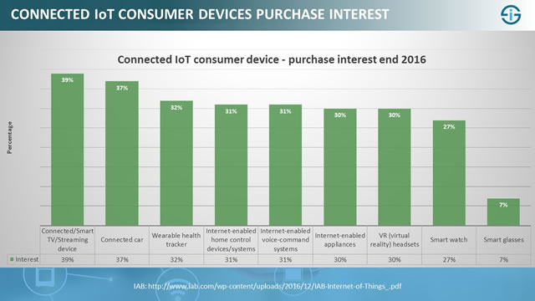

Purpose:

A portable unified medical record system which is a part of a distributed healthcare information system. It maintains a continuously-growing list of data records that each patient encounters. Each encounter refers to a previous encounter on the smart card and is thus the patient data on the smart card is comprehensive and hardened against tampering and revision by unauthorized users. the first point of patient's data entry will be determined by the circumstances of each individual patient. Current patients can be given their card on their next doctor visit, while new-borns can be registered in conjunction with the issuance of their social security card and/or birth certificate. The proposed system could work very similarly to a CarFax report that consumers can obtain for knowing the complete history of a car based on its vehicle identification number. a healthcare provider such as a physician or nurse practitioner in any part of the nation may have access to a patient's entire medical history, regardless of which part of the country and what type of service the patient receives. system to adopt the proposed plan nationwide, it is important that the federal government push this agenda which would help further the cause of moving from fee-based performance to value based system. Individual health organizations would not be willing to adopt such a system as they fear that it would lead to patient poaching by their competitors. The data available in the smart card could be available to competitors if patients come in contact with competitors. Therefore, in order to implement and reap the benefits of the proposed plan, it needs to be adopted by the government.

Solution:

Online portal needs to be available for the people to get registered on a valid government ID. For exception in patient registration is triggered on the very first visit of a patient to any health care facilities or at birth. The proposed system requires patients to register at a point of interest in any possible routes such as primary care practice, hospital facility, social services or emergency room. In emergency cases, healthcare takes precedence over recording patient information and in some cases the formalities are relaxed in an emergency situation. The prioritization of registration and healthcare support is largely dependent upon the individual patient circumstance. Therefore, the patient registration can take place before or after the treatment for first-time visitors. record for each patient is created in a database and stored on a portable electronic card. The next step of the process would be to encrypt the card with a secure password. Now the card is ready to be carried by the individual patient and presented at all health care facilities for data synchronization on each visit.

After the essential clinical and health care activities, the patient data is recorded in the information system and transferred over to the health care card. If the patient paid a visit to another health care facility and the card is holding new data, it is transferred over to the primary care information system. This will ensure completeness of patient data in all health care facilities. the patient may also choose only to have new reports downloaded and have their previous history be only viewable to the healthcare provider they are seeing. This method will prevent possible privacy leaks and also prevent a littering of data in healthcare databases throughout the country where the patient was only visiting and had needed unplanned emergency care.

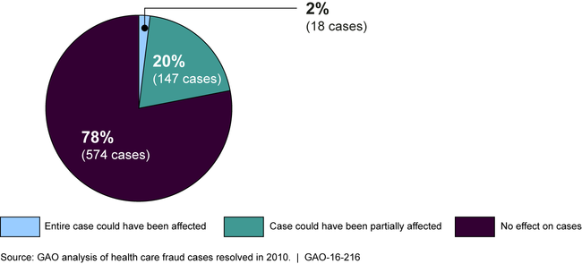

Architecture:

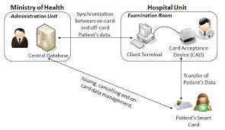

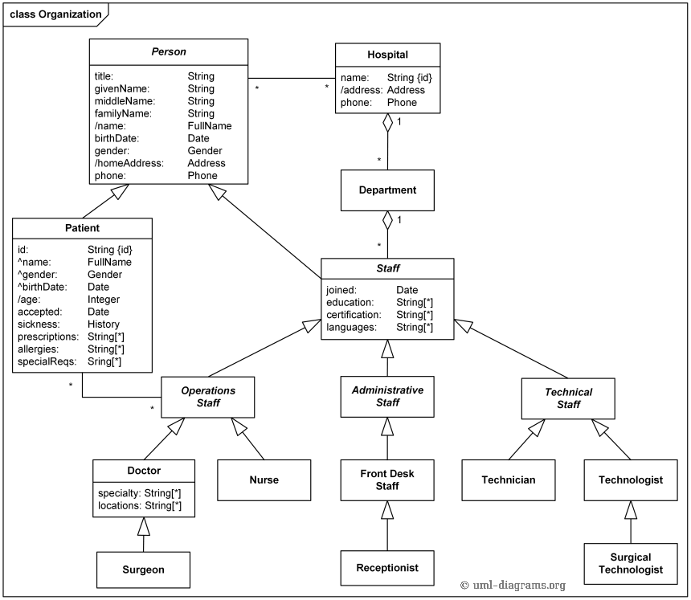

Customer Value Proposition:

|  |  |
| --- | --- |
| For Patients | For Doctors |
| Immediate access | Earns more money |
| Convenience | Increase patient referrals |
| Anonymity | Easily fix appointments |
| Continuity of care | Collaborate with other specialists |
| Cost competitive | Be a part of a global network |
| Transparencies | Better management of appointments |
| All data is stored in cloud | Better relation with patients |

Marketing Plan:

Smart cards are not a new technology. Over 5 billion smart cards are issued annually worldwide; over 140 million have been distributed in healthcare alone. For examples of smart healthcare card implementations initiating it from the small hospitals within the organization and test the failure rate fields and success rate fields.

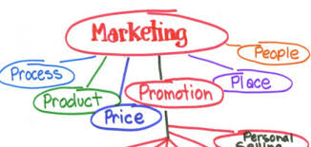

With a focus on strategy, properly executed tactics and continual monitoring, a well-executed strategic marketing plan is guaranteed to increase patient volume and achieve a sustainable competitive advantage in the marketplace.

## TACTICS:

Healthcare marketing has shifted from a one-size-fits-all, to a personalized, customized approach where we are building relationships with our customers for their health. Relational marketing tactics allow us to get closer to the customer by developing an ongoing relationship through careful attention to their needs and the way we can best deliver service.

Variety of Tactics Traditional Marketing

• Radio

• Outdoor/Billboard

• Online

• Direct mail

• Public/media relations

• Community relations (events, programs)

Start-Up EXPENSES and Capitalization:

|  |  |  |  |  |  |
| --- | --- | --- | --- | --- | --- |
| **ONE TIME START UP EXPENSES** |  | **AMOUNT** |  |  |  |
|  |  |  |  |  |  |
| **One Time Start-Up Costs:** |  |  |  |  |  |
| Rent Deposit |  | 15000 |  |  |  |
| Furniture & Fixtures |  | 10000 |  |  |  |
| Equipment |  | 100000 |  |  |  |
| Buildout/ Renovations |  | 3000 |  |  |  |
| Decorating, Painting and Remodelling |  | 40000 |  |  |  |
| Installation of Fixtures & Equipment |  | 1500 |  |  |  |
| Starting Inventory |  | 2000 |  |  |  |
| Deposits with Public Utilities |  | 10000 |  |  |  |
| Legal and Other Professional Fees |  | 65000 |  |  |  |
| License and Permits |  | 4000 |  |  |  |
| Advertising and Promotion |  | 80000 |  |  |  |
| Consulting |  | 5000 |  |  |  |
| Software |  | 35000 |  |  |  |
| Cash |  | 100000 |  |  |  |
| Other: |  | 10000 |  |  |  |
| **Total One Time Start-Up Costs:** |  | 480500 |  |  |  |
|  |  |  |  |  |  |
| **Monthly Expenses:** |  |  |  |  |  |
| Bank Charges |  | 5000 |  |  |  |
| Debt Service (Principal & Interest) |  | 15000 |  |  |  |
| Insurance |  | 0 |  |  |  |
| Membership & Dues |  | 0 |  |  |  |
| Maintenance & Repairs |  | 5000 |  |  |  |
| Marketing & Promotion: Advertising |  | 20000 |  |  |  |
| Marketing & Promotion: Other |  | 5000 |  |  |  |
| Miscellaneous |  | 2000 |  |  |  |
| Payroll: Wages (Owner/ Manager) |  | 10000 |  |  |  |
| Payroll: Wages (Employees) |  | 25000 |  |  |  |
| Payroll Tax |  | 400 |  |  |  |
| Professional Fees: Accounting |  | 0 |  |  |  |
| Professional Fees: Legal |  | 0 |  |  |  |
| Professional Fees: Other |  | 0 |  |  |  |
| Rent |  | 15000 |  |  |  |
| Subscriptions |  | 4000 |  |  |  |
| Supplies: Office |  | 25000 |  |  |  |
| Supplies: Operating |  | 20000 |  |  |  |
| Telephone |  | 1000 |  |  |  |
| Utilities |  | 5000 |  |  |  |
| Other: |  | 5000 |  |  |  |
| **Total Monthly Expenses:** |  | 162400 |  |  |  |
| Number of months required to cover Expenses: |  | 20 |  |  |  |
|  |  |  |  |  |  |
| **TOTAL START-UP FUNDS REQUIRED:** |  | 200000 |  |  |  |
|  |  |  |  |  |  |
| Loan Amount (At 80% of Total Start-Up) |  | 500000 |  |  |  |
|  |  |  |  |  |  |

Financial Plan:

We may need several different types of statements, depending on the requirements of our lender and your own technical expertise.

The statements we will probably need are:

* A start-up budget is like a projected cash flow statement, but with a little more guesswork. You may want to do a budget even if you don't need the funds for start-up. Your lender wants to know your budget - that is, what you expect to bring in and how much to expect to spend each month.  Lenders want to know that you can follow a budget and that you will not over-spend.
* A start-up costs worksheet This worksheet answers the question "What do you need the money for?"  In other words, it shows all the purchases you will need to make in order to open your doors for business.  We call this a "Day One" statement, because you'll need all of this stuff the first day of business.  Make sure you have included everything; it is better to over-estimate what you will need so you don't come up short with your loan proceeds.
* A pro forma (projected) profit and loss statement after you have completed the monthly budget and gathered some other information, you should be able to complete a P&L or Income Statement projecting your income for the first year.  This statement shows your profit for the year and how much tax you estimate having to pay.
* A pro forma (projected) balance sheet, and a large businesses use Sources and Uses of Funds statements in their annual reports, but you can create a slightly different simple statement to show your lender Lenders  exactly how much you need for start-up and [working capital](https://www.thebalancesmb.com/what-is-working-capital-how-to-get-a-working-capital-loan-398519)(on-going cash needs), how much collateral you will be bringing to the business, and how much you need to borrow.  In other words, how much you need and what do you need it for.

 Conclusion:

The use of heterogeneous patient information system in various health care facilities can make it a challenge to report and analyse patient data. The data integrity and completeness can be challenging for the employers, clinicians, and researchers. The Smart card distributed information system approach can combine and integrate the pertinent patient data in all the healthcare facilities to support quality of health care, reporting, treatment and management. Besides the innumerable benefits of this system, there are challenges to overcome. These challenges come in the shape of privacy, security, and costs associated with the initiation, implementation, and maintenance of this system.

There are endless possibilities and benefits that could come along with this program, such as globalization of healthcare and uniformity in the quality of services offered to the patients. This system has the potential to reduce malpractices, delayed decision making, etc. which usually occur as a result of healthcare providers not having enough information. Other future possibilities in health care would be with the use of analytics. Analytics for research purposes using the data derived from the widespread use of Smart card would potentially lead to better health care process reengineering.