**Introduction**

The chaotic nature of the atmosphere implies the need of massive computational power required to solve the equations that describe the atmospheric conditions. This is resulted from incomplete understanding of atmospheric processes mean that forecasts become less accurate as the difference in time between the present moment and the time for which the forecast is being made increases. Weather is a continuous, data-intensive, multidimensional, dynamic and chaotic process and these properties make weather prediction [6] a big challenge. Generally, two methods are used for weather forecasting

(a) the empirical approach and

(b) the dynamical approach.

The first approach is based on the occurrence of analogs and is often referred by meteorologists as analog forecasting. This approach is useful for predicting local-scale weather if recorded data’s are plentiful. The second approach is based on equations and forward simulations of the atmosphere and is often referred to as computer modeling. The dynamical approach is only useful for modeling large-scale weather phenomena and may not forecast short-term weather efficiently. Most weather prediction systems use a combination of empirical and dynamical techniques Artificial Neural Network (ANN) provides a methodology for solving many types of nonlinear problems that are difficult to be solved by traditional techniques

**Software and Existing Learning Required**

**1. Algorithm**

1. **Back Propogation:**

Backpropagation is a method used in artificial neural networks to calculate a gradient that is needed in the calculation of the weights to be used in the network.

Backpropagation is shorthand for "the backward propagation of errors," since an error is computed at the output and distributed backwards throughout the network’s layers. It is commonly used to train deep neural networks a term referring to neural networks with more than one hidden layer.

Backpropagation is a special case of a more general technique called automatic differentiation. In the context of learning, backpropagation is commonly used by the gradient descent optimization algorithm to adjust the weight of neurons by calculating the gradient of the loss function. This technique is also sometimes called backward propagation of errors, because the error is calculated at the output and distributed back through the network layers.

Backpropagation requires the derivative of the loss function with respect to the network output to be known, which typically (but not necessarily) means that a desired target value is known. For this reason, it is considered to be a supervised learning method, although it is used in some unsupervised networks such as autoencoders.

Backpropagation is also a generalization of the delta rule to multi-layered feedforward networks, made possible by using the chain rule to iteratively compute gradients for each layer. It is closely related to the Gauss–Newton algorithm, and is part of continuing research in neural backpropagation. Backpropagation can be used with any gradientbased optimizer.

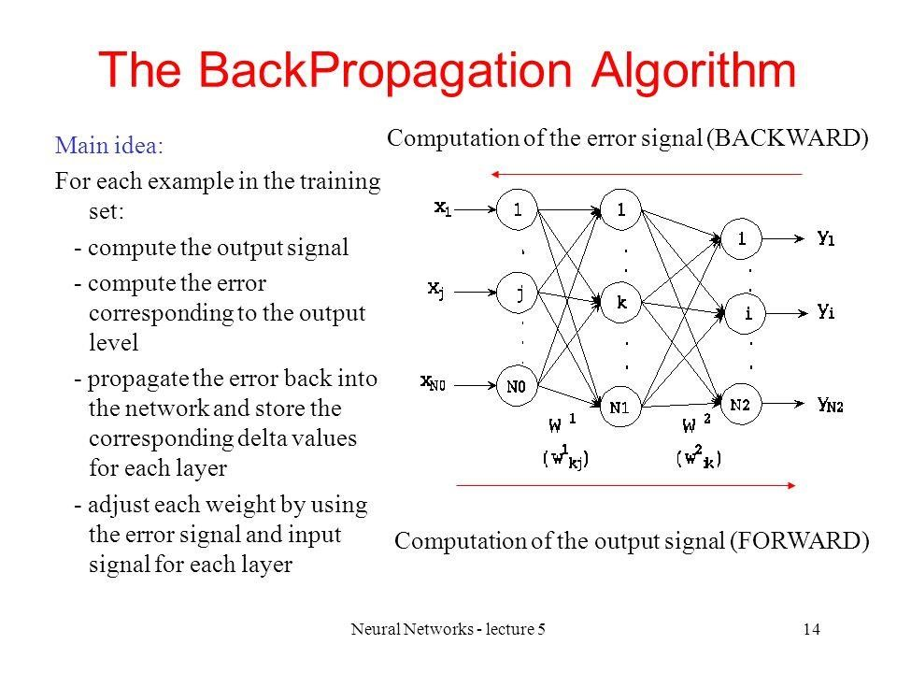

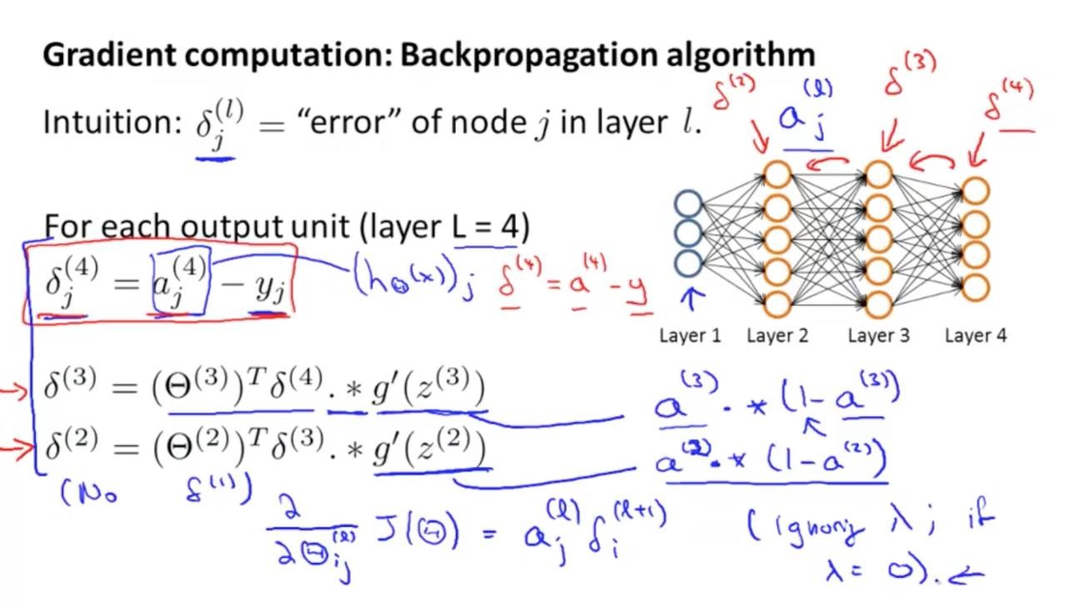

**BACK PROPOGATION STEPS Phase 1: propagation**

Each propagation involves the following steps:

1. Propagation forward through the network to generate the output value(s)

2. Calculation of the cost (error term)

3. Propagation of the output activations back through the network using the training pattern target to generate the deltas (the difference between the targeted and actual output values) of all output and hidden neurons.

Phase 2: weight update

For each weight, the following steps must be followed:

1. The weight's output delta and input activation are multiplied to find the gradient of the weight.

2. A ratio (percentage) of the weight's gradient is subtracted from the weight. This ratio (percentage) influences the speed and quality of learning; it is called the learning rate. The greater the ratio, the faster the neuron trains, but the lower the ratio, the more accurate the training is. The sign of the gradient of a weight indicates whether the error varies directly with, or inversely to, the weight. Therefore, the weight must be updated in the opposite direction, "descending" the gradient.

**Disadvantages of Back Propagation Algorithm**

● The actual performance of BackPropagation on particular data is completely dependent on its inputs.

● Backpropagation can be sensitive to noisy data and outliers.

● Fully matrix-based approach to backpropagation over a mini-batch.

**2) Fletcher-Reeves Model (Updation to Backpropagation Algorithm)**

Despite the general success of back-propagation method in the learning process, several major deficiencies are still needed to be solved. The convergence rate of back-propagation is very low and hence it becomes unsuitable for large problems. Furthermore, the convergence behavior of the back-propagation algorithm depends on the choice of initial values of connection weights and other parameters used in the algorithm such as the learning rate and the momentum term. Improving the training efficiency of neural network based algorithms is an active area of research and numerous papers have been proposed in the literature. Among these Fletcher and Reeves algorithm was turn out to be more efficient than Backpropagation Algorithm.

The following iterative algorithm is proposed for changing the gradient based search direction using a gain value. The gradient based search direction is a function of gradient of error with respect to weights.

Steps :

Step 1 Initialize the weight vector with random values and the vector of gain values with one. Step 2 Calculate the gradient of error w.r.t. to weights using Equation, and gradient of error w.r.t. to gain using Equation .

Step 3 Use the gradient weight vector and gradient of gain calculated in step 2 to calculate the new weight vector using equation and vector of new gain values using equation for use in the next epoch.

Step 4 Repeat the following steps 2 and 3 on an epoch-byepoch basis until the selected error minimization criteria is satisfied.

**3)Artificial Neural Network (ANN) Approach**

An Artificial Neural Network (ANN) is an information processing paradigm that is inspired by the way biological nervous systems, such as the brain, process information. The key element of this paradigm is the new structure of the information processing system. It is composed of a huge number of highly interconnected processing elements (neurons) working together to solve specific problems.

ANNs, like people, learn by example. An ANN is configured for a particular application, such as pattern recognition or data classification, through a learning process. Learning in biological systems adds adjustments to the synaptic connections that exist between the neurons.

The ANN has capability to extract the relationship between the inputs and outputs of a process, without the physics being explicitly provided. Thus, these properties of ANN are well suited to the problem of weather forecasting. The main purpose is to develop the most suitable ANN architecture and its associated training technique for weather prediction. This development will be based on using two different neural network architecture to demonstrate the suitable one for this application. Back Propagation (BPN) feed forward network and radial basis function network which were trained by differential evolution algorithm are the selected architectures in this study.

The basic architecture of the both Radial Basis Functions (RBF) neural network and multilayer feed forward neural networks are given. Components of a modern weather forecasting system include the following modules: data collection, data assimilation and numerical weather prediction

**Block diagram for ANN**

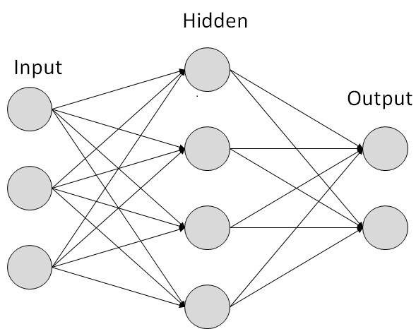

**Sigmoid Function and their Usage in Neural Network**

It is used in neural networks to give logistic neurons real-valued output that is a smooth and bounded function of their total input. It also has the added benefit of having nice derivatives which make learning the weights of a neural network easier.A neural network element computes a linear combination of its input signals, and applies a sigmoid function to the result. A reason for its popularity in neural networks is because the sigmoid function satisfies a property between the derivative and itself such that it is computationally easy to perform.

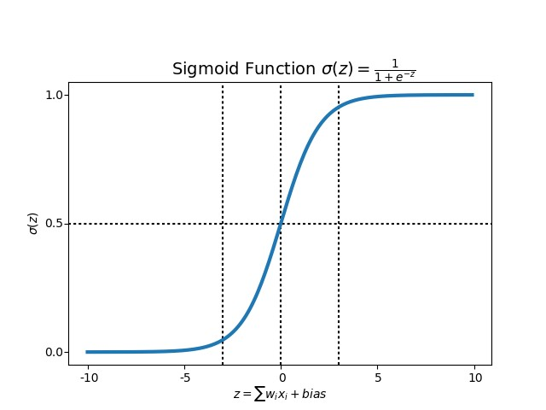

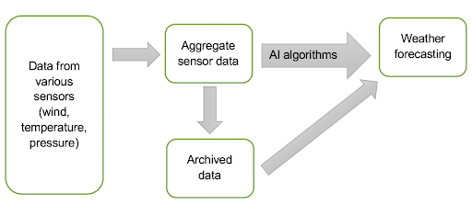

**Model**

**1.Steps involved in ANN approach**

**A. Data collection:**

Observations of atmospheric pressure, temperature, wind speed, wind direction, humidity and precipitation are made near the earth’s surface by trained observers, automatic weather stations.

The World Meteorological Organization acts to standardize the instrumentation, observing practices and timing of these observations worldwide.

**B. Data assimilation:**

During the data assimilation process, information gained from the

observations is used in conjunction with a numerical model most recent forecast for the time that observations were made to produce the meteorological analysis. This is the best

estimate of the current state of the atmosphere. It is a three-dimensional representation of the distribution of temperature, moisture and wind.

The features considered in this study are bar temperature, bar reading, sea level pressure, mean sea level pressure, dry bulb temperature, wet bulb temperature, duw point temperature, vapor pressure, wind speed, humidity, cloudiness, precipitation, wind direction, wind speed and for prediction of rain. It is easy to implement and produces desirable forecasting result by training the given data set.

**C. Numerical weather prediction:**

Numerical Weather Prediction (NWP) uses the power of computers to make a forecast. Complex computer programs, also known as forecast models, run on supercomputers and

provide predictions on many atmospheric variables such as temperature, pressure, wind and rainfall. A forecaster examines how the features predicted by the computer will interact to produce the day’s weather.

**2.Technology Used**

SCITKIT-Learn: Scikit-learn (formerly scikits.learn) is a free software machine learning library for the Python programming language. It features,various classification, regression and clustering algorith ms including support vector machines, random forests, gradient boosting, k-means and DBSCAN, and is designed to interoperate with the Python numerical and scientific libraries NumPy and SciPy

**3.Platform**

a. Python: Python is a valuable part of the data analyst’s toolbox, as it’s tailor-made for carrying out repetitive tasks and data manipulation, and anyone who has worked with large amounts of data knows just how often repetition enters into it. By having a tool that handles the grunt work, the data analysts are free to handle the more interesting and rewarding parts of the job.

b. Jupyter Notebook: The Jupyter Notebook is an open-source web application that allows you to create and share documents that contain live code, equations, visualizations and narrative text. Uses include: data cleaning and transformation, numerical simulation, statistical modelling, data visualization, machine learning, and much more.

**Results**

Artificial Neural Network the Back Propagation Algorithm is implemented and the variations in parameters are observed. According to these variations the logic in Back Propagation will be developed and the change in other parameters with respect to one parameter will be predicted. All the information of parameters which changed and predicted is collected together and the new classification of weather will be drawn, whether the future day will be rainy day, sunny day or windy day and whether on that particular day the probability of experiencing a thunderstorm is high or not.

**Conclusion**

It concludes that there can be a new method to predict the future weather with the help of back propagation training algorithm. It was found that the network learns very fast with back propagation algorithm. The results are more accurate for predicting the future weather. Back propagation is a gradient descent algorithm which learns by minimizing the error in the output by adjusting the weights in the network. Our model has potential to capture the complex relationships between many factors that contribute to certain weather condition.

The accuracy from weather forecasting model using ANN and Back Propagation Algorithm is more than other Statistical Model. An extension to this technology can be done using any of the other technique instead of Data mining and Different Algorithm. Furthermore, in order to improve the efficiency of the neural network algorithms other statistical based feature selection techniques, statistical indicators can be integrated. In another perspective fuzzy techniques can be incorporated, which an inferential, probality based approach to data comparisons is allowing to infer, based on probabilities, the strength of the relationships between attributes in the data sets and to achieve better predictability rate.