Design of an Intelligent Analog Front-End for EV Battery Diagnostics, Adaptive Calibration, Thermal Runaway Prevention, Aging-Aware Protection, and Fast-Fault Safety Monitoring

Project report submitted to
Indian Institute of Information Technology, Nagpur,
in partial fulfillment of the requirements for the Final Year Project

at

DEPARTMENT OF ELECTRONICS AND COMMUNICATION ENGINEERING

by
Palash Goswami (BT22ECE073) |  | Chaahat Singal (BT22ECE099)

Under the supervision of
Dr. Shankar Bhattacharjee
Dr. Girish Ghivela
Session Period: Jan to May 2026



भारतीय सूचना प्रौद्योगिकी संस्थान, नागपुर

INDIAN INSTITUTE OF INFORMATION TECHNOLOGY, NAGPUR
(An Institution of National Importance by Act of Parliament)
Survey No. 140, 141/1, Behind Br. Sheshrao Wankhede Shetkari Sahakari
SootGirni, Nagpur,441108.

Design of an Intelligent Analog Front-End for EV Battery Diagnostics, Adaptive Calibration, Thermal Runaway Prevention, Aging-Aware Protection, and Fast-Fault Safety Monitoring

Project report submitted to
Indian Institute of Information Technology, Nagpur,
in partial fulfillment of the requirements for the Final Year Project

at

DEPARTMENT OF ELECTRONICS AND COMMUNICATION ENGINEERING

by
Palash Goswami (BT22ECE073) |  | Chaahat Singal (BT22ECE099)

Under the supervision of
Dr. Shankar Bhattacharjee
Dr. Girish Ghivela
Session Period: Jan to May 2026



भारतीय सूचना प्रौद्योगिकी संस्थान, नागपुर

INDIAN INSTITUTE OF INFORMATION TECHNOLOGY, NAGPUR
(An Institution of National Importance by Act of Parliament)
Survey No. 140, 141/1, Behind Br. Sheshrao Wankhede Shetkari Sahakari
SootGirni, Nagpur,441108.


Department of Electronics and Communication Engineering
Indian Institute of Information Technology, Nagpur

Declaration

We, Chaahat Singal and Palash Goswami hereby declare that this project work titled “Design of an Intelligent Analog Front-End for EV Battery Diagnostics, Adaptive Calibration, Thermal Runaway Prevention, Aging-Aware Protection, and Fast-Fault Safety Monitoring” is carried out by me/us in the Department of Electronics and Communication Engineering of Indian Institute of Information Technology, Nagpur. The work is original and has not been submitted earlier whole or in part for the award of any degree/diploma at this or any other Institution /University.

Date:

Sr. No | Name | Enrollment No | Signature
1. | Chaahat Singal | BT22ECE099 | 
2. | Palash Goswami | BT22ECE073 | 

Declaration

We, Chaahat Singal, Palash Goswami Enrollment No (BT22ECE099, BT22ECE073), understand that plagiarism is defined as any one or the combination of the following:

- Uncredited verbatim copying of individual sentences, paragraphs or illustrations (such as graphs, diagrams, etc.) from any source, published or unpublished, including the internet.
- Uncredited improper paraphrasing of pages or paragraphs (changing a few words or phrases, or rearranging the original sentence order).
- Credited verbatim copying of a major portion of a paper (or thesis chapter) without clear delineation of who did or wrote what. (Source: IEEE, the institute, Dec.2004) I have made sure that all the ideas, expressions, graphs, diagrams, etc. that are not a result of my own work, are properly credited. Long phrases or sentences that had to be used verbatim from published literature have been clearly identified using quotation marks.

I affirm that no portion of my work can be considered as plagiarism and I take full responsibility if such a complaint occurs. I understand fully well that the guide of the thesis may not be in a position to check for the possibility of such incidences of plagiarism in this body of work.

Date:

Sr. No | Name | Enrollment No | Signature
1. | Chaahat Singal | BT22ECE099 | 
2. | Palash Goswami | BT22ECE073 | 

ELECTRONICS AND COMMUNICATION ENGINEERING IIIT, NAGPUR

Certificate

This is to certify that the project titled “Design of an Intelligent Analog Front-End for EV Battery Diagnostics, Adaptive Calibration, Thermal Runaway Prevention, Aging-Aware Protection, and Fast-Fault Safety Monitoring”, submitted by Palash Goswami, Chaahat Singal in partial fulfilment of the requirements for the award of the degree of Bachelor of Technology in Electronics and Communication Engineering, IIIT Nagpur. The work is comprehensive, complete and fit for final evaluation.

Date: 15th May, 2026

Dr. Shankar Bhattacharjee Dr. Girish Ghivela
Assistant Professor, ECE, Assistant Professor, ECE,
IIIT, Nagpur IIIT, Nagpur

Industry Expert’s Signature Academic Expert’s Signature

Dr. Harsh Goud
HOD, Electronics & Communication Engineering
IIIT, Nagpur

Acknowledgement

It gives us immense pleasure to present this final year project report, a culmination of dedicated effort, learning, and continuous exploration. This work would not have been possible without the guidance, encouragement, and support of several individuals and institutions, to whom we owe our heartfelt gratitude.

We express our sincere appreciation to Dr. Shankar Bhattacharjee and Dr. Girish Ghivela, our project supervisor, for his exceptional mentorship, constructive feedback, and invaluable insights throughout the project. His constant support and academic guidance have been instrumental in shaping the direction and quality of this work.

We extend our respectful thanks to Dr. Harsh Goud, Head of the Department, Electronics and Communication Engineering, Indian Institute of Information Technology, Nagpur, for providing us with the necessary academic environment, departmental facilities, and motivation that greatly facilitated the completion of this project.

We also acknowledge the Department of Electronics and Communication Engineering, IIIT Nagpur, for providing access to laboratory infrastructure, computational resources, and administrative assistance essential for carrying out the research. We are equally grateful to all faculty members, lab staff, and peers who supported us through their valuable suggestions and cooperation.

Finally, we express our profound gratitude to our families and friends whose unwavering support, encouragement, and understanding sustained us throughout this academic journey. Their motivation has been a constant source of strength.

Abstract

Electric vehicle battery packs require safe, accurate, and fast diagnostic systems because battery failure can occur through multiple mechanisms: over-current stress, sensor offset, thermal rise, internal degradation, poor cooling, and thermal runaway. Conventional battery management systems often depend on fixed temperature, voltage, or current thresholds. Such systems are useful for basic protection, but they usually respond late to internal thermal acceleration, do not dynamically adapt to aging, and may not distinguish between slow thermal hazards and fast electrical faults. This project presents a simulation-validated intelligent analog front-end for EV battery diagnostics and protection that combines calibrated sensing, electro-thermal modeling, aging-aware current governance, ADC/SAR support, RLS-based internal resistance estimation, and hierarchical fast-fault shutdown logic.
The proposed architecture is implemented mainly in LTspice using a first-order battery equivalent circuit model, coupled core-surface thermal network, behavioral heat-generation equations, sensor calibration paths, RC-qualified protection logic, and sampled ADC/SAR blocks. Python is used for post-simulation analysis, multi-case comparison, policy validation, and RLS-based estimation. The system is validated under six representative scenarios: baseline, thermal derating, runaway prevention, aging warning, severe aging, and fast fault. Results show that the controller provides graded thermal derating, early runaway precursor detection, aging-sensitive current scaling, and sub-10 ms fault protection. The project demonstrates that an EV battery front-end can be designed not only as a measurement circuit but also as a predictive safety and diagnostic layer suitable for future ASIC or embedded BMS integration.

Table of Contents
Abstract 7
List of Figures 11
List of Tables 12
List of Symbols, Abbreviations and Nomenclature 13
1. Introduction 14
1.1 Background 14
1.2 Need for Intelligent Battery Protection 14
1.3 Motivation 15
1.4 Project Contribution 15
2. Literature Review 16
2.1 Conventional Battery Management Systems 16
2.2 Thermal Runaway and Derivative-Based Warning 16
2.3 Internal Resistance and Aging 16
2.4 Calibration and ADC in Battery Front-Ends 16
2.5 Research Gap Addressed 16
3. Objectives and System Requirements 18
3.1 Overall Objective 18
3.2 Specific Objectives 18
3.3 Engineering Requirements 19
3.4 Design Philosophy 19
4. Proposed System Architecture 20
4.1 Functional Blocks 20
4.2 High-Level Signal Flow 20
4.3 Why This Architecture Is Different 21
5. LTspice Circuit Implementation 22
5.1 Battery Electrical Model 22
5.2 Electro-Thermal Heat Model 22
5.3 Protection Logic Implementation 22
5.4 Measurement and Sensor Trust 23
6. Adaptive Calibration Subsystem 24
6.1 Objective 24
6.2 Problem Solved 24
6.3 Circuit Approach 24
6.4 Quantitative Result 25
6.5 Significance 26
7. ADC and SAR Monitoring Subsystem 27
7.1 Objective 27
7.2 Sample-and-Hold and Quantization 27
7.3 SAR-Like Voltage Conversion 27
7.4 ADC Result Interpretation 28
7.5 Significance 28
8. RLS-Based Internal Resistance Estimation 29
8.1 Objective 29
8.2 Why RLS Was Used 29
8.3 Connection with Aging-Aware Protection 30
8.4 Significance 30
9. Electro-Thermal Protection and Fast Derating 31
9.1 Objective 31
9.2 Thermal Stress and Current Scaling 31
9.3 Case 2: Thermal Derating 31
9.4 Quantitative Result 32
9.5 Significance 33
10. Aging-Aware Policy and Health Scoring 34
10.1 Objective 34
10.2 R0eff and Age Stress 34
10.3 Case 4 vs Case 5 34
10.4 Significance 36
11. Fast Fault Protection Layer 37
11.1 Objective 37
11.2 Circuit Approach 37
11.3 Case 6 Result 37
11.4 Significance 38
12. Multi-Case Validation and Results 39
12.1 Validation Philosophy 39
12.2 Case Definitions 40
12.3 Case 3: Runaway Prevention 41
12.4 Comparative Result Dashboard 42
12.5 What Each Feature Solves 43
13. Engineering Significance and Future Scope 44
13.1 Engineering Significance 44
13.2 Comparison with Simple Threshold Protection 44
13.3 Limitations 44
13.4 Future Scope 45
14. Conclusion 46
References 47
Appendix A: Detailed Feature-to-Objective Mapping 48
Appendix B: Algorithmic Flow Used in the Protection Stack 49
B.1 Calibration Algorithm 49
B.2 Thermal Derating Algorithm 49
B.3 Aging Policy Algorithm 49
B.4 Fast Fault Algorithm 50
Appendix C: Case-by-Case Interpretation for Viva 51
C.1 Case 1 - Baseline 51
C.2 Case 2 - Thermal Derating 51
C.3 Case 3 - Runaway Prevention 51
C.4 Case 4 and Case 5 - Aging Policy 51
C.5 Case 6 - Fast Fault 51
Appendix D: Key LTspice Behavioral Blocks 54
D.1 Representative Equations 55
Appendix E: Selected Figures for Final Demonstration 56

List of Figures
Figure 4.1: Integrated LTspice top-level architecture of the proposed EV battery diagnostic and protection front-end. 21
Figure 4.2: ADC/SAR and sampled-interface region of the LTspice implementation. 21
Figure 6.1: Calibration bench trajectory showing REF/MEAS switching and
corrected output response. 25
Figure 6.2: Calibration error reduction comparing raw and settled-corrected measurement error. 25
Figure 7.1: Current ADC transfer behavior, input-code relation, and sample-wise quantization error. 28
Figure 8.1: Online R0 estimation using Recursive Least Squares. 29
Figure 8.2: Measured voltage compared with RLS-predicted voltage. 30
Figure 9.1: Case 2 thermal derating showing current reduction, dT/dt moderation
, and no-derate comparison. 32
Figure 10.1: Aging-aware policy comparison between Case 4 and Case 5. 34
Figure 10.2: Observed versus predicted current policy using health and resistance features. 34
Figure 11.1: Case 6 fast-fault latency compared with the 10 ms design requirement. 37
Figure 12.1: Case-wise summary table generated from Python post-processing. 38
Figure 12.2: Event timeline table showing key protection and fault events. 39
Figure 12.3: Case 3 runaway-prevention timeline and no-shutdown proxy comparison. 40
Figure 12.4: Comparative dashboard of protection windows, derating benefit,
current policy, and fast-fault latency. 41
Figure C.1: Detailed thermal derating waveform used for Case 2 defense. 52
Figure C.2: Detailed runaway prevention waveform used for Case 3 defense. 53
Figure E.1: Calibration timing and measurement/reference switching. 56
Figure E.2: Calibration error reduction summary. 56
Figure E.3: Aging policy model validation. 57
Figure E.4: RLS-based online internal resistance estimate. 57

List of Tables
Table 3.1: Engineering requirements and project implementation. 19
Table 6.1: Calibration performance metrics. 25
Table 9.1: Thermal derating quantitative results. 32
Table 10.1: Aging-aware policy comparison for Case 4 and Case 5. 34
Table 11.1: Fast-fault timing and latency results. 37
Table 12.1: Validation case definitions. 39
Table 12.2: Runaway-prevention phase durations. 40
Table 12.3: Feature-to-objective validation summary. 42
Table 13.1: Comparison between conventional threshold BMS and proposed architecture. 43
Table A.1: Detailed feature-to-objective mapping. 47
Table D.1: Key LTspice behavioral blocks. 54

List of Symbols, Abbreviations and Nomenclature

Abbreviation | Full Form
BMS | Battery Management System
EV | Electric Vehicle
AFE | Analog Front-End
ECM | Equivalent Circuit Model
OCV | Open Circuit Voltage
SOC | State of Charge
SOH | State of Health
ADC | Analog-to-Digital Converter
SAR | Successive Approximation Register
DAC | Digital-to-Analog Converter
S/H | Sample-and-Hold
RLS | Recursive Least Squares
RC | Resistor-Capacitor
OC | Over-Current
UV | Under-Voltage
SC | Short-Circuit
dT/dt | Rate of change of temperature
R0 | Ohmic Internal Resistance
R0eff | Effective Internal Resistance
ASIC | Application Specific Integrated Circuit
FPGA | Field Programmable Gate Array
LTspice | Linear Technology SPICE Simulator

Chapter 3
Introduction
1.1 Background
Electric vehicles depend heavily on lithium-ion battery packs. These packs must deliver high power, accept fast charging, and remain safe across different ambient temperatures, aging conditions, current transients, and fault events. Unlike small portable batteries, EV packs contain many cells connected in series and parallel, so local degradation or abnormal heating can propagate into a system-level hazard. Battery safety therefore cannot rely on a single alarm signal. A realistic protection system must monitor electrical, thermal, and aging-related behavior simultaneously.
The analog front-end is the first layer of a battery management system. It senses voltage, current, and temperature-related signals and sends them to the digital controller. If this front-end contains offset, drift, slow response, or poor fault qualification, the higher-level controller will make decisions based on unreliable information. For this reason, this project focuses on the design of an intelligent analog front-end that combines measurement, calibration, digitization, safety logic, and post-processing validation.
1.2 Need for Intelligent Battery Protection
Traditional BMS designs usually include over-voltage, under-voltage, over-current, and over-temperature cutoffs. These are necessary, but they are not sufficient for advanced EV operation. A thermal runaway event may begin internally before the surface temperature crosses a critical threshold. A degraded cell may appear usable at low current but become unsafe under fast charging. A short-circuit fault requires a millisecond-level response, while thermal derating may occur over hundreds or thousands of seconds. This difference in time scale motivates a hierarchical architecture.
The proposed design addresses this need by implementing multiple protection layers: a fast electrical fault layer, a thermal derating layer, a runaway precursor layer, an aging-aware current policy, and a measurement-trust layer. The result is not only a shutdown circuit but a complete safety stack that can reduce current gradually when possible and force shutdown when required.
1.3 Motivation
• Fast charging increases heat generation and accelerates aging if not controlled.
• Internal resistance increases with degradation and must influence allowable current.
• Sensor offset and drift can cause false decisions; calibration is therefore essential.
• Thermal runaway requires early detection using derivative and stress indicators, not only absolute temperature.
• Fast electrical faults require a separate millisecond-class path, because thermal models are too slow for short-circuit protection.
1.4 Project Contribution
The main contribution of this project is the development of a mixed-signal, simulation-validated EV battery front-end that integrates diagnostic estimation, calibration, ADC support, and multi-timescale protection. The project is intentionally designed as a system architecture rather than a single comparator circuit. Each subsystem has a defined purpose, an implementation method, and a measurable outcome.
• Self-calibrated voltage and current sensing path using reference-mode switching and correction holding.
• Electro-thermal battery model with irreversible, reversible, and reaction heat components.
• Fast derating and shutdown logic using stress fusion and RC filtering.
• Aging-aware current governance based on R0eff, age stress, risk score, and health score.
• ADC/SAR interface for sampled digital monitoring of front-end signals.
• RLS-based internal resistance estimation and measured-vs-predicted voltage validation.
• Case-wise Python validation that converts raw waveforms into engineering metrics.

Chapter 4
Literature Review
2.1 Conventional Battery Management Systems
A conventional BMS performs voltage monitoring, current measurement, temperature sensing, balancing, contactor control, and communication with the vehicle controller. In many simple systems, protective actions are threshold-based: if a voltage, current, or temperature crosses a limit, the system either warns the user or disconnects the pack. This approach is simple and robust, but it has two limitations. First, it is reactive; the system may wait until a severe threshold is reached. Second, it is often non-adaptive; a new cell and aged cell may be treated with similar current limits even though their safe operating regions differ.
2.2 Thermal Runaway and Derivative-Based Warning
Thermal runaway is a positive-feedback process in which heat generation exceeds heat dissipation. Absolute temperature is important, but derivative signals such as dT/dt are also valuable because they indicate acceleration. A cell with a rapidly rising dT/dt can be more dangerous than a cell at a moderately high but stable temperature. Therefore, the proposed design uses Tcell, core-surface thermal gradient, and filtered dT/dt as combined warning variables.
2.3 Internal Resistance and Aging
Internal resistance is an important indicator of battery health. As a cell ages, the effective series resistance increases due to electrochemical degradation, loss of active material, and interface changes. Higher resistance increases I^2R heat generation under the same current. Therefore, a fixed current policy can become unsafe for aged batteries. The proposed architecture computes R0eff and maps it to age stress, health score, and current policy.
2.4 Calibration and ADC in Battery Front-Ends
Battery front-end measurements are affected by input offsets, gain errors, reference drift, ADC quantization, noise, and leakage in sample-and-hold networks. Calibration is used to correct predictable measurement errors. ADC support is required to move from analog simulation toward a digital BMS interface. This project includes reference-mode switching, correction holding, quantized current/temperature ADC blocks, and a SAR-like voltage conversion path.
2.5 Research Gap Addressed
The gap addressed by this project is the lack of a unified student-level design that combines analog front-end calibration, thermal intelligence, aging-aware current scaling, fast electrical fault logic, ADC support, and parameter estimation in one coherent architecture. Instead of demonstrating only one protection condition, the proposed system validates multiple failure modes and shows how each protection layer responds.

Chapter 5
Objectives and System Requirements

3.1 Overall Objective
The objective of this project is to design and validate an intelligent EV battery analog front-end that can sense battery behavior accurately, compensate measurement errors, detect slow and fast hazards, adapt protection based on aging, and provide digitized information for a supervisory controller.
3.2 Specific Objectives
• Develop a first-order equivalent circuit model of a battery cell with current sensing and voltage sensing.
• Build an electro-thermal model that captures core-surface dynamics, ambient cooling, irreversible heat, reversible heat, and reaction heat.
• Design thermal warning, charge limit, and shutdown logic using Tcell, dT/dt, and thermal gradient.
• Implement fast-fault detection using over-current, under-voltage, short-circuit fusion, validation filtering, and hold logic.
• Add adaptive calibration with reference switching and correction output to reduce measurement error.
• Create an ADC/SAR support layer for digitized monitoring of voltage, current, and temperature-related channels.
• Estimate internal resistance using RLS in Python and connect the result with aging-aware protection.
• Validate the full system across six representative operating cases and extract measurable safety windows.

3.3 Engineering Requirements
Table 3.1: Engineering requirements and project implementation.
Requirement | Reason | Project Implementation
Stable baseline operation | Avoid nuisance trips under safe operation | Case 1 baseline remains normal without protection action
Thermal derating | Reduce stress before shutdown | CHG_LIMIT and ICMD_SCALE_FINAL reduce current
Runaway precursor response | Create early warning window | RUNAWAY_PRECURSOR and THERM_SHDN stage response
Aging sensitivity | Protect degraded cells | R0eff, AGE_STRESS, HEALTH_SCORE, AGE_SCALE
Fast fault reaction | Short-circuit requires ms response | FAST_FAULT_RAW, FAST_TRIP_VALID, FAST_SHDN
Measurement reliability | Avoid acting on invalid measurements | REFCHK, SENSOR_FAULT, MEAS_TRUST_OK
Digital interface readiness | BMS controller requires sampled data | S/H, quantization, ADC code, SAR logic

3.4 Design Philosophy
The design philosophy is hierarchical and time-scale aware. Fast electrical faults are handled using a dedicated path with RC validation and hold behavior. Thermal faults are handled using derating and shutdown logic. Aging is handled through a slower health-aware current policy. Calibration and ADC support form the measurement layer beneath these protections. This layered structure makes the system more realistic than a single threshold-based circuit.

Chapter 6
Proposed System Architecture
The proposed system is organized as a mixed-signal safety stack. At the lowest level, the battery equivalent circuit and sensing network generate voltage and current signals. The calibration block corrects offset and drift. The ADC/SAR layer samples and digitizes signals. The electro-thermal model estimates temperature evolution. The protection logic then computes warnings, derating, shutdown, and system state. Python post-processing validates the design using case-wise metrics.
4.1 Functional Blocks
• Battery electrical model: open-circuit source, series resistance, RC polarization branch, shunt current sensing.
• Calibration front-end: reference source, measurement/reference multiplexing, offset correction, filtered output.
• Thermal core-surface model: core heat capacity, surface heat capacity, core-surface resistance, surface-ambient resistance.
• Protection logic: thermal warning, precursor, charge limit, shutdown, aging derate, final shutdown.
• Fast fault logic: over-current, under-voltage, short-circuit fusion, RC validation, latch/hold.
• ADC/SAR interface: sample-and-hold, quantization, bit extraction, SAR comparison, DAC reconstruction.
• Python analytics: case summary, safety windows, policy fitting, calibration improvement, ADC metrics, RLS estimation.
4.2 High-Level Signal Flow
The signal flow begins with the battery current command and cell response. Current passes through a shunt, and voltage is sensed at the battery node. These raw analog values are filtered and passed through the calibration path. Calibrated and sampled values are used by the ADC and by the decision logic. In parallel, the thermal model integrates heat generation to produce Tcell_abs, thermal gradient, and dT/dt. These signals create warning, derating, and shutdown commands. Aging variables alter the allowable current even when temperature is not immediately critical.
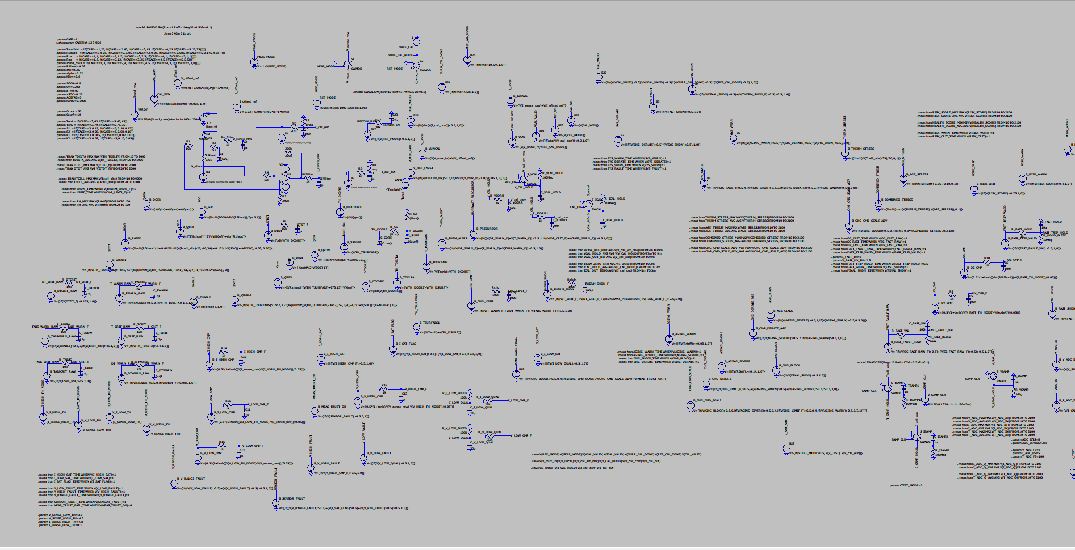
Figure 4.1: Integrated LTspice top-level architecture of the proposed EV battery diagnostic and protection front-end.
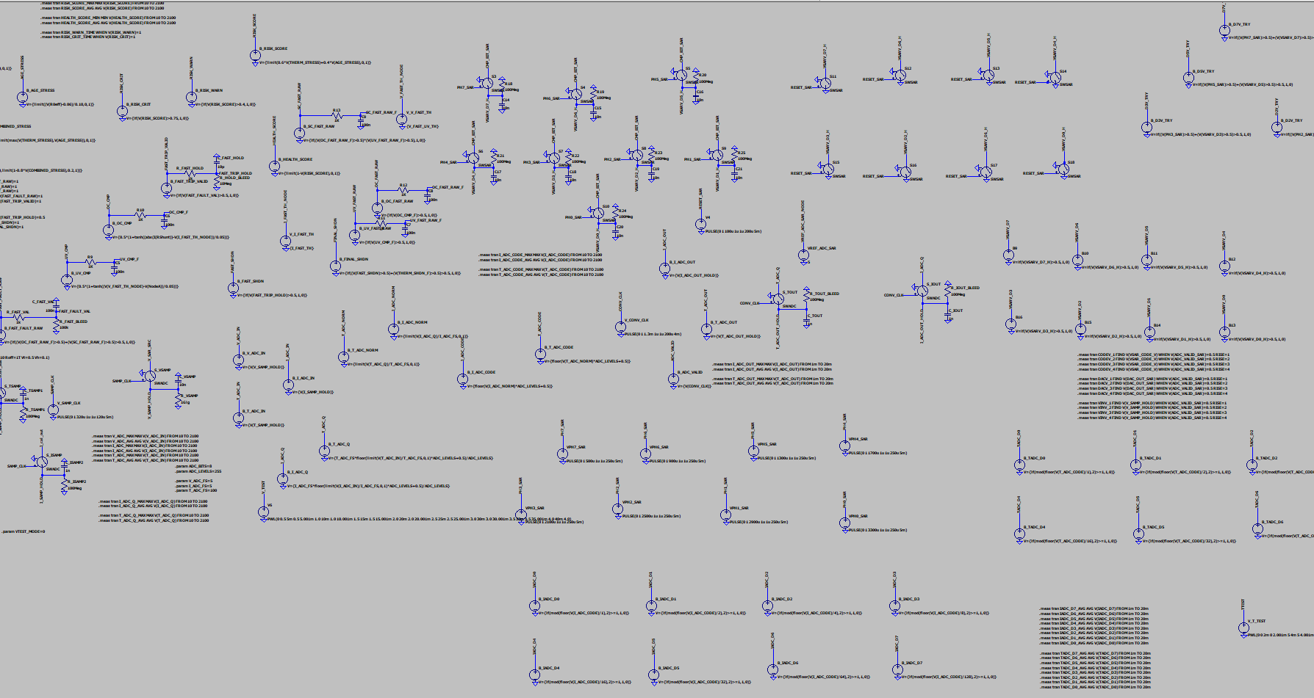
Figure 4.2: ADC/SAR and sampled-interface region of the LTspice implementation.
4.3 Why This Architecture Is Different
The architecture is not limited to alarm generation. It creates a complete chain: sensing -> calibration -> digitization -> estimation -> policy -> derating -> shutdown. This is important because EV battery protection must be both preventive and reactive. A preventive layer reduces current when stress increases.
Chapter 7
LTspice Circuit Implementation
5.1 Battery Electrical Model
The LTspice implementation uses a first-order battery equivalent circuit model. The model includes a voltage source, ohmic resistance R0, a polarization branch, and a current shunt. This representation is appropriate for front-end diagnostics because it captures both immediate voltage drop due to internal resistance and slower transient behavior due to electrochemical polarization.
V_cell = OCV - I R0 - V_RC
tau = R1 C1
The shunt current is used as the main electrical stress signal. A current command profile drives the system through different operating cases, including baseline operation, thermal stress, runaway stress, aged cell operation, and fast fault conditions.
5.2 Electro-Thermal Heat Model
The thermal section computes heat generation and temperature rise using a core-surface thermal network. The project separates heat into irreversible heat, reversible heat, and reaction heat. This separation is important because Joule heating dominates normal high-current operation, while reaction heat becomes important near runaway conditions.
Q_gen = Q_irr + Q_rev + Q_rxn
Q_irr = I^2 (R0_eff + eta R1_heat)
The thermal model uses a core node and a surface node connected through thermal resistance. This allows the design to monitor both absolute cell temperature and internal thermal gradient. The gradient is used as a precursor feature because internal heat accumulation can precede visible surface temperature rise.
5.3 Protection Logic Implementation
Behavioral sources implement warning, derating, shutdown, and system-state logic. The implementation includes T_WARN, DT_WARN, TABS_WARN, T_CRIT, DT_CRIT, and TABS_CRIT filtered signals. The signals are fused to generate RUNAWAY_PRECURSOR, CHG_LIMIT, THERM_SHDN, SYS_DERATE, SYS_SHDN, and FINAL_SHDN. RC filters are used to avoid switching on numerical noise and to model validation delay.
5.4 Measurement and Sensor Trust
The design contains voltage and current range checks, reference fault checks, and sensor fault logic. MEAS_TRUST_OK gates the final current command scale. This is important because protection decisions should not be based on invalid measurements. If a sensor path becomes unreliable, the system can reduce or block current command execution.

Chapter 8
Adaptive Calibration Subsystem
6.1 Objective
The objective of the calibration subsystem is to reduce measurement error caused by sensor offset and reference drift. In an EV battery front-end, small errors in voltage and current measurement can lead to wrong decisions, especially when estimating internal resistance or detecting under-voltage and over-current conditions.
6.2 Problem Solved
Without calibration, the front-end may confuse offset drift with real battery behavior. This can produce false aging estimates, incorrect derating, or missed protection events. The calibration subsystem solves this by periodically switching the measurement path to a known reference and storing the correction.
6.3 Circuit Approach
The LTspice implementation uses REF_MODE and MEAS_MODE control signals. During measurement mode, the sensed battery voltage passes through the normal path. During reference mode, a known reference voltage is injected into the calibration path. The difference between the observed value and reference is treated as calibration error. The correction is held and used to produce a corrected output.
• V_mux_in switches between sensed battery voltage and calibration reference.
• V_cal_err_raw captures the instantaneous reference error.
• V_cal_hold stores the correction during calibration windows.
• V_cal_out represents the corrected measurement output.
• VCAL_VALID and ICAL_VALID represent calibration validity decisions.
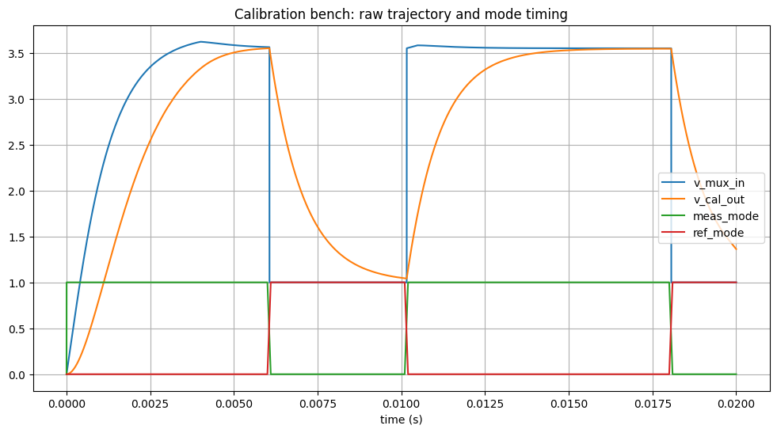
Figure 6.1: Calibration bench trajectory showing REF/MEAS switching and corrected output response.
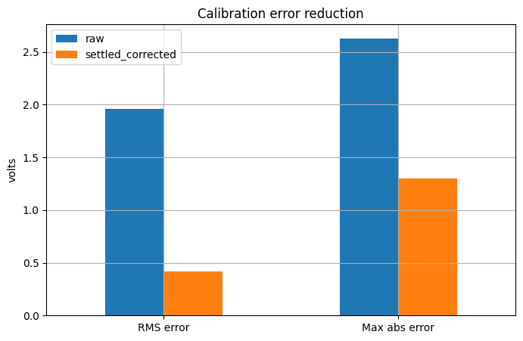
Figure 6.2: Calibration error reduction comparing raw and settled-corrected measurement error.
6.4 Quantitative Result
Table 6.1: Calibration performance metrics.
Metric | Value | Meaning
Raw error RMS | 1.957 V | Uncorrected reference-path error before calibration
Settled corrected RMS | 0.419 V | Residual error after correction settles
RMS improvement | 78.6% | Reduction in measurement error after calibration
Raw max absolute error | 2.629 V | Worst observed uncorrected error
Settled max absolute error | 1.301 V | Worst corrected error after settling

6.5 Significance
The calibration result shows that the project does not simply assume ideal sensing. It models a measurement error source and demonstrates that the analog front-end can reduce error through reference-based correction. This is a key step toward a practical battery diagnostics IC, where offset and drift cannot be ignored.

Chapter 9
ADC and SAR Monitoring Subsystem
7.1 Objective
The objective of the ADC subsystem is to bridge the analog diagnostic front-end with digital battery management logic. A real BMS requires digitized voltage, current, and temperature values. Therefore, this project includes sample-and-hold networks, quantization blocks, binary code generation, and a SAR-like voltage conversion path.
7.2 Sample-and-Hold and Quantization
The sample-and-hold section captures voltage, current, and temperature signals using sampling switches and hold capacitors. Quantization is modeled using behavioral sources that scale the input to an 8-bit code range. The code is then decomposed into individual bit outputs. This validates how analog measurements can be prepared for a digital controller.
Code = floor( limit(V_in / V_FS, 0, 1) * 255 + 0.5 )
7.3 SAR-Like Voltage Conversion
The SAR subsystem uses phased bit decisions and a DAC reconstruction path. During each bit trial, a tentative DAC voltage is formed and compared with the sampled input. The comparator output updates the stored bit value. This subsystem is implemented as a supporting mixed-signal demonstration rather than as a full transistor-level ADC.
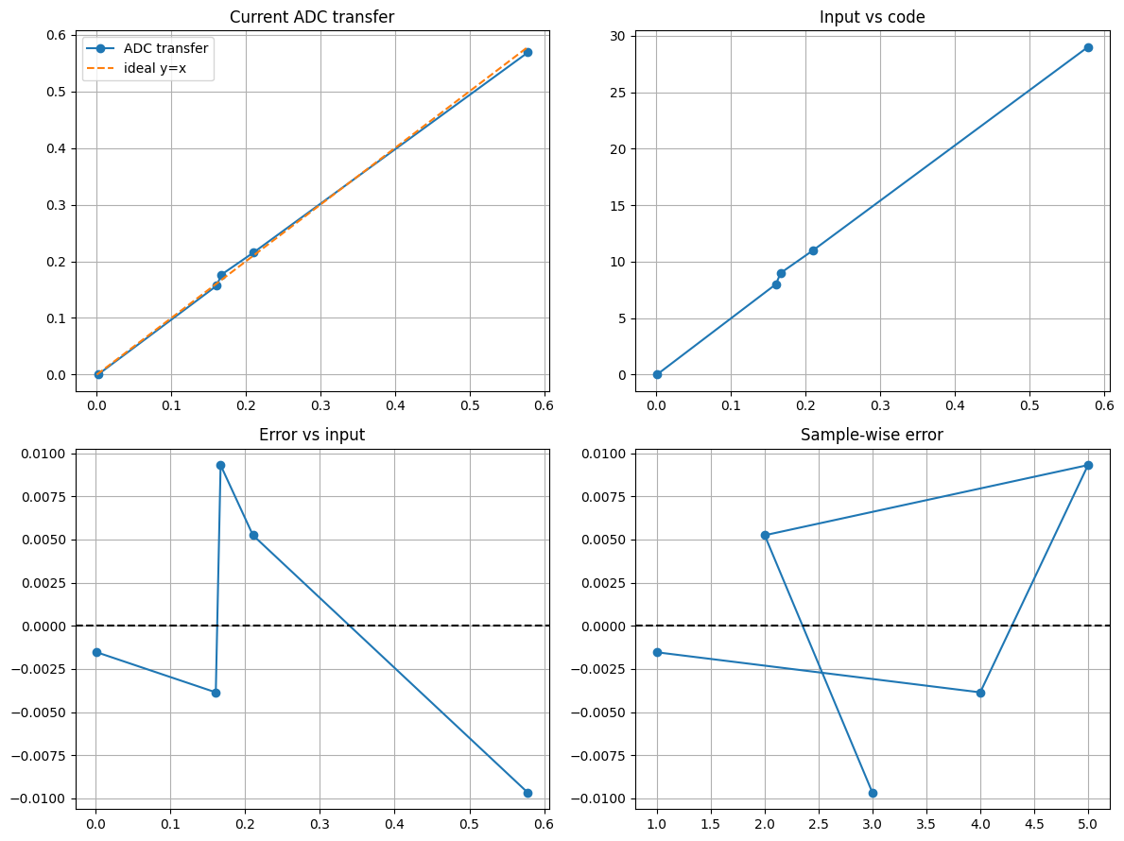
Figure 7.1: Current ADC transfer behavior, input-code relation, and sample-wise quantization error.
7.4 ADC Result Interpretation
The ADC plots show that the current channel follows the ideal transfer trend with small quantization and reconstruction error. Temperature ADC tests were also explored, but the final report emphasizes the current and voltage/SAR paths because they are more directly connected to protection decisions. The ADC layer proves that the design can be extended from purely analog protection to sampled supervisory control.
7.5 Significance
Including ADC and SAR support makes the project a mixed-signal front-end rather than only an analog comparator network. This improves the final system story: the analog layer senses and protects, while the digitized signals enable future microcontroller, FPGA, or ASIC implementation.

Chapter 10
RLS-Based Internal Resistance Estimation
8.1 Objective
The objective of the RLS subsystem is to estimate internal resistance online from voltage and current behavior. Internal resistance is a key aging indicator. A degraded battery exhibits larger voltage drop and greater heat generation under the same current. Therefore, estimating R0 helps connect diagnostics with protection policy.
8.2 Why RLS Was Used
A simple pulse method estimates R0 using Delta V / Delta I. This is useful for static tests but becomes less reliable during dynamic current profiles because the voltage response also contains RC polarization and noise. Recursive Least Squares updates parameters over time, allowing the estimator to adapt as new voltage-current samples arrive.
theta_k = theta_{k-1} + K_k ( y_k - phi_k^T theta_{k-1} )
K_k = P_{k-1} phi_k / ( lambda + phi_k^T P_{k-1} phi_k )
Here, theta represents the estimated parameter vector, phi is the regression vector, y is the measured output, P is the covariance matrix, and lambda is the forgetting factor. The estimator was implemented in Python using exported LTspice signals.
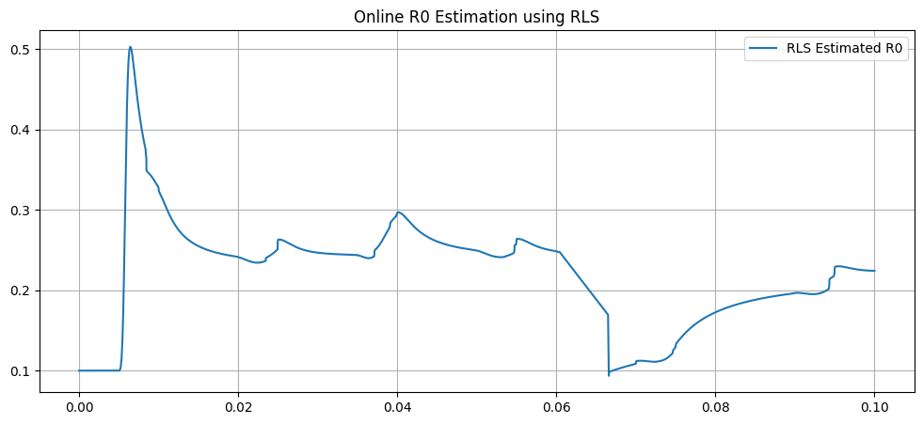
Figure 8.1: Online R0 estimation using Recursive Least Squares.
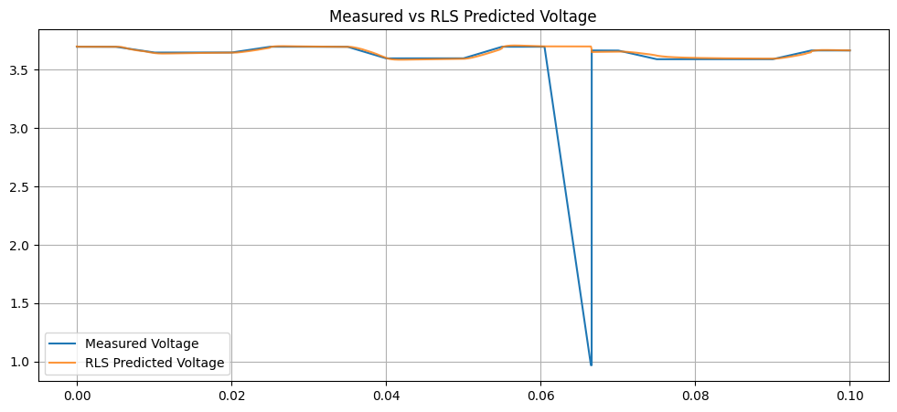
Figure 8.2: Measured voltage compared with RLS-predicted voltage.
8.3 Connection with Aging-Aware Protection
The estimated internal resistance supports the aging-aware policy. As R0 increases, the allowed current should reduce because the same current produces greater heat. In the LTspice design, R0eff is directly used to compute age stress and health score. The Python RLS analysis provides an algorithmic path for estimating this quantity from measured signals in a practical BMS.
8.4 Significance
This block gives the project a diagnostic intelligence layer. The system does not only react to present temperature or current; it can also infer degradation and use that information to modify current policy. This is one of the strongest advanced features of the project.
Chapter 11
Electro-Thermal Protection and Fast Derating
9.1 Objective
The objective of the electro-thermal protection layer is to reduce current before the battery reaches a severe thermal state. A threshold-only design waits for absolute temperature to exceed a limit. The proposed design uses thermal stress, dT/dt, and charge-limit scaling to reduce current earlier.
9.2 Thermal Stress and Current Scaling
Thermal stress is computed as a normalized variable based on cell temperature. Age stress is computed from R0eff. The combined stress is used to produce an advanced current scale. The final current command is selected from charge-limit scale, age scale, and advanced stress scale while also respecting measurement trust.
THERM_STRESS = limit((Tcell_abs - 35) / 20, 0, 1)
RISK_SCORE = limit(0.6 THERM_STRESS + 0.4 AGE_STRESS, 0, 1)
HEALTH_SCORE = limit(1 - RISK_SCORE, 0, 1)
9.3 Case 2: Thermal Derating
Case 2 represents thermal stress with degraded cooling conditions but without immediate runaway. The system detects rising thermal stress and applies current derating rather than forcing immediate shutdown. This is important because EV systems should avoid unnecessary pack disconnection when controlled derating is sufficient.
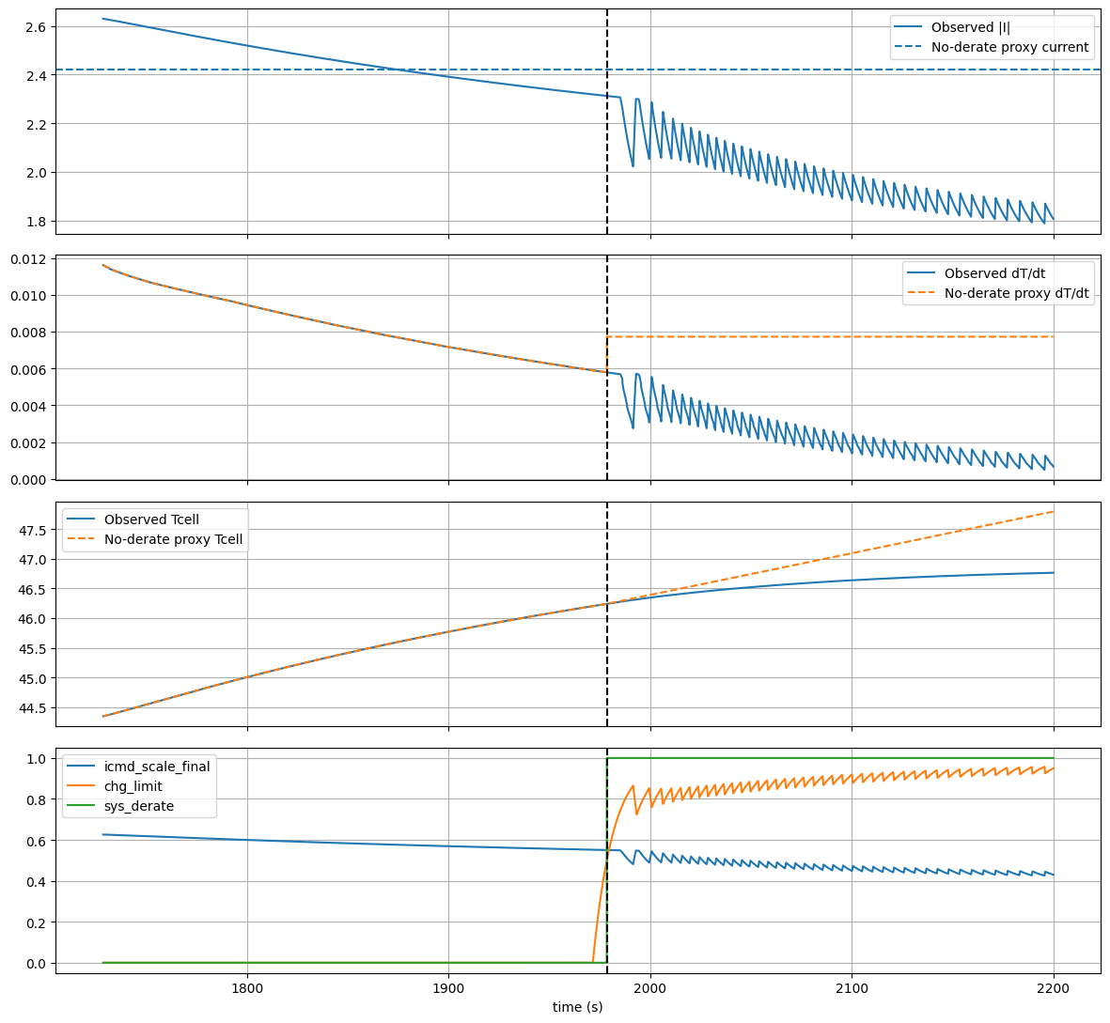
Figure 9.1: Case 2 thermal derating showing current reduction, dT/dt moderation, and no-derate comparison.
9.4 Quantitative Result
Table 9.1: Thermal derating quantitative results.
Parameter | Observed Result | Engineering Meaning
Warning window | 179.14 s | Time available before derating action
Current reduction | 17.48% | Reduction in current command after derating
I^2 thermal drive reduction | 31.75% | Reduction in Joule-heating driver
dT/dt reduction | 67.07% | Strong suppression of thermal acceleration
Temperature rise benefit | 64.00% | Lower temperature growth vs no-derate proxy

9.5 Significance
The thermal derating result proves that the controller does not wait passively for shutdown. It uses an intermediate operating state that lowers stress while maintaining operation. This is closer to real EV safety behavior where power derating is preferred before hard isolation.

Chapter 12
Aging-Aware Policy and Health Scoring
10.1 Objective
The objective of the aging-aware policy is to adapt allowable current based on battery health. A fixed current limit is unsafe because a degraded battery has higher internal resistance and generates more heat under the same current. The design therefore uses R0eff, age stress, risk score, and health score to govern charging current.
10.2 R0eff and Age Stress
R0eff is modeled as a function of base resistance, temperature, SOC, and aging factor. The age stress variable maps R0eff into a normalized degradation score. Severe aging triggers stronger current limitation than mild aging.
R0_eff = R0_base (1 + temperature term + SOC term + aging term)
AGE_STRESS = limit((R0_eff - 0.06) / 0.10, 0, 1)
10.3 Case 4 vs Case 7
Case 4 represents aging warning, while Case 5 represents severe aging. The policy keeps current less restricted in the warning case and significantly reduces current in the severe-aging case. This shows that the controller changes behavior based on battery health rather than using a constant current rule.
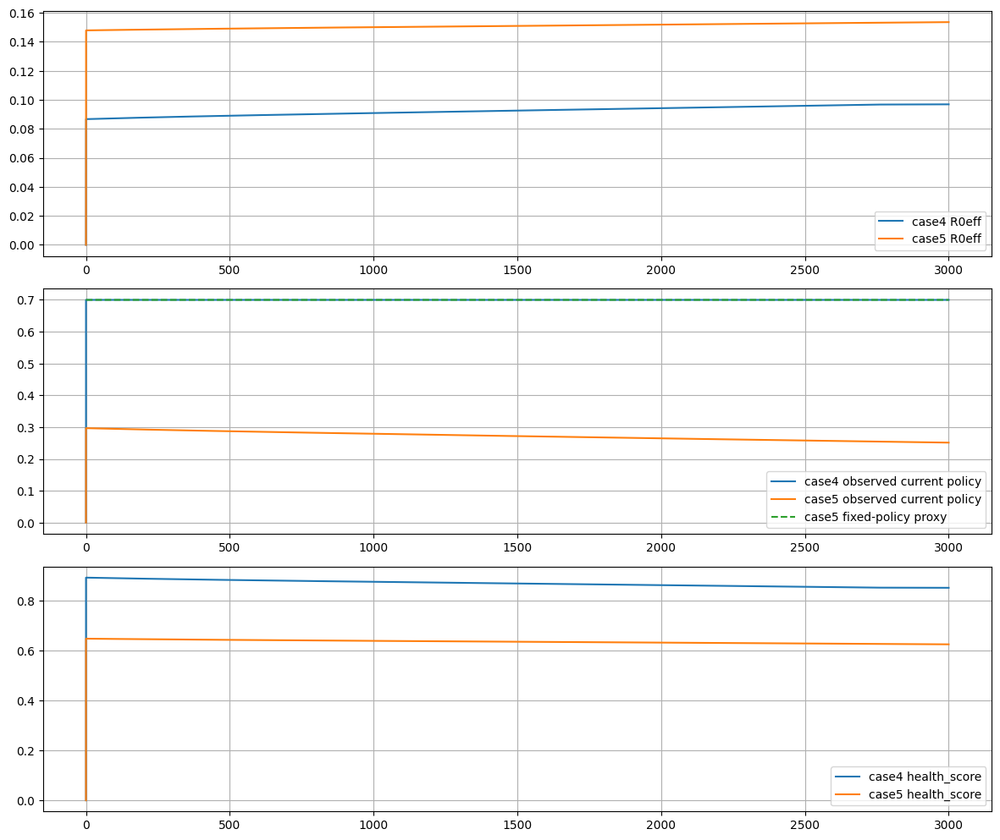
Figure 10.1: Aging-aware policy comparison between Case 4 and Case 5.
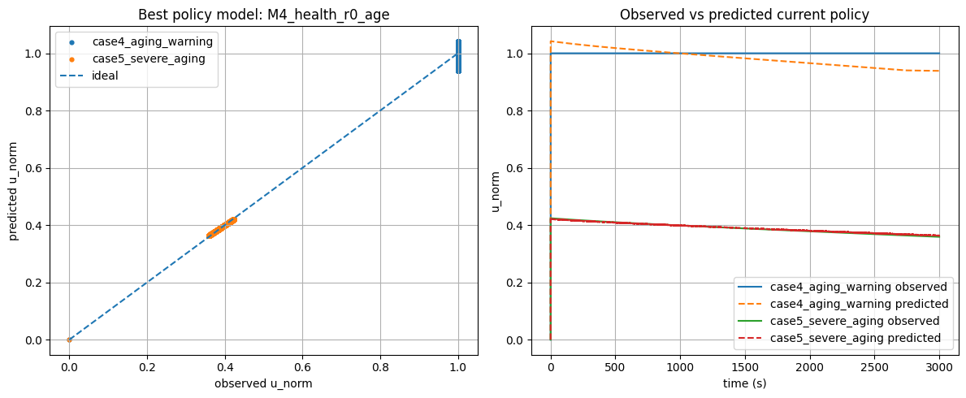
Figure 10.2: Observed versus predicted current policy using health and resistance features.

Table 10.1: Aging-aware policy comparison for Case 4 and Case 5.
Metric | Case 4: Aging Warning | Case 5: Severe Aging | Interpretation
R0eff avg | 0.091 ohm | 0.151 ohm | Higher internal resistance in severe aging
Health score min | 0.852 | 0.626 | Health decreases with aging
Minimum current scale | 0.700 | 0.251 | Severe aging receives stronger derating
Policy model R2 | 0.995 | 0.995 | Current policy is strongly explainable by health/R0/age features

10.4 Significance
This subsystem solves a real limitation of conventional protection: fixed thresholds ignore degradation. By linking internal resistance and health score to current policy, the architecture becomes adaptive over battery life. This improves safety and also provides a more realistic final-year project story because it connects diagnostic estimation with control action.

Chapter 13
Fast Fault Protection Layer
11.1 Objective
The fast fault layer is designed for events that cannot wait for thermal detection. Short-circuit and over-current faults require a response in milliseconds. Thermal models are too slow for such events, so the project implements a separate electrical fault path.
11.2 Circuit Approach
The fast-fault path uses over-current and under-voltage comparators. Filtered versions of these raw signals are fused to generate short-circuit and fast fault indicators. RC validation rejects narrow spikes, while a hold capacitor keeps the shutdown command active long enough for system response.
• OC_CMP and UV_CMP create analog comparator outputs.
• OC_FAST_RAW and UV_FAST_RAW create digital fault states.
• SC_FAST_RAW detects combined over-current and under-voltage signature.
• FAST_FAULT_RAW is validated by an RC network.
• FAST_TRIP_VALID and FAST_TRIP_HOLD create robust shutdown behavior.
• FINAL_SHDN combines fast electrical shutdown with thermal shutdown.
FINAL_SHDN = FAST_SHDN OR THERM_SHDN_F
11.3 Case 6 Result
Case 6 validates the fast electrical fault response. The observed fault-to-shutdown time is approximately 7.0 ms, which satisfies a 10 ms design target and leaves nearly 3 ms margin.
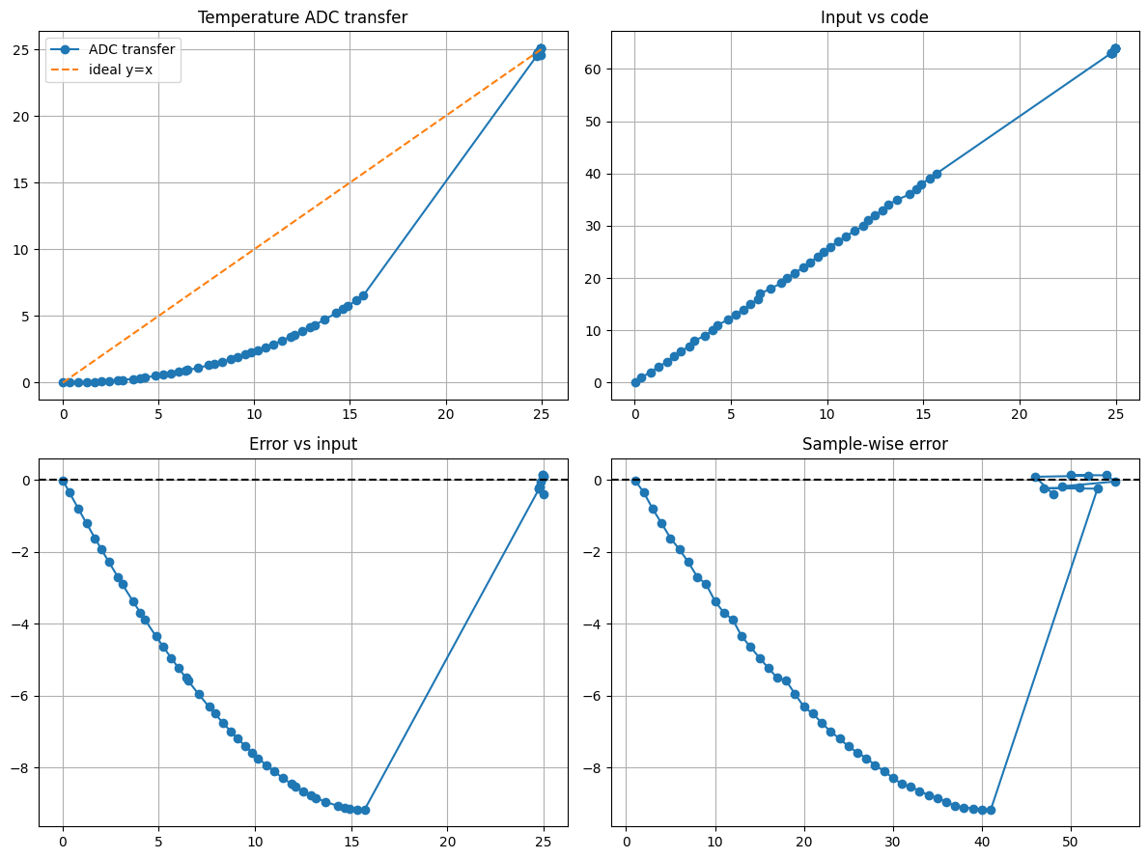
Figure 11.1: Case 6 fast-fault latency compared with the 10 ms design requirement.
Table 11.1: Fast-fault timing and latency results.
Signal / Metric | Value | Meaning
t_fast_fault | 0.005139 s | Fast fault detection time
t_fast_shdn | 0.012141 s | Fast shutdown assertion time
t_sys_fault | 0.012141 s | System fault assertion time
Fault-to-shutdown latency | 7.001 ms | Measured response delay
Requirement | 10 ms | Target design limit
Margin | 2.998 ms | Timing safety margin

11.4 Significance
This result proves that the design is multi-timescale. Slow thermal derating protects against gradual heat rise, while fast fault logic handles electrical hazards. Combining both into FINAL_SHDN makes the system more complete and defensible.

Chapter 14
Multi-Case Validation and Results
12.1 Validation Philosophy
The project is validated using multiple cases instead of a single waveform. Each case is designed to test a different subsystem. Case 1 verifies normal behavior. Case 2 tests thermal derating. Case 3 tests runaway prevention. Case 4 tests mild aging. Case 5 tests severe aging. Case 6 tests fast electrical fault response.
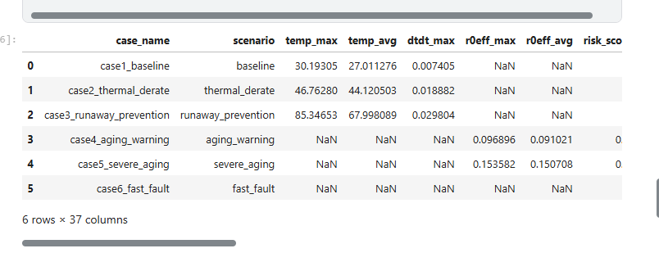
Figure 12.1: Case-wise summary table generated from Python post-processing.
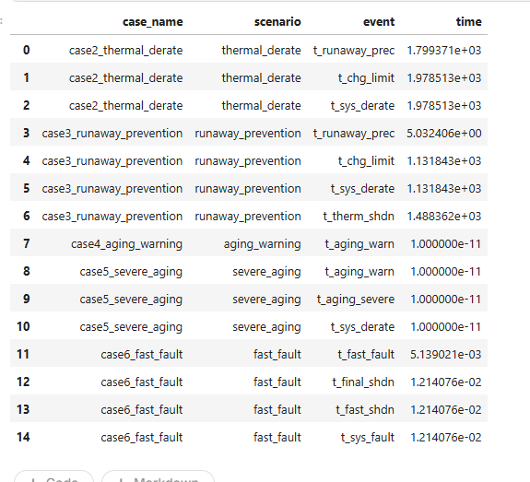
Figure 12.2: Event timeline table showing key protection and fault events.
12.2 Case Definitions
Table 12.1: Validation case definitions.
Case | Scenario | Main Objective | Expected Behavior
Case 1 | Baseline | Verify no false trip | Stable temperature and current policy
Case 2 | Thermal derating | Prove controlled current reduction | Current scale reduces; dT/dt falls
Case 3 | Runaway prevention | Prove early precursor and shutdown window | Warning, derate, then shutdown
Case 4 | Aging warning | Mild health-based derating | Current allowed around 0.7
Case 5 | Severe aging | Strong health-based derating | Current allowed near 0.25
Case 6 | Fast fault | Validate ms-level fault handling | Shutdown within 10 ms

12.3 Case 3: Runaway Prevention
Case 3 is the most important thermal safety case. The precursor is generated long before final shutdown. The system creates a safety window in which it can derate and then isolate the battery if the hazard continues. This demonstrates anticipatory protection instead of late alarm behavior.
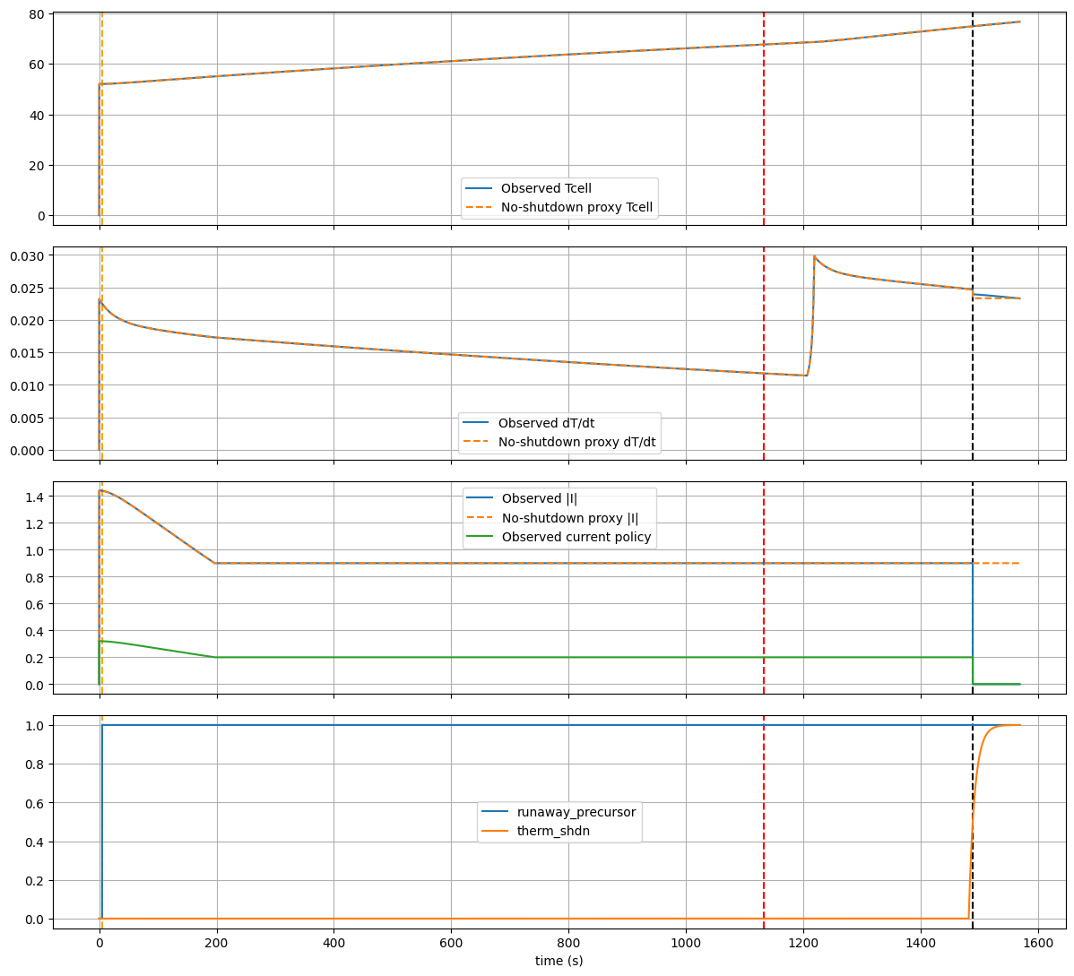
Figure 12.3: Case 3 runaway-prevention timeline and no-shutdown proxy comparison.

Table 12.2: Runaway-prevention phase durations.
Phase | Duration | Meaning
Precursor to derate | 1126.81 s | Long early-warning and monitoring interval
Derate to shutdown | 356.52 s | Intervention period before final isolation
Shutdown entry window | 50.00 s | Final shutdown activation window
Total safety window | 1483.33 s | Time between precursor and shutdown

12.4 Comparative Result Dashboard
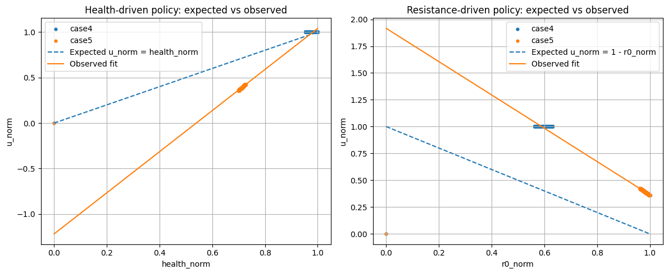
Figure 12.4: Comparative dashboard of protection windows, derating benefit, current policy, and fast-fault latency.
The dashboard summarizes the engineering contribution of the project. It shows that each protection case serves a different purpose: thermal derating reduces thermal drive, runaway prevention creates a safety window, aging policy reduces allowable current based on health, and fast fault protection operates in milliseconds.

12.5 What Each Feature Solves
Table 12.3: Feature-to-objective validation summary.
Feature | Objective | Problem Solved | Advanced Method | Result / Significance
Adaptive calibration | Improve measurement accuracy | Sensor offset and drift | REF/MEAS switching and correction hold | 78.6% RMS error reduction
Thermal derating | Avoid late-only shutdown | Rising heat during stress | dT/dt and stress-based scaling | 67% reduction in dT/dt
Runaway prevention | Create early safety window | Threshold systems react late | Precursor + derate + shutdown | 1483 s total safety window
Aging policy | Adapt to degradation | Fixed current ignores R0 rise | Health/R0/age model | Severe current scale near 0.251
Fast fault | React to short-circuit quickly | Thermal path too slow | OC/UV fusion + RC hold | 7 ms shutdown
ADC/SAR | Digitize AFE signals | Digital BMS needs sampled data | S/H, quantization, SAR DAC | Mixed-signal readiness
RLS estimation | Track internal resistance | Pulse method is limited | Recursive Least Squares | Online R0 diagnostic signal

Chapter 15
Engineering Significance and Future Scope
13.1 Engineering Significance
The strongest aspect of the project is not any single block but the integration of multiple safety and diagnostic layers. The front-end does not only sense signals; it validates them, calibrates them, digitizes them, estimates degradation, computes risk, and drives protection decisions. This makes the architecture closer to a real battery intelligence system.
13.2 Comparison with Simple Threshold Protection
Table 13.1: Comparison between conventional threshold BMS and proposed architecture.
Conventional Threshold BMS | Proposed Architecture
Acts only after fixed voltage/current/temperature limit is crossed | Uses warning, derating, precursor, and shutdown stages
Usually ignores measurement offset | Includes reference-based adaptive calibration
Often uses fixed current limits | Adapts current using R0eff, age stress, risk score, and health score
Thermal and electrical faults may share slow protection path | Uses separate millisecond fast-fault path
Limited analytics after simulation | Uses Python validation with case metrics and policy fitting
May not include digital interface validation | Includes ADC/SAR monitoring support

13.3 Limitations
The project is simulation-validated. It does not claim silicon implementation or hardware pack testing. Some blocks use behavioral sources to represent analog and mixed-signal behavior. The ADC and SAR blocks are functional mixed-signal demonstrations rather than transistor-level converter layouts. Thermal parameters are selected for scenario validation and would need tuning using real cell data for deployment.

13.4 Future Scope
• Replace behavioral comparators with transistor-level comparator and latch circuits.
• Implement the ADC/SAR subsystem using a full capacitor DAC and real SAR logic.
• Validate the model using real cell pulse-test data and thermal chamber measurements.
• Add cell balancing and multi-cell pack monitoring.
• Implement the supervisory logic on FPGA or microcontroller.
• Move the analog front-end toward ASIC-level design using Cadence or an equivalent EDA flow.
• Integrate SOC/SOH estimation using Kalman filtering or machine-learning-assisted parameter tracking.
• Add hardware-in-the-loop testing with real sensors and controlled battery load profiles.
13.5 Resume and Viva Positioning
This project can be positioned as a hierarchical EV battery safety and diagnostics platform. The core phrase is: self-calibrated mixed-signal battery front-end with predictive thermal safety, aging-aware current policy, and sub-10 ms fast-fault shutdown. In viva, the most important points to emphasize are the layered time-scale design, the reason for derating before shutdown, the use of internal resistance for aging, and the role of calibration before estimation.

Chapter 14: Conclusion
This project successfully demonstrates a simulation-validated intelligent analog front-end for EV battery diagnostics and protection. The system combines sensing, calibration, ADC support, electro-thermal modeling, RLS-based internal resistance estimation, aging-aware current governance, fast derating, runaway precursor detection, and fast fault shutdown. The work shows that battery protection should not be limited to simple threshold-based cutoff. A practical EV battery system must respond differently to slow thermal stress, long-term aging, and millisecond electrical faults.
Case-wise validation confirms that the baseline case remains stable, the thermal derating case reduces current and suppresses dT/dt, the runaway-prevention case creates a long warning and intervention window, the aging cases adjust current according to degradation, and the fast-fault case achieves approximately 7 ms shutdown against a 10 ms target. The calibration subsystem reduces measurement error, while ADC/SAR and RLS blocks make the architecture suitable for future mixed-signal and embedded BMS integration.
Overall, the project establishes a complete hierarchical battery intelligence framework. It is not only a thermal protection circuit but a multi-layer EV battery safety stack that combines analog front-end design with predictive diagnostics and quantitative validation.

REFERENCES
[1] M. Chen and G. A. Rincon-Mora, "Accurate electrical battery model capable of predicting runtime and I-V performance," IEEE Transactions on Energy Conversion, 2006.
[2] G. L. Plett, Battery Management Systems, Volume I: Battery Modeling. Artech House, 2015.
[3] G. L. Plett, Battery Management Systems, Volume II: Equivalent-Circuit Methods. Artech House, 2015.
[4] D. Linden and T. B. Reddy, Handbook of Batteries. McGraw-Hill, 2011.
[5] R. Xiong, Battery Management Algorithm for Electric Vehicles. Springer, 2020.
[6] LTspice 26.0.1 documentation and simulation environment, Analog Devices.
[7] S. Haykin, Adaptive Filter Theory. Pearson, 2014.
[8] B. Razavi, Design of Analog CMOS Integrated Circuits. McGraw-Hill, 2001.
[9] R. Jacob Baker, CMOS: Circuit Design, Layout, and Simulation. Wiley-IEEE Press, 2010.
[10] A. Jossen, "Fundamentals of battery dynamics," Journal of Power Sources, 2006.

Appendix A: Detailed Feature-to-Objective Mapping
This appendix summarizes how every major subsystem connects to a specific project objective. The purpose is to make clear that the system is not a collection of disconnected plots; every block exists to solve a defined engineering problem.
Table A.1: Detailed feature-to-objective mapping.
Subsystem | Objective Solved | Approach Used | Mentor-Level Significance
Voltage/current sensing | Acquire battery electrical response | ECM, shunt current, filtered sense nodes | Creates the analog basis for all protection and estimation decisions.
Adaptive calibration | Remove measurement drift/offset | Reference switching, error capture, correction hold | Improves trust in sensed signals before estimation or protection.
Electro-thermal model | Predict heating behavior | Core-surface thermal RC network with Qirr, Qrev, Qrxn | Captures slow thermal stress and internal heat acceleration.
Thermal derating | Avoid late shutdown | Stress-driven current scaling and charge limit | Shows controlled intervention instead of abrupt cutoff.
Runaway prevention | Detect early runaway signature | Precursor logic using dT/dt, Tcell and gradient | Provides long warning and intervention windows.
Aging policy | Adapt to degraded cell condition | R0eff, age stress, health score, current scale | Avoids unsafe fixed-current behavior for aged batteries.
Fast fault logic | Protect against short-circuit/over-current | Comparator fusion, RC validation, hold latch | Adds millisecond protection path independent of thermal response.
ADC/SAR layer | Prepare analog signals for digital BMS | S/H, quantization, bit extraction and SAR DAC | Makes the front-end mixed-signal and controller-ready.
RLS estimation | Estimate internal resistance online | Recursive Least Squares using voltage-current response | Connects diagnostics with aging-aware control policy.

Appendix B: Algorithmic Flow Used in the Protection Stack
B.1 Calibration Algorithm
Step 1: In measurement mode, route the battery sense voltage to the measurement path.
Step 2: In reference mode, route the known calibration reference into the same path.
Step 3: Compute raw error between reference and observed output.
Step 4: Store the correction on the hold path.
Step 5: Apply the correction during measurement mode.
Step 6: Use validity flags to decide whether the calibrated output is trusted.
B.2 Thermal Derating Algorithm
Step 1: Compute Tcell_abs, thermal gradient and filtered dT/dt.
Step 2: Evaluate warning and critical thresholds.
Step 3: Generate CHG_LIMIT when thermal stress crosses the derating region.
Step 4: Reduce ICMD_SCALE_FINAL using charge-limit and stress scaling.
Step 5: If critical thermal conditions persist, generate THERM_SHDN and FINAL_SHDN.
B.3 Aging Policy Algorithm
Step 1: Compute R0eff using the battery health model.
Step 2: Convert R0eff into AGE_STRESS.
Step 3: Generate AGING_WARN or AGING_SEVERE.
Step 4: Map the aging state to AGE_SCALE.
Step 5: Combine AGE_SCALE with thermal and trust limits to compute final allowable current. This prevents an aged cell from being charged as aggressively as a healthy cell.

B.4 Fast Fault Algorithm
Step 1: Compare current with fast over-current threshold.
Step 2: Compare voltage with fast under-voltage threshold.
Step 3: Fuse OC and UV information to detect short-circuit-like behavior.
Step 4: Pass the raw fault through an RC validation network.
Step 5: Store the fault through a hold node.
Step 6: Assert FAST_SHDN and combine it with thermal shutdown to create FINAL_SHDN.
• Fast layer response: milliseconds.
• Thermal derating response: seconds to minutes.
• Runaway precursor response: early warning and intervention window.
Appendix C: Case-by-Case Interpretation for Viva

C.1 Case 1 - Baseline
Case 1 proves that the architecture is not over-sensitive. The cell remains in a healthy operating region, thermal stress is low, and no shutdown event is produced. This is important because a protection system that trips during normal operation is not useful.
C.2 Case 2 - Thermal Derating
Case 2 is used to demonstrate controlled intervention. The current is reduced before thermal shutdown, and the dT/dt response decreases. The key defense point is that derating is a softer and more practical response than immediate shutdown.
C.3 Case 3 - Runaway Prevention
Case 3 is the strongest thermal safety case. It shows precursor detection, derating, and final shutdown. The long warning window demonstrates that the system has time to act before a severe event. This answers the mentor question: what is special compared with a normal temperature cutoff?
C.4 Case 4 and Case 5 - Aging Policy
Cases 4 and 5 prove that the system adapts with battery health. Case 4 has mild aging and therefore allows more current. Case 5 has severe aging and sharply restricts current. This is important because internal resistance directly affects heat generation.
C.5 Case 6 - Fast Fault
Case 6 validates that electrical faults are handled separately from thermal faults. A short-circuit cannot wait for cell temperature to rise. The observed shutdown latency of approximately 7 ms satisfies the 10 ms target and proves that the fast path is effective.

Figure C.1: Detailed thermal derating waveform used for Case 2 defense.

Figure C.2: Detailed runaway prevention waveform used for Case 3 defense.

Appendix D: Key LTspice Behavioral Blocks
The LTspice implementation uses behavioral sources to model system-level analog and mixed-signal behavior. These blocks make the design compact enough for simulation while still representing physical and logical relationships. The following descriptions summarize the key behavioral blocks used in the design.
Table D.1: Key LTspice behavioral blocks.
LTspice Block | Purpose | Explanation
B_R0EFF | Effective internal resistance | Models resistance variation with temperature, SOC and aging.
B_QIRR | Irreversible heat | Computes I^2R heat, the main heat source during high current.
B_QREV | Reversible heat | Models entropic contribution based on current, temperature and SOC.
B_QRXN | Reaction heat | Represents accelerated heat generation near runaway conditions.
B_PRECURSOR | Runaway precursor | Combines warning signals to detect early runaway tendency.
B_CHG_LIMIT | Charge limit | Triggers derating when thermal warnings accumulate.
B_ICMD_SCALE_FINAL | Final current scale | Combines thermal, aging and measurement-trust constraints.
B_FAST_FAULT_RAW | Fast electrical fault | Fuses over-current and short-circuit evidence.
B_FINAL_SHDN | Final shutdown | OR-combines thermal shutdown and fast shutdown.
B_MEAS_TRUST_OK | Measurement trust | Blocks unsafe operation if sensor path is invalid.

The design deliberately separates diagnostic variables from action variables. For example, R0eff and THERM_STRESS are diagnostic indicators, while ICMD_SCALE_FINAL and FINAL_SHDN are action outputs. This separation helps explain the project clearly during evaluation.

D.1 Representative Equations
Q_gen = Q_irr + Q_rev + Q_rxn
Q_irr = I^2 (R0_eff + eta R1heat)
THERM_STRESS = limit((Tcell_abs - 35) / 20, 0, 1)
AGE_STRESS = limit((R0_eff - 0.06) / 0.10, 0, 1)
RISK_SCORE = 0.6 THERM_STRESS + 0.4 AGE_STRESS
FINAL_SHDN = FAST_SHDN OR THERM_SHDN_F

Appendix E: Selected Figures for Final Demonstration
The following figures are the most useful for presentation and mentor discussion. They should be prioritized in the final PPT or project viva because they directly support the novelty claims of the project.

Figure E.1: Calibration timing and measurement/reference switching.

Figure E.2: Calibration error reduction summary.
Figure E.3: Aging policy model validation.

Figure E.4: RLS-based online internal resistance estimate.


