git hub repository - https://github.com/Chaante-lee/POE-wede5020

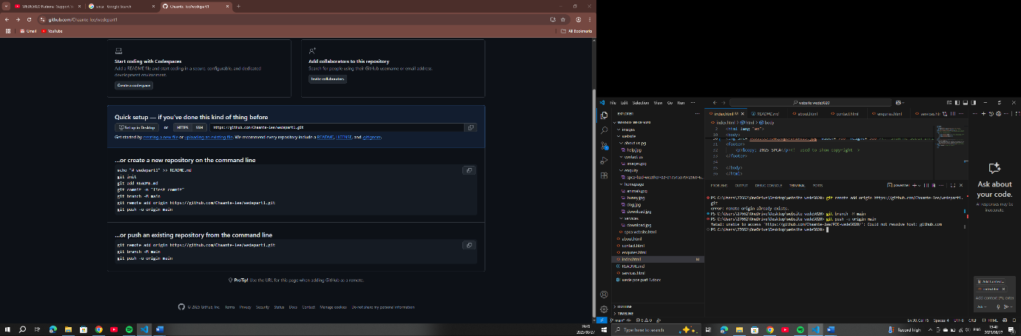

I tried to link it and it gave me this every time

Github acc- Chaante-lee

St10481788