FitBuddy – AI Fitness Plan Generator
Phase-wise documentation: a FastAPI web app that uses Google Gemini models to create personalized 7-day workout plans, nutrition tips, and feedback-based plan updates.
Tech stack: FastAPI · Gemini 1.5 Pro · Gemini Flash · SQLite + SQLAlchemy · Jinja2 · Uvicorn

1. Project overview
FitBuddy is a web application that uses Google Gemini models to create personalized fitness plans. It removes the need to hand-build routines: the user supplies a few details and receives a structured plan, a nutrition or recovery tip, and a way to refine the plan later.

Objectives
- Generate a 7-day workout plan from age, weight, goal (e.g. weight loss, muscle gain, general wellness) and intensity (low, medium, high).
- Give a short nutrition or recovery tip that matches the goal.
- Let users revise their plan with free-text feedback.
- Store users and plans so both the original and updated versions stay available.
- Give admins and coaches a dashboard of all users and plans.
- Offer both an interactive HTML interface and API endpoints (FastAPI docs at /docs).

Scenarios in detail
Scenario | Actor | Input | Outcome
1. Generate plan | User | Name, user ID, age, weight, goal, intensity | Day-by-day 7-day plan tailored to the goal, improving motivation and adherence.
2. Refine plan | User | User ID and feedback such as "more focus on cardio" or "include more rest days" | Plan regenerated from the original plus feedback; original kept.
3. Nutrition tip | User | Selected goal | Concise tip, e.g. "Include protein in your post-workout meal" for muscle gain.
4. Admin oversight | Admin or coach | Opens the dashboard | All users with original and updated plans, for tracking progress and activity.

Prerequisites
Skill or tool | Used for
Python | All backend code
FastAPI and Uvicorn | Web framework and ASGI server
Gemini API (Google Generative AI) | Plan and tip generation
HTML, CSS, Jinja2 | Templates and styling
SQLAlchemy and SQLite | Persistence
Git, pip/virtualenv/conda | Version control and environment management

Milestone map
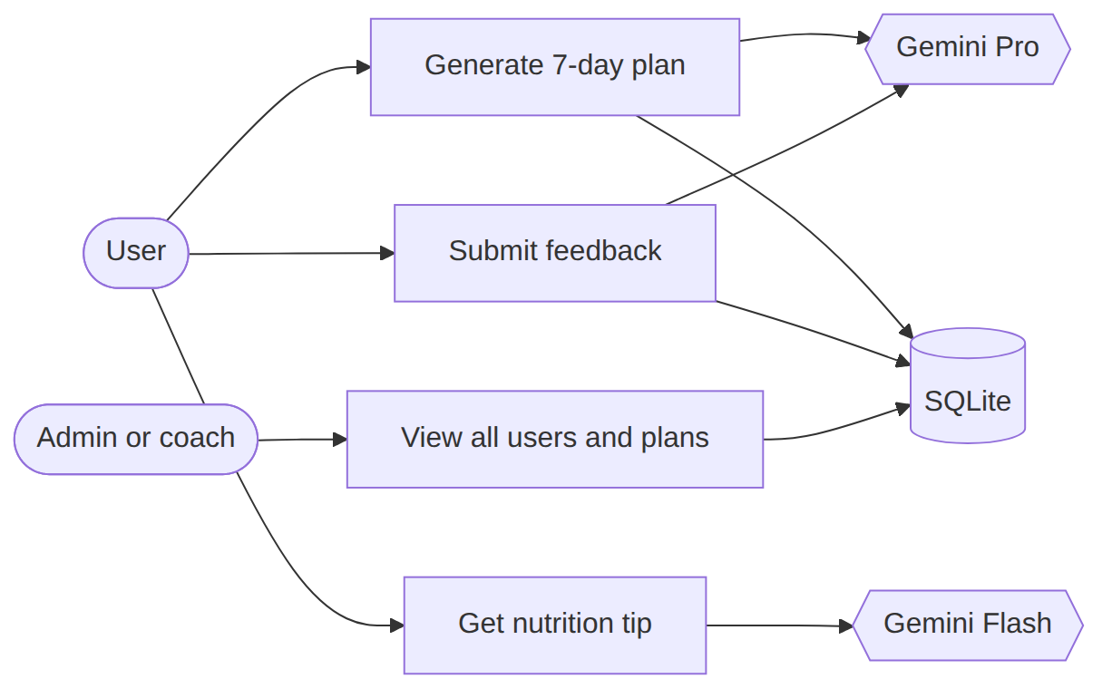
Figure 1: Who uses FitBuddy and what each action touches.
1 Model & architecture → 2 Core functions → 3 Routes → 4 Frontend → 5 Deployment
Phase 1

Model selection and architecture
Decide which generative models power the app, define how the parts fit together, and prepare the workspace.

1.1 Research and select the model
Requirements the model had to meet
- Produce structured 7-day workout plans.
- Produce concise, actionable nutrition tips.
- Update a plan from user feedback.
- Respond fast enough for real-time web use.
Options evaluated. Hugging Face models were tested first.
Model | Intended use | Finding
T5 and BART | Workout and nutrition text generation | Basic generation worked, but structured plans needed fine-tuning or complex prompting.
DistilBERT | Possible intent classification | Not a plan generator; limited relevance.
Bloom | General-purpose generation | Required Hugging Face hosting or a local GPU.
Decision. After comparative testing, Google Gemini models were chosen for production, split by task:
Model | Tasks | Why
Gemini 1.5 Pro | 7-day workout generation; plan updating from feedback | Rich, context-aware, reliably formatted output.
Gemini Flash | Nutrition and recovery tips | Lightweight and quick for short API calls.
Overall reasons for Gemini: API-based and simple to integrate with FastAPI; naturally understands structured formats (days, sections); accurate with minimal prompt tuning; scalable and fast for feedback revisions; no model hosting or GPU needed.

1.2 Define the architecture
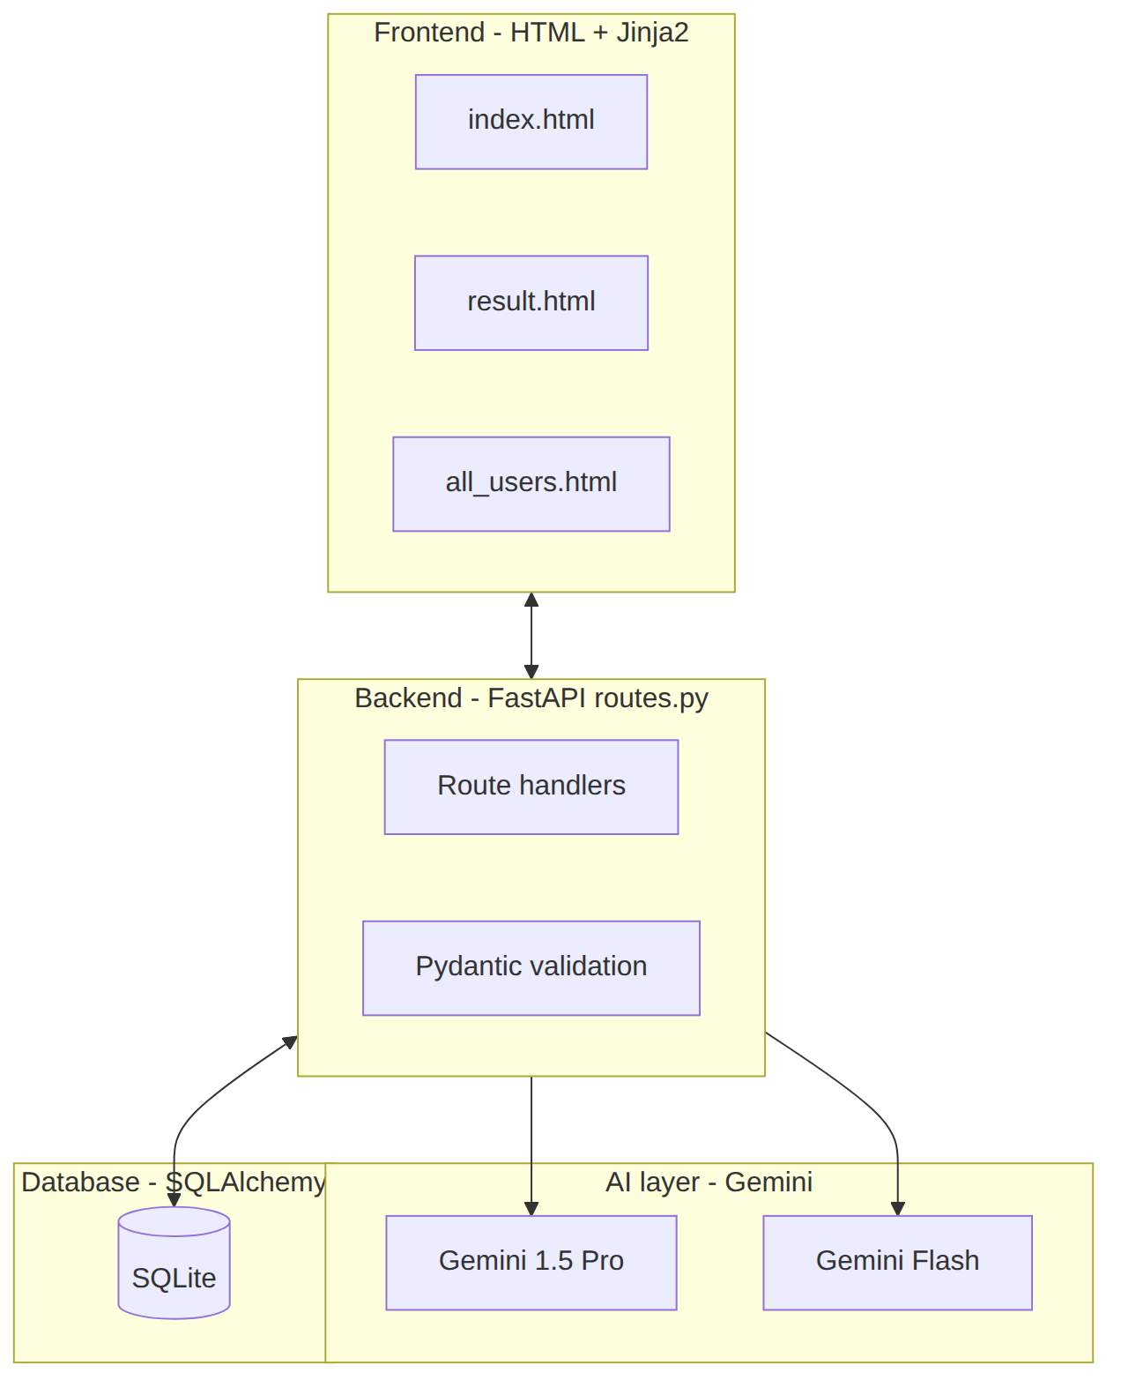
Figure 2: Layered architecture of FitBuddy.
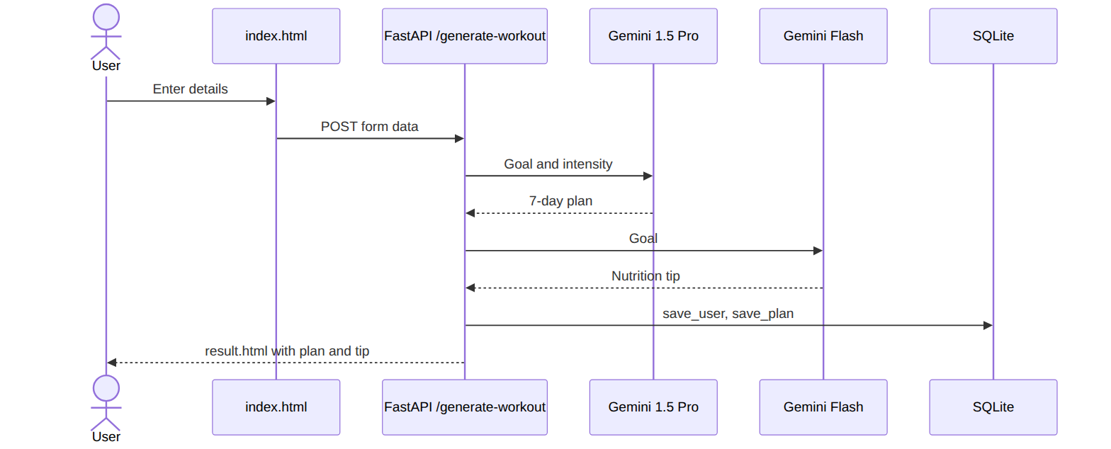
Figure 3: Sequence for generating a plan.
FitBuddy is modular, with four layers:
Layer | Technology | Responsibilities
Frontend | HTML + Jinja2 | index.html input form; result.html plan, tip, feedback; all_users.html admin panel.
Backend | FastAPI | Receive form data, call Gemini, store users and plans, render templates.
AI | Gemini Pro and Flash | Pro: workouts and updates. Flash: tips.
Database | SQLite + SQLAlchemy ORM | Persist user data and both plan versions.
Request flow (generate plan):
Form on index.html → POST /generate-workout → Gemini Pro (plan) → Gemini Flash (tip) → Save user + plan → result.html
Request flow (feedback):
Feedback form → POST /submit-feedback → Load original plan → Gemini Pro (revise) → Save updated plan → result.html

1.3 Set up the development environment
- Install Python and pip.
- Create and activate a virtual environment:
- python -m venv fitbuddy-env
fitbuddy-env\Scripts\activate # Windows
- Install libraries:
- pip install fastapi uvicorn jinja2 sqlalchemy python-multipart google-generativeai
- Create the project structure: /app (Python files), /templates (HTML), /static/images (assets).
- Run the server: uvicorn app.main:app --reload, then open http://127.0.0.1:8000 (app) and /docs (API testing).
Libraries and their roles
Package | Role
fastapi, uvicorn | API framework and server
jinja2 | Server-side HTML templating
sqlalchemy | ORM for SQLite
python-multipart | Parsing HTML form submissions
google-generativeai | Gemini SDK
Deliverables: justified model choice, defined architecture and flows, working environment with folder structure.
Phase 2

Core functionality development
Implement the AI functions, the database layer, and the backend input handling that the routes will call.

2.1 Workout plan generation
generate_workout_gemini() in gemini_generator.py
- Inputs: user details, especially goal (e.g. muscle gain, weight loss) and intensity (low, medium, high).
- Process: builds a prompt and sends it to Gemini 1.5 Pro.
- Output: a structured, day-wise 7-day plan where each day contains a warm-up (5–10 min), a main workout (exercises, sets, reps), and a cooldown or recovery tip.
- Hand-off: returned to routes.py and rendered in result.html inside <pre> blocks to keep formatting.

2.2 Nutrition tip generation
generate_nutrition_tip_with_flash() in gemini_flash_generator.py
- Uses Gemini Flash for a fast, concise tip based on the selected goal (hydration, protein, recovery).
- Displayed beneath the workout plan in result.html.

2.3 Feedback-based plan updating
update_workout_plan() in updated_plan.py
- Inputs: the original plan and the user's feedback (e.g. "Add yoga", "Include more cardio").
- Process: both are sent to Gemini 1.5 Pro, which returns a modified plan.
- Output: the updated plan is stored and shown with the new nutrition tip.

2.4 User and plan storage
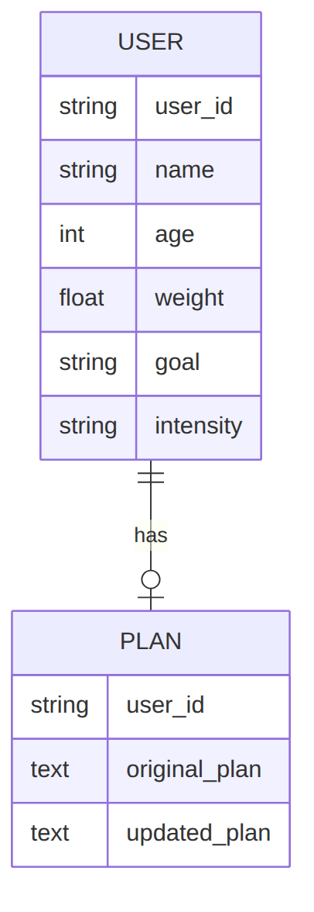
Figure 4: Stored data. The updated plan is a separate field, so both versions are kept.
database.py uses the SQLAlchemy ORM with SQLite.
Function | Purpose
save_user() | Store user ID, name, age, weight, goal, intensity
save_plan() | Store the AI-generated plan
update_plan() | Store the feedback-updated plan in a separate field
get_original_plan() | Fetch the original plan for revision
get_user() | Fetch a user record
get_all_users(), get_all_plans() | Feed the admin view (used in Phase 3)
Data stored
Field | Description
User ID, name | Identify the user; the ID is also used when submitting feedback
Age, weight (kg) | Personal details
Goal, intensity | Drive the AI prompt
Original plan | First AI-generated plan
Updated plan | Plan after feedback; kept separately so both versions remain

2.5 Admin view of all users
Route /view-all-users with template all_users.html loops over users with {% for user in users %} and shows original and updated plans in a structured table.

2.6 Implement the FastAPI backend
- Routing: all routes live in routes.py and call the functions above.
- Form input: index.html collects username, user_id, age, weight, goal, and intensity; FastAPI reads them with Form(...).
- Validation: Pydantic schemas UserInput and FeedbackRequest check structure.
- AI integration: /generate-workout calls the workout and tip functions; /submit-feedback retrieves the plan and calls update_workout_plan(). Responses are injected into templates.
Deliverables: three Gemini modules, database.py, Pydantic schemas, and form-handling logic.
Phase 3

Route development (routes.py)
routes.py is the operational core. It links templates, the Gemini modules, and the database, and defines how each input is collected, processed, and answered.

3.1 Routes at a glance
Route | Method | Purpose | Template
/ | GET | Show the user form | index.html
/generate-workout | POST | Create plan and tip | result.html
/submit-feedback | POST | Update plan from feedback | result.html
/view-all-users | GET | Admin dashboard | all_users.html

3.2 Route handlers step by step
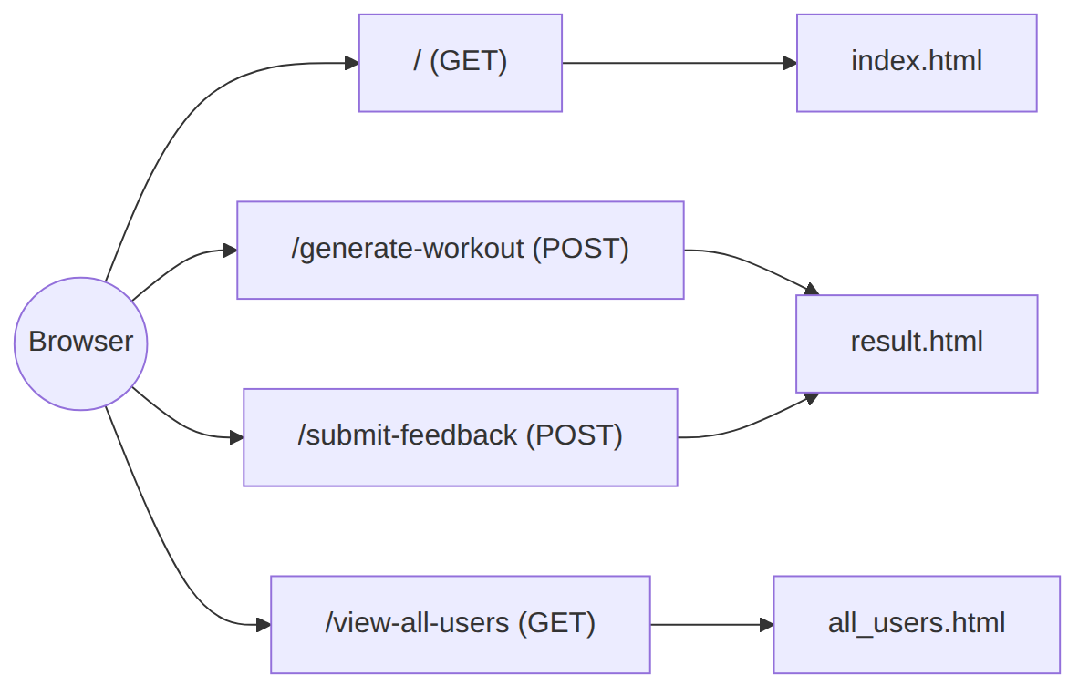
Figure 5: Routes and the templates they render.
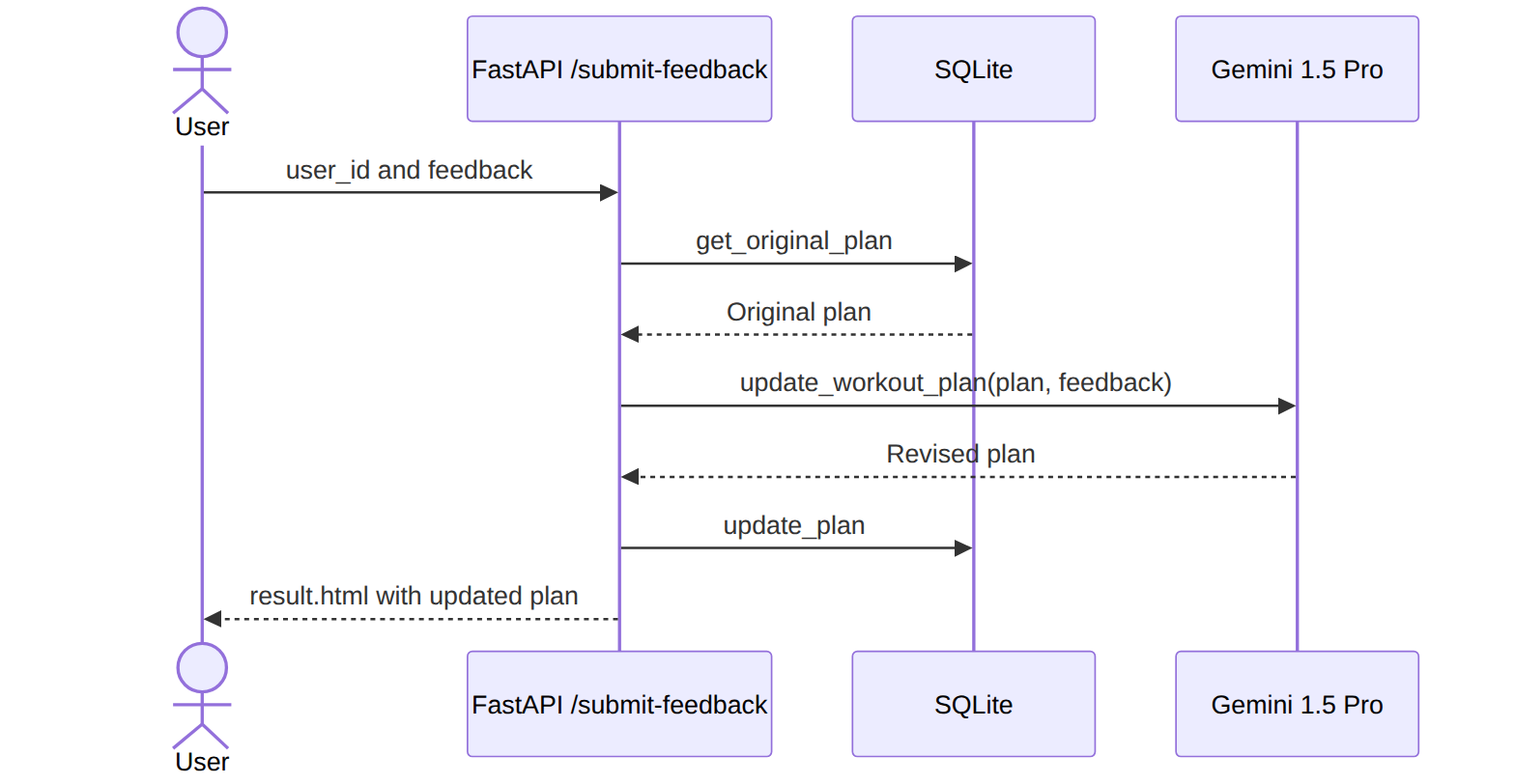
Figure 6: Sequence for feedback-based plan updates.
/ home route
- Returns index.html; no form processing logic.
/generate-workout plan generator
- Receive user input with Form(...).
- Build a UserInput Pydantic model.
- Call generate_workout_gemini() (Gemini 1.5 Pro) for the plan.
- Call generate_nutrition_tip_with_flash() (Gemini Flash) for the tip.
- Store the user with save_user() and the plan with save_plan().
- Return result.html with the dynamic data.
/submit-feedback update plan
- Capture the feedback text and user_id.
- Retrieve the original plan from the database.
- Call update_workout_plan() (Gemini 1.5 Pro) with plan and feedback.
- Save the revised plan with update_plan().
- Render the updated result in result.html.
/view-all-users admin view
- Call get_all_users() and get_all_plans().
- Pass the records to all_users.html.
- The admin sees username, age, weight, goal, intensity, and original and updated plans.

3.3 How Gemini is used in each route
Function | Model | Sends | Returns
generate_workout_gemini() | Gemini Pro | Goal and intensity | Structured 7-day plan
generate_nutrition_tip_with_flash() | Gemini Flash | Fitness goal | Practical tip
update_workout_plan() | Gemini Pro | Original plan + feedback | Revised plan
All responses reach the user through result.html, formatted in <pre> blocks for clarity. The source document also includes code screenshots for the workout route, nutrition tip route, save-user-and-plan route, and feedback route.
Deliverables: four working routes covering generation, tips, storage, feedback updates, and admin viewing.
Phase 4

Frontend development
Build a user-friendly, responsive interface where users can submit details, read plans, give feedback, and where admins can manage data.

4.1 Design and develop the interface
Base HTML structure
- index.html is the main entry point with a form for username, user_id, age, weight, goal, and intensity.
- Fields are labeled and grouped with semantic HTML.
- Gym-themed background image, Google Fonts (Roboto), and bold typography give a fitness feel.
- Navigation is minimal so the flow runs clearly from input to output.
Responsive layout with CSS
- CSS is embedded in each HTML file.
- Flexbox centers content vertically and horizontally.
- Media queries handle mobile screens.
- Buttons share styling with hover effects; inputs and result blocks have padding, shadows, and rounded corners.
- The color scheme keeps text readable on a dark background.
Pages
Template | Function
index.html | Input form for goal, intensity, and basic details
result.html | Shows the 7-day plan and nutrition tip; accepts feedback
all_users.html | Admin panel to view and delete users and review original and updated plans
Templates are modular and forms submit to FastAPI endpoints via POST.

4.2 Dynamic templates with Jinja2
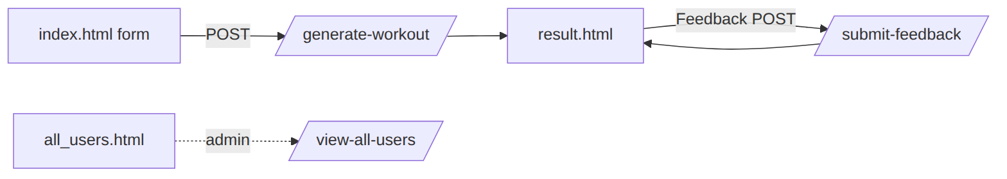
Figure 7: User journey across the three templates.
from fastapi.templating import Jinja2Templates
BASE_DIR = os.path.dirname(os.path.abspath(__file__))
TEMPLATE_DIR = os.path.join(BASE_DIR, "templates")
templates = Jinja2Templates(directory=TEMPLATE_DIR)
Each route returns TemplateResponse with a context dictionary, so plan and tip content appears right after form submission.
Template | Binding
index.html | Each name="..." matches a backend Form(...) parameter; submits to /generate-workout.
result.html | {{ username }}, {{ goal }}, {{ intensity }} for user data; {{ workout_plan }} and {{ nutrition_tip }} for AI output; a feedback form posts to /submit-feedback.
all_users.html | Loops over all user records to build the table.
Deliverables: three responsive, Jinja2-driven templates bound to backend data.
Phase 5

Deployment and testing
Run FitBuddy on a local server with Uvicorn, confirm every dependency works, and check each page. This prepares the app for future cloud deployment.

5.1 Prepare for local deployment
- Virtual environment and dependencies:
- python -m venv venv
source venv/bin/activate # Windows: venv\Scripts\activate
pip install -r requirements.txt
- requirements.txt includes FastAPI, Uvicorn, SQLAlchemy, and the Google Generative AI SDK.
- Environment variables: keep the Gemini API key out of source code, set in the terminal or a .env file loaded with python-dotenv:
- GOOGLE_API_KEY=your_gemini_api_key_here
- Rendering: all interaction runs through Jinja2 templates (index.html, result.html, all_users.html).

5.2 Test and verify
Figure 8: Local deployment steps.
Start the server with uvicorn main:app --reload. Open http://127.0.0.1:8000 for the app and http://127.0.0.1:8000/docs for interactive API docs.
Page-by-page walkthrough
Page | What it shows | Check
Home page | Centered form with Name, User ID, Age, Weight (kg), Fitness Goal (e.g. weight loss, flexibility), Workout Intensity (Low, Medium, High); "Generate Plan" button; active-person background image. | All fields render; button submits the form.
User information | Summary of name, user ID, age, weight, goal, and intensity. | Values match what was entered.
Workout plan | Day-wise plan with a focus per day (full body, upper or lower body, cardio, core, flexibility), exercises with sets, reps or duration, rest intervals, and warm-up and cool-down guidance. | Plan is goal-relevant, structured, and easy to follow.
Nutrition tip | Short advice, such as prioritizing protein in every meal (chicken, fish, beans, Greek yogurt) for muscle building, satiety, and metabolism. | Tip aligns with the goal.
Feedback page | User ID and feedback fields; the plan is adjusted and a confirmation message appears. | Updated plan reflects the feedback.
View all users | Every user's details, original plan, and updated plan if changed. | Both plan versions are visible per user.
End-to-end test checklist
- Submit the form for each goal and intensity and confirm a 7-day plan returns.
- Confirm a nutrition tip appears under each plan.
- Submit feedback (e.g. "more cardio") and confirm the plan changes and the original is kept.
- Open /view-all-users and confirm the new user and both plan versions appear.
- Test endpoints from /docs.
Deliverables: running local application, configured environment and API key, verified flow across all pages.

Appendix: notes and next steps

Points to check in the source document
- The run command appears as uvicorn app.main:app --reload in Phase 1 and uvicorn main:app --reload in Phase 5. Use the one that matches your folder layout.
- Phase 1 installs packages by name; Phase 5 uses requirements.txt and python-dotenv. Add python-dotenv to the Phase 1 install list if you use a .env file.
- Gemini model names change over time. Confirm that the "1.5 Pro" and "Flash" identifiers in your code are still available before deploying.

Suggested enhancements (not in the original)
- Add error handling and retries around Gemini calls, and show a friendly message on failure.
- Protect /view-all-users with admin authentication.
- Deploy to a cloud platform, as the deployment milestone anticipates.
- Use a proper table layout instead of <pre> blocks for plans.

Summary
FitBuddy combines Gemini 1.5 Pro (plans and updates) and Gemini Flash (tips) with FastAPI, SQLAlchemy/SQLite, and Jinja2. Users get personalized 7-day plans and a tip, can refine the plan through feedback, and admins can monitor every user's original and updated plan in one place.

