a. My research question is the difference in the median debt of people who completed and didn’t complete college.

b.

import io

import json

import sys

import requests

from matplotlib import pyplot as plt

def main():

with io.open('gov.json') as cred:

creds=json.load(cred)

key=creds['api_key']

# median_debt.completers.overall

# median_debt.noncompleters

# median_debt.dependent_students

# median_debt.independent_students

base_url = 'https://api.data.gov/ed/collegescorecard/v1/schools?fields=school.name,id,2014.aid.median_debt.completers.overall,2014.aid.median_debt.noncompleters&page=1&_per_page=100'

school = "California"

key_param= "&api_key="+key

dif=[]

full_query = base_url +school+key_param

data = requests.get(full_query)

text=str(data.json)

txt = open('edata.json', 'w')

text=text.encode("ascii","ignore")

txt.write(str(data.text))

with open('edata.json','r') as f:

data = json.loads(f.read())

name=[]

comp=[]

incomp=[]

for i in data['results']:

if(i["2014.aid.median_debt.noncompleters"] is not None and i["2014.aid.median_debt.completers.overall"] is not None):

dif.append((i["school.name"],(int(i["2014.aid.median_debt.completers.overall"])-int(i["2014.aid.median_debt.noncompleters"]))))

name.append(i["school.name"])

comp.append(int(i["2014.aid.median_debt.completers.overall"]))

incomp.append(int(i["2014.aid.median_debt.noncompleters"]))

data=list(zip(name,comp,incomp))

data=sorted(data)

width=1

xs = [i for i, _ in enumerate(comp)]

xy = [i for i, _ in enumerate(incomp)]

plt.bar(xs,comp,width,label='Completed College',color='b')

plt.bar(xy,incomp,width,color='r',label="Didn't Complete College")

plt.ylabel('Money in USD')

plt.xticks([i+10 for i, _ in enumerate(comp)],'')

plt.title("Median Debt After College")

plt.xlabel("Schools")

plt.legend(loc=1)

dif=sorted(dif,key=tup)

for i in range (0,len(dif)):

print("{:<60}".format(dif[i][0]),end="")

print("{:<25}".format(dif[i][1]))

plt.show()

def tup(tuple):

return tuple[-1]

if __name__ == '__main__':

main()

c.

All Beauty College 723

Buchanan Beauty College-Pleasantview 2162

Delta College of Arts & Technology-Lafayette Campus 2176

University of Cosmetology Arts & Sciences-La Joya 3034

Cosmotech School of Cosmetology 3926

Cactus Academy 4000

International Culinary Center-California 4066

Jolie Hair and Beauty Academy-Northfield 4097

Alexander Academy 4415

Vogue College of Cosmetology-San Antonio Fredericksburg 4417

Vantage College 4750

Midwest Technical Institute-Springfield 4750

Ross Medical Education Center-Johnson City 4750

Georgia Military College 4896

Paul Mitchell the School-Fort Myers 5607

New Castle School of Trades 5816

Academy of Salon and Spa - 5875

Ross Medical Education Center-Morgantown 6000

Ogle School Hair Skin Nails-Denton 6102

National Career Institute - Jersey City Branch 6121

Mount Carmel College of Nursing - Fairfield 6254

Empire Beauty School-West Greensboro 6308

Marinello School of Beauty-City of Industry 6373

University of Florida-Online 6500

MJ's Barber Academy 6767

Dorsey Business Schools-Lansing 7661

Beau Monde College of Hair Design-Beau Monde Academy of Cosmetology7750

San Joaquin Valley College-Hesperia 8692

San Joaquin Valley College-Bakersfield 8692

San Joaquin Valley College-Rancho Cordova 8692

Advance Beauty Techs Academy 8735

Vista College-Beaumont 9235

Regency Beauty Institute-Plano 9394

Regency Beauty Institute-Hoover 9394

Regency Beauty Institute-Carrollwood 9394

Chamberlain College of Nursing-Georgia 9812

Miami Ad School-New York 10250

Brown Mackie College-Oklahoma City 10750

WestMed College - Merced 10873

WestMed College 10873

Universal Technical Institute - Dallas Fort Worth 11313

ECPI University-Greensboro 11664

ECPI University-Raleigh 11664

ECPI University-Richmond West 11664

Virginia College-Knoxville 11997

Virginia College-Savannah 11997

Virginia College-Fort Pierce 11997

Virginia College-Tulsa 11997

ITT Technical Institute-Pensacola 16327

ITT Technical Institute-Philadelphia 16327

ITT Technical Institute-West Palm Beach 16327

ITT Technical Institute-Deerfield Beach 16327

Colorado State University-Global Campus 16482

City College-Hollywood 17348

Bryant & Stratton College-Online 17554

National American University-Houston 24023

University of Phoenix-Arizona 25119

University of Phoenix-Florida 25119

University of Phoenix-Oklahoma 25119

University of Phoenix-Pennsylvania 25119

DeVry University-Arizona 27195

Strayer University-Cedar Hill 27877

d.

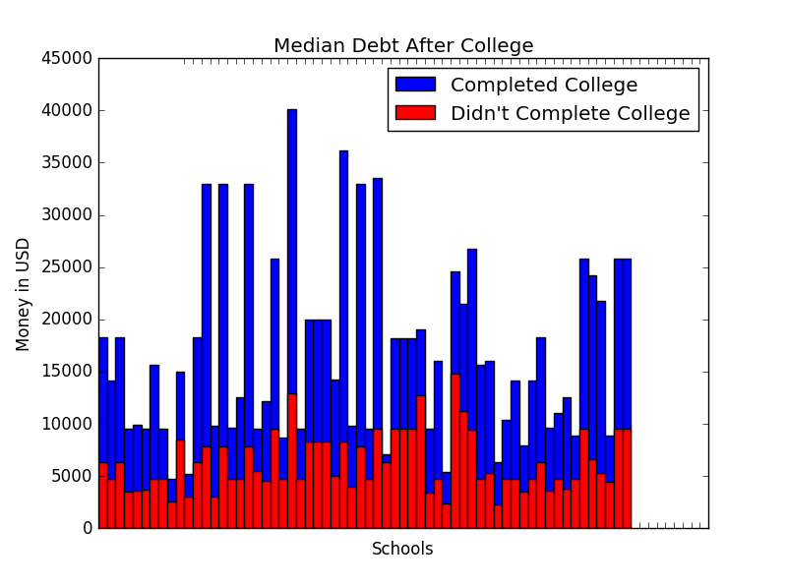

e. From the data collected by the API it is obvious that that there was going to be a big difference but the surprising thing is that there are some outliers in the data set because we can see that there were a few schools that had a similar median debt. I wasn’t expecting some colleges like the All beauty college to have a similar median value. The one problem with this data set is that it is median values so they can be skewed or not representative of the true population of median debt.