|  |
| --- |
|  |
| The Documentation |
| [Type the document subtitle] |
|  |
| **[Your Name]** |
| **[Pick the date]** |

[Type the abstract of the document here. The abstract is typically a short summary of the contents of the document. Type the abstract of the document here. The abstract is typically a short summary of the contents of the document.]

Table of Contents

[To update the table of contents, right click the message below and select Update Field (F9 on PC, ⌥⌘U on Mac).]

**No table of contents entries found.**

1. Pages
   1. Page Tree

会计  
 我要审核  
 我要定价  
 我的审核  
 我的定价  
 筛选页  
 个人中心

* 1. 会计
     1. User Interface

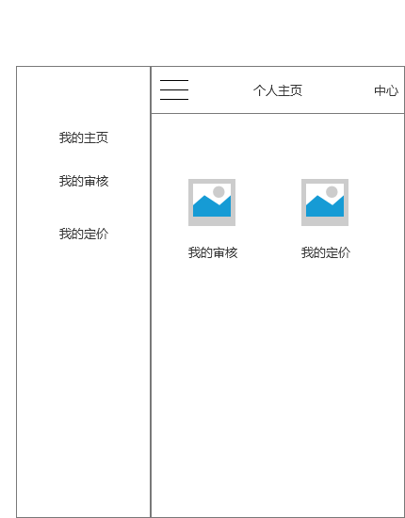

* 1. 我要审核
     1. User Interface

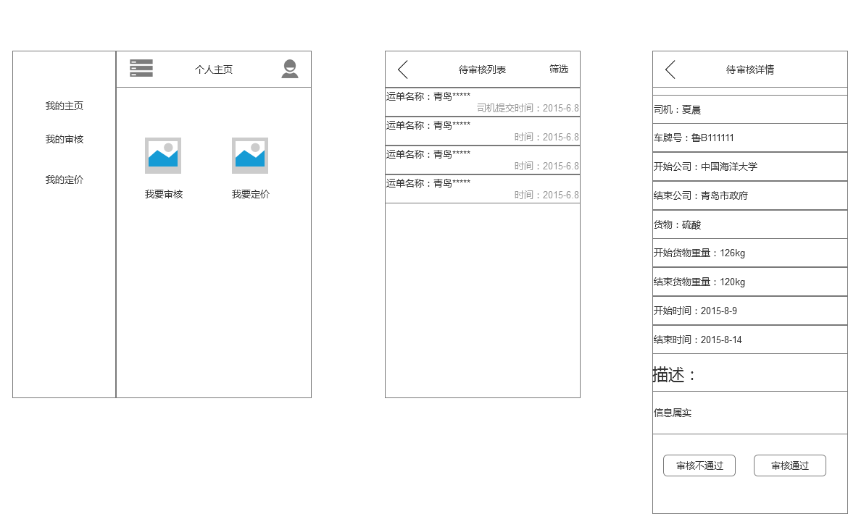

* 1. 我要定价
     1. User Interface

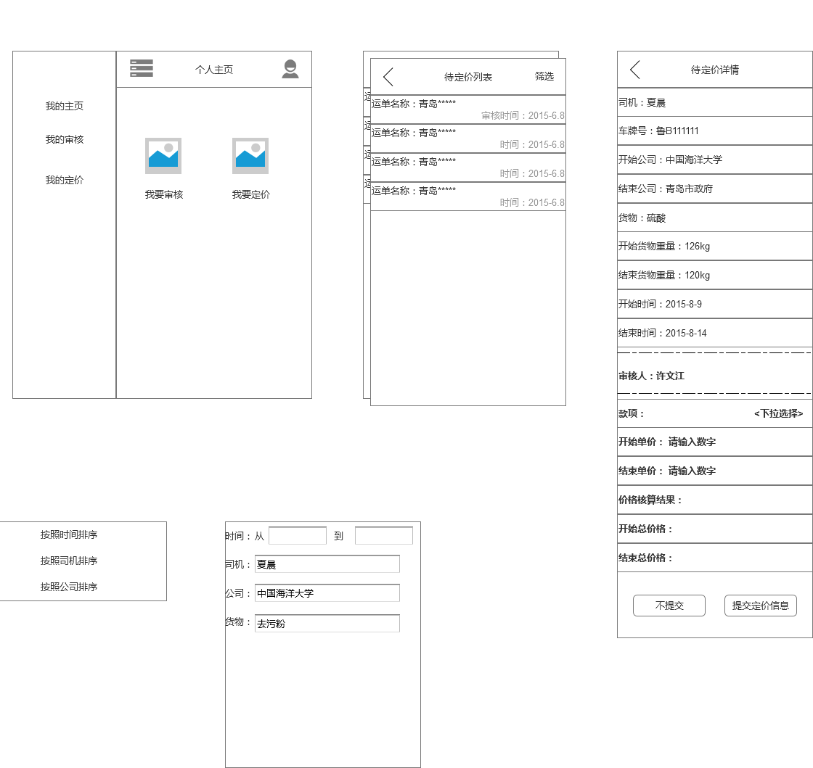

* 1. 我的审核
     1. User Interface

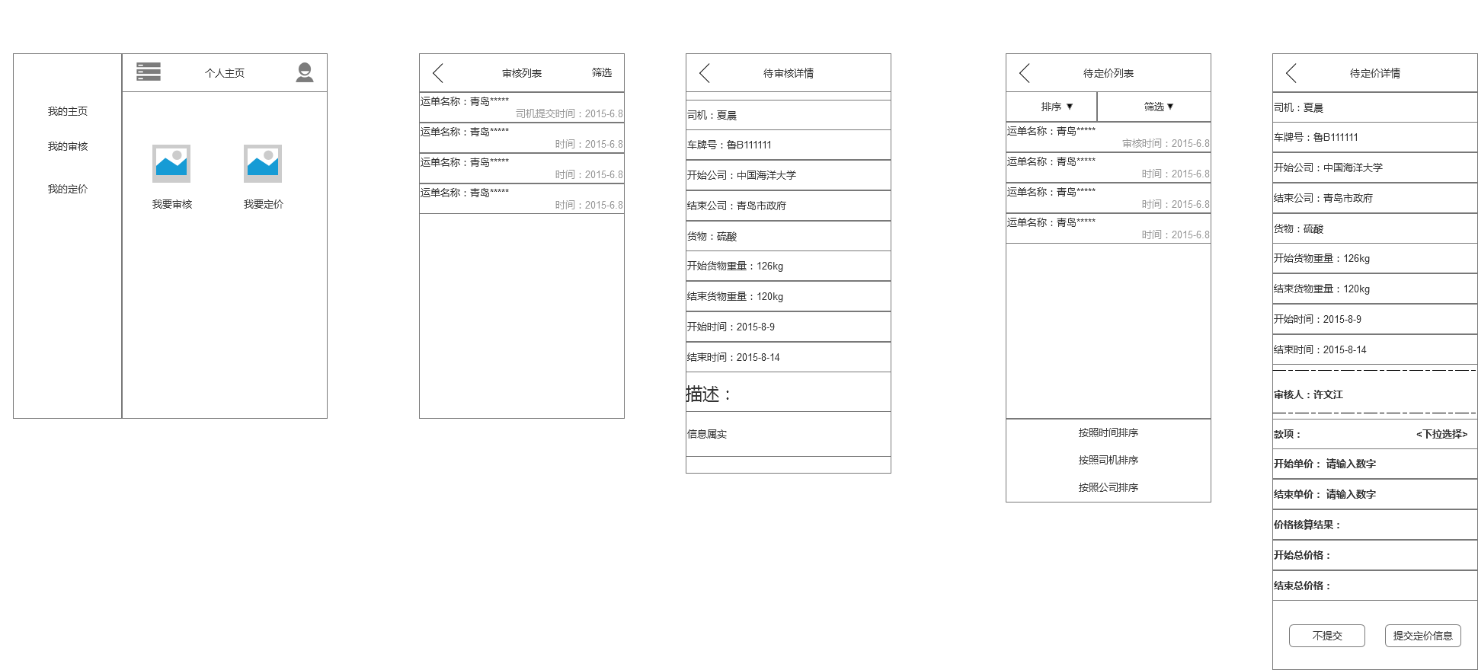

* 1. 我的定价
     1. User Interface

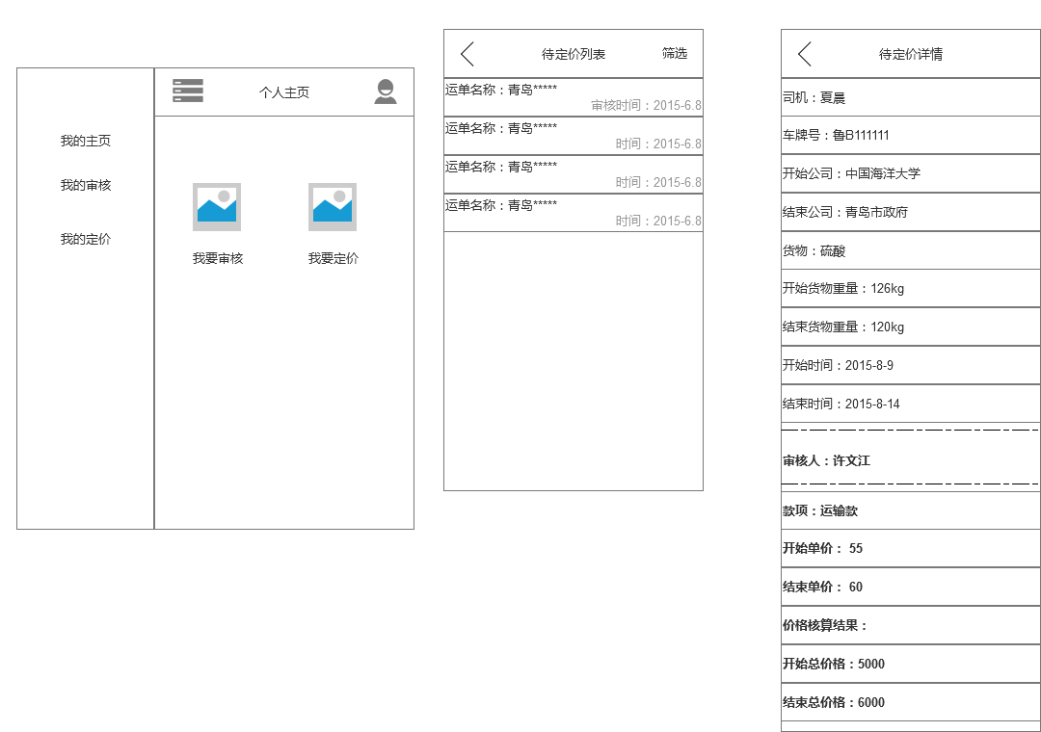

* 1. 筛选页
     1. User Interface

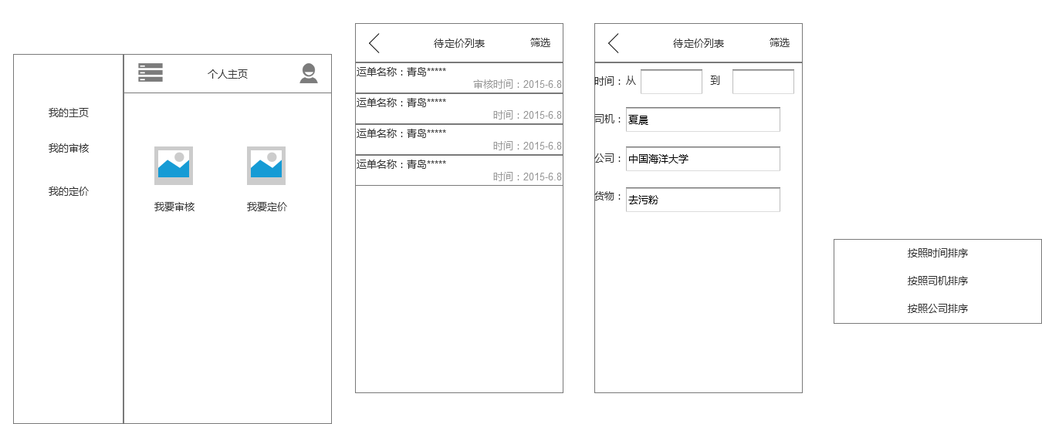

* 1. 个人中心
     1. User Interface

