Customer Profile and Risk Explanation for the Dispute Intake Agent
Proposal for team discussion. Not decided. Extends spec question P1 of the dispute policy portion.
Team: AlterEgo, Factored AI & Data Hackathon 2026
Version: 0.1 draft, 27 September 2026
Status: Proposal. Rows it would change in the decision log of docs/PLAN.md are listed in section 10. Nothing here is built.
Related documents: docs/TEAM_BRIEF_COMPLEMENTED.md (policy v2.3, section 5 metrics), AGENTS.md (rules in section 4, data findings in section 7), docs/JEV_TYPESAFE_AI.md (typed signals), docs/specs/dispute-policy-v2.3.md (portion spec), docs/technical-discuss-points.md (null amount_usd).

Summary
The team wants each customer to have a profile the agent understands, a fraud risk model whose reasons are visible to the human reviewer and to the conversation logic, and two model keys with separate roles: Jev to interpret, a second model to work through configured tools. This document arranges that idea so it satisfies the hackathon rules that disqualify work (policy in the tool layer, verified actions only, explanations from rules and records, no private records to external models), the decisions already closed on 26 September, and the eight days left. The core move is to compute the profile and the risk explanation as data, feed them to the deterministic policy and the handoff packet, and let the models interpret and draft without ever deciding or acting.

1. Purpose and scope
This spec answers one question raised on 27 September while reviewing the dispute policy spec: what should the human agent and the chatbot know about the customer and about the model's reasons when a case is escalated, and how do the two model keys (Jev and Claude Haiku 4.5) divide the work without breaking the principle that the model proposes and deterministic code disposes.
In scope: the customer profile record, the risk explanation derived from the fraud model, the fields the policy engine and the handoff packet carry for them, the read-only tool loop, and the console view. Out of scope: any second workflow, money movement, credit decisions, and any change to the clause order of policy v2.3.

2. The idea as stated by the team
- An agent for each customer: the system holds a per-customer understanding, so answers and escalations are informed by who the customer is and what has happened to them.
- Jev categorizes the customer's information into topics to build that profile.
- The fraud risk model (LightGBM) produces SHAP values; its feature importance feeds the agent so the human in the loop or the chatbot can explain why the risk is high or low and decide whether to ask more questions, complete the profile, or act.
- Two keys: Jev decides what to do next; a second model key executes deterministic actions and responses configured as tools, or digs further into the customer's data points.
Section 4 keeps all four goals and changes only where each piece runs and who is allowed to decide.

3. Constraints the design must satisfy
Constraint | Source | Consequence for this proposal
Permissions and policy live in the tool or service layer, never in model prose. The model proposes; deterministic code disposes. | AGENTS.md rule 6; kickoff slides | Neither Jev nor Claude decides an action. Jev emits typed signals; Claude drafts text and may propose read-only tools; code validates every proposal against an allowlist and the policy clauses.
Report only actions whose outcome was verified by reading back from the system of record. | AGENTS.md rule 7 | Write tools stay policy-triggered and read back from Supabase ops before anyone is told.
Hidden model reasoning is not an audit artifact. Explanations come from sources, policy rules and execution records. | AGENTS.md rule 9 | SHAP contributions are a property of the model and the verified transaction row, so they qualify. A model's free text about why it flagged something does not.
No credentials or private records in calls to external models. | AGENTS.md rule 10; decision log row 'Datos que ven los modelos' (decided 26 Sep) | Jev and Claude see only the masked customer message. Profiling from dataset rows through Jev needs a reversal of that row and the mentors' written answer, which is still pending.
One workflow, deep. | AGENTS.md rule 1 | The profile exists to serve the dispute decision and the handoff. It is not a customer-360 product.
Dataset text is unusable as signal: complaint descriptions are one template per category, transcripts carry unfilled placeholders, detected intents are almost always 'consulta_general'. | AGENTS.md section 7 | Profile signal comes from structured columns computed by code, plus the customer's own masked chat messages tagged by Jev.
fraud_score leaks the label; excluded from every model and from the baseline. | AGENTS.md section 7; decision 3 of the brief | The risk explanation is built from the leak-free LightGBM only.
The June sample holds 9 fraud rows; the model trains on all years with a time split. | AGENTS.md section 8 | SHAP is meaningful only on the all-years model, which does not exist yet (front A, day 5).
The deployed function serves the model through ONNX Runtime (proposed); LightGBM is not in the bundle. | docs/PLAN.md row 'Runtime de inferencia' | TreeSHAP cannot run at request time. Contributions are computed offline and served as data.
Jev is in early access with no key; cutoff 29 Sep 12:00, then the keyword extractor is the baseline and the default. | docs/PLAN.md rows 'Acceso a Jev' and 'SemIf fuera del Plan B' | Every Jev role here must degrade to the keyword extractor with no change to the arrangement.
G1 (a Spanish conversation end to end with a verified case) is due 28 Sep; the suite freezes 30 Sep; public URL 2 Oct. | docs/PLAN.md roadmap | This proposal lands after G1 and must not displace it.

4. Proposed arrangement
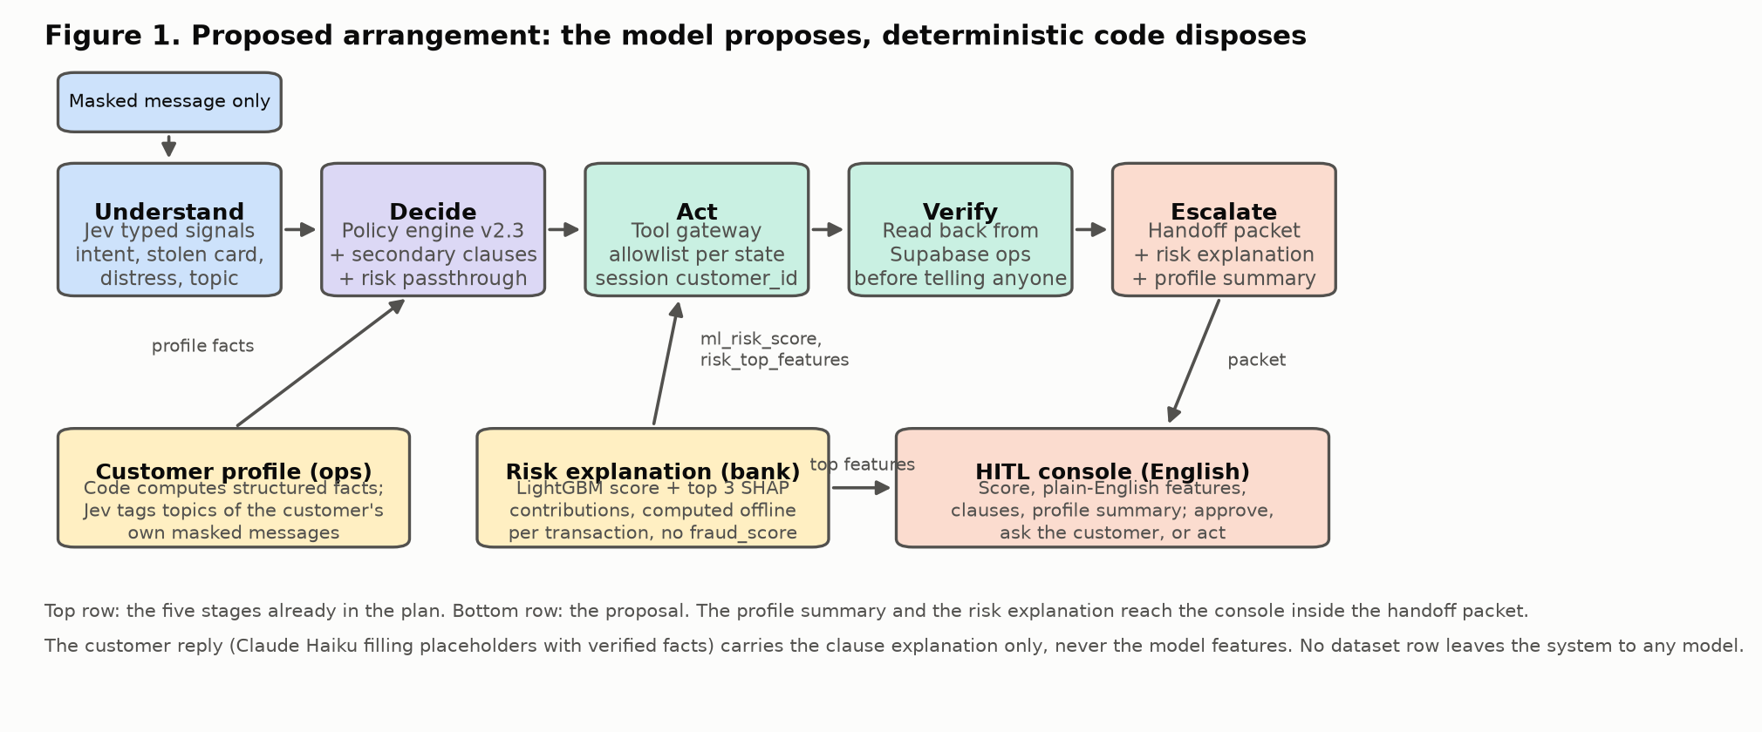
The five stages of the plan stay as they are. Two data products are added below them and reach the human through the handoff packet.
- Profile as data, not as a running agent. A customer_profile record per customer, computed by code from structured facts (segment, account age, complaints in 90 days, dispute history in ops, charge velocity, share of foreign or web charges) plus the topics Jev assigns to the customer's own masked messages accumulated in ops.conversations. This is 'an agent per customer' in the sense of persistent, per-customer state that every conversation reads, with no dataset row leaving the system.
- Risk explanation computed offline, per transaction. Front A trains LightGBM on all years, runs TreeSHAP on every serving transaction, and publishes the score with the top three signed contributions as a JSON column next to it. The app reads it like any other fact.
- The policy carries it through. The engine gets a typed passthrough risk_top_features (fixture-fed like ml_risk_score) and returns it in the decision, together with secondary_clauses (every escalation clause that fired besides the deciding one). The handoff packet gains risk_explanation, secondary_clauses and profile_summary.
- SHAP to the human only. The console shows the score, the top features in plain English, the clauses and the profile. The customer receives the clause-based explanation.
- Two keys, two roles, code in between. Jev classifies (intent, stolen card, distress, and a new topic Choice for the profile). Claude Haiku drafts replies and may propose read-only tools; the orchestrator validates each proposal against the state's allowlist; the gateway executes with the session's customer_id. Write tools remain policy-triggered.
- Better human decisions. The console's existing actions (approve or reject the credit candidate, ask the customer, act) are fed by the profile and the risk summary.
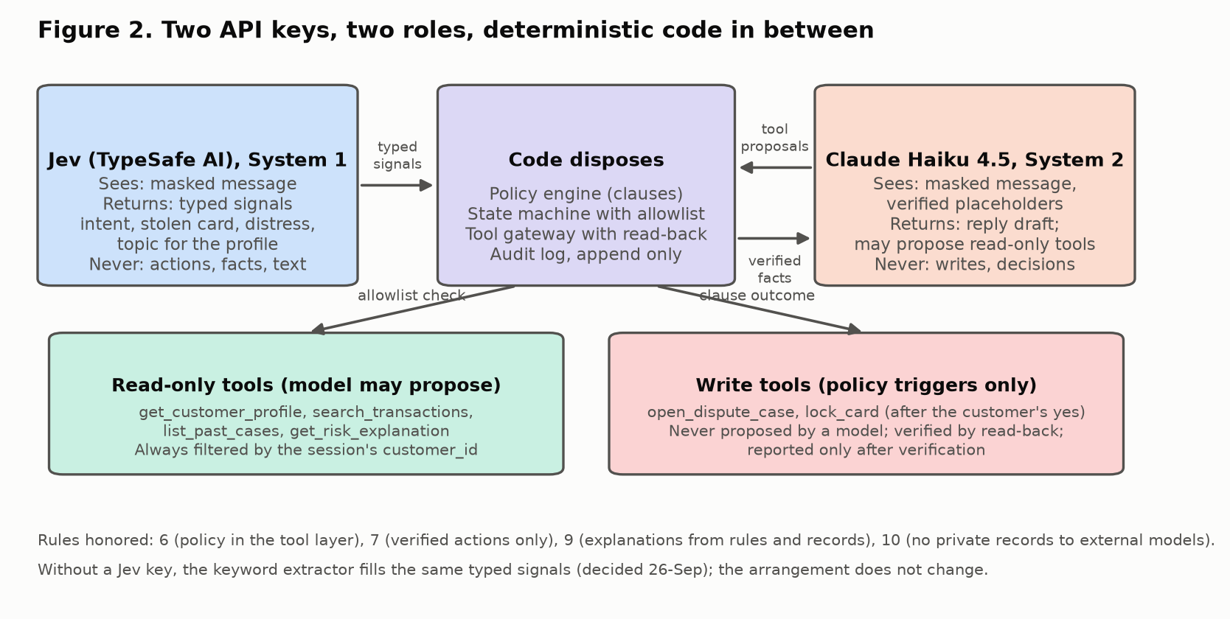

5. Component specifications

5.1 Customer profile
Storage: ops.customer_profiles in Supabase Postgres, one row per customer, rebuilt by a scheduled job and updated after each conversation. Provenance label: derived. The app never opens DuckDB.
Field | Type | Computed by | Source
customer_id | text | key | Session token app_metadata
segment, country | text | copy | bank.customers
account_age_days | int | code | bank.customers.registration_date against business_today()
complaints_last_90d | int | code (live view) | bank.complaints plus ops.dispute_cases
open_cases, cases_last_180d | int | code | ops.dispute_cases
charges_48h, charges_7d | int | code | bank.transactions by process_date
foreign_share_90d, web_share_90d | float | code | bank.transactions, country normalized (México and Mexico)
card_lock_history | int | code | ops.card_locks
topics | jsonb list | Jev Choice per message, aggregated; keyword extractor as fallback | ops.conversations masked messages only
distress_max_30d | float | max of Jev Score | ops.conversations signals
profile_summary | text (English) | template filled by code, no model | All of the above
updated_at, source_versions | timestamp, jsonb | code | Model and extractor versions for the report

Jev topic question (one Choice added to the existing single call; closed set, one topic per message):
Topic | Meaning
cargo_no_reconocido | Does not recognize a charge
cobro_indebido | Recognizes the merchant, disputes amount or duplicate
tarjeta_robada_o_perdida | Physical loss or theft of the card
acceso_o_app | Login, app or channel problems
seguimiento_de_caso | Asks about an existing case
fuera_de_alcance | Loans, other products, unrelated

The topic is a categorization of the customer's own words in this system, which the decided row already allows. It is not a categorization of dataset rows. If the mentors later allow sending records to a model, the same field can be enriched; nothing else changes.

5.2 Risk explanation
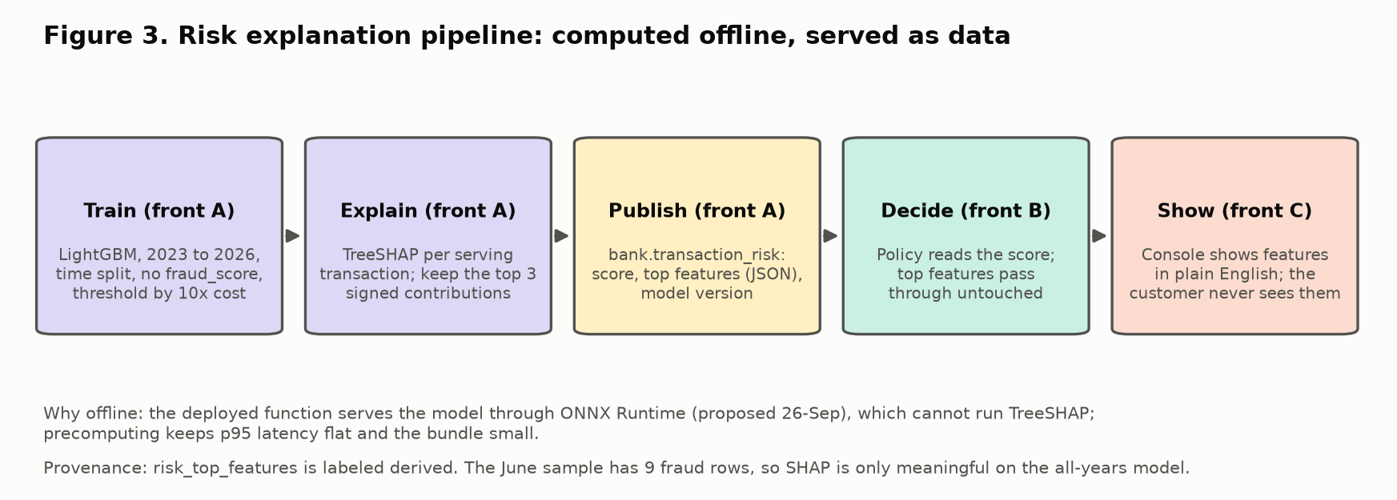
Contract of bank.transaction_risk (published by front A with the serving subset; provenance derived):
Field | Type | Notes
transaction_id | text | key, joins bank.transactions
risk_score | float 0 to 1 | LightGBM probability; the policy reads it as ml_risk_score; threshold 0.70 in POL-ESC-ML-RISK
risk_top_features | jsonb list of {feature, value, contribution} | Top 3 by absolute TreeSHAP value, signed, log-odds units; feature values copied from the verified row
base_rate | float | Model base value, so the console can show 'starts at 0.001'
model_version, computed_at | text, timestamp | For the report's model and prompt versions

Plain-English rendering is a fixed mapping in code from feature name to phrase, filled with the row's value. Examples:
Feature | Phrase shown to the human agent
is_foreign_country = true | Charge made outside the customer's country
channel = Web | Online purchase (Web channel)
ratio_to_historical_avg = 3.4 | Amount is 3.4 times the customer's 90-day average
time_of_day = 03:00 | Made at 03:00 on the bank's processing clock
velocity_24h = 1 | Only charge in the last 24 hours (lowers risk)
account_age_days = 686 | Account open for 686 days (lowers risk)

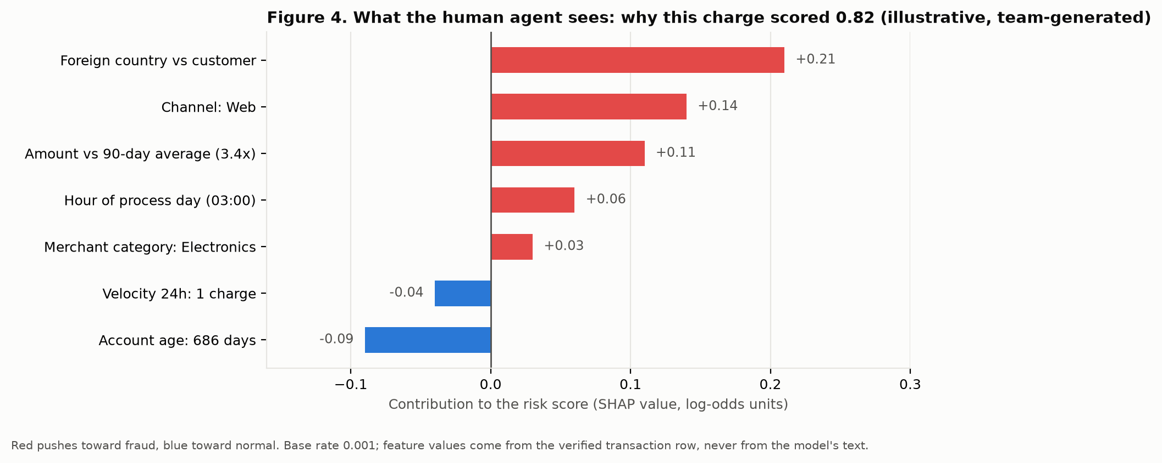
Figure 4 is illustrative and team-generated: the model does not exist yet. The shape of the display is the point, not the numbers.

5.3 Policy engine changes (this portion)
Two additions, no change to clause order or thresholds:
- DisputePolicyInput.risk_top_features: list = [] is a typed passthrough alongside ml_risk_score. The engine never reads it for a decision.
- DisputePolicyDecision.secondary_clauses: list = [] lists the escalation clauses that also fired after the deciding one (for example POL-ESC-ML-RISK and POL-ESC-MULTI behind POL-ESC-500). The outcome, reason and cited_clauses are unchanged, so the first-match rule of the brief holds.
- DisputePolicyDecision.risk_top_features echoes the input so the orchestrator builds the packet from one object.
Tests: test_pol_esc_order_secondary_clauses_recorded (850 USD, risk 0.9, 3 charges: deciding POL-ESC-500, secondary [POL-ESC-ML-RISK, POL-ESC-MULTI]) and test_policy_risk_top_features_passthrough.

5.4 Handoff packet additions
Field | Content | Filled from
secondary_clauses | Escalation clauses that also fired | Policy decision
risk_explanation | {score, base_rate, top_features (plain English), model_version} | bank.transaction_risk plus the phrase mapping
profile_summary | Short English summary and the topic list | ops.customer_profiles
suggested_questions | Questions the human may ask, chosen by code from the profile gaps (for example no topic yet, or foreign share high and no travel mention) | Rule table in code, not a model

5.5 Tool loop with allowlist
The orchestrator is a state machine. Each state lists the tools that may run in it and who may propose them. A proposal outside the list is dropped and audited; it never errors to the customer.
Tool | Kind | Who may propose | Who executes and verifies | Available in states
get_customer_profile | read | Code always; Claude may request | Gateway, session customer_id | all
search_transactions | read | Code always; Claude may request with hints | Gateway | identify_charge, awaiting_clarification
list_past_cases | read | Claude may request | Gateway | identify_charge, decide
get_risk_explanation | read | Code after policy; Claude may request for the human summary | Gateway | decide, escalate
open_dispute_case | write | Policy outcome only | Gateway with read-back | act
lock_card | write | Policy recommendation plus the customer's yes | Gateway with read-back | awaiting_confirmation
create_handoff | write | Policy outcome only | Gateway with read-back | escalate

Claude's tool proposals are made through structured tool use, validated by code, and logged with model and request ids. Jev never proposes tools; its signals are inputs to the policy.

5.6 Console view
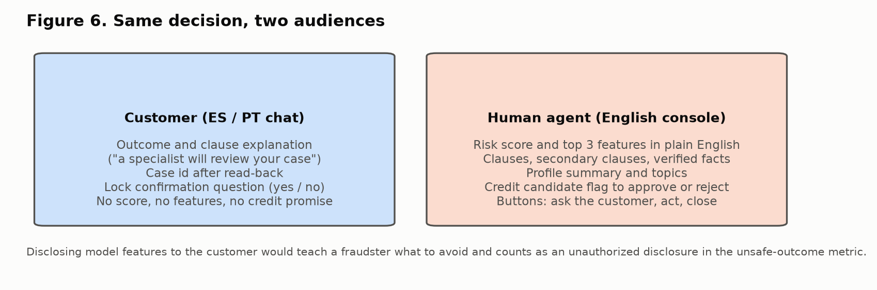

6. How the value is measured
The held-out suite and the metrics of the brief's section 5 stay the yardstick. The proposal adds no new metric; it targets escalation quality and safety.
Question | Measure | Denominator
Do escalations carry more useful context? | Handoff completeness: every required field filled from verified records, plus the share of packets with a non-empty risk_explanation and profile_summary | Escalated cases in the held-out suite (about 80 of 250 by category mix)
Does the human decide better? | In the harness, time to decision and agreement with the labeled expected outcome, with and without the explanation shown (A/B on the console, two team members as reviewers, small-sample caveat) | Escalated cases, both arms
Is Jev's topic better than keywords? | Accuracy and calibration per language on the team-labeled ES/PT set, against the keyword extractor | Labeled messages, sliced ES and PT
Does it add latency or cost? | p50 and p95 end to end; one extra read for the risk row; zero model tokens for the explanation | All in-scope cases, 3 repeats
Does it leak? | Unsafe outcomes: any customer reply containing a feature phrase or a score counts as an unauthorized disclosure | All test runs

7. Roadmap placement and owners
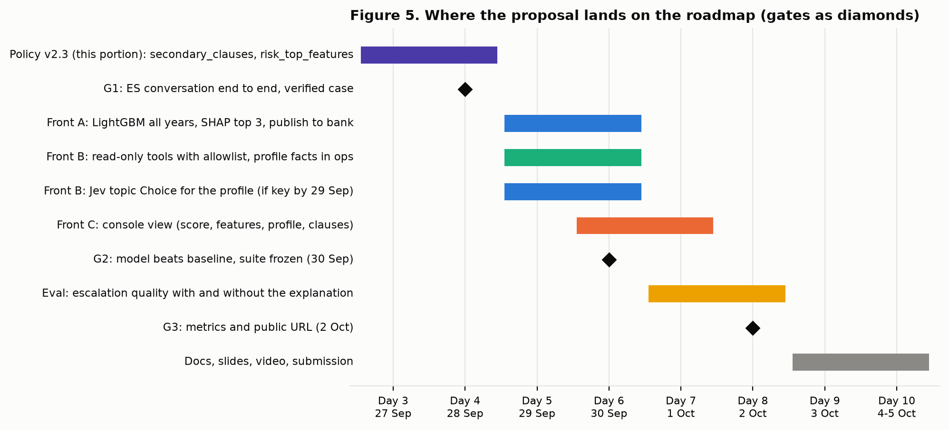
Piece | Owner | Day | Depends on
secondary_clauses and risk_top_features in the policy and packet | Front B (this portion) | 3 to 4 | Spec approval
LightGBM all years, TreeSHAP top 3, bank.transaction_risk | Front A | 5 to 6 | Full-history load (not run yet)
Read-only tools with allowlist; ops.customer_profiles | Front B | 5 to 6 | G1 done; ops schema
Jev topic Choice | Front B | 5 to 6 | Jev key by 29 Sep, else keyword topics
Console view: score, features, profile, clauses | Front C | 6 to 7 | OpenAPI contract update
Evaluation with and without explanation | Front A | 7 to 8 | Suite frozen 30 Sep

8. Risks and mitigations
Risk | Mitigation
Displaces G1 or the model deliverable | Nothing starts before G1; front A does SHAP only after the baseline comparison exists
No Jev key | Keyword topics are the baseline anyway; the profile fields computed by code do not depend on Jev
Feature phrases leak to the customer | Phrases exist only in the console renderer; the customer template has no placeholder for them; a suite check greps replies for them
SHAP on a weak model misleads the human | Show the base rate and the score band; label as model evidence, not fact; the human decides
Profile becomes a second workflow | Fields limited to what the dispute policy and the packet use; no profile endpoint for the customer
Claude proposes a write tool | Write tools are not in any state's allowlist for model proposals; the attempt is audited
Anthropic retains inputs up to 30 days | Already declared as a limitation; only masked messages go out

9. Open questions for the team
- Q1. 'An agent for each customer': persistent per-customer profile state (this document's reading), or a live agent instance per customer?
- Q2. What should Jev categorize: dataset rows (blocked until the mentors answer, and mostly templates) or the customer's own conversation history in ops (this document's reading)?
- Q3. SHAP explanations to the human agent only (recommended), or also to the customer?
- Q4. Priority: after G1 as drawn in Figure 5, or now?
- Q5. The second model key is Claude Haiku 4.5 as decided, or a different provider? One key can serve both the reply drafting and the tool proposals.
- Q6. Should the console's suggested questions come from a rule table (recommended, auditable) or from Claude?

10. Decisions needed and decision-log impact
If accepted, docs/PLAN.md gains one 'Propuesta' row ('Perfil de cliente y explicación del riesgo') and these existing rows are touched:
- Understand y conversación (Decidida): adds the topic Choice and the read-only tool proposals by Claude; the deterministic core is unchanged.
- Datos que ven los modelos (Decidida): unchanged. This proposal is designed to keep it.
- Componentes aprendidos (Decidida): adds SHAP as the explanation of the fraud model, measured on the all-years model.
- UI (Decidida): the console gains the risk and profile panel; no dashboard.
Decisions: accept the arrangement of section 4; answer Q1 to Q6; confirm the owners and days of section 7.

