GitHub Walk Thru

Basic operations:

* Commit: save all your changes on the project to local storage
* Push: upload all your commits to GitHub server
* Pull: download all the uploaded changes (if any) from either you or other contributors to your local storage.

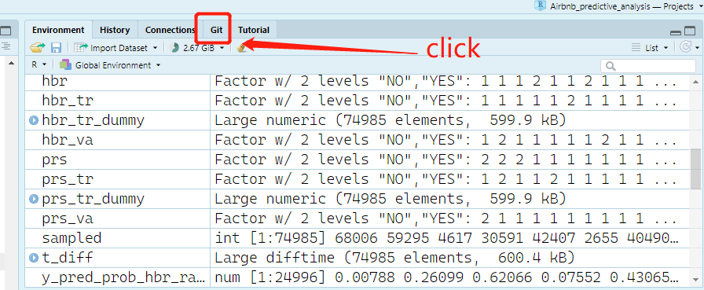Where to perform those operations using R Studio: