**James Chad Ballay**

Week 8

**Retrieve the header from an email message. Highlight the important components that make up an email header. Include the host identifiers (domain names and/or IP addresses) of the MTAs that carried the message.**

|  |
| --- |
| Delivered-To: chad.ballay@gmail.comReceived: by 2002:ab3:5a95:0:0:0:0:0 with SMTP id l21csp327155lte; Sun, 26 Jan 2020 08:57:33 -0800 (PST)X-Google-Smtp-Source: APXvYqzHYtEl/AFQwI2G7mnG9aSbDleNmB35LWqYvi4ZIzhoUDW/4WRNzxMbvcpBNw2sCotbvR78X-Received: by 2002:a17:906:9615:: with SMTP id s21mr10674307ejx.20.1580057853168; Sun, 26 Jan 2020 08:57:33 -0800 (PST)ARC-Seal: i=1; a=rsa-sha256; t=1580057853; cv=none; d=google.com; s=arc-20160816; b=Hwt7Xd3+hILZocFoCype6EZnMjVMeXX4UKLiL4Y6vghl7raW6b+1PCNskPVWB4A9UM LENCR/ZcD3vacXPnEyYKqIvutupzS84izuGiajVT/qjspN1LF/R8yQbKsypLEvu+JUQC PhX6HpHfRg+aY0Q2Hnfe3ni7xplj9XFr+Uy28glXsySG282sgWApvvnnUJdhdG4ixssS XRiBNkxuLx7KZmRG5H11+nSvpCjFRyCtiTz1InMyMsqnWDLKOlCnZPEt4/rZ/k4HeQJ3 1ULAoKhM3UUjZ8kLPrh3fOeuhxjL19Hpsd8HQCMZXTpZzBtRTO+oziyeF/738XtpIIrx jGmg==ARC-Message-Signature: i=1; a=rsa-sha256; c=relaxed/relaxed; d=google.com; s=arc-20160816; h=date:mime-version:subject:to:sender:from:message-id:dkim-signature :dkim-signature; bh=NHiCG/YCIMFGXZ418dEW4iKe02tDJkEUxI0AvE5YM0Q=; b=n4Eld8VIi9/DvniR+qHlXdfmRSYxDJkQm9x+uAOh8ZizUymzfdKa7XYfbwMpSqOdr2 8AF3XiYlyG9/HhiDrYKalle6maN6Zllhke2LrV4jNjvvSHaLxBFlFPcez8ai0R8OHl+V n2r+5XYPBUb3ZIr1XV/hNualwFfQz4Q6AcM5YS5EJF7d7v7/2s4x1zc6F85nID1CYEqw mqhnpxIh3EjxtplJWd+1Ttf+eG+cV96QdjNRC2l0Zlo2l3a7ZVKBTJnZcWfo75KGgBJF VoKV1UUYCKIkmAlxmzXVW7bz6cd7VWNpCASuVppY5zEibxdH762SlTP/ZWAqv/Hz7SJk QRDg==ARC-Authentication-Results: i=1; mx.google.com; dkim=pass header.i=@meetup.com header.s=s1 header.b=alCXiQRC; dkim=pass header.i=@sendgrid.info header.s=smtpapi header.b="e/Wbcs8a"; spf=pass (google.com: domain of bounces+11930396-7934-chad.ballay=gmail.com@sendgrid.meetup.com designates 167.89.54.3 as permitted sender) smtp.mailfrom="bounces+11930396-7934-chad.ballay=gmail.com@sendgrid.meetup.com"; dmarc=pass (p=QUARANTINE sp=QUARANTINE dis=NONE) header.from=meetup.comReturn-Path: <bounces+11930396-7934-chad.ballay=gmail.com@sendgrid.meetup.com>Received: from o7.sendgrid.meetup.com (o7.sendgrid.meetup.com. [167.89.54.3]) by mx.google.com with ESMTPS id g23si2366608edv.454.2020.01.26.08.57.32 for <chad.ballay@gmail.com> (version=TLS1_2 cipher=ECDHE-RSA-AES128-GCM-SHA256 bits=128/128); Sun, 26 Jan 2020 08:57:33 -0800 (PST)Received-SPF: pass (google.com: domain of bounces+11930396-7934-chad.ballay=gmail.com@sendgrid.meetup.com designates 167.89.54.3 as permitted sender) client-ip=167.89.54.3;Authentication-Results: mx.google.com; dkim=pass header.i=@meetup.com header.s=s1 header.b=alCXiQRC; dkim=pass header.i=@sendgrid.info header.s=smtpapi header.b="e/Wbcs8a"; spf=pass (google.com: domain of bounces+11930396-7934-chad.ballay=gmail.com@sendgrid.meetup.com designates 167.89.54.3 as permitted sender) smtp.mailfrom="bounces+11930396-7934-chad.ballay=gmail.com@sendgrid.meetup.com"; dmarc=pass (p=QUARANTINE sp=QUARANTINE dis=NONE) header.from=meetup.comDKIM-Signature: v=1; a=rsa-sha256; c=relaxed/relaxed; d=meetup.com; h=from:sender:to:subject:mime-version:content-type; s=s1; bh=NHiCG/YCIMFGXZ418dEW4iKe02tDJkEUxI0AvE5YM0Q=; b=alCXiQRC4k0ZM I8AL9c4zIZAA2i1N8SYakYAxCkepDxOA/sdGuyXcYqwBD7o6oVizdt35GZ2HtFrX 2MPN//+XznS//1wxxzoZ0I/ROFQ1NvMpWyO5ZfsRU1JZXWDB2jbpM+iomEWqb8Yt n5eNQVi2MB9qEYZrj4BP2yLwrurN/k=DKIM-Signature: v=1; a=rsa-sha256; c=relaxed/relaxed; d=sendgrid.info; h=from:sender:to:subject:mime-version:content-type:x-feedback-id; s=smtpapi; bh=NHiCG/YCIMFGXZ418dEW4iKe02tDJkEUxI0AvE5YM0Q=; b=e/ Wbcs8aXYEk2tVUR3sRNl+YkLunBSbxs7uYQ40K+MHkHtVgVF54OKclmg3/HsTtb6 FT9nbF9Nxxf72B0VtOJKoHfpJJBsDlxoNpCQ7zfwXZdlfu/zUG3Me2Fdw1WXsXIR 93pUGeN47mA+BJEqnM7dPsELQf7H7LT3yH9rMCGzs=Received: by filter1322p1mdw1.sendgrid.net with SMTP id filter1322p1mdw1-26672-5E2DC4FB-10 2020-01-26 16:57:31.369480827 +0000 UTC m=+223594.101819664Received: from ip-10-192-22-24.ec2.internal (ec2-34-197-78-164.compute-1.amazonaws.com [34.197.78.164]) by ismtpd0024p1iad2.sendgrid.net (SG) with ESMTP id jnObPeMxReSGgsEsz3IiUQ for <chad.ballay@gmail.com>; Sun, 26 Jan 2020 16:57:31.193 +0000 (UTC)Message-ID: <1289694448.1580057851236.JavaMail.root@ip-10-192-22-24.ec2.internal>From: Meetup <info@meetup.com>Sender: info@meetup.comTo: chad.ballay@gmail.comSubject: New Meetup Group: Cloud Security Alliance Arkansas Chapter (DevelopingChapter)MIME-Version: 1.0Content-Type: multipart/alternative; boundary="----=_Part_17086_1583804625.1580057851236"X-MEETUP-RECIP-ID: 256515205X-MEETUP-TRACK: wg6.2.1.2Date: Sun, 26 Jan 2020 16:57:31 +0000 (UTC)X-SG-EID: 1K4nIXPyW1oPfX03ZT4T71cSf/xSKTERxp+/ofVCAmWIQgywMUYEnzzt7ytlcrfQBYJBEG3A2nKT7S qjYQKRbtUSo/1TDL7V0nWVzRQ/bH4jy3pwrnUYnnUhIbIfp4wIO3b3sXr1K5lmxArbl39z5lRsqvSq vp4Wy9S4Qkjrg+t/4ztxM4ryywhszd9wwpE2TK/tgfWrFU25HmD+86n+Yw==X-SG-ID: At9+ZSyNLzzlf+nqYaHHi0M3uBwzOkIH2Iczwqq1Thm9/wbJq8n2Xezp718Ilo9XX-Feedback-ID: 11930396:Gk6shbn8/2BmK8wGsJmQo0RAOBISFxALtoPYc0NtHUA=:88C3dh5Uv9Ek5HRO9Ei4RA==:SG |

**Write a simple web page in HTML. Use Figure 16.2 as an example, but customize it to contain different titles, headings, and text. Hand in two items: 1) page’s HTML source text, and 2) a copy of the page produced by the browser after the script has executed.**

|  |
| --- |
| <!DOCTYPE html>  <html>  <head>  <meta charset="UTF-8">  <title>Testy McTesterson</title>  </head>  <body>  This body text.  <h1>This is a heading</h1>  <a href="https://www.google.com">This is a link to google.com</a>  </body>  </html> |

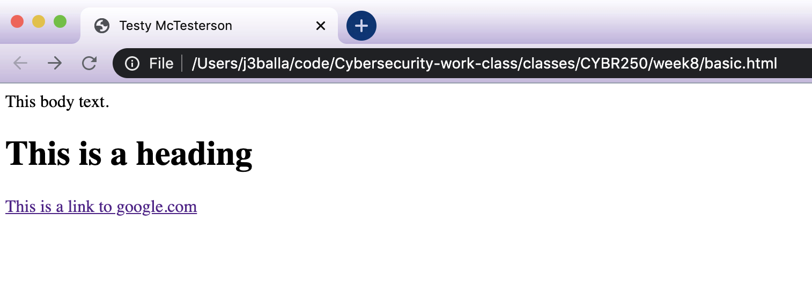

**Visit an SSL-protected web site. Use the browser to display the certificate.**

* **Make a copy of the certificate’s contents to include in your document. (A screenshot is fine.)**

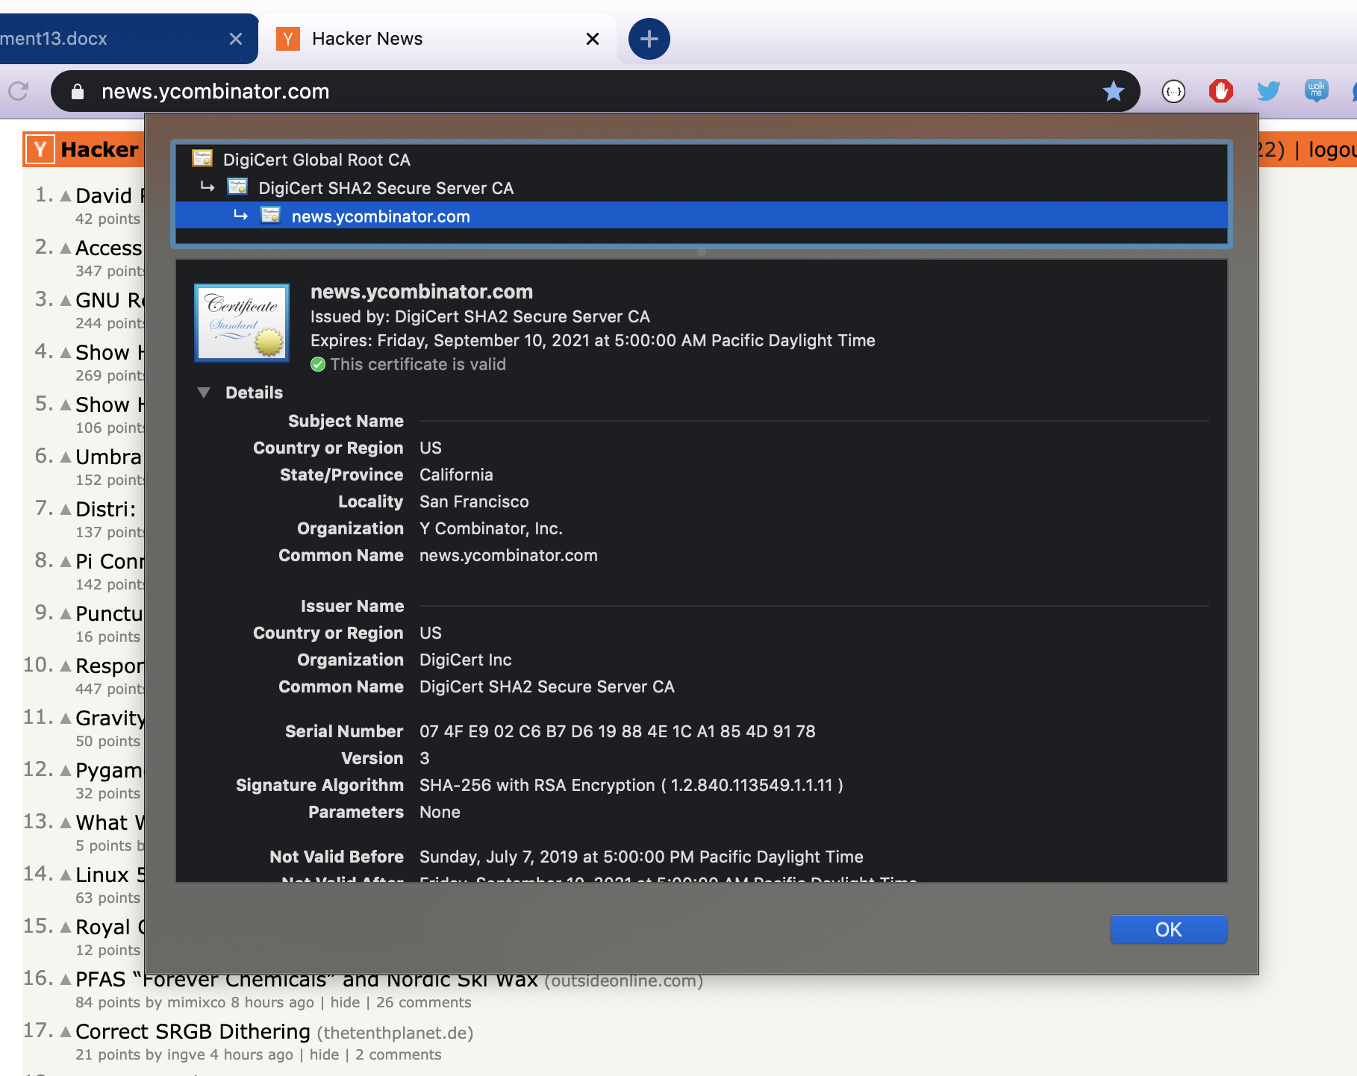

* **What is the name of the certificate authority that issued the certificate?**



* Use the browser to display the certificate for that certificate authority. Include a copy of that certificate’s contents.

