Chad Ballay

CYBR340-342

Week 2 – Module 1

7/12/2020

Windows PowerShell

* **How to start PowerShell.**

There are a couple of different ways to start PowerShell. The simplest is to run “start powershell” from the command prompt.

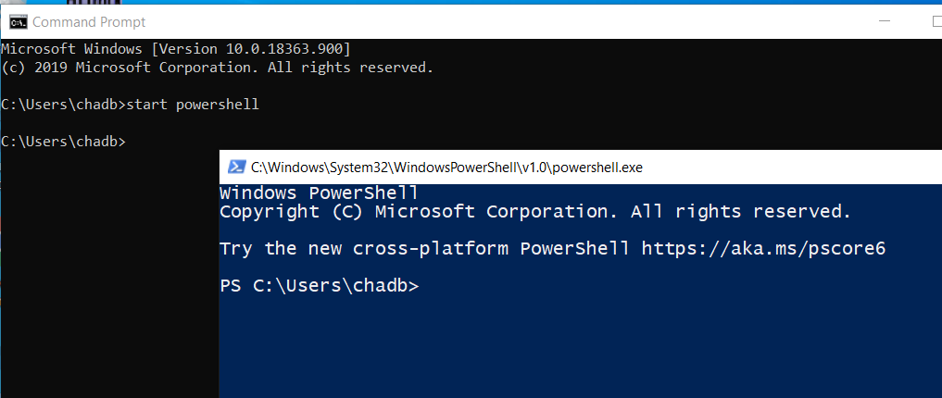

The next one is from the start menu. Navigate to Windows PowerShell.

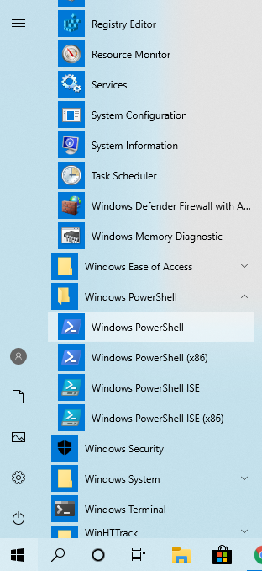

* **What's the difference between PowerShell and PowerShell ISE. Include how you can use ISE with PowerShell.**

Powershell ISE is the Integrated Scripting Environment. More of the sandbox for creating, debugging, etc on PowerShell scripts. PowerShell refers to the whole framework itself. So maybe the best analogy would be PowerShell ISE would be a word processing tool while PowerShell would be the file format that the documents use. It’s a weak analogy but it holds up for the relationship a bit.

* **Command to see your PowerShell version**

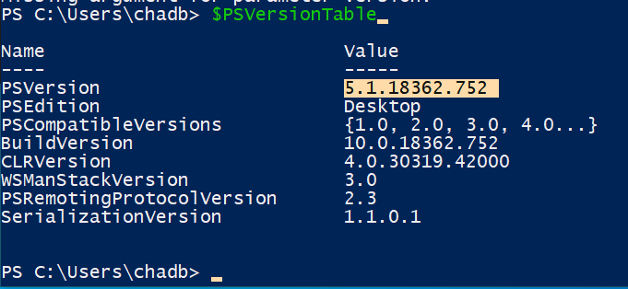

Conceptually this seems to be in line with environment variables in Unix based systems. Dollarsign to denote a special object. The lack of a verb to tell the interpretor what to do with this object is a departure from what I would expect. (Cat, echo, run, type, etc...) But I’m very weak on Windows and if all I know is Linux then the issue lays in my understanding not in their implementation.

* **Command that "Displays information about Windows PowerShell commands and concepts."**

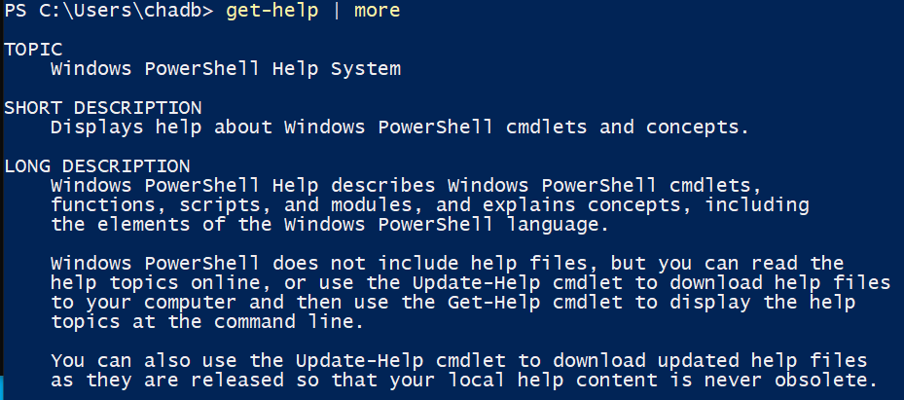

Had to use the more command to stop the output from scrolling by.

* **Command that lists available commands.**

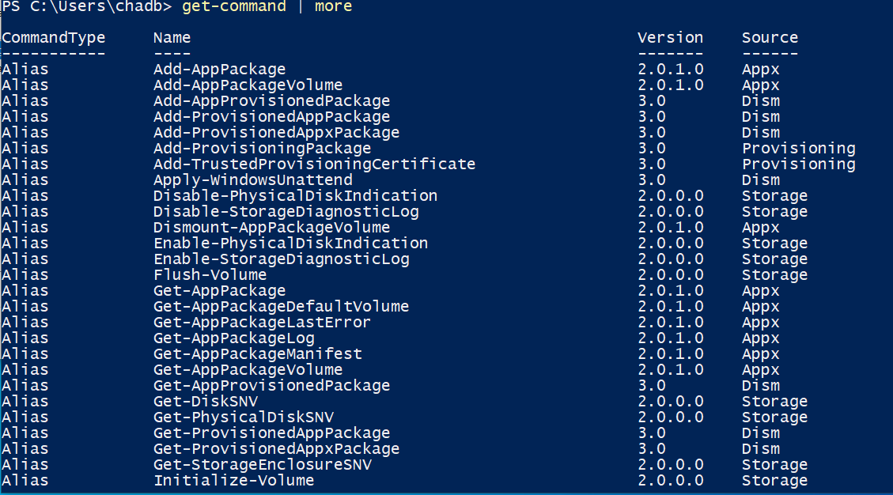

* **Explain what a cmdlet is. Include an example of a cmdlet.**

Single task operators that perfom a very focused task. These usually have a verb-noun style name which usually makes them easy to intuit what their purpose is. For example, get-service sole purpose is to list all services that are installed on the system.

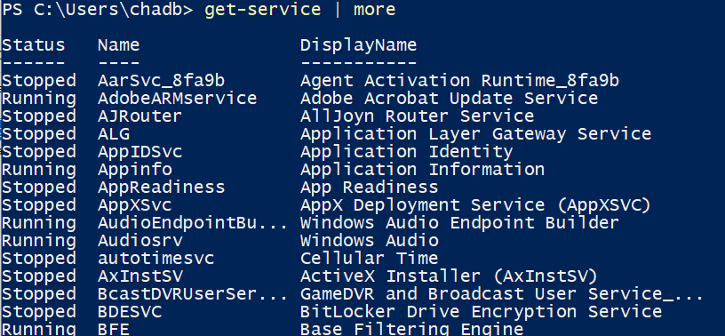

* **An example of a PowerShell script. What it does is up to you. If you're looking, try one that provides the largest files in a folder or drive.**

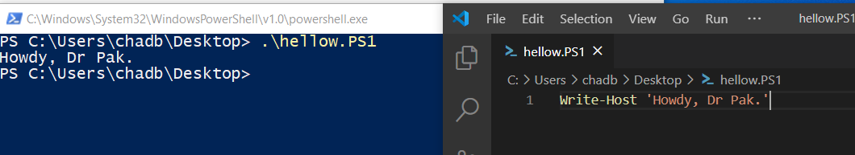

Went with the traditional Hello World style first script.