Chad Ballay

CYBR340-342N

Week 4

7/26/2020

Regedit & Msconfig

**Run regedit**

Ran regedit and then decided to figure out how to find Visual Studio Code’s entry. Pulled out the version number to give me a unique string to search for. 1.47.2 Regedit provides a search feature so using that string I was able to pull up this registry entry. Didn’t start editing anything but I was sorely tempted to see what tweaks could be done. My previous registry experience has been minor. The most complex I think I ever did was back when we would have to edit some TCP/IP parameters in Windows 98 to maximize network throughput. But the theory remains the same on what you can do within the registry.

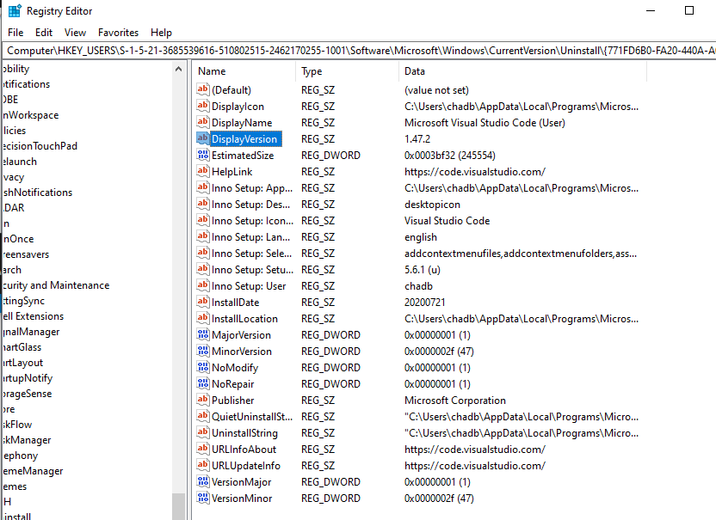

**Run msconfig**

This tool could be really handy but also very easy for me to mess things up. Very often we just need to have a previously known good restore point handy. A way to undo the most recent changes. This provides the functionality through how you can disable items and tinker with the startup. It also allows you to really make a mess of things too....

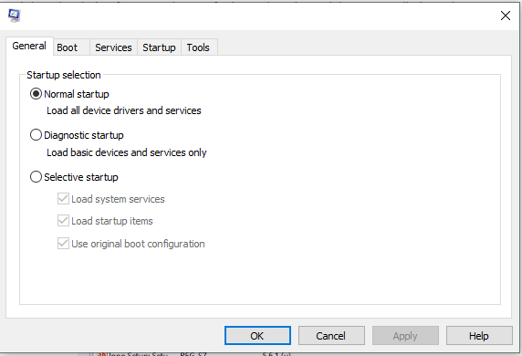

**Step-by-Step 6.03**

Explored the Device Manager. It was a unique UI for me since most of the paradigm I know is the UNIX one with items being on /dev/. I was able to easily navigate the tree though. Spidered down to the leaf nodes for some of the more interesting ones. The USB branch was intersting to explore because I wanted to see how well I could read the entries to understand how it relates to the items I know I have installed. I’ll need more time exploring to get a better understanding.

