Chad Ballay

Week 3

CYBR 350-320N

7/17/2020

WireShark Lab

1. Downloaded, installed and started.

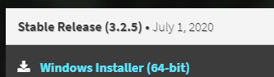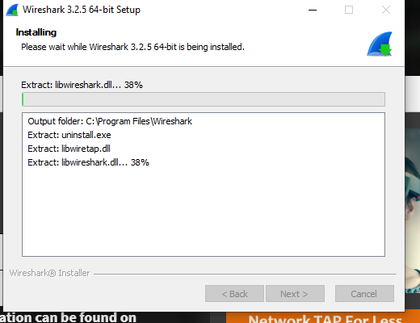

1. Browser launched

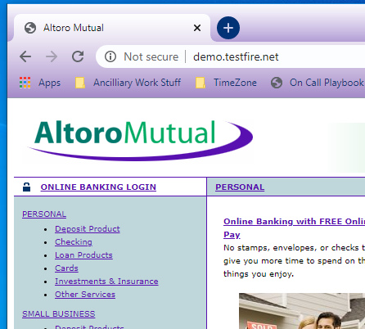

1. In WireShark

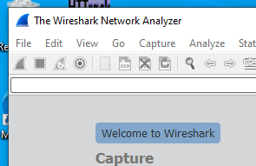

1. Captureing on WIFI

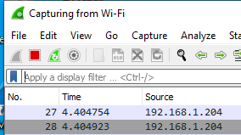

1. Logging in.

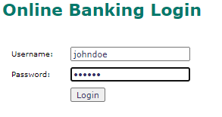

1. Clicked stop.

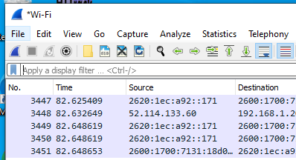

1. Reviewed

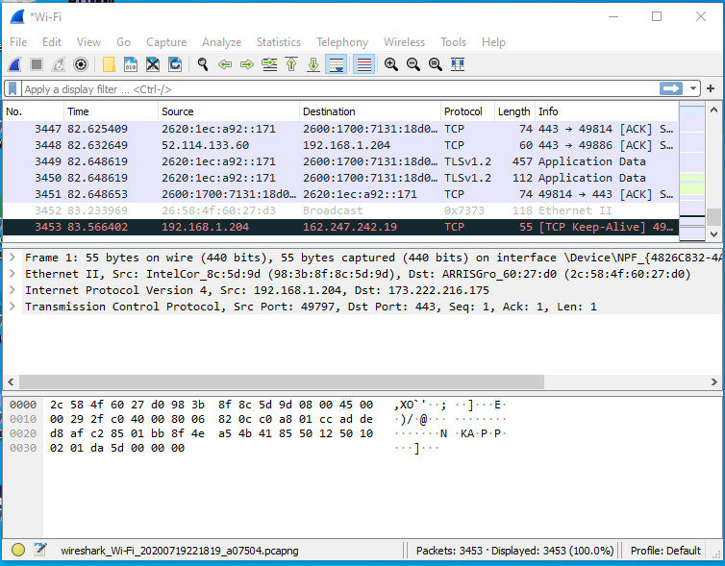

1. Finding packet

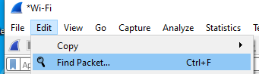

1. Searched for string.

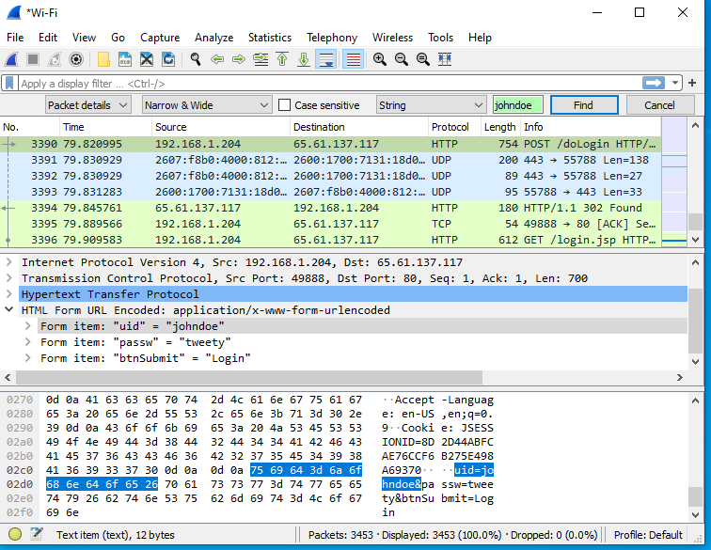

1. Saw the display windows

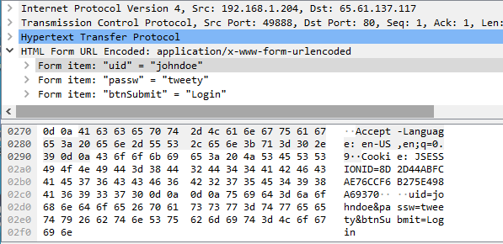

1. Found as a part of the http request as well as in the packet contents

