Chad Ballay

CYBR410

10/12/2020

Week 5 -Database Installation with Oracle

For this week’s assignment we will answer three key questions with regard to Oracle DB installations.

## Why would you perform a silent installation?

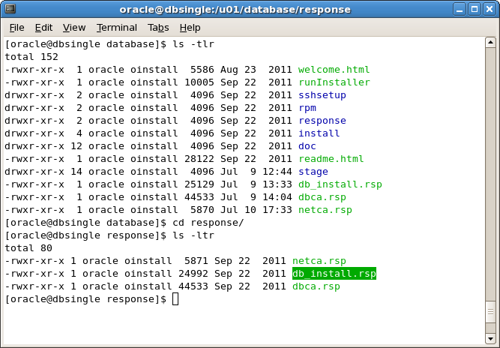 (Sgobe, n.d.)

A silent installation is an installation with minimal to no interaction to correctly select the user prompts needed to install the DB. This is a templatization of the install process so that an economy of scale can exist. Often times this is driven by the recent push for Infrastructure as Code(IaC). (Infrastructure as Code, n.d.) With the mass adoption of virtualization technologies coupled with cloud based architecture, you will often need to dynamically scale up and down your infrastructure footprint. With Oracle this means automating the installation through the silent install process.

There is a newer effort to do away from the custom silent install mechanism and instead to use the industry standard tool called Terraform from Hashicorp. This process at a high level is very similar in goals as the existing silent install is, it’s just an adoption of a tooling that is broadly accepted. (Shroff, n.d.)

## Under what circumstances would a system administrator lose access to an instance of SQL Server? Give an example.

Barring accidental removal or lockout, a likely reason would be for compliance with security policy. Forced vacation policies are rare but no unheard of. In that example, a system administrator would be given no notice. Instead they would have all access revoked temporarily while their access history and access scope be audited.

From a failure perspective the system administrator could lose access due to software failure. Credentials being lost/disrupted. In that kind of situation the system administrator may have to boot the instance into single user mood. Once in that mode the access issues can be troubleshot and resolved.

## Oracle offers a free download of all editions of the Oracle Database. How does the company derive benefits from this approach?

The cynical view is that Oracle wants to get developers used to it’s software by any means nessacary. What is familiar is often picked by others so by giving it away to people they are focused on mindshare.

A less cynical view is that it allows it’s user base to feel free to rapidly create proof of concepts with minimal inertial issues. By the time they could get an approved budget to purchase the DB. In reducing barriers, Oracle helps ensure a timely speed to market which in turn can grow their business due to the benefit of the “First-Move Advantage.” (First-Mover Advantage, n.d.) This overwhelming benefit makes it very attractive to flood the area with working versions of their product. Knowing that some of these installs would never translate to sales makes the process less dreary. All it takes is one of those installs given for free to become a success and all the missed opportunity.

# Works Cited

*First-Mover Advantage*. (n.d.). Retrieved from WIkepidea: https://en.wikipedia.org/wiki/First-mover_advantage

*Infrastructure as Code*. (n.d.). Retrieved from Wikipedia: https://en.wikipedia.org/wiki/Infrastructure_as_code

Sgobe, T. (n.d.). *Installation and Oracle Database Creation in Silent Mode*. Retrieved from EzDBA - BLOG: https://ezdba.wordpress.com/2016/09/01/installation-and-oracle-database-creation-in-silent-mode/

Shroff, A. (n.d.). *Oracle Developer's blog*. Retrieved from Infrastructure as Code using Terraform on Oracle Developer Cloud: https://blogs.oracle.com/developers/infrastructure-as-code-using-terraform-on-oracle-developer-cloud