Chad Ballay

CYBR420-342N

09/20/2020

Week 2 Lab: Hidden Message

### Supplied Lab File

<https://github.com/Chad-Ballay/Cybersecurity-work-class/blob/master/classes/CYBR420/week2/Assignment%202.docx>

##### Hint

The hidden message is a quote from one of the US Founding Fathers.

Steps

1. Downloaded this file locally and ran it through the UNIX strings command. Didn’t see any quotes, just the expected metadata you would expect.

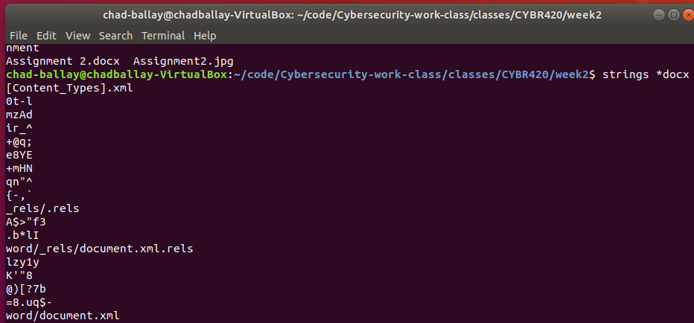

1. Opened the file with a VI to peruse the contents to see if anything jumped out at me. Nothing did.

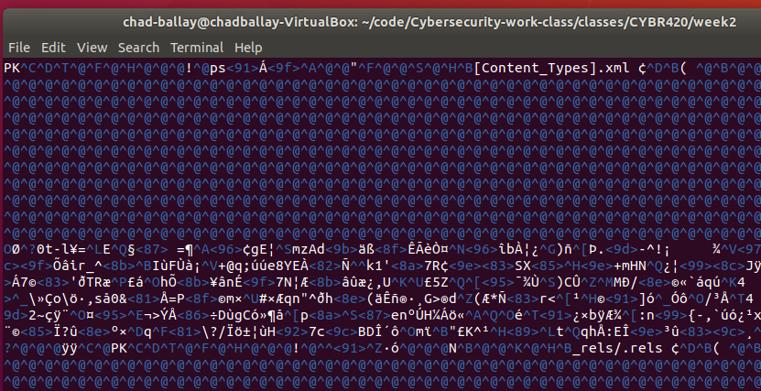

1. Shifted over to a Windows machine and redownloaded the file. Inspected the properties of the file and it continues to look mundane. Office Open XML Document.

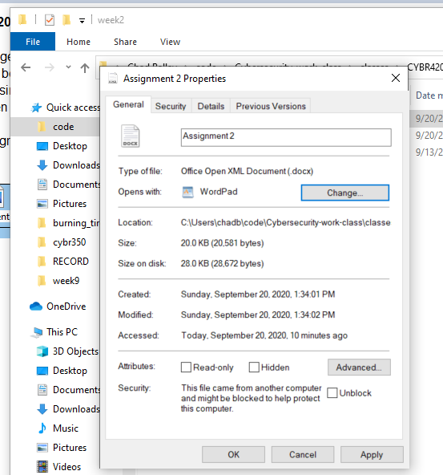

1. Opened the file and was presented with further instructions and an embedded image. (Assignment 2.jpg)

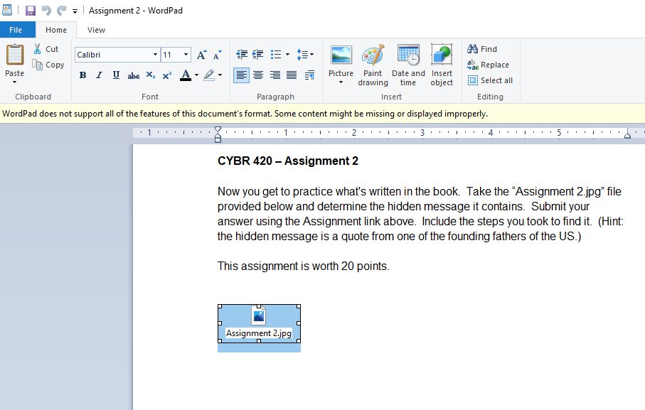

1. Opened Assignment 2.jpg but Windows was unable to display the contents in the image viewer application.

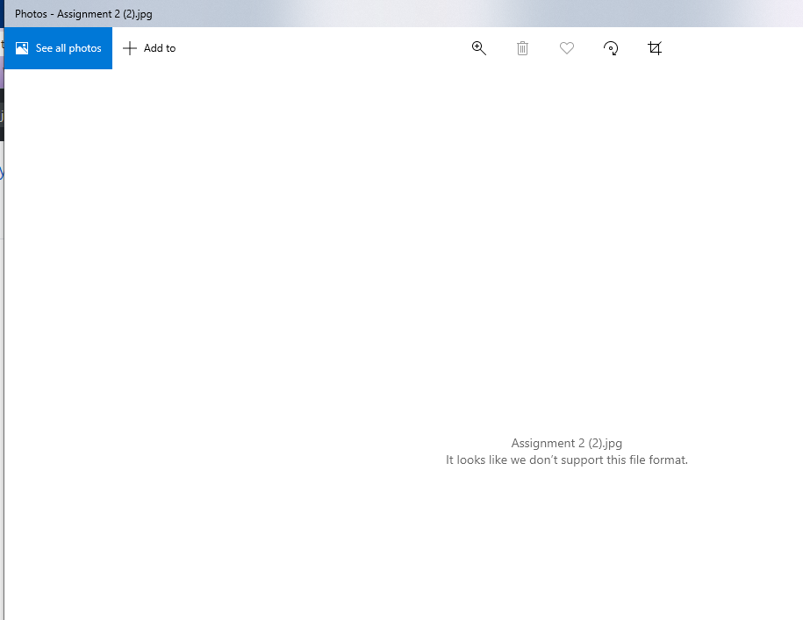

1. Extracted the image out of the word document to try and review it directly.

<https://github.com/Chad-Ballay/Cybersecurity-work-class/blob/master/classes/CYBR420/week2/Assignment2.jpg>

1. Looking at the contents of the file shows to be binary data.

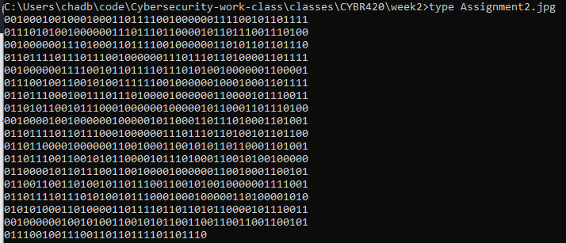

1. On a hunch I dumped the binary into a translator tool.

<https://cryptii.com/pipes/binary-decoder>

1. Tool was able to grab the bytes and do the conversion automatically with no further tweaking.

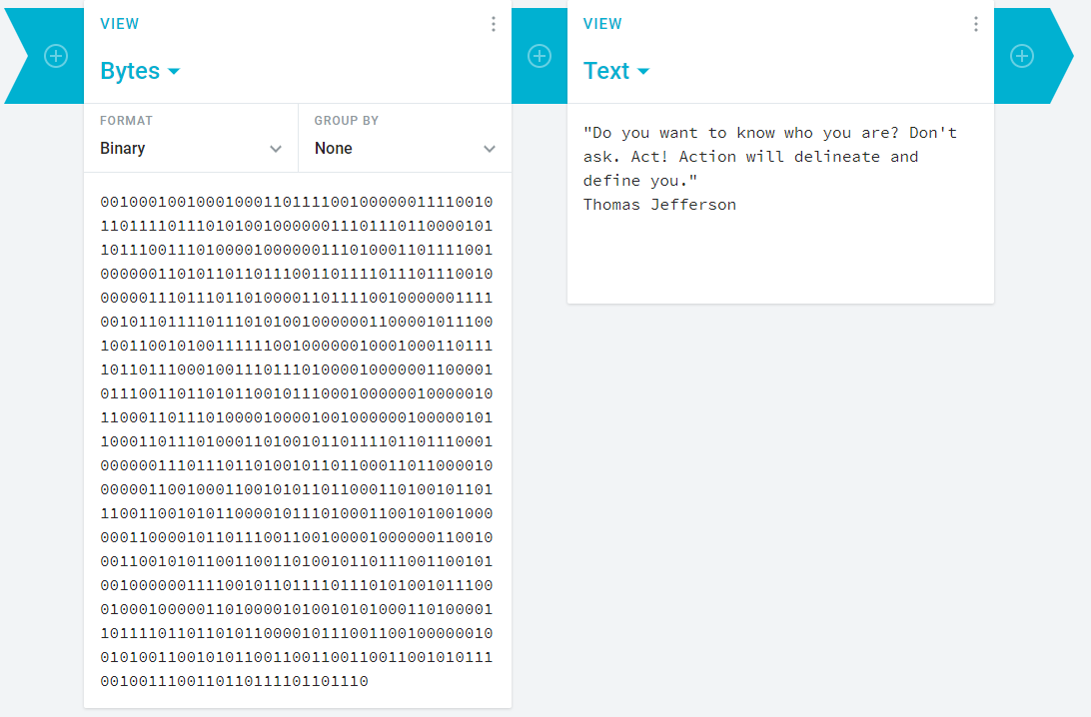

1. To confirm I manually checked some of the bin->ascii conversions by hand.
2. I also used a PERL oneliner to validate as well.

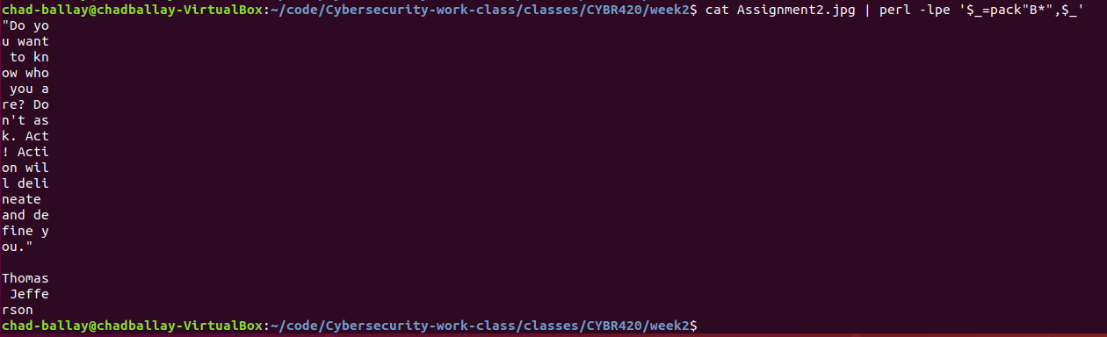

## Solution

"Do you want to know who you are? Don't ask. Act! Action will delineate and define you." Thomas Jefferson