Chad Ballay

CYBR430-342

11/22/2020

Week 1 – Building My Own Lab Environment

**Describe the hardware utilized in your test lab. Is this a laptop, desktop, physical server? How much memory does it have, how much drive space, which operating system are you using? Which hypervisor (if you are using a virtualized environment) are you using? What else can you tell me about it?**

I didn’t get around to ordering a Raspberry Pi 4 to use as a dedicated test lab hardware. My original intent was to have a standalone device that I could reimage with little care as well as isolate as much as possible without introducing the additional headache of whether an issue was due the hypervisor/virtualization implementation of my infrastructure or something else. Being that the shipment was delayed I have opted to go with VMware Workstation. I have a time limited license from my SANS course so I really need to ensure that it doesn’t expire during our class. If my Raspberry Pi comes in soon enough, I’ll redo the setup to using it.

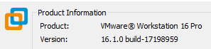

I’m running this on an old IBM ThinkPad due to wanting to ensure I have the utmost freedom to tinker.

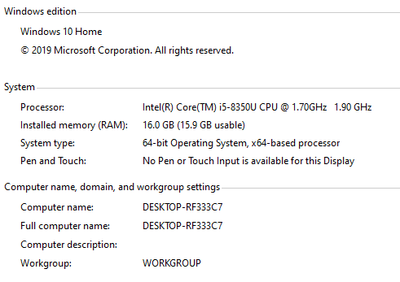

Within VMware I’m running a Kali Linux VM. I chose to go with a prebuilt VM to help ensure I’m starting off with a consistent environment. In the past, my tinkering and exploring has yielded a need to rebuild/reinstall from scratch. The download is a torrent file which then pulls the actual compressed archive down. From there I copied in into my Virtual Machine’s directory and imported it in VMware.

<https://www.offensive-security.com/kali-linux-vm-vmware-virtualbox-image-download/>

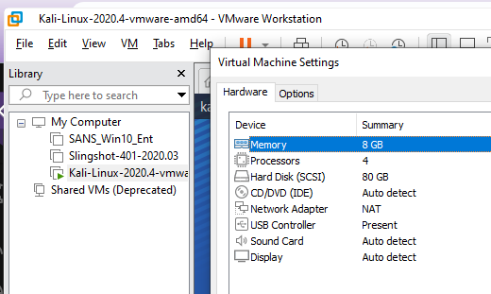

**Provide screen shots of your lab desktop, applications that you have loaded, etc. The purpose of this step is to show me you have actually installed lab tools. You don't need to screenshot everything but it should be obvious I'm not looking at a standard windows or linux desktop. Also, use this as an opportunity to begin finding out what capabilities your tools have. A good place to start your study of Kali capabilities is:** [**https://tools.kali.org/tools-listing**](https://tools.kali.org/tools-listing)**.**

Using apt to update any packages or software.

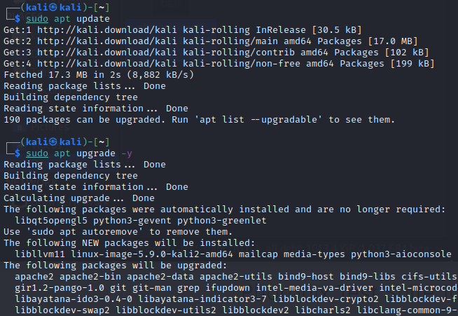

Overall it’s a good setup. Better than I would have expected. VMware has come a longer way than what I remembered of it for administration of VM’s. Within the VM it’s not sluggish. Running a few performance test that I can think of off the top of my head.

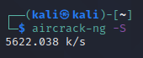

Now on to some of the tools. I need to puzzle out the networking setup because I had hoped to demonstrate using arp-scan on my home network to get a clearer idea of what all is being talkative on the network. But 192.168.253.128 is a private IP address range so I’m kinda limited in what I can see.

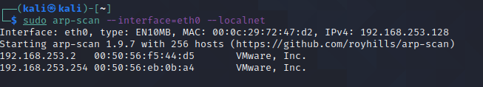

I was able to scan my own website just to test out the tools.

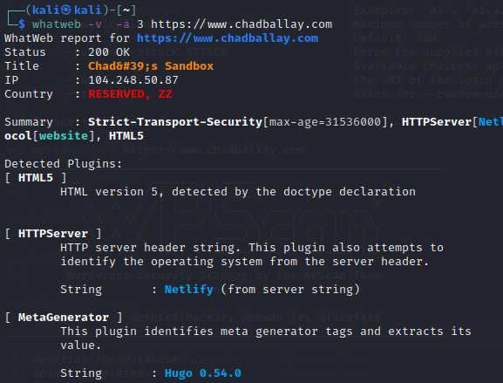

For now I’ll limit it this till I understand how VMware has the network topology configured. I have waaayy too many IoT and various other networked hardware that I want to poke at using some of the tools here. Until I understand this setup better I’m limited in what I can attempt vs what I want to attempt.