Chad Ballay

Cybr 450-342

Week 6

1/26/2021

**CYBR430, Penetration Testing and Incident Response**  
**Week 6-2 Lab – Web Attacks and Accessing Shares**

**Provide a screenshot of the login confirmation displayed after your successful SQL injection attack (5 pts).**

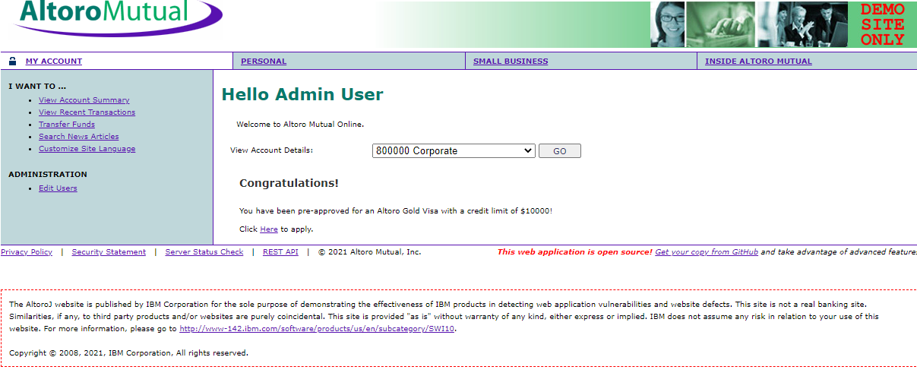

**Provide a screen shot of the alert dialog box generated from your XSS attack (5pts).**

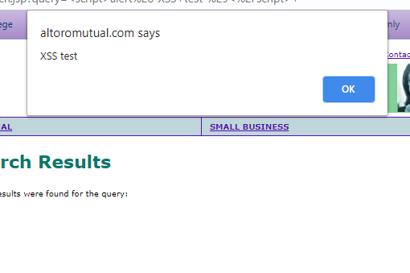

**Part 2: Accessing HAL shares**

