Chad Ballay

CYBR 430-342

Week 7

1/26/2021

**CYBR430, Penetration Testing and Incident Response  
Week 7 Lab – Retaining access, covering your tracks**

**Provide a screenshot of your meterpreter shell access on your target host**

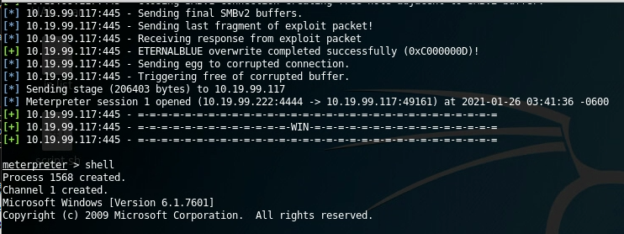

**Provide a screenshot of your target’s audit settings**

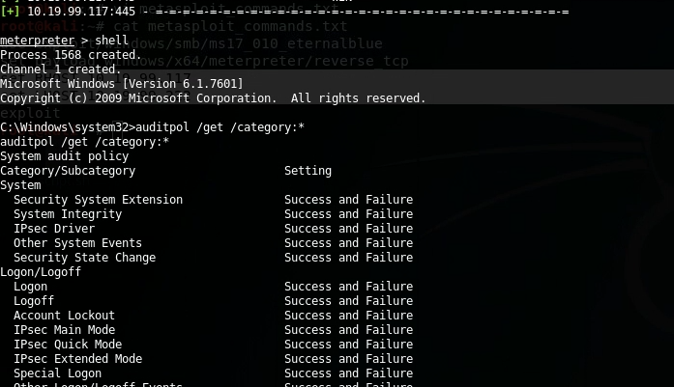

**Provide a screenshot of your upload confirmation**

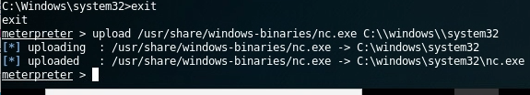

**Provide a screendump of your registry commands similar to the above**

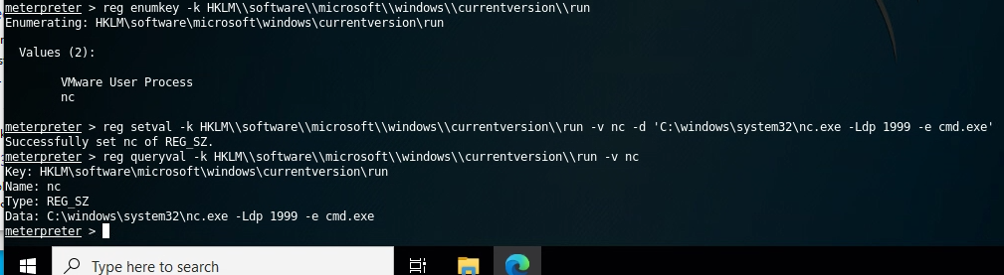**Provide a screendump of your target’s firewall settings**

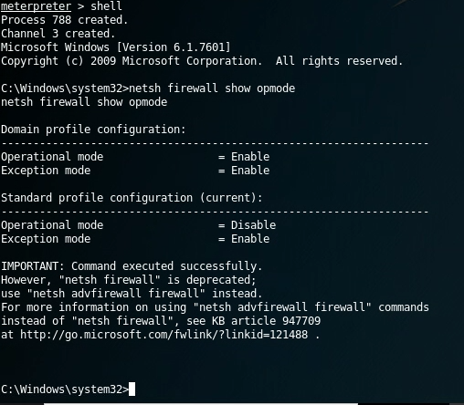

**Provide a screenshot showing your new firewall port openings**

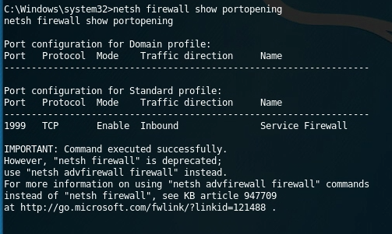

**Execute an ipconfig command to show the ip address of your target system and provide a screen dump**

Enabled remote desktop

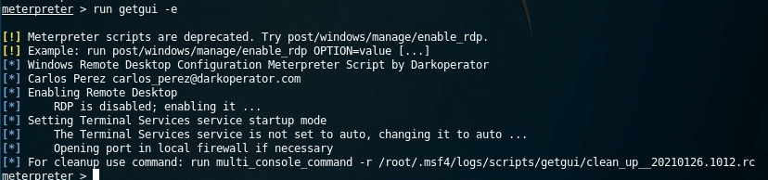

Remote Desktop access

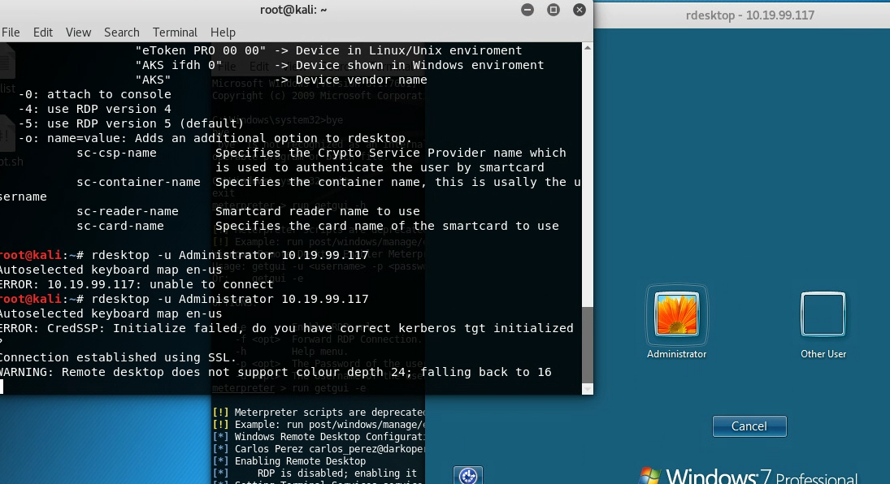

Logged in as russells from passwords harvested previously.

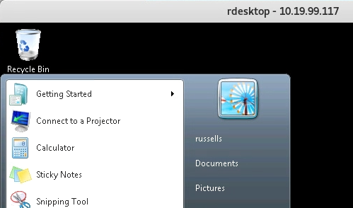

Connected over using nc

