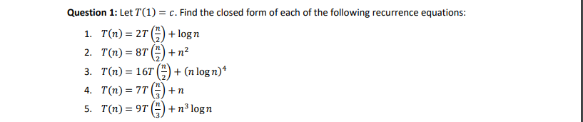

$T\left(n\right)= 2T\left(\frac{n}{2}\right)+\log{n}$

T(2) = $2T\left(1\right)+\log{2}$

T(2) = $2c+1=2c+[4-(2+log{2)]}$

T(4) = $2T\left(2\right)+\log{4}$

T(4) = 4c + 4 = $4c+[8-(2+\log{4)}]$

T(8) = $2T\left(4\right)+\log{8}$

T(8) = $8c+11= 8c+[16-(2+\log{8)}]$

T(16) = $2T\left(8\right)+\log{16}$

T(16) = $16c+26=16c+[32-(2+\log{16)}]$

T(n) $=n*c+2n-(2+\log{n})$

$T\left(n\right)= 8T\left(\frac{n}{2}\right)+n^{2}$

= $8[8T\left(\frac{n}{4}\right)+{(\frac{n}{2})}^{2}]+n^{2}$

= $8^{2}T\left(\frac{n}{4}\right)+3n^{2}$

= $8^{2}[8T\left(\frac{n}{8}\right)+{(\frac{n}{4})}^{2}]+3n^{2}$

= $8^{3}T\left(\frac{n}{8}\right)+7n^{2}$

= $8^{3}[8T\left(\frac{n}{16}\right)+{(\frac{n}{8})}^{2}]+7n^{2}$

= $8^{4}T\left(\frac{n}{16}\right)+15n^{2}$

…

= $8^{k}T\left(\frac{n}{2^{k}}\right)+(2^{k}-1)n^{2}$

$\frac{n}{2^{k}}$ = 1 => k = $\log{n}$

$T\left(n\right)=$ $n^{3}T\left(1\right)+\left(n-1\right)n^{2}$ $= {c*n}^{3}+(n-1)n^{2}$

$T\left(n\right)= 16T\left(\frac{n}{2}\right)+{(n\log{n})}^{4}$

$= 16[16T\left(\frac{n}{4}\right)+{(\frac{n}{2}\log{\frac{n}{2}})}^{4}]+{(n\log{n})}^{4}$

$= {16}^{2}T\left(\frac{n}{4}\right)+{n^{4}[(log{\frac{n}{2}})}^{4}+{(\log{n})}^{4}]$

$= {16}^{2}[16T\left(\frac{n}{8}\right)+{(\frac{n}{4}\log{\frac{n}{4}})}^{4}]+{n^{4}[(log{\frac{n}{2}})}^{4}+{(\log{n})}^{4}]$

$= {16}^{3}T\left(\frac{n}{8}\right)+{n^{4}[(\log{\frac{n}{4}})}^{4}{+(log{\frac{n}{2}})}^{4}+{\left(\log{n}\right)}^{4}]$

$= {16}^{3}[16T\left(\frac{n}{16}\right)+{(\frac{n}{8}\log{\frac{n}{8}})}^{4}]+{n^{4}[(\log{\frac{n}{4}})}^{4}{+(log{\frac{n}{2}})}^{4}+{(\log{n})}^{4}]$

$= {16}^{4}T\left(\frac{n}{16}\right)+{n^{4}[{(\log{\frac{n}{8}})}^{4}+ (\log{\frac{n}{4}})}^{4}{+(log{\frac{n}{2}})}^{4}+{(\log{n})}^{4}]$

…

$= {16}^{k}T\left(\frac{n}{2^{k}}\right)+{n^{4}[{(\log{\frac{n}{2^{k-1}}})}^{4}+ (\log{\frac{n}{2^{k-2}}})}^{4}{+(log{\frac{n}{2^{k-3}}})}^{4}+…+{(\log{n})}^{4}]$

$\frac{n}{2^{k}}=1 =>k=\log{n}$

$T(n)$ = ${16}^{\log{n}}*c+n^{4} [ \sum_{i=0}^{n-1}{{\left(\log{\frac{n}{2^{i}}}\right)}^{4}}$]

$T\left(n\right)= 7T\left(\frac{n}{3}\right)+n$

$= 7[7T\left(\frac{n}{9}\right)+\frac{n}{3}]+n$

$= 7^{2}T\left(\frac{n}{9}\right)+[n+\frac{7^{1}n}{3} ]$

$= 7^{2}[7T\left(\frac{n}{27}\right)+\frac{n}{9}]+[n+\frac{7^{1}n}{3} ]$

$= 7^{3}T\left(\frac{n}{27}\right)+[n+\frac{7^{1}n}{3}+\frac{7^{2}n}{9}]$

$= 7^{3}[7T\left(\frac{n}{81}\right)+\frac{n}{27}]+[n+\frac{7^{1}n}{3}+\frac{7^{2}n}{9}]$

$= 7^{4}T\left(\frac{n}{81}\right)+[\frac{7^{0}n}{3^{0}}+\frac{7^{1}n}{3^{1}}+\frac{7^{2}n}{3^{2}}+\frac{7^{3}n}{3^{3}}]$

…

$= 7^{k}T\left(\frac{n}{3^{k}}\right)+n[ \sum_{i=0}^{n-1}{{\left(\frac{7}{3}\right)}^{i}}$]

$\left(\frac{n}{3^{k}}\right)=1=>k=\log_{3}n$

$T\left(n\right)= 7^{\log_{3}n }*c+n[ \sum_{i=0}^{n-1}{{\left(\frac{7}{3}\right)}^{i}}$]

$T\left(n\right)= 9T\left(\frac{n}{3}\right)+n^{3}\log{n}$

$= 9[9T\left(\frac{n}{9}\right)+{(\frac{n}{3})}^{3}\log{(\frac{n}{3})}]+n^{3}\log{n}$

$= 9^{2}T\left(\frac{n}{9}\right)+n^{3} (\frac{4}{3}\log{n}-\frac{1}{3})$

${= 9}^{2}[9T\left(\frac{n}{27}\right)+{(\frac{n}{9})}^{3}\log{(\frac{n}{9})}]+n^{3} (\frac{4}{3}\log{n}-\frac{1}{3})$

# note $\frac{1}{1}+\frac{1}{3}=\frac{4}{3}$

${= 9}^{3}T\left(\frac{n}{27}\right)+n^{3} (\frac{13}{9}\log{n}-\frac{5}{9})$

# note $\frac{1}{1}+\frac{1}{3}+\frac{1}{9}=\frac{13}{9}$ and $\frac{1}{3}+\frac{2}{9}=\frac{5}{9}$

${= 9}^{3}\left[9T\left(\frac{n}{81}\right)+{\left(\frac{n}{27}\right)}^{3}\log\left(\frac{n}{27}\right)\right]+n^{3}(\frac{13}{9}\log{n}-\frac{5}{9})$

${= 9}^{4}T(\frac{n}{81})+n^{3}(\frac{40}{27}\log{n}-\frac{2}{3})$

# note $\frac{1}{1}+\frac{1}{3}+\frac{1}{9}+\frac{1}{27}=\frac{40}{27}$ and $\frac{1}{3}+\frac{2}{9}+\frac{3}{27}=\frac{2}{3}$

…



${= 9}^{k}T(\frac{n}{3^{k}})+n^{3}\left[ \log_{3}n \sum_{i=0}^{n-1}{(\frac{1}{3^{i}}})-{\sum_{i=0}^{n-1}{(\frac{i}{3}})}^{i} \right]$

$\frac{n}{3^{k}}=1 =>k=\log_{3}n$

${T\left(n\right)= 9}^{\log_{3}n}*c+n^{3}\left[ \log_{3}n \sum_{i=0}^{n-1}{(\frac{1}{3^{i}}})-{\sum_{i=0}^{n-1}{(\frac{i}{3}})}^{i} \right]$

A = ac, B = bd, C = (a+b)(c+d) = (ac + ad + bc +bd)

D = A – B = ac –bd

E = C – B – A = (ac + ad + bc +bd)– bd –ac = ad +bc

X x Y = D + iE = (ac-bd) + i(ad+bc)

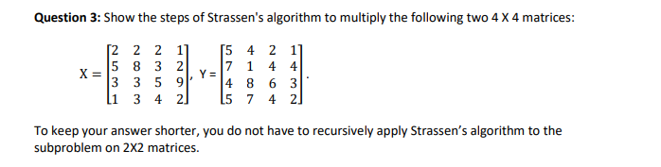

* Divide each matrix into 4 parts. Let $X_{1}$ = top left matrix, $X_{2}$ = top right matrix, $X_{3}$ = bottom left matrix, and $X_{4}$ = bottom right matrix. Y is split into $Y_{1},Y_{2},Y_{3},Y_{4}$ similarly



­

* According to Strassen’s algorithm,
* For a matrix X = [ a b ]  
   [ c d ]
* For a matrix Y = [ e f ]  
   [ g h ]
* P1= a * ( f – h )
* P2 = ( a + b )*h
* P3 = ( c + d )*e
* P4 = d * ( g – e )
* P5 = ( a + d ) * ( e + h )
* P6 = ( b – d ) * ( g + h )
* P7 = ( a – c ) * ( e + f )
* X * Y = Z
* Z = [P6 + P5 + P4 – P2] [P1 + P2]  
   [P3 + P4] [P1 + P5 – P7 – P3]
* Our result matrix will be Z
* Using Strassen’s algorithm to get Z,
* P1 = $X_{1}$* ($Y_{2}-Y_{4})$
  + P1 = [2 2 ] * ( [2 1] - [6 3] ) = [2 2] * [-4 -2] = [-8 0]  
     [5 8 ] [4 4] [4 2] [5 8] [0 2] [-20 6]
* P2 = ($X_{1}+X_{2})$ $Y_{4}$

*
  + P2 = ( [2 2] + [2 1] ) * [6 3 ] = [4 3] * [6 3] = [36 18]  
     [5 8] [3 2] [4 2 ] [8 10] [4 2] [88 44]
* P3 = ( $X_{3}+X_{4})$ $Y_{1}$

*
  + P3 = ( [3 3] + [5 9] ) * [5 4] = [8 12] * [5 4] = [124 44]  
     [1 3] [4 2] [7 1 ] [5 5] [7 1] [60 25]
* P4 = $X_{4}$* ($Y_{3}-Y_{1})$
  + P4 = [5 9 ] * ( [4 8] - [5 4] ) = [5 9] * [-1 4] = [-23 74]  
     [4 2 ] [5 7] [7 1] [4 2] [-2 6] [-8 28]
* P5 = $(X_{1}+X_{4})$* ($Y_{1}+Y_{4})$
  + P5 = ( [2 2] + [5 9] ) * ( [5 4] + [6 3] ) = [7 11] * [11 7] = [198 82]  
     [5 8] [4 2] [7 1] [4 2] [9 10] [11 3] [209 93]
* P6 = ${(X}_{2}-X_{4})$* ($Y_{3}+Y_{4}$)
  + P6 = ( [2 1] - [5 9] ) * ( [4 8] + [6 3] ) = [-3 -8] * [10 11] = [-102 -105]  
     [3 2] [4 2] [5 7] [4 2] [-1 0] [ 9 9] [ -10 -11]
* P7 = $(X_{1}-X_{3})$* ($Y_{1}+Y_{2})$
  + P7 = ( [2 2] - [3 3] ) * ( [5 4] + [2 1] ) = [-1 -1] * [7 5] = [-18 -10]  
     [5 8] [1 3] [7 1] [4 4] [4 5] [11 5] [ 83 45]
* $Z_{1}$ = P6 + P5 + P4 – P2
  + $Z_{1}$ = [-102 -105] + [198 82] + [-23 74] - [36 18] = [37 33]  
     [ -10 -11] [209 93] [-8 28] [88 44] = [103 66]
* $Z_{2}$ = P1 + P2
  + $Z_{2}$ = [-8 0] + [36 18] = [28 18]

[-20 6] [88 44] [68 50]

* $Z_{3}$ = P3 + P4
  + $Z_{3}$ = [124 44]+ [-23 74] = [101 118]

[60 25] [-8 28] [52 53]

* $Z_{4}$ = P1 + P5 – P7 – P3
  + $Z_{4}$ = [-8 0] + [198 82] - [-18 -10] - [124 44] = [84 48]  
     [-20 6] [209 93] [ 83 45] [60 25] = [46 29]
* Z = [ 37 33 28 18 ]

[ 103 66 68 50 ]

[ 101 118 84 48 ]

[ 52 53 46 29 ]

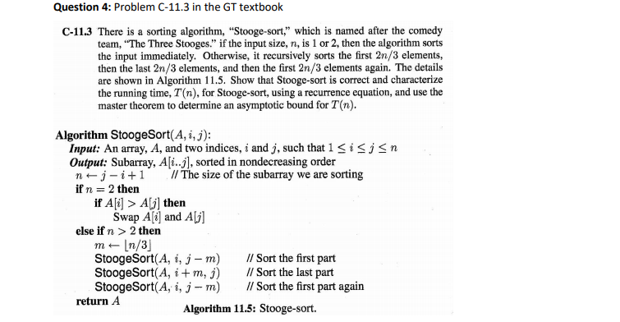

If n <= 2, the algorithm clearly works. If we call the first third of the array X, the second third Y, and the final third Z, then after sorting the first 2/3 of the array recursively, then we know that all elements in X are less than all elements in Y. After recursively sorting the final 2/3 elements, all the elements in Y are less than all the elements in Z. Since all the elements in Y were greater than the elements in X, then all the elements in Z are greater than all the elements in X. Therefore, the elements in Z are in the correct location. Then after sorting the first 2/3 of the array again, we know get the all the elements in X and Y are now in the correct location. Now we have a sorted array and we see that StoogeSort works.

$T\left(n\right)= 3*T\left(\frac{2n}{3}\right)+ O(1)$, since StoogeSort is recursively called 3 times on 2/3 of the size of the original input.

Master’s Theorm:

f(n) = 1 = $O\left(n^{c}\right) if c=0.$

$a=3, b=3/2$

$\log_{b}\left(a\right)= \log_{\frac{3}{2}}\left(3\right)=\sim 2.71$

c < 2.71, so T(n) $= O\left(n^{\log_{\frac{3}{2}}\left(3\right)}\right)= O(n^{2.71})$