NBA Cluster Report
Chad Huntebrinker
The dataset used for this analysis comes from Basketball Reference, a reliable public source providing detailed player statistics for the 2023–2024 NBA season. The dataset includes quantitative variables such as points, assists, rebounds, steals, blocks, and shooting percentages for all players. For this assignment, the top 100 scorers are used to ensure that each player has sufficient playing time and was relatively useful to their teams.

To perform clustering, only quantitative variables are included since clustering methods like PCA and hierarchical clustering rely on numeric data. The following variables were selected to capture player performance, efficiency, and playing style:
Player Player name
FGA Field goals attempted per game
FG Field goals made per game
3P 3-point field goals made per game
2P 2-point field goals made per game
eFG% Effective field goal percentage (weights 3-point shots more)
FT Free throws made per game
TRB Total rebounds per game
AST Assists per game
STL Steals per game
BLK Blocks per game
TOV Turnovers per game
PF Personal fouls per game
PTS Points per game
We removed the position that players played since they are non-numeric. However, player position may later be used to interpret clusters (for example, checking whether guards, forwards, and centers group together).

Both FG% and eFG% measure shooting efficiency, but eFG% provides a more accurate representation by accounting for the added value of 3-point shots. So FG% was excluded to avoid redundancy.

The purpose of clustering this NBA dataset is to identify groups of players with similar statistical profiles. By examining these clusters, we can discover distinct player archetypes — such as high-volume scorers, efficient shooters, playmakers, or defensive specialists. This helps uncover deeper patterns in playing style and performance beyond basic averages or rankings.

Clustering offers a data-driven way to answer questions such as:
- Which statistical traits define groups of similar players?
- Are there clear differences between offensive and defensive contributors?
- How do efficiency metrics relate to overall production?

Two clustering methods will be used:
Principal Component Analysis (PCA):
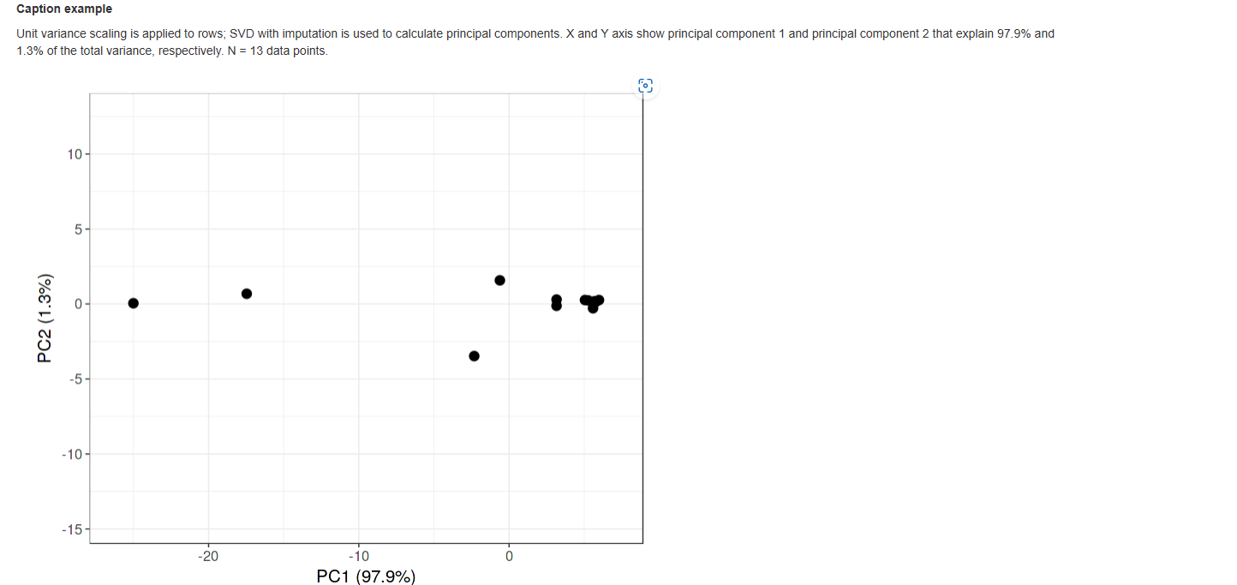
Something interesting we see is that the PC1 is 97.9% while PC2 is 1.3% and compare that to our PC table:
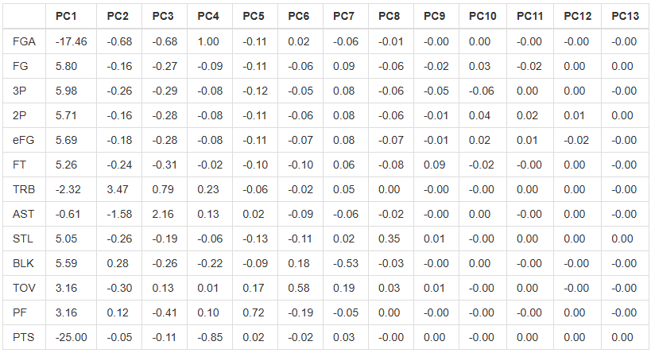
We see that PC1 represents our offensive productivity axis (since Field Goal Attempts and Points both have large negative weights) while PC2 represents playmaking and rebounding axis (since their our largest contributors). Since PC1 explains most of our variance, we see that most difference between the players are with scoring and shot attempts. However, the inclusion of PC2 captures a smaller difference between playmakers and rebounders.

Heatmap:
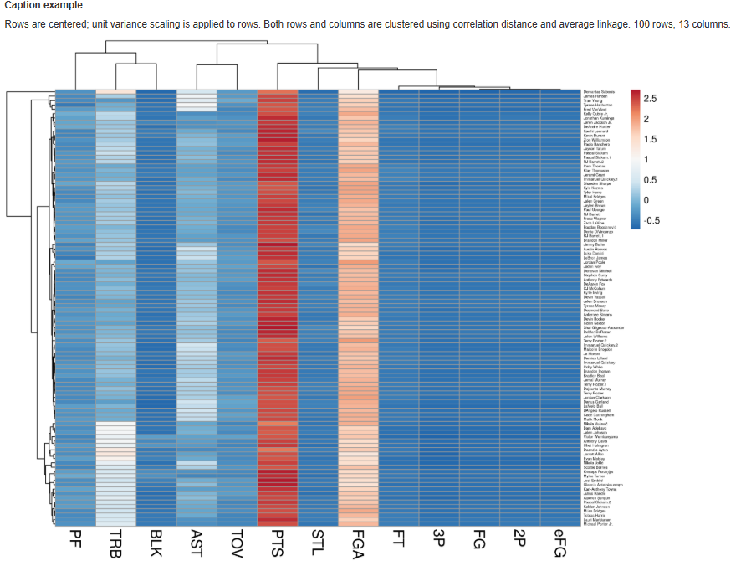
To explore our heatmap, we used correlation clustering distance and complete clustering method. These confirm what we had seen previously (high scoring players have the biggest impact with PTS and FGA, we see some rebounding and assists are involved in a minor way). However, what if we tried removing PTS and FGA since they seem to play a dominating role? Well, our PCA and Heat Map looks like this:
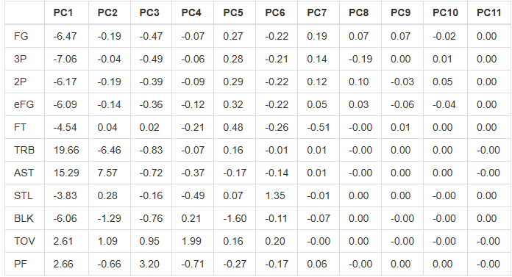
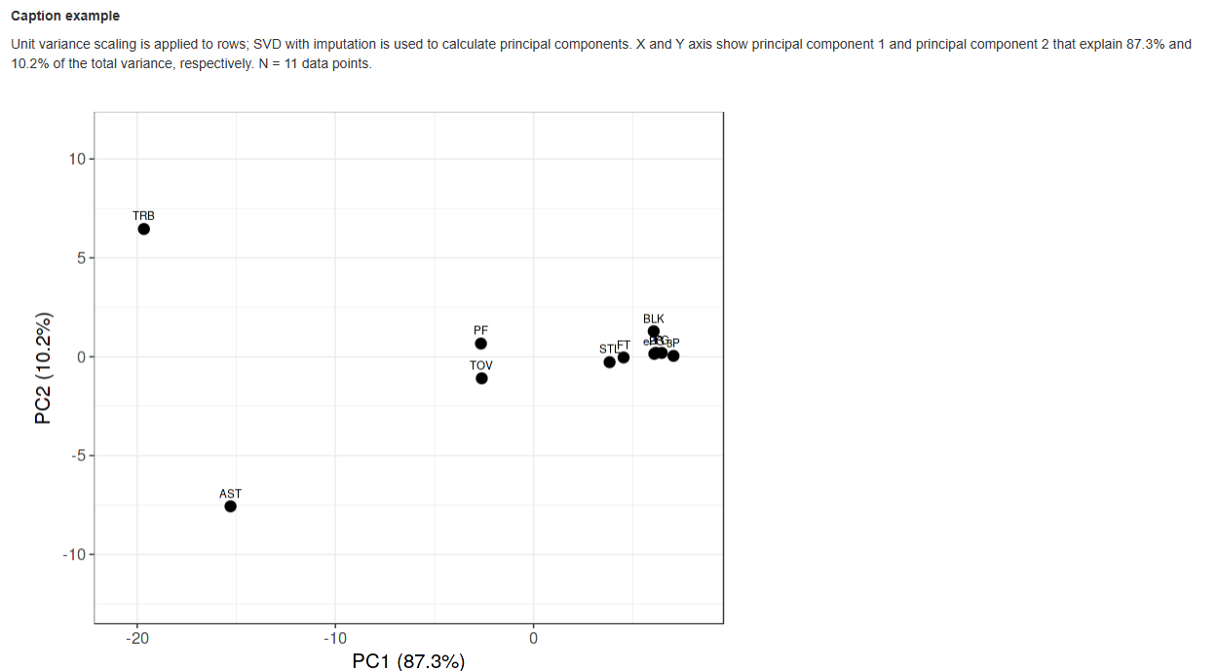
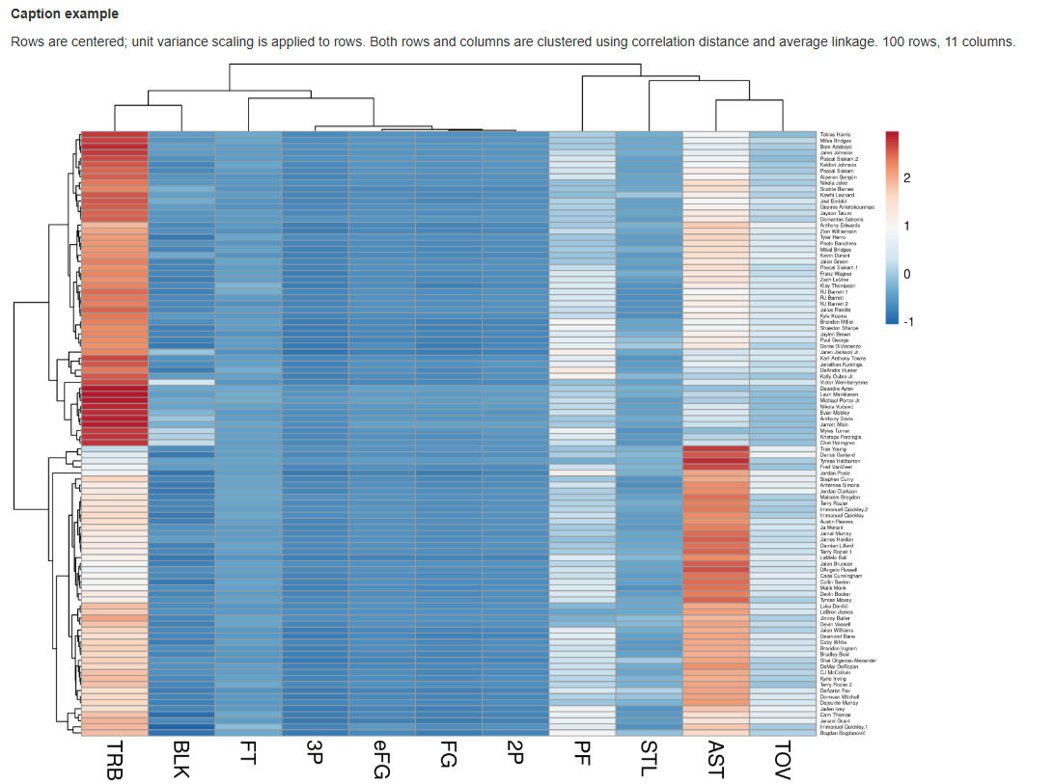
Now in these cases, we see that PC1 mostly contains TRB (+19.7) and AST (+15.3) as their biggest influence with most offensive efficiency stats (FG, 3P, eFG) contributing moderately to the negative weights. PC1 is now showing us the difference between players who generate possessions and make plays happen (high rebounds or assists) from those who primarily score efficiently. PC2 is showing us that AST is strongly positive (+7.6) while TRB is strongly negative (−6.5), which contrasts our PC1. This is distinguishing between playmakers from rebounders.
With our PC1 = 87.3%, it’s still explaining most of the variation in the data. However, it’s less extreme than before (97.9%), meaning that removing PTS and FGA diversified our dataset and variance is now shared among more aspects besides scoring.
With our PC2 = 10.2%, the second component now captures a significant secondary dimension, rather than being negligible (1.3% before). This confirms that without pure scoring volume, playmaking vs. rebounding emerges as an important distinction between player types.

