Chad Huntebrinker Module 14 Assignment
Chad Huntebrinker
2025-11-27
#Chad Huntebrinker
library(tidyverse)
## ── Attaching core tidyverse packages ──────────────────────── tidyverse 2.0.0 ──
## ✔ dplyr 1.1.4 ✔ readr 2.1.5
## ✔ forcats 1.0.0 ✔ stringr 1.5.1
## ✔ ggplot2 3.5.1 ✔ tibble 3.2.1
## ✔ lubridate 1.9.3 ✔ tidyr 1.3.1
## ✔ purrr 1.0.2
## ── Conflicts ────────────────────────────────────────── tidyverse_conflicts() ──
## ✖ dplyr::filter() masks stats::filter()
## ✖ dplyr::lag() masks stats::lag()
## ℹ Use the conflicted package (<http://conflicted.r-lib.org/>) to force all conflicts to become errors
library(readxl)
library(igraph)
## Warning: package 'igraph' was built under R version 4.4.3
##
## Attaching package: 'igraph'
##
## The following objects are masked from 'package:lubridate':
##
## %--%, union
##
## The following objects are masked from 'package:dplyr':
##
## as_data_frame, groups, union
##
## The following objects are masked from 'package:purrr':
##
## compose, simplify
##
## The following object is masked from 'package:tidyr':
##
## crossing
##
## The following object is masked from 'package:tibble':
##
## as_data_frame
##
## The following objects are masked from 'package:stats':
##
## decompose, spectrum
##
## The following object is masked from 'package:base':
##
## union
library(ggraph)
## Warning: package 'ggraph' was built under R version 4.4.3
library(network)
## Warning: package 'network' was built under R version 4.4.3
##
## 'network' 1.19.0 (2024-12-08), part of the Statnet Project
## * 'news(package="network")' for changes since last version
## * 'citation("network")' for citation information
## * 'https://statnet.org' for help, support, and other information
##
##
## Attaching package: 'network'
##
## The following objects are masked from 'package:igraph':
##
## %c%, %s%, add.edges, add.vertices, delete.edges, delete.vertices,
## get.edge.attribute, get.edges, get.vertex.attribute, is.bipartite,
## is.directed, list.edge.attributes, list.vertex.attributes,
## set.edge.attribute, set.vertex.attribute
library(sna)
## Warning: package 'sna' was built under R version 4.4.3
## Loading required package: statnet.common
## Warning: package 'statnet.common' was built under R version 4.4.3
##
## Attaching package: 'statnet.common'
##
## The following objects are masked from 'package:base':
##
## attr, order, replace
##
## sna: Tools for Social Network Analysis
## Version 2.8 created on 2024-09-07.
## copyright (c) 2005, Carter T. Butts, University of California-Irvine
## For citation information, type citation("sna").
## Type help(package="sna") to get started.
##
##
## Attaching package: 'sna'
##
## The following objects are masked from 'package:igraph':
##
## betweenness, bonpow, closeness, components, degree, dyad.census,
## evcent, hierarchy, is.connected, neighborhood, triad.census
library(visNetwork)
## Warning: package 'visNetwork' was built under R version 4.4.3
library(threejs)
## Warning: package 'threejs' was built under R version 4.4.3
library(networkD3)
## Warning: package 'networkD3' was built under R version 4.4.3
library(ndtv)
## Warning: package 'ndtv' was built under R version 4.4.3
## Loading required package: networkDynamic
## Warning: package 'networkDynamic' was built under R version 4.4.3
##
## 'networkDynamic' 0.11.5 (2024-11-21), part of the Statnet Project
## * 'news(package="networkDynamic")' for changes since last version
## * 'citation("networkDynamic")' for citation information
## * 'https://statnet.org' for help, support, and other information
##
## Loading required package: animation
## Warning: package 'animation' was built under R version 4.4.3
##
## 'ndtv' 0.13.4 (2024-06-30), part of the Statnet Project
## * 'news(package="ndtv")' for changes since last version
## * 'citation("ndtv")' for citation information
## * 'https://statnet.org' for help, support, and other information
drug_network_data <- read_xls("Interaction_drug_network.xls")
Exercise 1
#Exercise 1
#Node type for shape/color mapping
g <- graph_from_data_frame(drug_network_data, directed = FALSE)
V(g)$type <- ifelse(V(g)$name %in% drug_network_data$BAIT, "BAIT", "PREY")
V(g)$shape <- ifelse(V(g)$type == "BAIT", "square", "circle")
V(g)$color <- ifelse(V(g)$type == "BAIT", "blue", "green")
E(g)$color <- drug_network_data$COLOR
E(g)$weight <- abs(drug_network_data$WEIGHT)
ggraph(g, layout = "circle") +
geom_edge_link(aes(color = color)) +
geom_node_point(aes(shape = type, color = color), size = 6) +
geom_node_text(aes(label = name), repel = TRUE) +
theme_void()
## Warning: ggrepel: 295 unlabeled data points (too many overlaps). Consider
## increasing max.overlaps
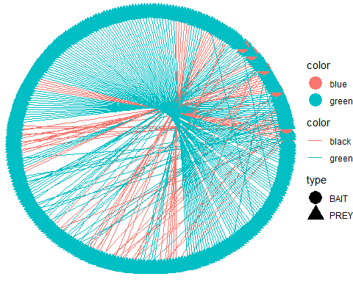
Exercise 2
#Exercise 2
#Generate some data
drugnet <- data.frame(
Drug = c("DrugA","DrugA","DrugB","DrugC","DrugC"),
Target = c("P1","P3","P2","P1","P4"),
Effect = c("inhibits","activates","inhibits","binds","activates")
)
g2 <- graph_from_data_frame(drugnet, directed = TRUE)
plot(g2, vertex.color="orange", vertex.size=25, edge.arrow.size=0.4, edge.label=drugnet$Effect,
edge.label.cex=0.5)
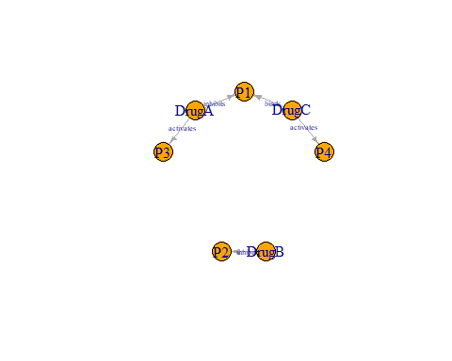
Created a dataset representing a drug–target interaction network. The goal is to model the relationships between two different types of entities:
Drugs (small molecules or compounds) Targets (proteins or receptors they act on) Each interaction is represented as a directed connection from a drug to the protein it affects
DrugA → P1 (inhibits) DrugA → P3 (activates) DrugB → P2 (inhibits) DrugC → P1 (binds) DrugC → P4 (activates)

