Chad Huntebrinker Module 15 Assignment
Chad Huntebrinker
2025-11-28
#Chad Huntebrinker
library(FactoMineR)
## Warning: package 'FactoMineR' was built under R version 4.4.3
library(factoextra)
## Warning: package 'factoextra' was built under R version 4.4.3
## Loading required package: ggplot2
## Warning: package 'ggplot2' was built under R version 4.4.3
## Welcome! Want to learn more? See two factoextra-related books at https://goo.gl/ve3WBa
library(datasets)
library(heatmap3)
## Warning: package 'heatmap3' was built under R version 4.4.3
#Get the data
data(iris)
iris_data <- iris
Exercise 1: PCA, CA, and MCA
#Exercise 1
#PCA
iris_pca <- PCA(iris_data, graph=FALSE, quali.sup = 5)
fviz_eig(iris_pca)
## Warning in geom_bar(stat = "identity", fill = barfill, color = barcolor, :
## Ignoring empty aesthetic: `width`.
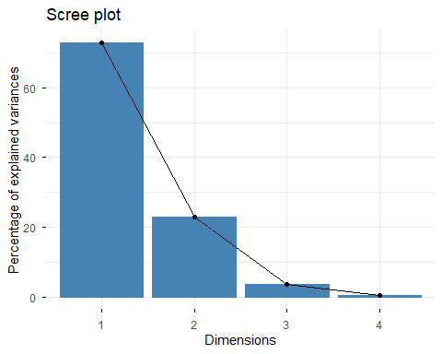
fviz_pca_ind(iris_pca, repel=TRUE)
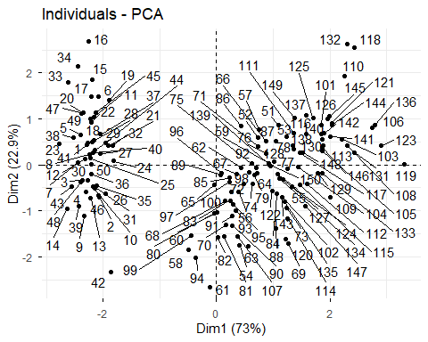
fviz_pca_biplot(iris_pca, repel=TRUE)
## Warning: Using `size` aesthetic for lines was deprecated in ggplot2 3.4.0.
## ℹ Please use `linewidth` instead.
## ℹ The deprecated feature was likely used in the ggpubr package.
## Please report the issue at <https://github.com/kassambara/ggpubr/issues>.
## This warning is displayed once every 8 hours.
## Call `lifecycle::last_lifecycle_warnings()` to see where this warning was
## generated.
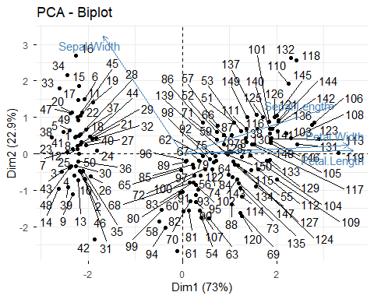
#CA
iris_ca <- CA(iris_data, graph=FALSE, quali.sup = 5)
fviz_ca_biplot(iris_ca, repel =TRUE)
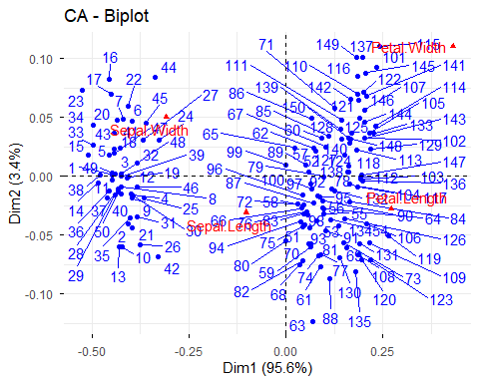
#MCA
iris_pca <- PCA(iris[, -5], graph = FALSE)
p<-fviz_mca_ind(iris_pca,
label="none",
repel=TRUE,
habillage = iris_data,
addEllipses = TRUE,
ellipse.level = 0.95)
## Warning: `gather_()` was deprecated in tidyr 1.2.0.
## ℹ Please use `gather()` instead.
## ℹ The deprecated feature was likely used in the factoextra package.
## Please report the issue at <https://github.com/kassambara/factoextra/issues>.
## This warning is displayed once every 8 hours.
## Call `lifecycle::last_lifecycle_warnings()` to see where this warning was
## generated.
## Warning in stats::qt(ci/2 + 0.5, data_sum$length - 1): NaNs produced
## Warning in stats::qt(ci/2 + 0.5, data_sum$length - 1): NaNs produced
## Warning in stats::qt(ci/2 + 0.5, data_sum$length - 1): NaNs produced
## Warning in stats::qt(ci/2 + 0.5, data_sum$length - 1): NaNs produced
## Warning in stats::qt(ci/2 + 0.5, data_sum$length - 1): NaNs produced
## Warning in stats::qt(ci/2 + 0.5, data_sum$length - 1): NaNs produced
## Warning in stats::qt(ci/2 + 0.5, data_sum$length - 1): NaNs produced
## Warning in stats::qt(ci/2 + 0.5, data_sum$length - 1): NaNs produced
## Warning in stats::qt(ci/2 + 0.5, data_sum$length - 1): NaNs produced
## Warning in stats::qt(ci/2 + 0.5, data_sum$length - 1): NaNs produced
## Warning in stats::qt(ci/2 + 0.5, data_sum$length - 1): NaNs produced
## Warning in stats::qt(ci/2 + 0.5, data_sum$length - 1): NaNs produced
## Warning in stats::qt(ci/2 + 0.5, data_sum$length - 1): NaNs produced
## Warning in stats::qt(ci/2 + 0.5, data_sum$length - 1): NaNs produced
## Warning in stats::qt(ci/2 + 0.5, data_sum$length - 1): NaNs produced
## Warning in stats::qt(ci/2 + 0.5, data_sum$length - 1): NaNs produced
## Warning in stats::qt(ci/2 + 0.5, data_sum$length - 1): NaNs produced
## Warning in stats::qt(ci/2 + 0.5, data_sum$length - 1): NaNs produced
## Warning in stats::qt(ci/2 + 0.5, data_sum$length - 1): NaNs produced
## Warning in stats::qt(ci/2 + 0.5, data_sum$length - 1): NaNs produced
## Warning in stats::qt(ci/2 + 0.5, data_sum$length - 1): NaNs produced
## Warning in stats::qt(ci/2 + 0.5, data_sum$length - 1): NaNs produced
## Warning in stats::qt(ci/2 + 0.5, data_sum$length - 1): NaNs produced
## Warning in stats::qt(ci/2 + 0.5, data_sum$length - 1): NaNs produced
## Warning in stats::qt(ci/2 + 0.5, data_sum$length - 1): NaNs produced
## Warning in stats::qt(ci/2 + 0.5, data_sum$length - 1): NaNs produced
## Warning in stats::qt(ci/2 + 0.5, data_sum$length - 1): NaNs produced
## Warning in stats::qt(ci/2 + 0.5, data_sum$length - 1): NaNs produced
## Warning in stats::qt(ci/2 + 0.5, data_sum$length - 1): NaNs produced
## Warning in stats::qt(ci/2 + 0.5, data_sum$length - 1): NaNs produced
## Warning in stats::qt(ci/2 + 0.5, data_sum$length - 1): NaNs produced
## Warning in stats::qt(ci/2 + 0.5, data_sum$length - 1): NaNs produced
## Warning in stats::qt(ci/2 + 0.5, data_sum$length - 1): NaNs produced
## Warning in stats::qt(ci/2 + 0.5, data_sum$length - 1): NaNs produced
## Warning in stats::qt(ci/2 + 0.5, data_sum$length - 1): NaNs produced
## Warning in stats::qt(ci/2 + 0.5, data_sum$length - 1): NaNs produced
## Warning in stats::qt(ci/2 + 0.5, data_sum$length - 1): NaNs produced
## Warning in stats::qt(ci/2 + 0.5, data_sum$length - 1): NaNs produced
## Warning in stats::qt(ci/2 + 0.5, data_sum$length - 1): NaNs produced
## Warning in stats::qt(ci/2 + 0.5, data_sum$length - 1): NaNs produced
## Warning in stats::qt(ci/2 + 0.5, data_sum$length - 1): NaNs produced
## Warning in stats::qt(ci/2 + 0.5, data_sum$length - 1): NaNs produced
## Warning in stats::qt(ci/2 + 0.5, data_sum$length - 1): NaNs produced
## Warning in stats::qt(ci/2 + 0.5, data_sum$length - 1): NaNs produced
## Warning in stats::qt(ci/2 + 0.5, data_sum$length - 1): NaNs produced
## Warning in stats::qt(ci/2 + 0.5, data_sum$length - 1): NaNs produced
## Warning in stats::qt(ci/2 + 0.5, data_sum$length - 1): NaNs produced
## Warning in stats::qt(ci/2 + 0.5, data_sum$length - 1): NaNs produced
## Warning in stats::qt(ci/2 + 0.5, data_sum$length - 1): NaNs produced
## Warning in stats::qt(ci/2 + 0.5, data_sum$length - 1): NaNs produced
## Warning in stats::qt(ci/2 + 0.5, data_sum$length - 1): NaNs produced
## Warning in stats::qt(ci/2 + 0.5, data_sum$length - 1): NaNs produced
print(p)
## Too few points to calculate an ellipse
## Too few points to calculate an ellipse
## Too few points to calculate an ellipse
## Too few points to calculate an ellipse
## Too few points to calculate an ellipse
## Too few points to calculate an ellipse
## Too few points to calculate an ellipse
## Too few points to calculate an ellipse
## Too few points to calculate an ellipse
## Too few points to calculate an ellipse
## Too few points to calculate an ellipse
## Too few points to calculate an ellipse
## Too few points to calculate an ellipse
## Too few points to calculate an ellipse
## Too few points to calculate an ellipse
## Too few points to calculate an ellipse
## Too few points to calculate an ellipse
## Too few points to calculate an ellipse
## Too few points to calculate an ellipse
## Too few points to calculate an ellipse
## Too few points to calculate an ellipse
## Too few points to calculate an ellipse
## Too few points to calculate an ellipse
## Too few points to calculate an ellipse
## Too few points to calculate an ellipse
## Too few points to calculate an ellipse
## Too few points to calculate an ellipse
## Too few points to calculate an ellipse
## Too few points to calculate an ellipse
## Too few points to calculate an ellipse
## Too few points to calculate an ellipse
## Too few points to calculate an ellipse
## Too few points to calculate an ellipse
## Too few points to calculate an ellipse
## Too few points to calculate an ellipse
## Too few points to calculate an ellipse
## Too few points to calculate an ellipse
## Too few points to calculate an ellipse
## Too few points to calculate an ellipse
## Too few points to calculate an ellipse
## Too few points to calculate an ellipse
## Too few points to calculate an ellipse
## Too few points to calculate an ellipse
## Too few points to calculate an ellipse
## Too few points to calculate an ellipse
## Too few points to calculate an ellipse
## Too few points to calculate an ellipse
## Too few points to calculate an ellipse
## Too few points to calculate an ellipse
## Too few points to calculate an ellipse
## Too few points to calculate an ellipse
## Too few points to calculate an ellipse
## Too few points to calculate an ellipse
## Too few points to calculate an ellipse
## Too few points to calculate an ellipse
## Too few points to calculate an ellipse
## Too few points to calculate an ellipse
## Too few points to calculate an ellipse
## Too few points to calculate an ellipse
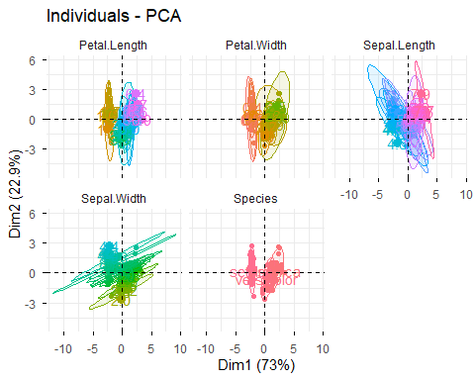
## Graph of variables categories
fviz_mca_var(iris_pca, repel=TRUE)
## Warning: `aes_string()` was deprecated in ggplot2 3.0.0.
## ℹ Please use tidy evaluation idioms with `aes()`.
## ℹ See also `vignette("ggplot2-in-packages")` for more information.
## ℹ The deprecated feature was likely used in the factoextra package.
## Please report the issue at <https://github.com/kassambara/factoextra/issues>.
## This warning is displayed once every 8 hours.
## Call `lifecycle::last_lifecycle_warnings()` to see where this warning was
## generated.
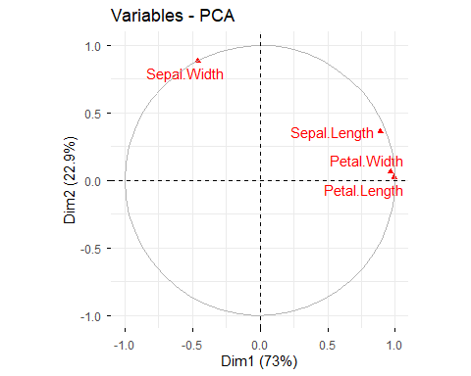
##Biplot of individuals and variables
fviz_mca_biplot(iris_pca, repel=TRUE,
ggtheme=theme_minimal())
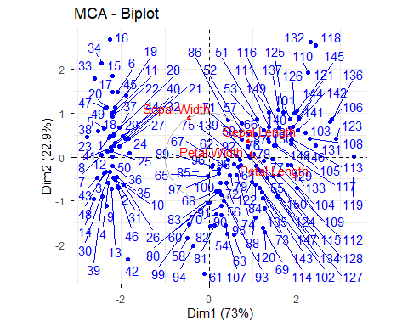
Exercise 2: Heatmap
#Exercise 2
df_scaled <- scale(iris_data[, 1:4])
heatmap3(df_scaled,
distfun = function(x) dist(x, method = "euclidean"),
hclustfun = function(x, ...) hclust(x, method = "ward.D2"),
scale = "none",
main = "Heatmap with Hierarchical Clustering (Iris Dataset)",
margins = c(6, 6))
