Chad Huntebrinker’s Assignment 4
Chad Huntebrinker
2025-09-14
library(ggplot2)
library(tidyr)
character_columns <- names(mpg)[sapply(mpg, is.character)]
mpg[character_columns] <- lapply(mpg[character_columns], as.factor)
str(mpg)
## tibble [234 × 11] (S3: tbl_df/tbl/data.frame)
## $ manufacturer: Factor w/ 15 levels "audi","chevrolet",..: 1 1 1 1 1 1 1 1 1 1 ...
## $ model : Factor w/ 38 levels "4runner 4wd",..: 2 2 2 2 2 2 2 3 3 3 ...
## $ displ : num [1:234] 1.8 1.8 2 2 2.8 2.8 3.1 1.8 1.8 2 ...
## $ year : int [1:234] 1999 1999 2008 2008 1999 1999 2008 1999 1999 2008 ...
## $ cyl : int [1:234] 4 4 4 4 6 6 6 4 4 4 ...
## $ trans : Factor w/ 10 levels "auto(av)","auto(l3)",..: 4 9 10 1 4 9 1 9 4 10 ...
## $ drv : Factor w/ 3 levels "4","f","r": 2 2 2 2 2 2 2 1 1 1 ...
## $ cty : int [1:234] 18 21 20 21 16 18 18 18 16 20 ...
## $ hwy : int [1:234] 29 29 31 30 26 26 27 26 25 28 ...
## $ fl : Factor w/ 5 levels "c","d","e","p",..: 4 4 4 4 4 4 4 4 4 4 ...
## $ class : Factor w/ 7 levels "2seater","compact",..: 2 2 2 2 2 2 2 2 2 2 ...
Exercise 1:
#Exercise 1
#Scatter plot
ggplot(data = mpg, aes(x = cty, y = hwy)) +
geom_point() +
geom_smooth(method = lm, se = TRUE) +
labs(
title = "City vs Highway MPG",
x = "City MPG",
y = "Highway MPG"
)
## `geom_smooth()` using formula = 'y ~ x'
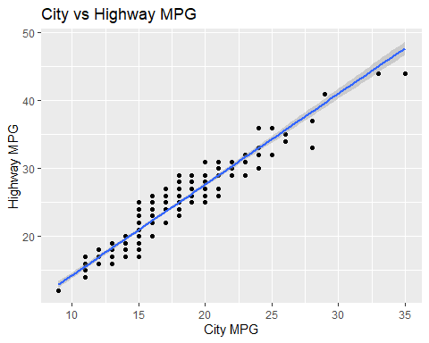
#rugplot and heatmap
ggplot(data = mpg, aes(x = cty, y = hwy)) +
geom_point() +
geom_rug() +
labs(
title = "Rug Map City vs Highway MPG",
x = "City MPG",
y = "Highway MPG"
)
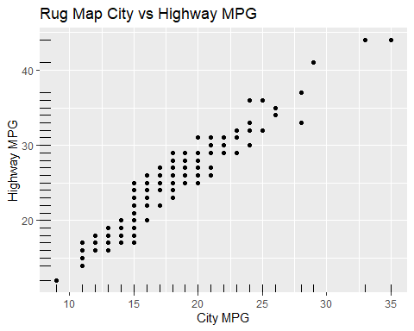
ggplot(data = mpg, aes(x = cty, y = hwy)) +
geom_bin2d() +
labs(
title = "Heat Map of City vs Highway MPG",
x = "City Highway",
y = "Highway MPG"
)
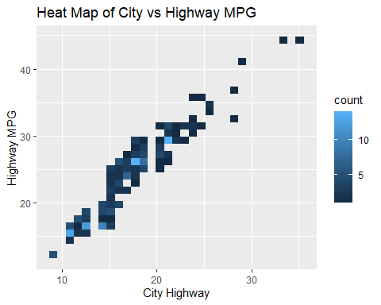
#What's the insight?
#Insight is that there is a linear relationship between city fuel efficiency and
#highway fuel efficiency. As the city MPG increases, so does the highway.
The insight we’ve found is that there is a linear relationship between city fuel efficiency and highway fuel efficiency. As the city MPG increases, so does the highway.
Exercise 2:
#Exercise 2:
p1 <- ggplot(data = mpg, aes(x = manufacturer, y = hwy)) +
geom_boxplot(fill = "lightblue") +
geom_jitter(color = "black") +
labs(
title = "Boxplot of Manfacturers' Highway MPG",
x = "Manufacturers",
y = "Highway MPG"
) +
theme_minimal() +
theme(axis.text.x = element_text(angle = 45, hjust = 1))
p2 <- ggplot(data = mpg, aes(x = displ, y = hwy)) +
geom_hex() +
labs(
title = "Engine Displacement vs. Highway MPG",
x = "Engine Displacement",
y = "Highway MPG",
fill = "Count"
) +
theme_minimal()
p3 <- ggplot(data=mpg, aes(x=class, y=hwy)) +
geom_violin(trim = FALSE) +
labs(
title = "Highway MPG by Car Class",
x = "Car Class",
y = "Highway MPG"
) +
theme_minimal()
first_row <- cowplot::plot_grid(p1, p2, ncol = 2, nrow = 1)
second_row <- cowplot::plot_grid(p3, nrow = 1)
cowplot::plot_grid(first_row, second_row, ncol = 1, nrow = 2)
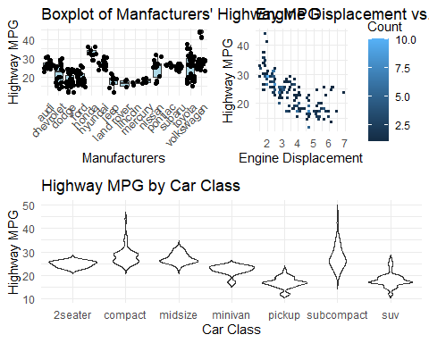
It looks like Honda is the most fuel efficient company while Land Rover is the least. Also looks like there is negative relationship between highway MPG and engine displacement. As engine displacement increases, the highway mpg decreases. Finally it looks like compact cars are the most efficient car while pickups and SUVs are the least.

