Chad Huntebrinker Homework 5
Chad Huntebrinker
2025-09-22
#Chad Huntebrinker
library(ggplot2)
library(tidyverse)
## ── Attaching core tidyverse packages ──────────────────────── tidyverse 2.0.0 ──
## ✔ dplyr 1.1.4 ✔ readr 2.1.5
## ✔ forcats 1.0.0 ✔ stringr 1.5.1
## ✔ lubridate 1.9.3 ✔ tibble 3.2.1
## ✔ purrr 1.0.2 ✔ tidyr 1.3.1
## ── Conflicts ────────────────────────────────────────── tidyverse_conflicts() ──
## ✖ dplyr::filter() masks stats::filter()
## ✖ dplyr::lag() masks stats::lag()
## ℹ Use the conflicted package (<http://conflicted.r-lib.org/>) to force all conflicts to become errors
mpg_factors <- mpg %>%
mutate(across(where(is.character), as.factor))
Problem 1:
#Problem 1
ggplot(mpg_factors, aes(x = cty, y = hwy, color = displ)) +
geom_point() +
labs(
title = "City vs. Highway MPG with Displacement as color",
x = "City MPG",
y = "Highway MPG",
color = "Engine Displacement"
) +
theme_minimal()
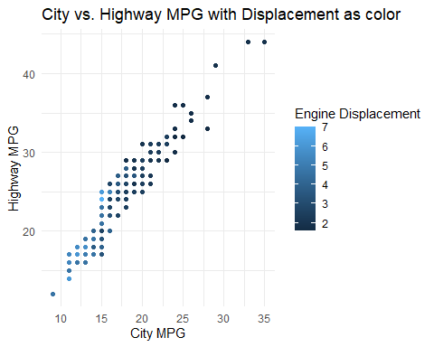
#Displacement with size
ggplot(data = mpg, aes(x = cty, y = hwy, size = displ)) +
geom_point() +
labs(title = "City vs. Highway MPG with Displacement as Size") +
theme_minimal()
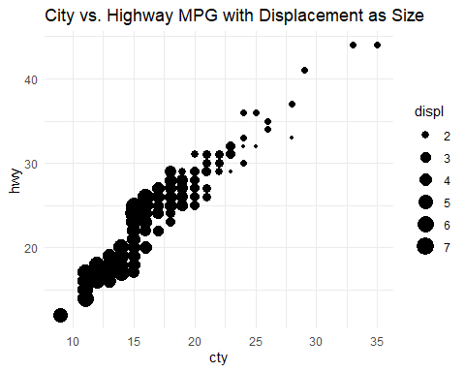
I prefer the one with size because it seems easier to distinguish which displacment via size vs colors that are a little different.
Problem 2:
#Problem 2
ggplot(mpg, aes(x = cty, y = hwy, color = factor(cyl), shape = drv)) +
geom_point() +
facet_wrap(~fl) +
labs(
title = "City vs. Highway MPG by Cylinders, Drivetrain, and Fuel Type",
x = "City MPG",
y = "Highway MPG",
color = "Cylinders",
shape = "Drivetrain"
) +
theme_bw() +
theme(legend.position = "bottom")
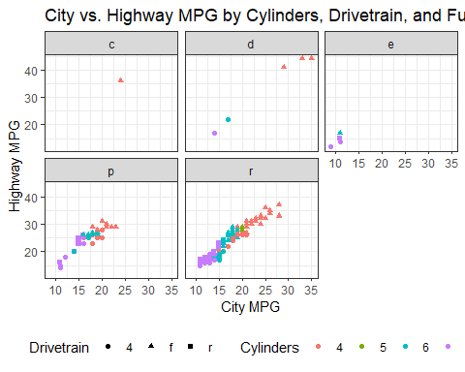
We see a couple of things: First, there a lot more cars that have the ‘p’ and ‘r’ fuel type than the other ones. We also see that as the number cylinders increase, the highway MPG efficiency decreases. We also see that cars with a front wheel drive train are the most efficient, followed by 4-wheel, and then rear-wheel.

