Chad Huntebrinker Assignment 6
Chad Huntebrinker
2025-09-30
#Chad Huntebrinker
library(tidyverse)
## ── Attaching core tidyverse packages ──────────────────────── tidyverse 2.0.0 ──
## ✔ dplyr 1.1.4 ✔ readr 2.1.5
## ✔ forcats 1.0.0 ✔ stringr 1.5.1
## ✔ ggplot2 3.5.1 ✔ tibble 3.2.1
## ✔ lubridate 1.9.3 ✔ tidyr 1.3.1
## ✔ purrr 1.0.2
## ── Conflicts ────────────────────────────────────────── tidyverse_conflicts() ──
## ✖ dplyr::filter() masks stats::filter()
## ✖ dplyr::lag() masks stats::lag()
## ℹ Use the conflicted package (<http://conflicted.r-lib.org/>) to force all conflicts to become errors
library(patchwork)
## Warning: package 'patchwork' was built under R version 4.4.2
library(waterfalls)
## Warning: package 'waterfalls' was built under R version 4.4.3
library(ggwordcloud)
## Warning: package 'ggwordcloud' was built under R version 4.4.3
load("corona.RData")
Assignment 1:
#Assignment 1
coin_data <- read.table("coin_prices_2017.txt", header = TRUE)
#Get coin data and data just for bitcoin
coin_data <- coin_data %>%
mutate(
DATE = ymd(DATE),
)
bitcoin_prices <- coin_data %>%
filter(COIN_ABR == "BTC") %>%
select(DATE, CLOSE)
#Create line graph
line_chart <- ggplot(bitcoin_prices, aes(x = DATE, y = CLOSE)) +
geom_line(color = "darkblue", size = 1) +
labs(
title = "Bitcoin Daily Closing Price in 2017",
x = "Date",
y = "Closing Price ($)"
) +
theme_minimal() +
theme(plot.title = element_text(hjust = 0.5))
## Warning: Using `size` aesthetic for lines was deprecated in ggplot2 3.4.0.
## ℹ Please use `linewidth` instead.
## This warning is displayed once every 8 hours.
## Call `lifecycle::last_lifecycle_warnings()` to see where this warning was
## generated.
#Prep waterfall data
btc_waterfall_data <- bitcoin_prices %>%
mutate(CHANGE = CLOSE - lag(CLOSE, default = first(CLOSE))) %>%
# Calculate the y-axis coordinates for geom_rect
mutate(
END_PRICE = cumsum(CHANGE),
START_PRICE = lag(END_PRICE, default = 0)
) %>%
# Add labels for fill colors
mutate(DIFF_TYPE = case_when(
CHANGE > 0 ~ "Increase",
CHANGE < 0 ~ "Decrease",
TRUE ~ "Initial"
)) %>%
# Make sure the first bar has the correct start/end values
mutate(
START_PRICE = if_else(row_number() == 1, 0, START_PRICE),
END_PRICE = if_else(row_number() == 1, first(CLOSE), END_PRICE)
)
#Plot the waterfall graph
waterfall_plot <- ggplot(btc_waterfall_data, aes(x = DATE, fill = DIFF_TYPE)) +
geom_rect(aes(
xmin = DATE - 10, xmax = DATE + 5, # Adjust bar width
ymin = START_PRICE, ymax = END_PRICE
)) +
#Theme and style
scale_x_date(date_breaks = "2 months") +
scale_fill_manual(
values = c("Increase" = "limegreen", "Decrease" = "red", "Initial" = "gray", "Total" = "steelblue"),
name = "Price Change"
) +
labs(
title = "Waterfall Chart of Bitcoin Price Changes in 2017",
x = "Date",
y = "Price (USD)"
) +
theme_minimal() +
theme(
axis.text.x = element_text(angle = 45, hjust = 1),
legend.position = "bottom"
)
line_chart + waterfall_plot
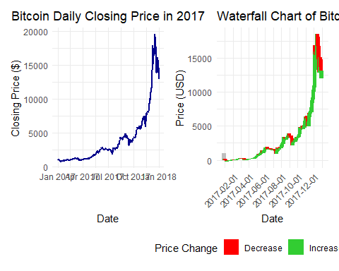
Assignment 2:
#Assignment 2
#Refine data
infected$Date <- as.Date(infected$Date)
#Create subdata with max date and at least 1 infected
infected_sub <- infected %>%
filter(Date == "2020-03-11") %>%
filter(Infected > 0)
#Manage data for the word cloud
country_infected_counts <- infected_sub %>%
group_by(Country.Region) %>%
summarize(Total_Infected = sum(Infected)) %>%
mutate(angle = 90 * sample(c(0,1), n(), replace = T, prob = c(0.7, 0.3))) %>%
rename(word = Country.Region, n = Total_Infected)
#Plot the word cloud
ggplot(country_infected_counts, aes(label = word, size = n, angle = angle, color = word)) +
geom_text_wordcloud(area_corr_power = 1) +
scale_size_area(max_size = 25) +
scale_color_viridis_d(option = "magma") +
theme_minimal() +
labs(title = "Corona Virus Infected by Country")
## Warning in geom_text_wordcloud(area_corr_power = 1): Ignoring unknown
## parameters: `area_corr_power`
