Chad Huntebrinker’s Midterm
Chad Huntebrinker
2025-10-17
#Chad Huntebriner
library(ggplot2)
library(readr)
#Get data
col_names <- c("Sepal.Length", "Sepal.Width", "Petal.Length", "Petal.Width", "Species")
iris_data <- read_csv("iris.data", col_names = col_names)
## Rows: 150 Columns: 5
## ── Column specification ────────────────────────────────────────────────────────
## Delimiter: ","
## chr (1): Species
## dbl (4): Sepal.Length, Sepal.Width, Petal.Length, Petal.Width
##
## ℹ Use `spec()` to retrieve the full column specification for this data.
## ℹ Specify the column types or set `show_col_types = FALSE` to quiet this message.
Good Graph:
#Good Plot
ggplot(iris_data, aes(x = Petal.Length, y = Petal.Width, color = Species)) +
geom_point(size = 2) +
labs(
title = "Petal Length vs Petal Width for Iris Species",
x = "Petal Length (cm)",
y = "Petal Width (cm)",
color = "Iris Species"
) +
theme_minimal() +
theme(plot.title = element_text(hjust = 0.5))
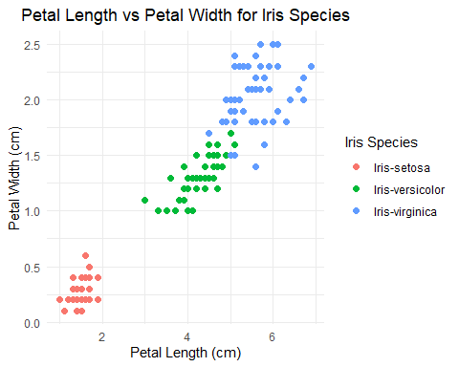
This graph shows petal length vs petal width. It’s color encoded based on the species with colors that are distinct. The graph title, labels, and axes are informative without becoming too overloaded.
Bad Graph:
#Bad Plot
ggplot(iris_data, aes(x = Sepal.Length, y = Sepal.Width, color = Petal.Length, size = Petal.Width)) +
geom_point(alpha = 0.5) +
labs(
title = "Iris Measurements",
x = "Sepal Length",
y = "Sepal Width",
color = "Petal Length",
size = "Petal Width"
) +
theme_minimal()
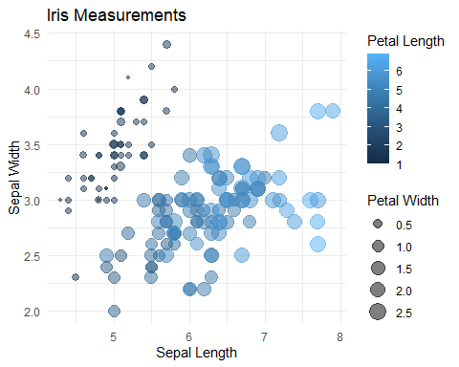
This second graph is also showing petal length vs petal width. However, there isn’t any grouping by species, there are overlapping points that lack transparency, and the color isn’t as easy to separate which petals have a larger length. Also, the axes don’t have their units and the title of the graph isn’t clear.

