chad_huntebrinker_hw1

Chad Huntebrinker

2024-08-31

Question 1: Calculate the mean, median, and standard deviation of the following vector. my_vec <- c(15, 20, 25, 30, 35)

my_vec <- c(15, 20, 25, 30, 35)  
mean_vec <- mean(my_vec)  
median_vec <- median(my_vec)  
standard_vec <- sd(my_vec)  
  
#Print vector and it's mean, median, and standard deviation  
print(my_vec)

## [1] 15 20 25 30 35

print(mean_vec)

## [1] 25

print(median_vec)

## [1] 25

print(standard_vec)

## [1] 7.905694

Question 2: Generate two vectors called “abc” and “xyz” with a random values of 100 in each. Generate scatter plot, bar plot and line plot with required labels and headings.

#Generate two vectors with random values between 1 and 20  
abc <- runif(100, min = 1, max = 20)  
xyz <- runif(100, min = 1, max = 20)  
  
#Plot the scatter, bar, and line plot  
plot(abc, xyz, xlab = "abc axis", ylab = "xyz axis", main = "Scatter Plot")

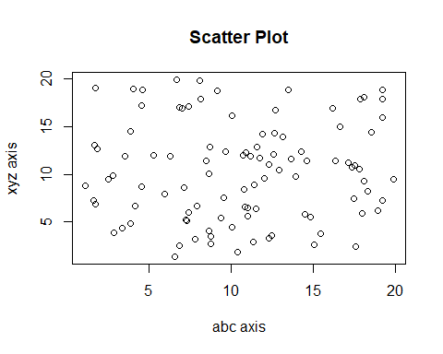

barplot(abc, xyz, xlab = "abc axis", ylab = "xyz axis", main = "Bar Plot")

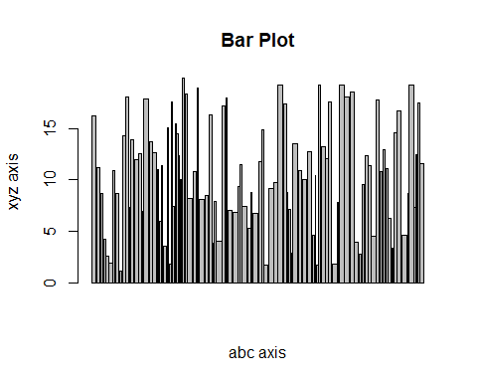

plot(abc, xyz, type = "l", xlab = "abc axis", ylab = "xyz axis", main = "Line Plot")

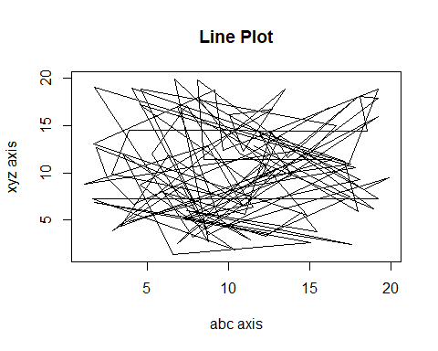

Question 3: Generate 1000 random numbers from a normal distribution with mean 0 and standard deviation 10. Save the result into object x. Plot a histogram for x object. Calculate the mean and variance of x.

#create vector and histogram  
x <- rnorm(1000, mean = 0, sd = 10)  
hist(x)

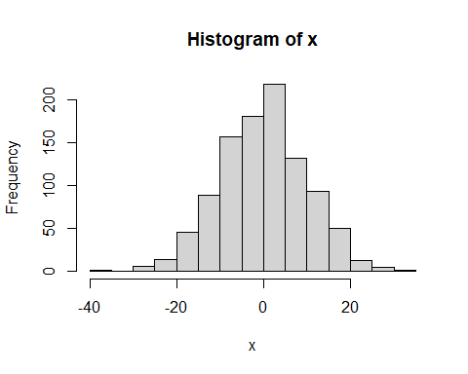

#print mean and variance of vector x  
print(mean(x))

## [1] 0.004812799

print(var(x))

## [1] 96.53329