Visualize Data

Your Turn 0
Add a setup chunk that loads the tidyverse packages.
mpg
## # A tibble: 234 × 11
## manufacturer model displ year cyl trans drv cty hwy fl class
## <chr> <chr> <dbl> <int> <int> <chr> <chr> <int> <int> <chr> <chr>
## 1 audi a4 1.8 1999 4 auto… f 18 29 p comp…
## 2 audi a4 1.8 1999 4 manu… f 21 29 p comp…
## 3 audi a4 2 2008 4 manu… f 20 31 p comp…
## 4 audi a4 2 2008 4 auto… f 21 30 p comp…
## 5 audi a4 2.8 1999 6 auto… f 16 26 p comp…
## 6 audi a4 2.8 1999 6 manu… f 18 26 p comp…
## 7 audi a4 3.1 2008 6 auto… f 18 27 p comp…
## 8 audi a4 quattro 1.8 1999 4 manu… 4 18 26 p comp…
## 9 audi a4 quattro 1.8 1999 4 auto… 4 16 25 p comp…
## 10 audi a4 quattro 2 2008 4 manu… 4 20 28 p comp…
## # ℹ 224 more rows

Your Turn 1
Run the code on the slide to make a graph. Pay strict attention to spelling, capitalization, and parentheses!
ggplot(data = mpg) +
geom_point(mapping = aes(x = displ, y = hwy))
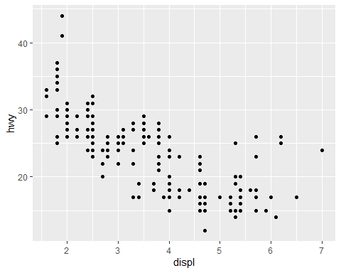

Your Turn 2
Add color, size, alpha, and shape aesthetics to your graph. Experiment.
ggplot(data = mpg) +
geom_point(mapping = aes(displ, hwy, color = class, size = class, alpha = class, shape = class))
## Warning: Using size for a discrete variable is not advised.
## Warning: Using alpha for a discrete variable is not advised.
## Warning: The shape palette can deal with a maximum of 6 discrete values because more
## than 6 becomes difficult to discriminate
## ℹ you have requested 7 values. Consider specifying shapes manually if you need
## that many have them.
## Warning: Removed 62 rows containing missing values or values outside the scale range
## (`geom_point()`).
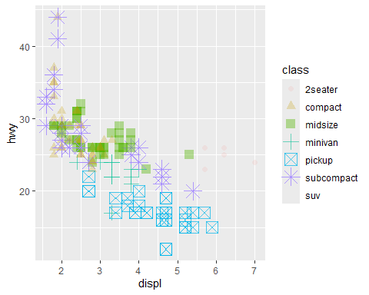

Help Me
What do facet_grid() and facet_wrap() do? (run the code, interpret, convince your group)
# Makes a plot that the commands below will modify
q <- ggplot(mpg) + geom_point(aes(x = displ, y = hwy))
q + facet_grid(. ~ cyl)
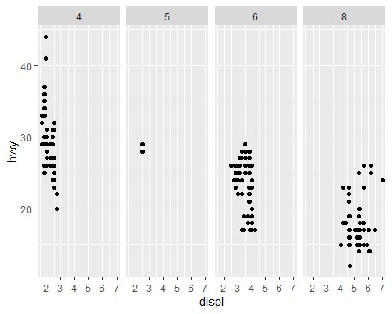
q + facet_grid(drv ~ .)
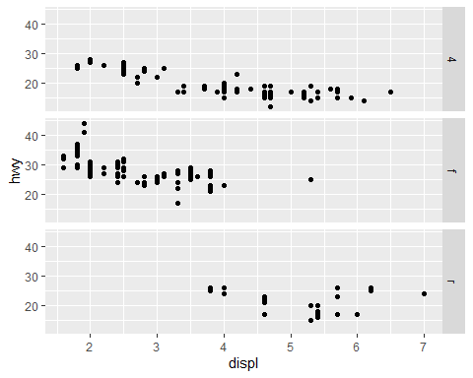
q + facet_grid(drv ~ cyl)
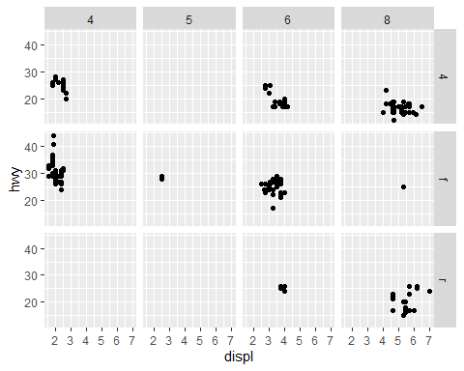
q + facet_wrap(~ class)
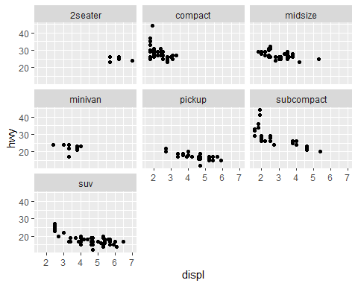 It separates each type of car into a different scatter plot. ## Your Turn 3
Add the black code to your graph. What does it do?
ggplot(data = mpg) +
geom_point(mapping = aes(displ, hwy, color = class)) +
labs(title = "Fuel Efficiency by Engine Size",
x = "Engine Size (displacement in liters)",
y = "Fuel Efficiency (MPG)",
color = "Class of \nAutomobile",
caption = "Data from the EPA")
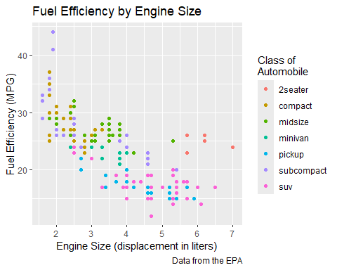 Adds a title, subtitle, color title, x and y text, and a caption

Your Turn 4
Replace this scatterplot with one that draws boxplots. Use the cheatsheet. Try your best guess.
ggplot(mpg) + geom_boxplot(mapping = aes(x = class, y = hwy))
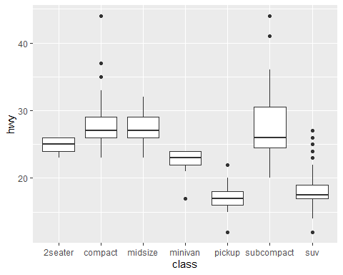

Your Turn 5
Make a histogram of the hwy variable from mpg. Hint: do not supply a y variable.
ggplot(data = mpg) + geom_histogram(mapping = aes(x = hwy))
## `stat_bin()` using `bins = 30`. Pick better value with `binwidth`.
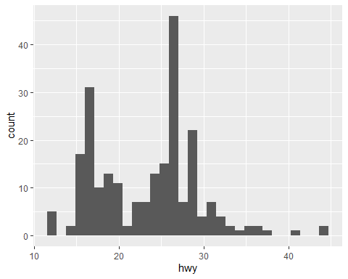

Your Turn 6
Use the help page for geom_histogram to make the bins 2 units wide.
ggplot(data = mpg) +
geom_histogram(mapping = aes(x = hwy), binwidth = 2)
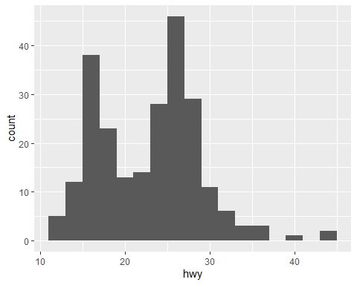

Your Turn 7
Make a bar chart class colored by class. Use the help page for geom_bar to choose a “color” aesthetic for class.
ggplot(data = mpg) +
geom_bar(mapping = aes(x = class, fill = class))
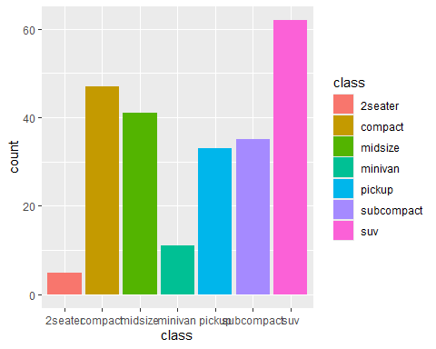

Quiz
What will this code do?
ggplot(mpg) +
geom_point(aes(displ, hwy)) +
geom_smooth(aes(displ, hwy))
## `geom_smooth()` using method = 'loess' and formula = 'y ~ x'
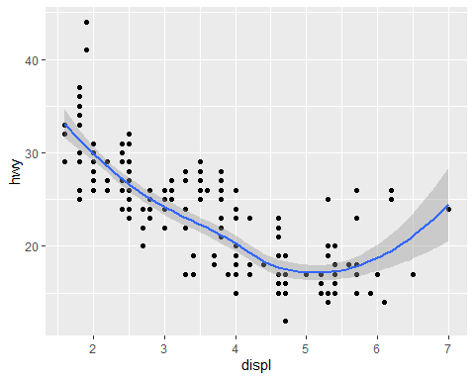 This code will add a scatterplot to the graph and then a smoothing line.

Quiz
What is different about this plot? Run the code! Note: had to comment out this code in order to knit it.
#p <- ggplot(mpg) +
# geom_point(aes(displ, hwy)) +
# geom_smooth(aes(displ, hwy))
#library(plotly)
#ggplotly(p)
This graph is interactive. You are able to see what the x and y values are for the data points or a specific part of the smooth line.

Take aways
You can use this code template to make thousands of graphs with ggplot2.
ggplot(data = <DATA>) +
<GEOM_FUNCTION>(mapping = aes(<MAPPINGS>))

Other Exercises
- What happens if you facet on a continuous variable? It’ll create a new panel for each unique value for that variable.
- What are the advantages to using faceting instead of the color aesthetic? What are the disadvantages? How might the balance change if you had a larger dataset? Some of the advantages include each panel showing a distinct set of the data and easy comparison between all the facets. Some of the disadvantages include a complexity in the vision when there are a large number of facets and not as much details in each one. One will need to consider whether it is better to use faceting (like trying to find a pattern between different variables) or color aesthetic (distinguishing between groups and how they perform compared to each other).
- What does the se argument to geom_smooth() do? It tells the argument whether or not to display the confidence interval.
- What is the default position adjustment for geom_boxplot()? Create a visualization from the mpg dataset that demonstrates different position adjustments. The default position adjustment for the function is dodge2.
ggplot(data = mpg) +
geom_boxplot(aes(x = class, y = hwy, fill = class))
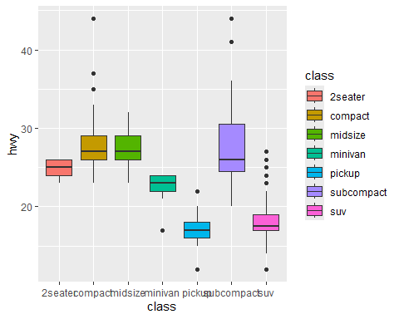
#vs
ggplot(data = mpg) +
geom_boxplot(aes(x = class, y = hwy, fill = factor(cyl)), position = "identity", alpha =0.5)
