Comparing Groups on Continuous Outcomes
library(tidyverse)
## ── Attaching core tidyverse packages ──────────────────────── tidyverse 2.0.0 ──
## ✔ dplyr 1.1.4 ✔ readr 2.1.5
## ✔ forcats 1.0.0 ✔ stringr 1.5.1
## ✔ ggplot2 3.5.1 ✔ tibble 3.2.1
## ✔ lubridate 1.9.3 ✔ tidyr 1.3.1
## ✔ purrr 1.0.2
## ── Conflicts ────────────────────────────────────────── tidyverse_conflicts() ──
## ✖ dplyr::filter() masks stats::filter()
## ✖ dplyr::lag() masks stats::lag()
## ℹ Use the conflicted package (<http://conflicted.r-lib.org/>) to force all conflicts to become errors
library(emmeans)
## Warning: package 'emmeans' was built under R version 4.4.2
## Welcome to emmeans.
## Caution: You lose important information if you filter this package's results.
## See '? untidy'
# Add the code to import hsb2 here
### Backup Import
hsb2 <- within(read.csv("https://stats.idre.ucla.edu/wp-content/uploads/2016/02/hsb2-2.csv"), {
race <- as.factor(race)
schtyp <- as.factor(schtyp)
prog <- as.factor(prog)
})
# These variables are categorical factors
# This is an important step
attach(hsb2)
hsb2$race <- as.factor(race)
hsb2$schtyp <- as.factor(schtyp)
hsb2$prog <- as.factor(prog)

Your Turn 1
- Assume 22 degrees of freedom.
- Use the pt() function to calculate the $p−$value for $t=−7.5$. What is your conclusion?
- Use the pt() function to calculate the $p−$value for $t=0.5$. What is your conclusion?
- Use the qt() function to determine the value of $t$ that corresponds to $p=α=0.05$ and compare it to the values of $t$ produced by the data.
pt(-7.5, 22)
## [1] 8.471024e-08
pt(0.5, 22)
## [1] 0.6889802
qt(0.975, df = 22)
## [1] 2.073873

Your Turn 2
- Uncomment the code below to generate a random sample of 50 observations and calculate their mean.
- Complete the code to create a boxplot of the data using ggplot().
set.seed(1)
Y <- rnorm(50, 10, 2)
df <- data.frame(Y)
df %>%
summarise(mean=mean(Y))
## mean
## 1 10.2009
df %>% ggplot() +
geom_boxplot(aes(y=Y)) +
labs(x="") +
scale_x_discrete(labels=c(""))
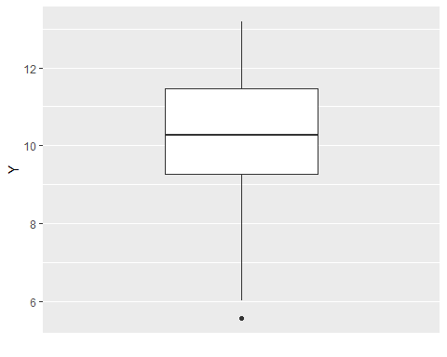

Your Turn 3
- Uncomment the code below to generate a random sample of 16 observations per group and calculate their means by group.
- Complete the code to create a boxplot of the data using ggplot().
set.seed(1)
X <- c(rep(0,25),rep(1,25))
Y <- 2*X + rnorm(50, 10, 1)
df <- data.frame(cbind(X,Y))
df %>%
group_by(X) %>%
summarise(mean=mean(Y))
## # A tibble: 2 × 2
## X mean
## <dbl> <dbl>
## 1 0 10.2
## 2 1 12.0
df %>% ggplot() +
geom_boxplot(aes(x=factor(X),y=Y)) +
labs(x="Group")
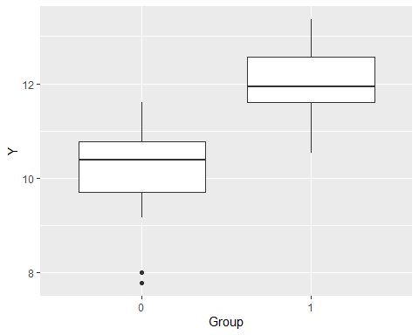

Your Turn 4
- Set your seed to 1.
- Generate 48 random numbers: 16 from $N\left(10,1^{2}\right)$, 16 from $N\left(11,1^{2}\right)$, and 16 from $N\left(12,1^{2}\right)$.
- Calculate the group means using summarise().
- Create boxplots of the data by group using ggplot().
set.seed(1)
X <- c(rep(0,16),rep(1,16),rep(2,16))
Y <- X + rnorm(48, 10, 1)
df <- data.frame(cbind(X,Y))
df %>%
group_by(X) %>%
summarise(mean=mean(Y))
## # A tibble: 3 × 2
## X mean
## <dbl> <dbl>
## 1 0 10.1
## 2 1 11.1
## 3 2 12.0
df %>% ggplot() +
geom_boxplot(aes(x=factor(X),y=Y)) +
labs(x="Group")
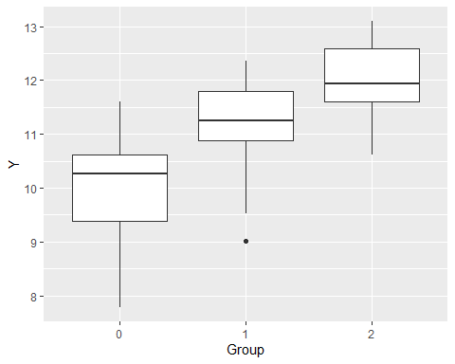

Your Turn 5
- Set your seed to 1.
- Generate 50 random numbers from a uniform distribution with a minimum of 0 and a maximum of 10 and save it as X.
- Generate 50 random numbers from a normal distribution with standard deviation 2 and a mean equal to $X_{i}$ and save it as Y.
- Combine X and Y into a dataframe named df.
- Create a scatterplot of the data using ggplot().
set.seed(1)
X <- runif(50, 0, 10)
Y <- 2*X + rnorm(50, 0, 2)
df <- data.frame(cbind(X,Y))
df %>% ggplot(aes(x=X, y=Y)) +
geom_point()
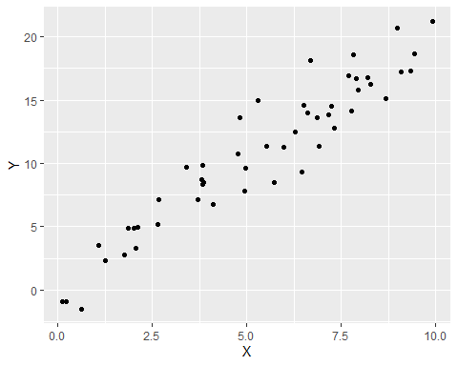

Your Turn 6
- Using math, test $H_{0}:μ=50$ versus $H_{1}:μ=50$.
- Create the boxplot.
- Calculate the 95% confidence interval for $μ$.
- What is your conclusion?
hsb2 %>% ggplot(aes(y=math)) +
geom_boxplot()
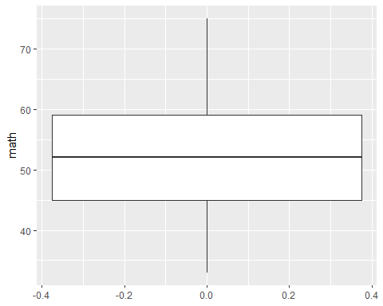
t <- t.test(math, mu = 50)$statistic
t > qt (0.975, 199, lower.tail = TRUE)
## t
## TRUE
#Reject H0: mu = 50
#Conclude H1: mu != 50

Your Turn 7
- Compare math across schtyp by testing $H_{0}:μ_{1}=μ_{2}$ versus $H_{1}:μ_{1}≠μ_{2}$.
- Create the boxplots.
- Calculate the 95% confidence interval for $μ_{1}−μ_{2}$.
- What is your conclusion?
hsb2 %>% ggplot(aes(x=schtyp, y=math)) +
geom_boxplot() +
scale_x_discrete(labels=c("Public", "Private"))
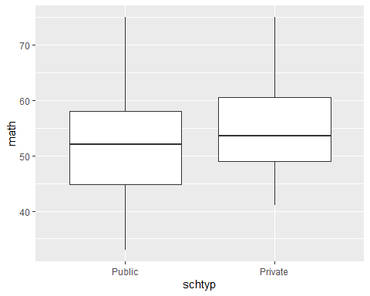
t <- t.test(math~schtyp)$statistic
t < qt(0.025, 55, 0.5, lower.tail = TRUE)
## t
## FALSE
#Reject H0: mu1 = mu2
#Conclude H1: mu1 != mu2

Your Turn 8
- Compare math across prog by testing $H_{0}:μ_{1}=μ_{2}=μ_{3}$ versus $H_{1}:μ_{j}≠μ_{j}^{′}$ for some $j≠j^{′}$.
- Create the boxplots.
- Calculate the 95% confidence intervals for each $μ_{j}$.
- What is your conclusion?
hsb2 %>% ggplot(aes(x=prog,y=math)) +
geom_boxplot() +
scale_x_discrete(labels=c("General", "Academic", "Vocational"))
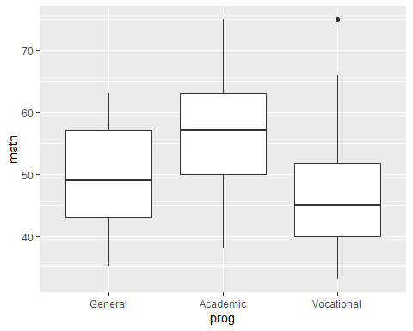
m <- lm(math ~ prog, data = hsb2)
anova(m)
## Analysis of Variance Table
##
## Response: math
## Df Sum Sq Mean Sq F value Pr(>F)
## prog 2 4002.1 2001.05 29.279 7.364e-12 ***
## Residuals 197 13463.7 68.34
## ---
## Signif. codes: 0 '***' 0.001 '**' 0.01 '*' 0.05 '.' 0.1 ' ' 1
anova(m)$"F value"[1] > qf(0.95,2,197)
## [1] TRUE
#Reject H0: mu1 = mu2 = m3
#Conclude H1: at least one muj != muj'

Your Turn 9
- Test whether math is linearly related to science by testing $H_{0}:β_{1}=0$ versus $H_{1}:β_{1}≠0$.
- Create the scatterplot and overlay the fitted line.
- Calculate the 95% confidence interval for $β_{1}$.
- What is your conclusion?
hsb2 %>% ggplot(aes(x=math,y=science)) +
geom_point() +
labs(x = "Math Score",
y = "Science Score")
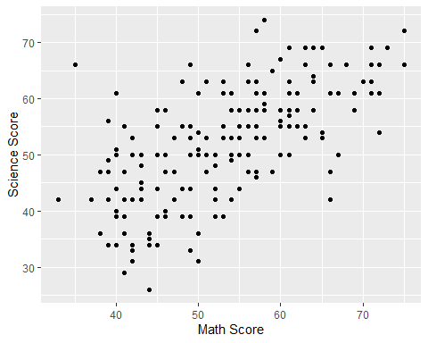
m <- lm(science~math, data = hsb2)
summary(m)$coefficient[2,3] > qt(0.975, 198)
## [1] TRUE
#Reject H0: B1 = 0
#Conclude H1: B1 != 0

Take Aways
- Boxplots are good for comparing a continuous measure between groups.
- Scatterplots are good for investigating the association between two continuous measures.
- Student’s $t$ tests are appropriate for tests of a continuous measure in 1 or 2 groups.
- ANOVA is appropriate for tests of a continuous measure in 2+ groups.
- Simple linear regression is appropriate for testing whether two continuous measures are linearly associated.
- Use t.test(), lm(), and anova() to compare group means across 2 or more levels of $X$.
- All these methods have assumptions that must be verified. Otherwise, non-parametric methods should be substituted.

