Linear Regression
library(tidyverse)
## ── Attaching core tidyverse packages ──────────────────────── tidyverse 2.0.0 ──
## ✔ dplyr 1.1.4 ✔ readr 2.1.5
## ✔ forcats 1.0.0 ✔ stringr 1.5.1
## ✔ ggplot2 3.5.1 ✔ tibble 3.2.1
## ✔ lubridate 1.9.3 ✔ tidyr 1.3.1
## ✔ purrr 1.0.2
## ── Conflicts ────────────────────────────────────────── tidyverse_conflicts() ──
## ✖ dplyr::filter() masks stats::filter()
## ✖ dplyr::lag() masks stats::lag()
## ℹ Use the conflicted package (<http://conflicted.r-lib.org/>) to force all conflicts to become errors
library(modelr)
library(broom)
##
## Attaching package: 'broom'
##
## The following object is masked from 'package:modelr':
##
## bootstrap
library(readxl)
# Import wages here
wages <- read_excel("wages-1.xlsx", na = "NA")
# Fall back in case you cannot load wages
# wages <- heights %>%
# filter(income > 0) %>%
# mutate(marital = as.character(marital),
# sex = as.character(sex))

Your Turn 1
- Save the wages.xlsx dataset to your computer.
- Change the working directory to the same location.
- Import wages.xlsx as wages and copy the code to your setup chunk.
- Be sure to set NA: to NA.

Your Turn 2
Fit the model on the slide and then examine the output. What does it look like?
mod_e <- lm(log(income)~ education, data = wages)
mod_e
##
## Call:
## lm(formula = log(income) ~ education, data = wages)
##
## Coefficients:
## (Intercept) education
## 8.5577 0.1418
class(mod_e)
## [1] "lm"

Your Turn 3
Use a pipe to model log(income) against height. Then use broom and dplyr functions to extract:
- The coefficient estimates and their related statistics
- The adj.r.squared and p.value for the overall model
mod_h <- wages %>%
lm(log(income)~height, data =.)
mod_h %>% tidy()
## # A tibble: 2 × 5
## term estimate std.error statistic p.value
## <chr> <dbl> <dbl> <dbl> <dbl>
## 1 (Intercept) 6.98 0.237 29.4 4.13e-176
## 2 height 0.0520 0.00352 14.8 2.44e- 48
mod_h %>%
glance() %>%
select(adj.r.squared, p.value)
## # A tibble: 1 × 2
## adj.r.squared p.value
## <dbl> <dbl>
## 1 0.0396 2.44e-48

Your Turn 4
Model log(income) against education and height and sex. Interpret the coefficients in narrative here.
mod_ehs <- wages %>%
lm(log(income)~education + height + sex, data = .)
mod_ehs %>% tidy()
## # A tibble: 4 × 5
## term estimate std.error statistic p.value
## <chr> <dbl> <dbl> <dbl> <dbl>
## 1 (Intercept) 7.79 0.307 25.3 9.41e-134
## 2 education 0.148 0.00520 28.5 5.16e-166
## 3 height 0.00673 0.00479 1.40 1.61e- 1
## 4 sexmale 0.462 0.0389 11.9 5.02e- 32
#The sexmale term is an indicator variable (0,1). As a result, if the person is a male they get 0.46 but
#if they are a female, they get 0. We also see that taller people are expected to get paid
#slightly more than shorter ones.

Your Turn 5
Add + geom_smooth(method = lm) to the code below. What happens?
wages %>%
ggplot(aes(x = height, y = log(income))) +
geom_point(alpha = 0.1) +
geom_smooth(method=lm)
## `geom_smooth()` using formula = 'y ~ x'
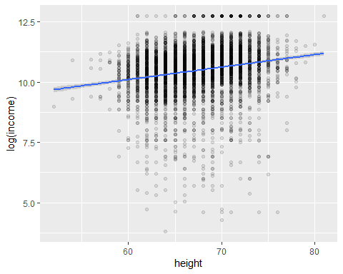
#geom_smooth adds a line for predicting how height impacts income.

Your Turn 6
Use add_predictions to make the plot below.
# In case you haven't made the ehs model
mod_ehs <- wages %>% lm(log(income) ~ education + height + sex, data = .)
# Make plot here
wages %>%
add_predictions(mod_ehs) %>%
ggplot(mapping = aes(x = height, y = pred, color = sex)) +
geom_line() +
facet_wrap(~ education)
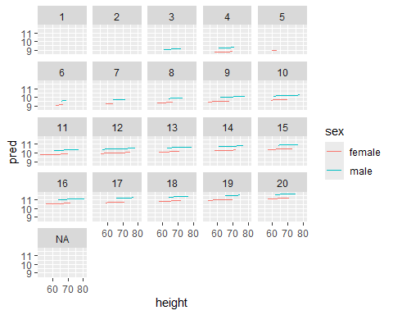

Take Aways
- Use glance(), tidy(), and augment() from the broom package to return model values in a data frame.
- Use add_predictions() or gather_predictions() or spread_predictions() from the modelr package to visualize predictions.
- Use add_residuals() or gather_residuals() or spread_residuals() from the modelr package to visualize residuals.

