Chad Huntebrinker’s Homework 10
Chad Huntebrinker
2024-11-17
Problem 9.10 and 9.11
#Chad Huntebrinker
library(leaps)
## Warning: package 'leaps' was built under R version 4.4.2
library(readxl)
excel_data <- read_excel("Job_Proficiency_Data.xlsx")
#Problem 9.10a
stem(excel_data$X1)
##
## The decimal point is 1 digit(s) to the right of the |
##
## 6 | 248
## 8 | 4671468
## 10 | 014456902
## 12 | 0003
## 14 | 00
stem(excel_data$X2)
##
## The decimal point is 1 digit(s) to the right of the |
##
## 6 | 37
## 8 | 135947
## 10 | 127034789
## 12 | 01112599
stem(excel_data$X3)
##
## The decimal point is 1 digit(s) to the right of the |
##
## 8 | 0
## 9 | 01335556789
## 10 | 002356789
## 11 | 3456
stem(excel_data$X4)
##
## The decimal point is 1 digit(s) to the right of the |
##
## 7 | 48
## 8 | 03457889
## 9 | 0557
## 10 | 0223345889
## 11 | 0
#Some noteworthy features include:
#1) All tests have max scores that go over 100, but some max scores are 116 while others
#are 140
#2) The distribution of the data for X2 seem to be more on the larger side (greater than
# 110) while the distribution for X1 are on the less side (less than 110)
#Problem 9.10b
pairs(excel_data)
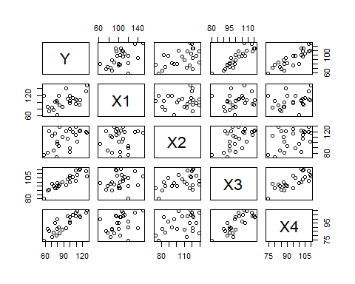
cor(excel_data)
## Y X1 X2 X3 X4
## Y 1.0000000 0.5144107 0.4970057 0.8970645 0.8693865
## X1 0.5144107 1.0000000 0.1022689 0.1807692 0.3266632
## X2 0.4970057 0.1022689 1.0000000 0.5190448 0.3967101
## X3 0.8970645 0.1807692 0.5190448 1.0000000 0.7820385
## X4 0.8693865 0.3266632 0.3967101 0.7820385 1.0000000
cor(excel_data[,-1])
## X1 X2 X3 X4
## X1 1.0000000 0.1022689 0.1807692 0.3266632
## X2 0.1022689 1.0000000 0.5190448 0.3967101
## X3 0.1807692 0.5190448 1.0000000 0.7820385
## X4 0.3266632 0.3967101 0.7820385 1.0000000
#It looks like there might be some correlation concerns with Y for X3 and X4
#There also might be some concerns with X3 and X4
#Problem 9.10c
model_1 <- lm(Y~X1 + X2 + X3 + X4, data=excel_data)
sum_of_model_1 <- summary(model_1)
#Y = -124.38182 + 0.29573X1 + 0.04829X2 + 1.30601X3 + 0.51982X4
sum_of_model_1
##
## Call:
## lm(formula = Y ~ X1 + X2 + X3 + X4, data = excel_data)
##
## Residuals:
## Min 1Q Median 3Q Max
## -5.9779 -3.4506 0.0941 2.4749 5.9959
##
## Coefficients:
## Estimate Std. Error t value Pr(>|t|)
## (Intercept) -124.38182 9.94106 -12.512 6.48e-11 ***
## X1 0.29573 0.04397 6.725 1.52e-06 ***
## X2 0.04829 0.05662 0.853 0.40383
## X3 1.30601 0.16409 7.959 1.26e-07 ***
## X4 0.51982 0.13194 3.940 0.00081 ***
## ---
## Signif. codes: 0 '***' 0.001 '**' 0.01 '*' 0.05 '.' 0.1 ' ' 1
##
## Residual standard error: 4.099 on 20 degrees of freedom
## Multiple R-squared: 0.9629, Adjusted R-squared: 0.9555
## F-statistic: 129.7 on 4 and 20 DF, p-value: 5.262e-14
sum_of_model_1$adj.r.squared
## [1] 0.9554702
#the adjusted R^2 has a good score (0.9554702) and the p-value for these predictor variables
#seem okay for all except one. X2 has a p-value of 0.40383, suggesting that it might be
#better to drop X2 from the model
#Problem 9.11a
ma <- regsubsets(Y~., nbest = 4, data=excel_data)
(sma <- summary(ma))
## Subset selection object
## Call: regsubsets.formula(Y ~ ., nbest = 4, data = excel_data)
## 4 Variables (and intercept)
## Forced in Forced out
## X1 FALSE FALSE
## X2 FALSE FALSE
## X3 FALSE FALSE
## X4 FALSE FALSE
## 4 subsets of each size up to 4
## Selection Algorithm: exhaustive
## X1 X2 X3 X4
## 1 ( 1 ) " " " " "*" " "
## 1 ( 2 ) " " " " " " "*"
## 1 ( 3 ) "*" " " " " " "
## 1 ( 4 ) " " "*" " " " "
## 2 ( 1 ) "*" " " "*" " "
## 2 ( 2 ) " " " " "*" "*"
## 2 ( 3 ) "*" " " " " "*"
## 2 ( 4 ) " " "*" "*" " "
## 3 ( 1 ) "*" " " "*" "*"
## 3 ( 2 ) "*" "*" "*" " "
## 3 ( 3 ) " " "*" "*" "*"
## 3 ( 4 ) "*" "*" " " "*"
## 4 ( 1 ) "*" "*" "*" "*"
sma$adjr2
## [1] 0.7962344 0.7452170 0.2326452 0.2142762 0.9269043 0.8660988 0.7984716
## [8] 0.7884436 0.9560482 0.9246779 0.8616797 0.8232664 0.9554702
order(sma$adjr2, decreasing = TRUE)[1:4]
## [1] 9 13 5 10
#(1) [X1, X3, X4] = 0.9560482
#(2) [X1, X2, X3, X4] = 0.9554702
#(3) [X1, X3] = 0.9269043
#(4) [X1, X2, X3] = 0.9246779
#9.11b
#There are a couple of other criteria we could look at to narrow down what model we should use.
#First, we could use some of the other measurements to see if a model is a good fit (like AIC, SSEp,
# and PRESSp) to see if they agree. Another thing we could do is look at the residuals of these models
#to see if they fit the model well. Finally, we can look at the simplicity of the model. In general,
#it's better to have a model that has less predictive variables than one that has more.
Problem 9.25
#Chad Huntebrinker
library(leaps)
library(readxl)
excel_data <- read_excel("SENIC_Data.xlsx")
#Use only rows 57 thru 113 and remove Region and Medical Affiliation
model_data <- excel_data[57:113, ]
model_data <- model_data[, -9]
model_data <- model_data[, -8]
#Note: I believe we should also remove the ID number from the data we use as this shouldn't have
#an impact on the patient's length of stay. But we'll keep it in as the instructions didn't say
#to remove it.
#Problem 9.25a
for (col_name in names(model_data)) {
dotchart(model_data[[col_name]], main = paste("Dot Plot of", col_name), xlab = col_name)
}
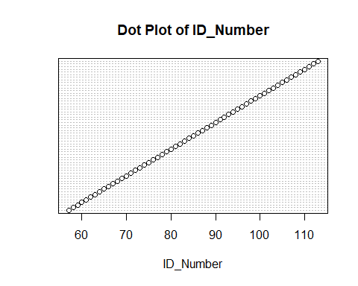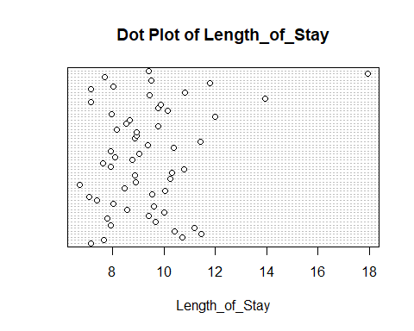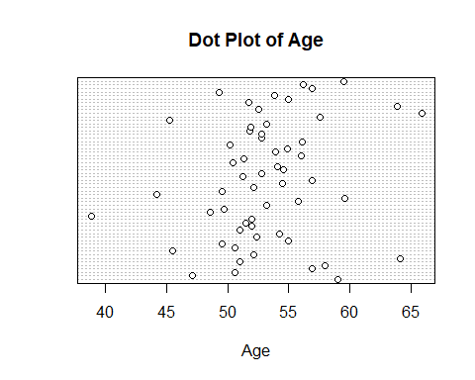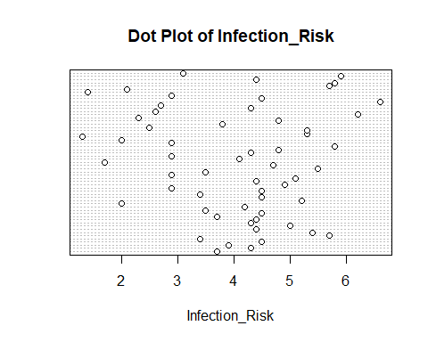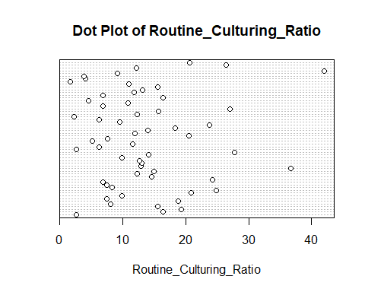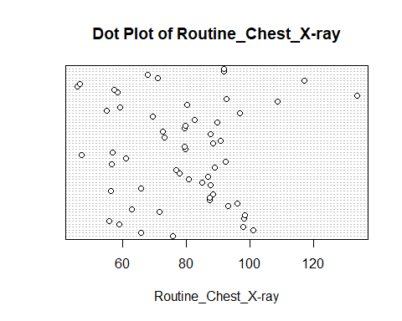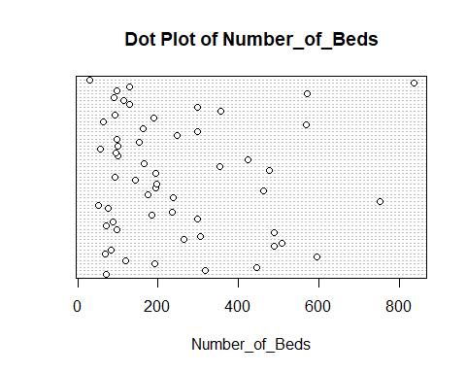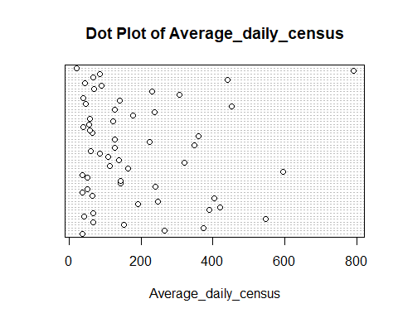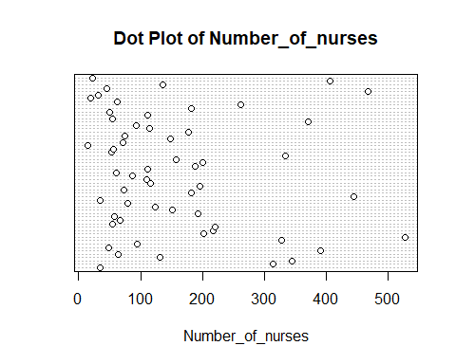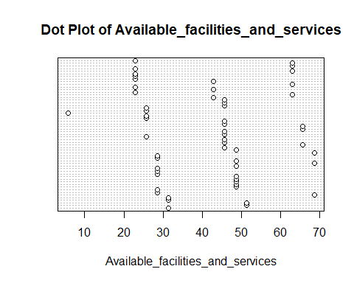
#Variables that have outliers:
#Number of Beds
#Average daily census
#Number of nurses
#Variables that have spaces in the data:
#Available facilities and services
#Also, ID number is completely linear as patients are assigned them as they are admitted
#Problem 9.25b
pairs(model_data)
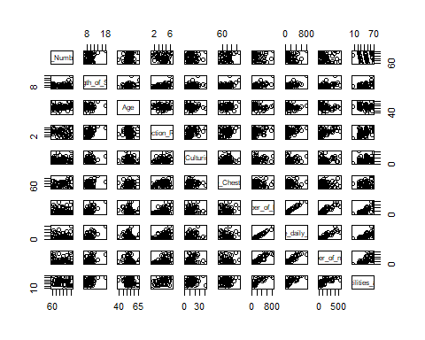
cor(model_data)
## ID_Number Length_of_Stay Age
## ID_Number 1.000000000 0.2172148 0.20080286
## Length_of_Stay 0.217214831 1.0000000 0.18962190
## Age 0.200802862 0.1896219 1.00000000
## Infection_Risk -0.074891449 0.4700307 0.02518057
## Routine_Culturing_Ratio -0.006311356 0.2577142 -0.10112797
## Routine_Chest_X-ray -0.017645336 0.3639358 0.16098871
## Number_of_Beds -0.059173991 0.5913953 -0.19786822
## Average_daily_census -0.055113659 0.6345872 -0.17221214
## Number_of_nurses -0.147822193 0.4658741 -0.23643184
## Available_facilities_and_services -0.095798792 0.4009459 -0.16351870
## Infection_Risk Routine_Culturing_Ratio
## ID_Number -0.07489145 -0.006311356
## Length_of_Stay 0.47003068 0.257714155
## Age 0.02518057 -0.101127969
## Infection_Risk 1.00000000 0.447832724
## Routine_Culturing_Ratio 0.44783272 1.000000000
## Routine_Chest_X-ray 0.33395894 0.194817381
## Number_of_Beds 0.49007435 0.167802589
## Average_daily_census 0.50084503 0.203624821
## Number_of_nurses 0.53008986 0.238843918
## Available_facilities_and_services 0.45333767 0.239544944
## Routine_Chest_X-ray Number_of_Beds
## ID_Number -0.01764534 -0.05917399
## Length_of_Stay 0.36393576 0.59139525
## Age 0.16098871 -0.19786822
## Infection_Risk 0.33395894 0.49007435
## Routine_Culturing_Ratio 0.19481738 0.16780259
## Routine_Chest_X-ray 1.00000000 0.06682347
## Number_of_Beds 0.06682347 1.00000000
## Average_daily_census 0.08554147 0.99000302
## Number_of_nurses 0.06020464 0.90892888
## Available_facilities_and_services 0.12832885 0.76447839
## Average_daily_census Number_of_nurses
## ID_Number -0.05511366 -0.14782219
## Length_of_Stay 0.63458724 0.46587415
## Age -0.17221214 -0.23643184
## Infection_Risk 0.50084503 0.53008986
## Routine_Culturing_Ratio 0.20362482 0.23884392
## Routine_Chest_X-ray 0.08554147 0.06020464
## Number_of_Beds 0.99000302 0.90892888
## Average_daily_census 1.00000000 0.90388584
## Number_of_nurses 0.90388584 1.00000000
## Available_facilities_and_services 0.72941653 0.70705586
## Available_facilities_and_services
## ID_Number -0.09579879
## Length_of_Stay 0.40094591
## Age -0.16351870
## Infection_Risk 0.45333767
## Routine_Culturing_Ratio 0.23954494
## Routine_Chest_X-ray 0.12832885
## Number_of_Beds 0.76447839
## Average_daily_census 0.72941653
## Number_of_nurses 0.70705586
## Available_facilities_and_services 1.00000000
#Remove ID number and length of stay
cor(model_data[,-2])
## ID_Number Age Infection_Risk
## ID_Number 1.000000000 0.20080286 -0.07489145
## Age 0.200802862 1.00000000 0.02518057
## Infection_Risk -0.074891449 0.02518057 1.00000000
## Routine_Culturing_Ratio -0.006311356 -0.10112797 0.44783272
## Routine_Chest_X-ray -0.017645336 0.16098871 0.33395894
## Number_of_Beds -0.059173991 -0.19786822 0.49007435
## Average_daily_census -0.055113659 -0.17221214 0.50084503
## Number_of_nurses -0.147822193 -0.23643184 0.53008986
## Available_facilities_and_services -0.095798792 -0.16351870 0.45333767
## Routine_Culturing_Ratio Routine_Chest_X-ray
## ID_Number -0.006311356 -0.01764534
## Age -0.101127969 0.16098871
## Infection_Risk 0.447832724 0.33395894
## Routine_Culturing_Ratio 1.000000000 0.19481738
## Routine_Chest_X-ray 0.194817381 1.00000000
## Number_of_Beds 0.167802589 0.06682347
## Average_daily_census 0.203624821 0.08554147
## Number_of_nurses 0.238843918 0.06020464
## Available_facilities_and_services 0.239544944 0.12832885
## Number_of_Beds Average_daily_census
## ID_Number -0.05917399 -0.05511366
## Age -0.19786822 -0.17221214
## Infection_Risk 0.49007435 0.50084503
## Routine_Culturing_Ratio 0.16780259 0.20362482
## Routine_Chest_X-ray 0.06682347 0.08554147
## Number_of_Beds 1.00000000 0.99000302
## Average_daily_census 0.99000302 1.00000000
## Number_of_nurses 0.90892888 0.90388584
## Available_facilities_and_services 0.76447839 0.72941653
## Number_of_nurses
## ID_Number -0.14782219
## Age -0.23643184
## Infection_Risk 0.53008986
## Routine_Culturing_Ratio 0.23884392
## Routine_Chest_X-ray 0.06020464
## Number_of_Beds 0.90892888
## Average_daily_census 0.90388584
## Number_of_nurses 1.00000000
## Available_facilities_and_services 0.70705586
## Available_facilities_and_services
## ID_Number -0.09579879
## Age -0.16351870
## Infection_Risk 0.45333767
## Routine_Culturing_Ratio 0.23954494
## Routine_Chest_X-ray 0.12832885
## Number_of_Beds 0.76447839
## Average_daily_census 0.72941653
## Number_of_nurses 0.70705586
## Available_facilities_and_services 1.00000000
#Major concern with linear pairwise associations:
#number of beds and average daily census = 0.99000302
#average daily census and number of nurses 0.90388584
#number of beds and number of nurses = 0.90892888
#Minor concern:
#available facilities and services and number of nurses = 0.7070559
#available facilities and services and number of beds = 0.7644784
#average daily census and available facilities and services = 0.7294165
#Problem 9.25c
model_subsets <- regsubsets(log(Length_of_Stay)~., nbest = 12, data=model_data)
(sum_of_model_subsets <- summary(model_subsets))
## Subset selection object
## Call: regsubsets.formula(log(Length_of_Stay) ~ ., nbest = 12, data = model_data)
## 9 Variables (and intercept)
## Forced in Forced out
## ID_Number FALSE FALSE
## Age FALSE FALSE
## Infection_Risk FALSE FALSE
## Routine_Culturing_Ratio FALSE FALSE
## `Routine_Chest_X-ray` FALSE FALSE
## Number_of_Beds FALSE FALSE
## Average_daily_census FALSE FALSE
## Number_of_nurses FALSE FALSE
## Available_facilities_and_services FALSE FALSE
## 12 subsets of each size up to 8
## Selection Algorithm: exhaustive
## ID_Number Age Infection_Risk Routine_Culturing_Ratio
## 1 ( 1 ) " " " " " " " "
## 1 ( 2 ) " " " " " " " "
## 1 ( 3 ) " " " " "*" " "
## 1 ( 4 ) " " " " " " " "
## 1 ( 5 ) " " " " " " " "
## 1 ( 6 ) " " " " " " " "
## 1 ( 7 ) " " " " " " "*"
## 1 ( 8 ) "*" " " " " " "
## 1 ( 9 ) " " "*" " " " "
## 2 ( 1 ) " " " " " " " "
## 2 ( 2 ) " " "*" " " " "
## 2 ( 3 ) " " " " " " " "
## 2 ( 4 ) "*" " " " " " "
## 2 ( 5 ) " " "*" " " " "
## 2 ( 6 ) " " " " " " " "
## 2 ( 7 ) " " " " "*" " "
## 2 ( 8 ) " " " " " " " "
## 2 ( 9 ) " " " " " " "*"
## 2 ( 10 ) "*" " " " " " "
## 2 ( 11 ) " " " " "*" " "
## 2 ( 12 ) " " " " " " " "
## 3 ( 1 ) "*" " " " " " "
## 3 ( 2 ) " " "*" " " " "
## 3 ( 3 ) " " " " " " " "
## 3 ( 4 ) " " " " " " " "
## 3 ( 5 ) " " "*" " " " "
## 3 ( 6 ) "*" " " " " " "
## 3 ( 7 ) "*" "*" " " " "
## 3 ( 8 ) " " " " "*" " "
## 3 ( 9 ) " " " " " " " "
## 3 ( 10 ) " " " " " " "*"
## 3 ( 11 ) " " "*" "*" " "
## 3 ( 12 ) " " "*" " " "*"
## 4 ( 1 ) "*" "*" " " " "
## 4 ( 2 ) "*" " " " " " "
## 4 ( 3 ) " " "*" " " " "
## 4 ( 4 ) "*" " " " " " "
## 4 ( 5 ) " " "*" " " " "
## 4 ( 6 ) "*" " " "*" " "
## 4 ( 7 ) " " "*" " " "*"
## 4 ( 8 ) "*" "*" " " " "
## 4 ( 9 ) "*" " " " " "*"
## 4 ( 10 ) "*" " " " " " "
## 4 ( 11 ) " " "*" "*" " "
## 4 ( 12 ) " " "*" " " " "
## 5 ( 1 ) "*" "*" " " " "
## 5 ( 2 ) "*" "*" " " "*"
## 5 ( 3 ) "*" "*" " " " "
## 5 ( 4 ) "*" "*" "*" " "
## 5 ( 5 ) "*" "*" " " " "
## 5 ( 6 ) "*" " " "*" " "
## 5 ( 7 ) "*" " " "*" " "
## 5 ( 8 ) "*" " " " " " "
## 5 ( 9 ) " " "*" " " "*"
## 5 ( 10 ) " " "*" "*" " "
## 5 ( 11 ) "*" " " " " "*"
## 5 ( 12 ) "*" " " " " "*"
## 6 ( 1 ) "*" "*" "*" " "
## 6 ( 2 ) "*" "*" "*" " "
## 6 ( 3 ) "*" "*" " " "*"
## 6 ( 4 ) "*" "*" " " " "
## 6 ( 5 ) "*" "*" " " "*"
## 6 ( 6 ) "*" "*" " " "*"
## 6 ( 7 ) "*" "*" " " " "
## 6 ( 8 ) "*" " " "*" " "
## 6 ( 9 ) "*" "*" "*" " "
## 6 ( 10 ) "*" "*" "*" "*"
## 6 ( 11 ) "*" "*" " " " "
## 6 ( 12 ) "*" " " "*" " "
## 7 ( 1 ) "*" "*" "*" " "
## 7 ( 2 ) "*" "*" "*" "*"
## 7 ( 3 ) "*" "*" " " "*"
## 7 ( 4 ) "*" "*" "*" " "
## 7 ( 5 ) "*" "*" " " "*"
## 7 ( 6 ) "*" "*" "*" "*"
## 7 ( 7 ) "*" "*" "*" " "
## 7 ( 8 ) "*" "*" " " "*"
## 7 ( 9 ) "*" "*" " " " "
## 7 ( 10 ) "*" "*" "*" "*"
## 7 ( 11 ) "*" " " "*" "*"
## 7 ( 12 ) "*" " " "*" " "
## 8 ( 1 ) "*" "*" "*" "*"
## 8 ( 2 ) "*" "*" "*" " "
## 8 ( 3 ) "*" "*" "*" "*"
## 8 ( 4 ) "*" "*" " " "*"
## 8 ( 5 ) "*" "*" "*" "*"
## 8 ( 6 ) "*" " " "*" "*"
## 8 ( 7 ) "*" "*" "*" "*"
## 8 ( 8 ) " " "*" "*" "*"
## 8 ( 9 ) "*" "*" "*" "*"
## `Routine_Chest_X-ray` Number_of_Beds Average_daily_census
## 1 ( 1 ) " " " " "*"
## 1 ( 2 ) " " "*" " "
## 1 ( 3 ) " " " " " "
## 1 ( 4 ) " " " " " "
## 1 ( 5 ) " " " " " "
## 1 ( 6 ) "*" " " " "
## 1 ( 7 ) " " " " " "
## 1 ( 8 ) " " " " " "
## 1 ( 9 ) " " " " " "
## 2 ( 1 ) "*" " " "*"
## 2 ( 2 ) " " " " "*"
## 2 ( 3 ) "*" "*" " "
## 2 ( 4 ) " " " " "*"
## 2 ( 5 ) " " "*" " "
## 2 ( 6 ) " " "*" "*"
## 2 ( 7 ) " " " " "*"
## 2 ( 8 ) " " " " "*"
## 2 ( 9 ) " " " " "*"
## 2 ( 10 ) " " "*" " "
## 2 ( 11 ) " " "*" " "
## 2 ( 12 ) " " " " "*"
## 3 ( 1 ) "*" " " "*"
## 3 ( 2 ) "*" " " "*"
## 3 ( 3 ) "*" " " "*"
## 3 ( 4 ) "*" "*" "*"
## 3 ( 5 ) "*" "*" " "
## 3 ( 6 ) "*" "*" " "
## 3 ( 7 ) " " " " "*"
## 3 ( 8 ) "*" " " "*"
## 3 ( 9 ) "*" " " "*"
## 3 ( 10 ) "*" " " "*"
## 3 ( 11 ) " " " " "*"
## 3 ( 12 ) " " " " "*"
## 4 ( 1 ) "*" " " "*"
## 4 ( 2 ) "*" "*" "*"
## 4 ( 3 ) "*" " " "*"
## 4 ( 4 ) "*" " " "*"
## 4 ( 5 ) "*" "*" "*"
## 4 ( 6 ) "*" " " "*"
## 4 ( 7 ) "*" " " "*"
## 4 ( 8 ) "*" "*" " "
## 4 ( 9 ) "*" " " "*"
## 4 ( 10 ) "*" " " "*"
## 4 ( 11 ) "*" " " "*"
## 4 ( 12 ) "*" " " "*"
## 5 ( 1 ) "*" "*" "*"
## 5 ( 2 ) "*" " " "*"
## 5 ( 3 ) "*" " " "*"
## 5 ( 4 ) "*" " " "*"
## 5 ( 5 ) "*" " " "*"
## 5 ( 6 ) "*" " " "*"
## 5 ( 7 ) "*" "*" "*"
## 5 ( 8 ) "*" "*" "*"
## 5 ( 9 ) "*" " " "*"
## 5 ( 10 ) "*" " " "*"
## 5 ( 11 ) "*" " " "*"
## 5 ( 12 ) "*" "*" "*"
## 6 ( 1 ) "*" " " "*"
## 6 ( 2 ) "*" "*" "*"
## 6 ( 3 ) "*" " " "*"
## 6 ( 4 ) "*" "*" "*"
## 6 ( 5 ) "*" "*" "*"
## 6 ( 6 ) "*" " " "*"
## 6 ( 7 ) "*" "*" "*"
## 6 ( 8 ) "*" "*" "*"
## 6 ( 9 ) "*" " " "*"
## 6 ( 10 ) "*" " " "*"
## 6 ( 11 ) "*" " " "*"
## 6 ( 12 ) "*" " " "*"
## 7 ( 1 ) "*" "*" "*"
## 7 ( 2 ) "*" " " "*"
## 7 ( 3 ) "*" "*" "*"
## 7 ( 4 ) "*" " " "*"
## 7 ( 5 ) "*" " " "*"
## 7 ( 6 ) "*" "*" "*"
## 7 ( 7 ) "*" "*" "*"
## 7 ( 8 ) "*" "*" "*"
## 7 ( 9 ) "*" "*" "*"
## 7 ( 10 ) "*" " " "*"
## 7 ( 11 ) "*" "*" "*"
## 7 ( 12 ) "*" "*" "*"
## 8 ( 1 ) "*" "*" "*"
## 8 ( 2 ) "*" "*" "*"
## 8 ( 3 ) "*" " " "*"
## 8 ( 4 ) "*" "*" "*"
## 8 ( 5 ) "*" "*" "*"
## 8 ( 6 ) "*" "*" "*"
## 8 ( 7 ) "*" "*" " "
## 8 ( 8 ) "*" "*" "*"
## 8 ( 9 ) " " "*" "*"
## Number_of_nurses Available_facilities_and_services
## 1 ( 1 ) " " " "
## 1 ( 2 ) " " " "
## 1 ( 3 ) " " " "
## 1 ( 4 ) "*" " "
## 1 ( 5 ) " " "*"
## 1 ( 6 ) " " " "
## 1 ( 7 ) " " " "
## 1 ( 8 ) " " " "
## 1 ( 9 ) " " " "
## 2 ( 1 ) " " " "
## 2 ( 2 ) " " " "
## 2 ( 3 ) " " " "
## 2 ( 4 ) " " " "
## 2 ( 5 ) " " " "
## 2 ( 6 ) " " " "
## 2 ( 7 ) " " " "
## 2 ( 8 ) "*" " "
## 2 ( 9 ) " " " "
## 2 ( 10 ) " " " "
## 2 ( 11 ) " " " "
## 2 ( 12 ) " " "*"
## 3 ( 1 ) " " " "
## 3 ( 2 ) " " " "
## 3 ( 3 ) "*" " "
## 3 ( 4 ) " " " "
## 3 ( 5 ) " " " "
## 3 ( 6 ) " " " "
## 3 ( 7 ) " " " "
## 3 ( 8 ) " " " "
## 3 ( 9 ) " " "*"
## 3 ( 10 ) " " " "
## 3 ( 11 ) " " " "
## 3 ( 12 ) " " " "
## 4 ( 1 ) " " " "
## 4 ( 2 ) " " " "
## 4 ( 3 ) "*" " "
## 4 ( 4 ) "*" " "
## 4 ( 5 ) " " " "
## 4 ( 6 ) " " " "
## 4 ( 7 ) " " " "
## 4 ( 8 ) " " " "
## 4 ( 9 ) " " " "
## 4 ( 10 ) " " "*"
## 4 ( 11 ) " " " "
## 4 ( 12 ) " " "*"
## 5 ( 1 ) " " " "
## 5 ( 2 ) " " " "
## 5 ( 3 ) "*" " "
## 5 ( 4 ) " " " "
## 5 ( 5 ) " " "*"
## 5 ( 6 ) "*" " "
## 5 ( 7 ) " " " "
## 5 ( 8 ) "*" " "
## 5 ( 9 ) "*" " "
## 5 ( 10 ) "*" " "
## 5 ( 11 ) "*" " "
## 5 ( 12 ) " " " "
## 6 ( 1 ) "*" " "
## 6 ( 2 ) " " " "
## 6 ( 3 ) "*" " "
## 6 ( 4 ) "*" " "
## 6 ( 5 ) " " " "
## 6 ( 6 ) " " "*"
## 6 ( 7 ) " " "*"
## 6 ( 8 ) "*" " "
## 6 ( 9 ) " " "*"
## 6 ( 10 ) " " " "
## 6 ( 11 ) "*" "*"
## 6 ( 12 ) "*" "*"
## 7 ( 1 ) "*" " "
## 7 ( 2 ) "*" " "
## 7 ( 3 ) "*" " "
## 7 ( 4 ) "*" "*"
## 7 ( 5 ) "*" "*"
## 7 ( 6 ) " " " "
## 7 ( 7 ) " " "*"
## 7 ( 8 ) " " "*"
## 7 ( 9 ) "*" "*"
## 7 ( 10 ) " " "*"
## 7 ( 11 ) "*" " "
## 7 ( 12 ) "*" "*"
## 8 ( 1 ) "*" " "
## 8 ( 2 ) "*" "*"
## 8 ( 3 ) "*" "*"
## 8 ( 4 ) "*" "*"
## 8 ( 5 ) " " "*"
## 8 ( 6 ) "*" "*"
## 8 ( 7 ) "*" "*"
## 8 ( 8 ) "*" "*"
## 8 ( 9 ) "*" "*"
sum_of_model_subsets$cp
## [1] 19.388893 23.960723 36.323274 36.465548 43.103459 46.642320 54.381254
## [8] 57.490685 58.494848 10.144822 12.416413 13.747055 15.396149 16.301905
## [15] 16.993418 17.121005 17.422410 19.331957 19.940133 20.509882 21.004753
## [22] 5.935733 6.218611 8.690994 9.309078 9.367642 9.487228 10.799968
## [29] 11.160453 11.244932 11.441974 11.564080 11.716168 4.032107 5.380489
## [36] 6.182477 6.192455 6.606737 6.665581 7.011539 7.204526 7.263889
## [43] 7.372622 7.562821 7.628945 4.414536 4.951662 4.953849 5.118260
## [50] 5.632481 6.027037 6.133510 6.418307 6.530534 6.704149 7.144378
## [57] 7.160537 5.385926 5.478069 5.543931 5.788681 5.861514 6.376906
## [64] 6.410640 6.483551 6.542487 6.593056 6.718816 7.556996 6.336248
## [71] 6.779775 6.950371 7.020266 7.177946 7.329563 7.439387 7.788274
## [78] 7.788467 7.930008 8.438062 8.461812 8.085196 8.308118 8.343960
## [85] 8.881629 9.242676 10.397829 10.966718 11.188088 13.125181
order(sum_of_model_subsets$cp, decreasing = FALSE)[1:3]
## [1] 34 46 47
sum_of_model_subsets$which[34,]
## (Intercept) ID_Number
## TRUE TRUE
## Age Infection_Risk
## TRUE FALSE
## Routine_Culturing_Ratio `Routine_Chest_X-ray`
## FALSE TRUE
## Number_of_Beds Average_daily_census
## FALSE TRUE
## Number_of_nurses Available_facilities_and_services
## FALSE FALSE
sum_of_model_subsets$which[46,]
## (Intercept) ID_Number
## TRUE TRUE
## Age Infection_Risk
## TRUE FALSE
## Routine_Culturing_Ratio `Routine_Chest_X-ray`
## FALSE TRUE
## Number_of_Beds Average_daily_census
## TRUE TRUE
## Number_of_nurses Available_facilities_and_services
## FALSE FALSE
sum_of_model_subsets$which[47,]
## (Intercept) ID_Number
## TRUE TRUE
## Age Infection_Risk
## TRUE FALSE
## Routine_Culturing_Ratio `Routine_Chest_X-ray`
## TRUE TRUE
## Number_of_Beds Average_daily_census
## FALSE TRUE
## Number_of_nurses Available_facilities_and_services
## FALSE FALSE
#(1) 4.032107
#(Intercept), ID_Number, Age, Routine_Chest_X-ray, Average_daily_census
5 - 4.032107
## [1] 0.967893
#(2) 4.414536
#(Intercept), ID_Number, Age, Routine_Chest_X-ray, Number_of_Beds, Average_daily_census
6 - 4.414536
## [1] 1.585464
#(3) 4.951662
#(Intercept), ID_Number, Age, Routine_Culturing_Ratio, Routine_Chest_X-ray, Average_daily_census
6 - 4.951662
## [1] 1.048338
#The first model (the one with with the predictor values of Intercept, ID_Number,
#Age, Routine_Chest_X-ray, Average_daily_census) has the least bias as the Cp score is closest to the
#number of predictor variables it uses.

