Chad Huntebrinker’s Homework 11
Chad Huntebrinker
2024-11-26
Problem 9.21 and 9.22
#Chad Huntebrinker
library(leaps)
## Warning: package 'leaps' was built under R version 4.4.2
library(readxl)
excel_data <- read_excel("Job_Proficiency_Data.xlsx")
#Fit the model
model_1 <- lm(Y~X1 + X3 + X4, data=excel_data)
sum_of_model_1 <- summary(model_1)
#Problem 9.21
#Calculate the SSE and PRESS models
model_1_SSE <- sum(model_1$residuals^2)
model_1_PRESS <- sum((model_1$residuals / (1 - hatvalues(model_1)))^2)
model_1_PRESS
## [1] 471.452
model_1_SSE
## [1] 348.197
#Since PRESS is larger than the SSE, this suggest that the model might be overfitted and MSE is
#not a reliable indicator.
#Problem 9.22a
excel_data2 <- read_excel("Job_Proficiency_Data2.xlsx")
pairs(excel_data)
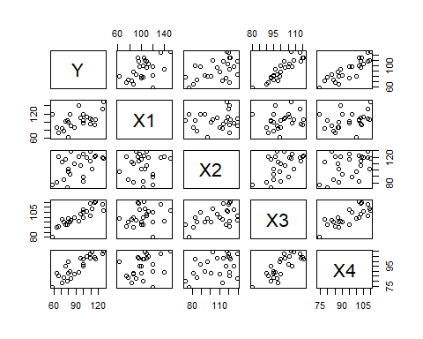
cor(excel_data[,-1])
## X1 X2 X3 X4
## X1 1.0000000 0.1022689 0.1807692 0.3266632
## X2 0.1022689 1.0000000 0.5190448 0.3967101
## X3 0.1807692 0.5190448 1.0000000 0.7820385
## X4 0.3266632 0.3967101 0.7820385 1.0000000
pairs(excel_data2)
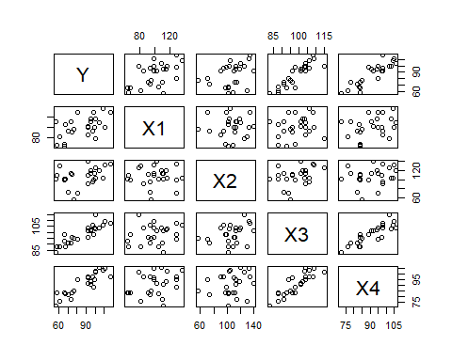
cor(excel_data2[,-1])
## X1 X2 X3 X4
## X1 1.00000000 0.01057088 0.1772891 0.3196395
## X2 0.01057088 1.00000000 0.3437441 0.2207638
## X3 0.17728907 0.34374413 1.0000000 0.8714466
## X4 0.31963945 0.22076377 0.8714466 1.0000000
#Yes, they are reasonably similiar
#Problem 9.22b
model_2 <- lm(Y~X1 + X3 + X4, data=excel_data2)
#Validation Model
summary(model_2)
##
## Call:
## lm(formula = Y ~ X1 + X3 + X4, data = excel_data2)
##
## Residuals:
## Min 1Q Median 3Q Max
## -9.4619 -2.3836 0.6834 2.1123 7.2394
##
## Coefficients:
## Estimate Std. Error t value Pr(>|t|)
## (Intercept) -122.76705 11.84783 -10.362 1.04e-09 ***
## X1 0.31238 0.04729 6.605 1.54e-06 ***
## X3 1.40676 0.23262 6.048 5.31e-06 ***
## X4 0.42838 0.19749 2.169 0.0417 *
## ---
## Signif. codes: 0 '***' 0.001 '**' 0.01 '*' 0.05 '.' 0.1 ' ' 1
##
## Residual standard error: 4.284 on 21 degrees of freedom
## Multiple R-squared: 0.9489, Adjusted R-squared: 0.9416
## F-statistic: 130 on 3 and 21 DF, p-value: 1.017e-13
summary(model_2)$coefficients[, "Std. Error"]
## (Intercept) X1 X3 X4
## 11.84783231 0.04729415 0.23261650 0.19749332
sum(model_2$residuals^2)
## [1] 385.4536
anova(model_2)["Residuals", "Mean Sq"]
## [1] 18.35493
#Y = 122.76705 + 0.31238X1 + 1.40676X3 + 0.42838X4
#Regular Model
sum_of_model_1
##
## Call:
## lm(formula = Y ~ X1 + X3 + X4, data = excel_data)
##
## Residuals:
## Min 1Q Median 3Q Max
## -5.4579 -3.1563 -0.2057 1.8070 6.6083
##
## Coefficients:
## Estimate Std. Error t value Pr(>|t|)
## (Intercept) -124.20002 9.87406 -12.578 3.04e-11 ***
## X1 0.29633 0.04368 6.784 1.04e-06 ***
## X3 1.35697 0.15183 8.937 1.33e-08 ***
## X4 0.51742 0.13105 3.948 0.000735 ***
## ---
## Signif. codes: 0 '***' 0.001 '**' 0.01 '*' 0.05 '.' 0.1 ' ' 1
##
## Residual standard error: 4.072 on 21 degrees of freedom
## Multiple R-squared: 0.9615, Adjusted R-squared: 0.956
## F-statistic: 175 on 3 and 21 DF, p-value: 5.16e-15
sum_of_model_1$coefficients[, "Std. Error"]
## (Intercept) X1 X3 X4
## 9.87405909 0.04367948 0.15183247 0.13105392
sum(model_1$residuals^2)
## [1] 348.197
anova(model_1)["Residuals", "Mean Sq"]
## [1] 16.58081
#Y = 124.20002 + 0.29633X1 + 1.35697X3 + 0.51742X4
#Problem 9.22c
model_2_prediction <- predict(model_2)
model_2_MSPE <- mean((excel_data2$Y - model_2_prediction)^2)
model_2_MSPE
## [1] 15.41814
model_1_MSE <- mean((excel_data$Y - predict(model_1))^2)
model_1_MSE
## [1] 13.92788
#MSE is lower than MSPE but not significantly; thus, there isn't much
#evidence of bias.
#Problem 9.22d
full_data <- rbind(excel_data, excel_data2)
model_3 <- lm(Y~X1 + X3 + X4, data=full_data)
summary(model_3)
##
## Call:
## lm(formula = Y ~ X1 + X3 + X4, data = full_data)
##
## Residuals:
## Min 1Q Median 3Q Max
## -9.7192 -2.7369 0.1278 2.0971 7.0657
##
## Coefficients:
## Estimate Std. Error t value Pr(>|t|)
## (Intercept) -123.44104 7.16508 -17.228 < 2e-16 ***
## X1 0.30364 0.03072 9.886 5.86e-13 ***
## X3 1.36906 0.12280 11.148 1.15e-14 ***
## X4 0.48735 0.10475 4.652 2.79e-05 ***
## ---
## Signif. codes: 0 '***' 0.001 '**' 0.01 '*' 0.05 '.' 0.1 ' ' 1
##
## Residual standard error: 4.006 on 46 degrees of freedom
## Multiple R-squared: 0.9567, Adjusted R-squared: 0.9539
## F-statistic: 338.9 on 3 and 46 DF, p-value: < 2.2e-16
summary(model_1)
##
## Call:
## lm(formula = Y ~ X1 + X3 + X4, data = excel_data)
##
## Residuals:
## Min 1Q Median 3Q Max
## -5.4579 -3.1563 -0.2057 1.8070 6.6083
##
## Coefficients:
## Estimate Std. Error t value Pr(>|t|)
## (Intercept) -124.20002 9.87406 -12.578 3.04e-11 ***
## X1 0.29633 0.04368 6.784 1.04e-06 ***
## X3 1.35697 0.15183 8.937 1.33e-08 ***
## X4 0.51742 0.13105 3.948 0.000735 ***
## ---
## Signif. codes: 0 '***' 0.001 '**' 0.01 '*' 0.05 '.' 0.1 ' ' 1
##
## Residual standard error: 4.072 on 21 degrees of freedom
## Multiple R-squared: 0.9615, Adjusted R-squared: 0.956
## F-statistic: 175 on 3 and 21 DF, p-value: 5.16e-15
#The intercept standard deviations are reduced, but not the other ones; in fact, they increased.
Problem 9.27
#Chad Huntebrinker
library(leaps)
library(readxl)
excel_data <- read_excel("SENIC_Data.xlsx")
data_part1 <- excel_data[1:56,]
data_part2 <- excel_data[57:113,]
#Problem 9.27a
#The best subset according to the Cp criterion is using age, check x-ray ratio, and census.
#So we will use that as our regression model
model_1 <- lm(log(Length_of_Stay)~Age + `Routine_Chest_X-ray` + Average_daily_census, data = data_part2)
validation_model <- lm(log(Length_of_Stay)~Age + `Routine_Chest_X-ray` + Average_daily_census, data = data_part1)
summary(model_1)$coefficients[, "Std. Error"]
## (Intercept) Age `Routine_Chest_X-ray`
## 0.2045023221 0.0037460580 0.0009643419
## Average_daily_census
## 0.0001049466
sum(model_1$residuals^2)
## [1] 0.8579723
anova(model_1)["Residuals", "Mean Sq"]
## [1] 0.01618816
summary(validation_model)$coefficients[, "Std. Error"]
## (Intercept) Age `Routine_Chest_X-ray`
## 0.2872850008 0.0048558381 0.0010067914
## Average_daily_census
## 0.0001431377
sum(validation_model$residuals^2)
## [1] 1.16534
anova(validation_model)["Residuals", "Mean Sq"]
## [1] 0.02241038
#The validation model seems similar to the model-building one.
#Problem 9.27b
model_1_MSE <- mean((data_part2$Length_of_Stay - predict(model_1))^2)
validation_model_MSPE <- mean((data_part1$Length_of_Stay - predict(validation_model))^2)
model_1_MSE
## [1] 53.88792
validation_model_MSPE
## [1] 62.3442
#The MSE and MSPE have a slight difference which wouldn't indicate any bias
#Problem 9.27c
model_2 <- lm(log(Length_of_Stay)~Age + `Routine_Chest_X-ray` + Average_daily_census, data=excel_data)
summary(model_2)$coefficients
## Estimate Std. Error t value Pr(>|t|)
## (Intercept) 1.444129952 1.699914e-01 8.495313 1.122971e-13
## Age 0.008117543 2.964507e-03 2.738244 7.216257e-03
## `Routine_Chest_X-ray` 0.003303817 6.833786e-04 4.834534 4.403894e-06
## Average_daily_census 0.000544456 8.617587e-05 6.317963 5.920449e-09
summary(model_1)$coefficients
## Estimate Std. Error t value Pr(>|t|)
## (Intercept) 1.4055759329 0.2045023221 6.873154 7.216907e-09
## Age 0.0089342528 0.0037460580 2.384974 2.068909e-02
## `Routine_Chest_X-ray` 0.0027050480 0.0009643419 2.805071 7.018153e-03
## Average_daily_census 0.0006737651 0.0001049466 6.420078 3.859019e-08
#The coefficients and standard deviations are different from those of the model building set.
#We would expect there to be a difference in the estimates due to new examples being introduced.
Problem 10.5
#Chad Huntebrinker
library(readxl)
require(faraway)
## Loading required package: faraway
## Warning: package 'faraway' was built under R version 4.4.2
excel_data <- read_excel("Brand_preference_data.xlsx")
#Problem 10.5a
model_1 <- lm(Yi~Xi1+Xi2, data = excel_data)
prplot(model_1,1)
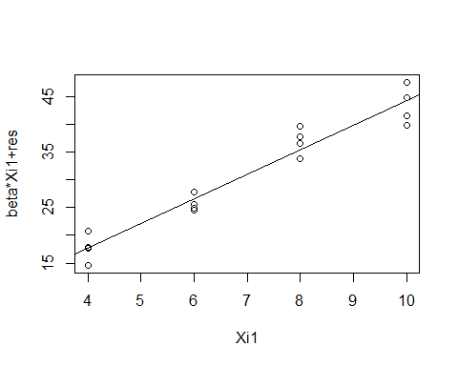
prplot(model_1,2)
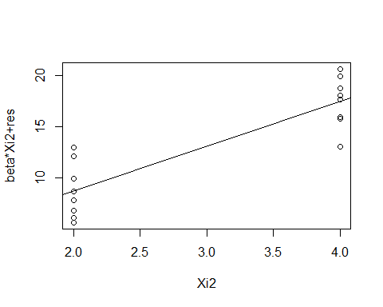
#Problem 10.5b
#It looks like both Xi1 and Xi2 would contribute to the model due to both of them having
#a linear relationship with the residuals of the model
#Problem 10.5c
model_Yi_X1 <- lm(Yi ~ Xi1, data = excel_data)
model_X2_X1 <- lm(Xi2 ~ Xi1, data = excel_data)
model_2 <- lm(model_Yi_X1$residuals~model_X2_X1$residuals)
summary(model_2)
##
## Call:
## lm(formula = model_Yi_X1$residuals ~ model_X2_X1$residuals)
##
## Residuals:
## Min 1Q Median 3Q Max
## -4.400 -1.762 0.025 1.587 4.200
##
## Coefficients:
## Estimate Std. Error t value Pr(>|t|)
## (Intercept) 0.0000 0.6488 0.000 1
## model_X2_X1$residuals 4.3750 0.6488 6.743 9.43e-06 ***
## ---
## Signif. codes: 0 '***' 0.001 '**' 0.01 '*' 0.05 '.' 0.1 ' ' 1
##
## Residual standard error: 2.595 on 14 degrees of freedom
## Multiple R-squared: 0.7646, Adjusted R-squared: 0.7478
## F-statistic: 45.47 on 1 and 14 DF, p-value: 9.427e-06
Problem 10.15
#Chad Huntebrinker
library(readxl)
excel_data <- read_excel("Brand_preference_data.xlsx")
model_1 <- lm(Yi~Xi1+Xi2, data = excel_data)
#Problem 10.15a
pairs(excel_data)
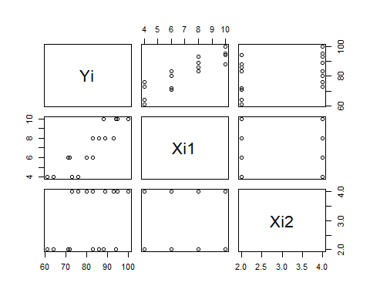
cor(excel_data[,-1])
## Xi1 Xi2
## Xi1 1 0
## Xi2 0 1
#It shows there is no association between X1 and X2
#Problem 10.15b
vif(model_1)
## Xi1 Xi2
## 1 1
#They are both equal to 1 because there is no correlation between the predictor variables
Problem 10.19
#Chad Huntebrinker
library(readxl)
library(dplyr)
##
## Attaching package: 'dplyr'
## The following objects are masked from 'package:stats':
##
## filter, lag
## The following objects are masked from 'package:base':
##
## intersect, setdiff, setequal, union
require(faraway)
excel_data <- read_excel("Job_Proficiency_Data.xlsx")
#Problem 10.19a
model_1 <- lm(Y~X1 + X3, data=excel_data)
model_1_residuals <- model_1$residuals
excel_data <-excel_data %>%
mutate(X1X3 = X1*X3)
plot(model_1_residuals~predict(model_1))
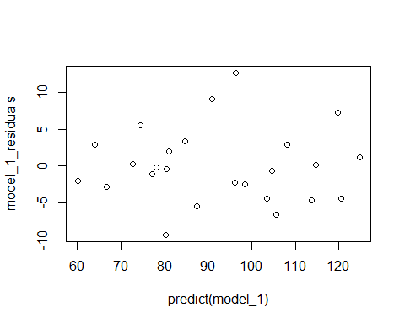
plot(model_1_residuals~X1, data = excel_data)
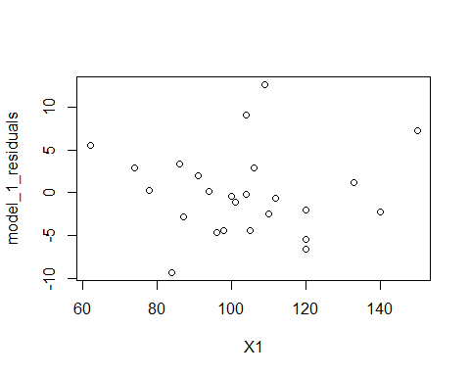
plot(model_1_residuals~X2, data = excel_data)
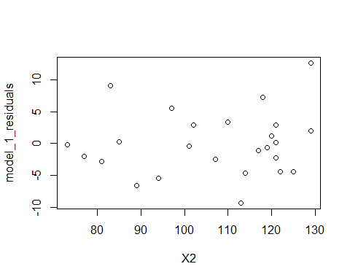
plot(model_1_residuals~X3, data = excel_data)
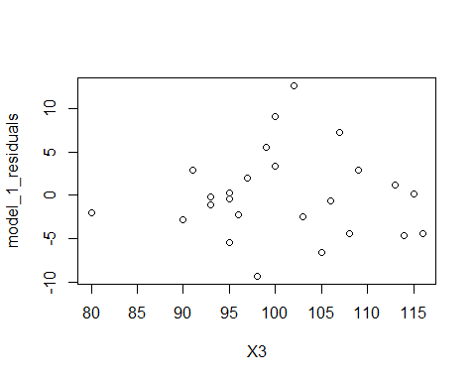
plot(model_1_residuals~X4, data = excel_data)
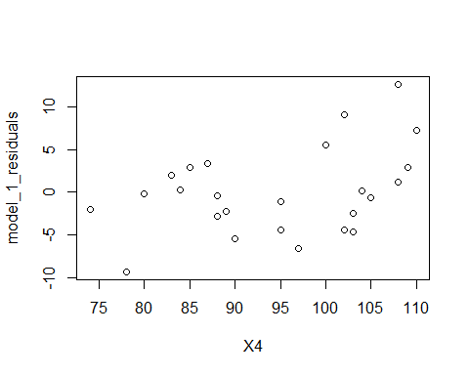
plot(model_1_residuals~X1X3, data = excel_data)
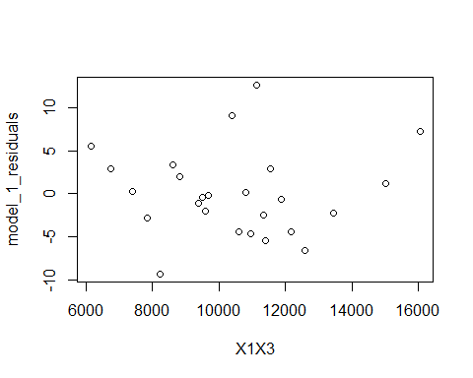
#The Yhat graph seems okay along with X1, X2, and X3 and X1X3.
#X4 might have a curve (starts up, goes down, then starts going up again).
#Overall, doesn't look like there's any modification needed.
#Problem 10.19b
model_X1_X3 <- lm(X1 ~ X3, data = excel_data)
model_X3_X1 <- lm(X3 ~ X1, data = excel_data)
prplot(model_X1_X3, 1)
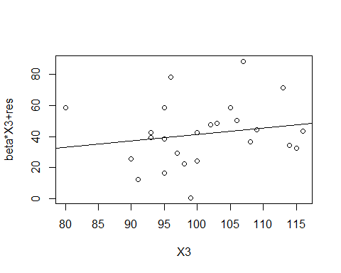
prplot(model_X3_X1, 1)
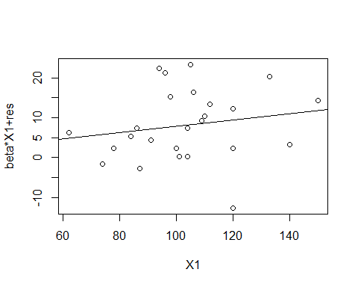
#No modification seems to be needed.
#Problem 10.19c
qqnorm(model_1$residuals)
qqline(model_1$residuals)
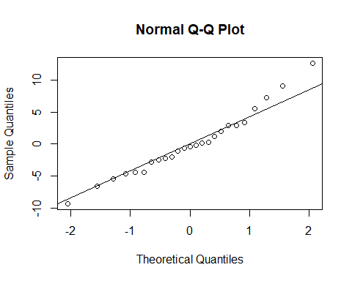
cor(model_1$residuals, qqnorm(model_1$residuals, plot.it = FALSE)$x)
## [1] 0.9840739
#The table has it listed between 0.957 and 0.96 and the correlation coefficient is 0.98
#Thus, it is reasonable.
#Problem 10.19d
#Ha: If SDR > 2.508325, then it is an outlier
#H1: If SDR <= 2.508325, then it is not an outlier
model_1_SDR <- rstudent(model_1)
bon_cutoff <- qt(1 - 0.5 / 50, df = model_1$df.residual)
outliers <- abs(model_1_SDR) > bon_cutoff
#The following are outliers
which(outliers)
## 16
## 16
model_1_SDR[16]
## 16
## 2.826891
#Problem 10.19e
which(hatvalues(model_1)>2*3/25)
## 7 18
## 7 18
excel_data[c(7,18),]
## # A tibble: 2 × 6
## Y X1 X2 X3 X4 X1X3
## <dbl> <dbl> <dbl> <dbl> <dbl> <dbl>
## 1 58 120 77 80 74 9600
## 2 127 150 118 107 110 16050
#Problem 10.19f
dffits_values <- dffits(model_1)
dfbetas_values <- dfbetas(model_1)
cooks_values <- cooks.distance(model_1)
dffits_values[c(7, 16, 18)]
## 7 16 18
## -0.3395422 0.6030725 0.9998970
#Case 7 and 16 are okay, case 18 indicates a possible influence as it is almost equal to 1
dfbetas_values[c(7, 16, 18)]
## [1] -0.24018835 -0.06867086 -0.46436969
#All the cases seem okay (they are less than 1)
cooks_values[c(7, 16, 18)]
## 7 16 18
## 0.03982863 0.09199677 0.30812948
#Case 7 and 16 are okay, case 18 indicates a possible influence as it is greater than
#the 10 or 20 percent cutoff.
#As a result, case 7 and 16 do not seem to be outliers. Case 18 indicates some suspicion and
#should be investigated deeper.
#Problem 10.19g
vif_values <- vif(model_1)
vif_values
## X1 X3
## 1.033781 1.033781
#They indicate a basically no multicollinearity between the predictor variables.

