chad_huntebrinker_hw2_plots
Chad Huntebrinker
2024-09-09
Problem 1.19:
#Chad Huntebrinker
library(Hmisc)
##
## Attaching package: 'Hmisc'
## The following objects are masked from 'package:base':
##
## format.pval, units
#Load data
y_data <- c(3.897, 3.885, 3.778, 2.54,
3.028,
3.865,
2.962,
3.961,
0.5,
3.178,
3.31,
3.538,
3.083,
3.013,
3.245,
2.963,
3.522,
3.013,
2.947,
2.118,
2.563,
3.357,
3.731,
3.925,
3.556,
3.101,
2.42,
2.579,
3.871,
3.06,
3.927,
2.375,
2.929,
3.375,
2.857,
3.072,
3.381,
3.29,
3.549,
3.646,
2.978,
2.654,
2.54,
2.25,
2.069,
2.617,
2.183,
2,
2.952,
3.806,
2.871,
3.352,
3.305,
2.952,
3.547,
3.691,
3.16,
2.194,
3.323,
3.936,
2.922,
2.716,
3.37,
3.606,
2.642,
2.452,
2.655,
3.714,
1.806,
3.516,
3.039,
2.966,
2.482,
2.7,
3.92,
2.834,
3.222,
3.084,
4,
3.511,
3.323,
3.072,
2.079,
3.875,
3.208,
2.92,
3.345,
3.956,
3.808,
2.506,
3.886,
2.183,
3.429,
3.024,
3.75,
3.833,
3.113,
2.875,
2.747,
2.311,
1.841,
1.583,
2.879,
3.591,
2.914,
3.716,
2.8,
3.621,
3.792,
2.867,
3.419,
3.6,
2.394,
2.286,
1.486,
3.885,
3.8,
3.914,
1.86,
2.94)
x_data <- c(21,
14,
28,
22,
21,
31,
32,
27,
29,
26,
24,
30,
24,
24,
33,
27,
25,
31,
25,
20,
24,
21,
28,
27,
28,
26,
28,
22,
26,
21,
25,
16,
28,
26,
22,
24,
21,
30,
27,
26,
26,
30,
24,
26,
29,
24,
31,
15,
19,
18,
27,
16,
27,
26,
24,
30,
21,
20,
30,
29,
25,
23,
25,
23,
30,
21,
24,
32,
18,
23,
20,
23,
18,
18,
29,
20,
23,
26,
28,
34,
20,
20,
26,
32,
25,
27,
27,
29,
19,
21,
24,
27,
25,
18,
29,
24,
27,
21,
19,
18,
25,
18,
20,
32,
24,
35,
25,
28,
28,
25,
22,
30,
20,
20,
31,
20,
29,
28,
16,
28)
#Plot the Data
plot(y_data ~ x_data, pch = 16, xlab = "ACT Test Scores", ylab = "GPA")
minor.tick(ny = 1, tick.ratio = 0.25)
#Fit a Linear Regression model
lrgm <- lm(y_data ~ x_data)
#Find b coefficients
b_coefficients <- lrgm$coefficients
#Add the fitted line
abline(b_coefficients, lwd =2, lty =2, col="red")
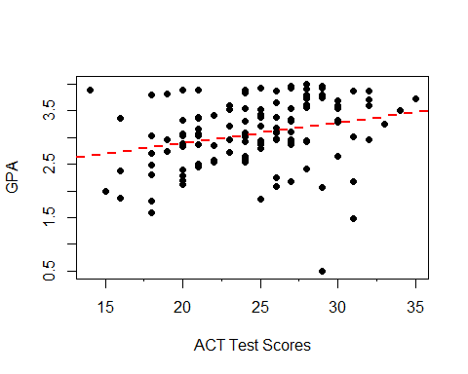
Question 1.21
#Load the data
x_data <- c(1, 0, 2, 0, 3, 1, 0, 1, 2, 0)
y_data <- c(16, 9, 17, 12, 22, 13, 8, 15, 19, 11)
#Plot the Data
plot(y_data ~ x_data, pch = 16, xlab = "Number of Transfers", ylab = "Number of Broken Ampules")
minor.tick(nx = 2, tick.ratio = 0.5)
#Fit a Linear Regression model
lrgm <- lm(y_data ~ x_data)
#Find b coefficients
b_coefficients <- lrgm$coefficients
#Add the fitted line
abline(b_coefficients, lwd =2, lty =2, col="red")
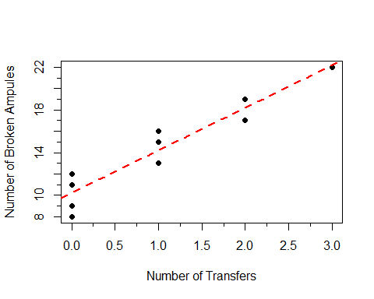
Problem 1.45
#Chad Huntebrinker
#Length of Stay
y_data <- c(7.13,8.82,8.34,8.95,11.2,9.76,9.68,11.18,8.67,8.84,11.07,8.3,12.78,
7.58,9,11.08,8.28,11.62,9.06,9.35,7.53,10.24,9.78,9.84,9.2,8.28,
9.31,8.19,11.65,9.89,11.03,9.84,11.77,13.59,9.74,10.33,9.97,7.84,
10.47,8.16,8.48,10.72,11.2,10.12,8.37,10.16,19.56,10.9,7.67,8.88,
11.48,9.23,11.41,12.07,8.63,11.15,7.14,7.65,10.73,11.46,10.42,11.18,
7.93,9.66,7.78,9.42,10.02,8.58,9.61,8.03,7.39,7.08,9.53,10.05,8.45,
6.7,8.9,10.23,8.88,10.3,10.79,7.94,7.63,8.77,8.09,9.05,7.91,10.39,
9.36,11.41,8.86,8.93,8.92,8.15,9.77,8.54,8.66,12.01,7.95,10.15,
9.76,9.89,7.14,13.95,9.44,10.8,7.14,8.02,11.8,9.5,7.7,17.94,9.41)
#Infection Risk
x1_data <- c(4.1,1.6,2.7,5.6,5.7,5.1,4.6,
5.4,4.3,6.3,4.9,4.3,7.7,3.7,4.2,5.5,4.5,6.4,4.2,4.1,4.2,4.8,5,
4.8,4,3.9,4.5,3.2,4.4,4.9,5,5.2,5.3,6.1,6.3,5,2.8,4.6,4.1,1.3,3.7,4.7,3,
5.6,5.5,4.6,6.5,5.5,1.8,4.2,5.6,4.3,7.6,7.8,3.1,3.9,3.7,4.3,3.9,4.5,
3.4,5.7,5.4,4.4,5,4.3,4.4,3.7,4.5,3.5,4.2,2,5.2,4.5,3.4,4.5,2.9,4.9,
4.4,5.1,2.9,3.5,5.5,4.7,1.7,4.1,2.9,4.3,4.8,5.8,2.9,2,1.3,5.3,5.3,2.5,
3.8,4.8,2.3,6.2,2.6,4.3,2.7,6.6,4.5,2.9,1.4,2.1,5.7,5.8,4.4,5.9,3.1)
#Available facilities and services
x2_data <- c(60,40,20,40,40,40,40,60,40,40,80,40,57.1,37.1,17.1,57.1,37.1,37.1,
37.1,77.1,17.1,37.1,57.1,57.1,57.1,57.1,37.1,37.1,37.1,37.1,57.1,54.3,34.3,
54.3,54.3,54.3,34.3,34.3,54.3,14.3,34.3,34.3,34.3,54.3,34.3,74.3,51.4,51.4,
11.4,51.4,51.4,71.4,51.4,31.4,31.4,51.4,31.4,51.4,51.4,31.4,31.4,68.6,28.6,28.6,
48.6,48.6,48.6,48.6,48.6,28.6,28.6,28.6,48.6,68.6,48.6,28.6,28.6,68.6,48.6,45.7,
65.7,45.7,45.7,25.7,45.7,45.7,65.7,65.7,45.7,45.7,25.7,25.7,5.7,25.7,25.7,45.7,45.7,45.7,
42.9,62.9,22.9,42.9,22.9,62.9,42.9,22.9,22.9,22.9,62.9,22.9,62.9,62.9,22.9)
#Routine Chest X-ray
x3_data <- c(39.6,51.7,74,122.8,88.9,97,79,85.8,90.8,82.6,122,83.8,116.9,88,76.4,
63.6,101.8,99.2,75.9,80.9,98.9,112.6,95.9,82.3,71.1,113.1,101.3,59.2,96.1,
103.6,102.1,72.6,56,111.7,76.1,104.3,76.5,87.9,69.1,58,92.8,94.1,78.9,
79.1,84.8,51.5,113.7,71.9,40.4,86.9,82,42.6,97.9,105.3,56.2,73.9,75.8,
65.7,101,97.7,59,55.9,98.1,98.3,71.6,62.8,93,95.9,87.2,87.3,88.4,56.4,
65.7,87.5,85,80.8,86.9,77.9,76.8,88.9,56.6,92.3,61.1,47,56.9,79.8,
79.5,88.3,90.6,73,87.5,72.5,79.5,79.8,89.7,82.5,69.5,96.9,54.9,59.2,
80.1,108.7,92.6,133.5,58.5,57.4,45.7,46.5,116.9,70.9,67.9,91.8,91.7)
#For X1, plot the Data
plot(y_data ~ x1_data, pch = 16, xlab = "Infection Risk", ylab = "Length of Stay")
minor.tick(nx = 2, tick.ratio = 0.5)
#Fit a Linear Regression model
lrgm <- lm(y_data ~ x1_data)
#Find b coefficients
b_coefficients <- lrgm$coefficients
#Add the fitted line
abline(b_coefficients, lwd =2, lty =2, col="red")
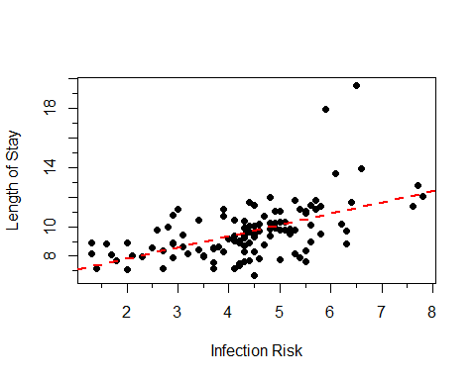
#For X2, plot the Data
plot(y_data ~ x2_data, pch = 16, xlab = "Available facilities and services", ylab = "Length of Stay")
minor.tick(nx = 2, tick.ratio = 0.5)
#Fit a Linear Regression model
lrgm <- lm(y_data ~ x2_data)
#Find b coefficients
b_coefficients <- lrgm$coefficients
#Add the fitted line
abline(b_coefficients, lwd =2, lty =2, col="green")
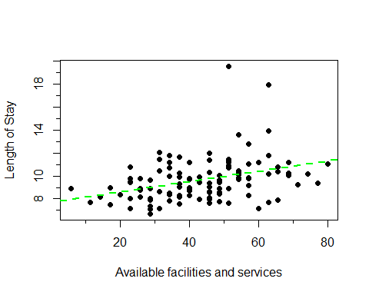
#For X3, plot the Data
plot(y_data ~ x3_data, pch = 16, xlab = "Routine Chest X-ray", ylab = "Length of Stay")
minor.tick(nx = 2, tick.ratio = 0.5)
#Fit a Linear Regression model
lrgm <- lm(y_data ~ x3_data)
#Find b coefficients
b_coefficients <- lrgm$coefficients
#Add the fitted line
abline(b_coefficients, lwd =2, lty =2, col="blue")
