Chad Huntebrinker’s Homework 5
Chad Huntebrinker
2024-10-01
Question 3.3:
#Chad Huntebrinker
library(readxl)
excel_data <- read_excel("Grade_Point_Average_Data.xlsx")
# GPA ~ ACT
# Fit the model and get the summary of the model
model_1 <- lm(GPA~ACT_Score,data=excel_data)
sum_of_model_1 <- summary(model_1)
sum_of_model_1
##
## Call:
## lm(formula = GPA ~ ACT_Score, data = excel_data)
##
## Residuals:
## Min 1Q Median 3Q Max
## -2.74004 -0.33827 0.04062 0.44064 1.22737
##
## Coefficients:
## Estimate Std. Error t value Pr(>|t|)
## (Intercept) 2.11405 0.32089 6.588 1.3e-09 ***
## ACT_Score 0.03883 0.01277 3.040 0.00292 **
## ---
## Signif. codes: 0 '***' 0.001 '**' 0.01 '*' 0.05 '.' 0.1 ' ' 1
##
## Residual standard error: 0.6231 on 118 degrees of freedom
## Multiple R-squared: 0.07262, Adjusted R-squared: 0.06476
## F-statistic: 9.24 on 1 and 118 DF, p-value: 0.002917
# Plot the graph just to see
plot(GPA~ACT_Score,data=excel_data)
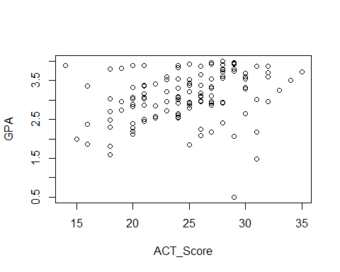
#Problem 3.3a - Create boxplot
boxplot(excel_data$ACT_Score, horizontal = TRUE)
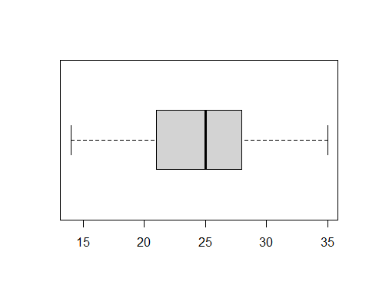
#Problem 3.3b - Create dot plot of residuals
residuals_model_1 <- resid(model_1)
stripchart(residuals_model_1, main = "Dot Plot of Residuals", xlab = "Residuals", method = "jitter")
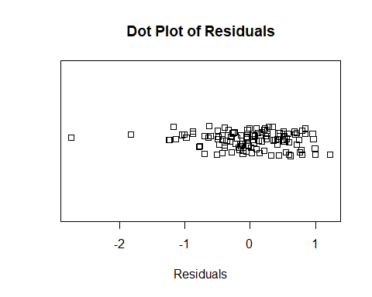
#Problem 3.3c - Create plot of residuals against the fitted values
fitted_values <- fitted(model_1)
plot(residuals_model_1 ~ fitted_values, main = "Residual Plot", xlab = "Fitted Values", ylab = "Residuals")
abline(h = 0, lty = 2)
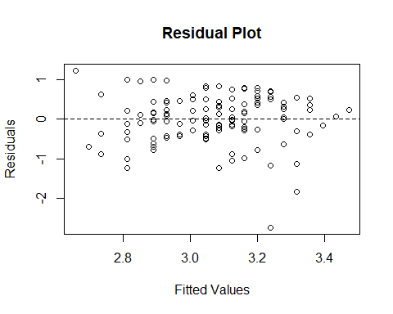
#Problem 3.3d - Create Normal Plot
q <- qqnorm(residuals_model_1, main = "Normal Probability Plot of Residuals")
qqline(residuals_model_1)
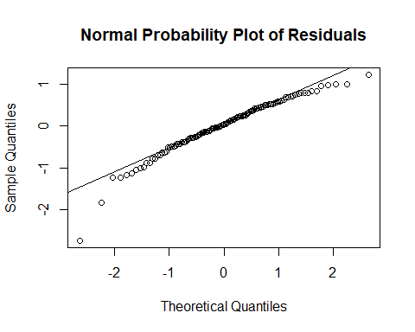
cor.test(q$x, q$y, method=c("pearson")) # Table B6 in book
##
## Pearson's product-moment correlation
##
## data: q$x and q$y
## t = 47.128, df = 118, p-value < 2.2e-16
## alternative hypothesis: true correlation is not equal to 0
## 95 percent confidence interval:
## 0.9634938 0.9821475
## sample estimates:
## cor
## 0.9744497
#Problem 3.3e - calculate t sample test statistic and the Brown-Forsythe test
group_1 <- subset(excel_data, excel_data$ACT_Score < 26)
group_2 <- subset(excel_data, excel_data$ACT_Score >= 26)
model_group1 <- lm(GPA~ACT_Score,data=group_1)
model_group2 <- lm(GPA~ACT_Score,data=group_2)
median_1 <- median(resid(model_group1))
median_2 <- median(resid(model_group2))
abs_dev_group1 <- abs(resid(model_group1) - median_1)
abs_dev_group2 <- abs(resid(model_group2) - median_2)
s <- sqrt((sum((abs_dev_group1 - mean(abs_dev_group1))^2) + sum((abs_dev_group2 - mean(abs_dev_group1))^2))
/ (nrow(excel_data) - 2))
two_sample_t <- ((mean(abs_dev_group1) - mean(abs_dev_group2)) / (s * (sqrt(1/nrow(group_1) + 1/nrow(group_2)))))
print(two_sample_t)
## [1] -0.9533587
#Is H0 true? We find it is not
abs(two_sample_t) > qt(0.995, 118)
## [1] FALSE
#Problem 3.3f - Plot x2 and x3 with the residuals
plot(residuals_model_1 ~ excel_data$Intelligence_Test_Score,
main = "X2 Residual Plot", xlab = "Intelligence Test Score", ylab = "Residuals")
abline(h = 0, lty = 2)
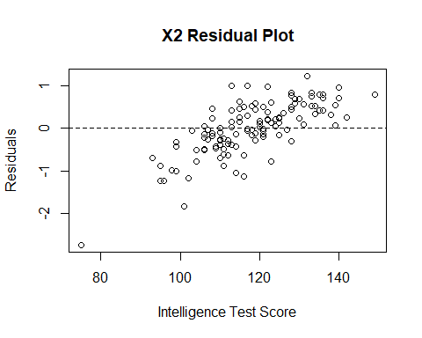
plot(residuals_model_1 ~ excel_data$Class_Rank_Percentile,
main = "X3 Residual Plot", xlab = "Class Rank Percentile", ylab = "Residuals")
abline(h = 0, lty = 2)
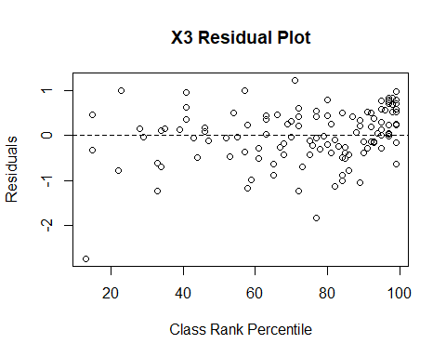
Question 3.8:
#Chad Huntebrinker
library(readxl)
excel_data <- read_excel("Crime_Rate_Data.xlsx")
# Fit the model and get the summary of the model
model_1 <- lm(Crime_Rate~Highschool_Diploma_Percentage,data=excel_data)
sum_of_model_1 <- summary(model_1)
sum_of_model_1
##
## Call:
## lm(formula = Crime_Rate ~ Highschool_Diploma_Percentage, data = excel_data)
##
## Residuals:
## Min 1Q Median 3Q Max
## -5278.3 -1757.5 -210.5 1575.3 6803.3
##
## Coefficients:
## Estimate Std. Error t value Pr(>|t|)
## (Intercept) 20517.60 3277.64 6.260 1.67e-08 ***
## Highschool_Diploma_Percentage -170.58 41.57 -4.103 9.57e-05 ***
## ---
## Signif. codes: 0 '***' 0.001 '**' 0.01 '*' 0.05 '.' 0.1 ' ' 1
##
## Residual standard error: 2356 on 82 degrees of freedom
## Multiple R-squared: 0.1703, Adjusted R-squared: 0.1602
## F-statistic: 16.83 on 1 and 82 DF, p-value: 9.571e-05
# Plot the graph just to see
plot(Crime_Rate~Highschool_Diploma_Percentage,data=excel_data)
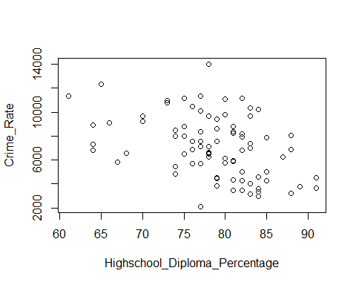
#Problem 3.4a - Create stem and leaf plot
stem(excel_data$Highschool_Diploma_Percentage)
##
## The decimal point is 1 digit(s) to the right of the |
##
## 6 | 1444
## 6 | 5678
## 7 | 00334444
## 7 | 5555666677777778888888999999
## 8 | 000011111112222222233333344444
## 8 | 55578889
## 9 | 11
#Problem 3.4b - Create boxplot of residuals
residuals_model_1 <- resid(model_1)
boxplot(residuals_model_1, horizontal = TRUE)
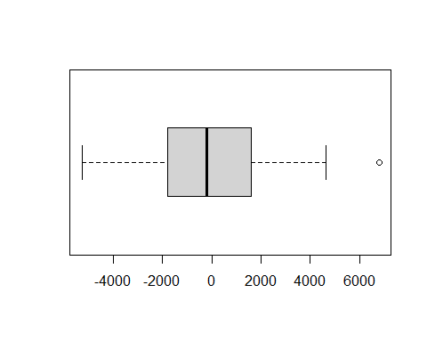
#Problem 3.4c - Create a residual plot with the fitted values
fitted_values <- fitted(model_1)
plot(residuals_model_1 ~ fitted_values, main = "Residual Plot", xlab = "Fitted Values", ylab = "Residuals")
abline(h = 0, lty = 2)
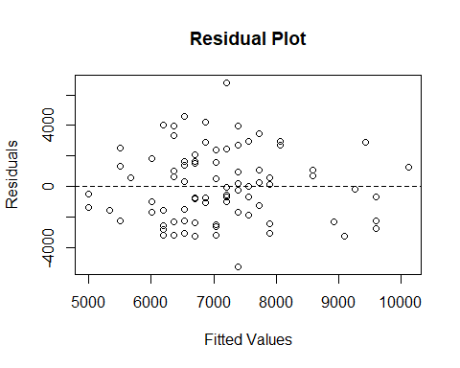
#Problem 3.4d - Get the correlation coefficient and the normal probability plot
q <- qqnorm(residuals_model_1, main = "Normal Probability Plot of Residuals")
qqline(residuals_model_1)
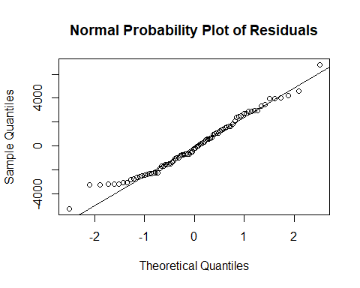
cor.test(q$x, q$y, method=c("pearson")) # Table B6 in book
##
## Pearson's product-moment correlation
##
## data: q$x and q$y
## t = 59.465, df = 82, p-value < 2.2e-16
## alternative hypothesis: true correlation is not equal to 0
## 95 percent confidence interval:
## 0.9824370 0.9926123
## sample estimates:
## cor
## 0.988603
#Problem 3.4e - Do the Brown-Forsythe test
group_1 <- subset(excel_data, excel_data$Highschool_Diploma_Percentage < 69)
group_2 <- subset(excel_data, excel_data$Highschool_Diploma_Percentage >= 69)
model_group1 <- lm(Crime_Rate~Highschool_Diploma_Percentage,data=group_1)
model_group2 <- lm(Crime_Rate~Highschool_Diploma_Percentage,data=group_2)
median_1 <- median(resid(model_group1))
median_2 <- median(resid(model_group2))
abs_dev_group1 <- abs(resid(model_group1) - median_1)
abs_dev_group2 <- abs(resid(model_group2) - median_2)
s <- sqrt((sum((abs_dev_group1 - mean(abs_dev_group1))^2) + sum((abs_dev_group2 - mean(abs_dev_group1))^2))
/ (nrow(excel_data) - 2))
two_sample_t <- ((mean(abs_dev_group1) - mean(abs_dev_group2)) / (s * (sqrt(1/nrow(group_1) + 1/nrow(group_2)))))
print(two_sample_t)
## [1] -0.9155
#Is H0 true? We find it is not.
abs(two_sample_t) > qt(0.975, 82)
## [1] FALSE
Question 3.9:
#Chad Huntebrinker
#Problem 3.9
x_values <- c(2, 3, 4, 5, 6, 7, 8, 9, 10, 11)
residual_values <- c(3.2, 2.9, -1.7, -2.0, -2.3, -1.2, -0.9, 0.8, 0.7, 0.5)
plot(residual_values ~ x_values)
abline(h = 0, lty = 2)
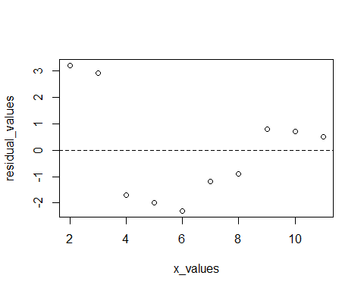
Question 3.11:
#Chad Huntebrinker
#Problem 3.11a
x_values <- c(-1, 0, 1, -1, 0, 1, -1, 0, 1)
residual_values <- c(0.5, 2.1, -3.4, 0.3, -1.7, 4.2, -0.6, 2.6, -4.0)
plot(residual_values ~ x_values)
abline(h = 0, lty = 2)
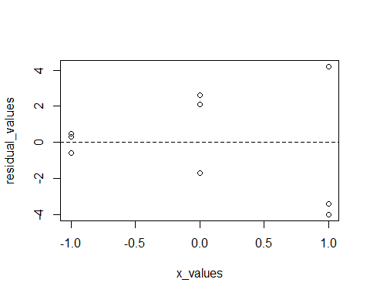
#They have a megaphone type
#Problem 3.11b
m.sig <- lm(residual_values^2~x_values)
anova(m.sig)
## Analysis of Variance Table
##
## Response: residual_values^2
## Df Sum Sq Mean Sq F value Pr(>F)
## x_values 1 330.04 330.04 51.348 0.0001828 ***
## Residuals 7 44.99 6.43
## ---
## Signif. codes: 0 '***' 0.001 '**' 0.01 '*' 0.05 '.' 0.1 ' ' 1
csq <- (anova(m.sig)$"Sum Sq"[1]/2)/((anova(m.sig)$"Sum Sq"[2]/9)^2)
csq > qchisq(0.95,1)
## [1] TRUE
#Ha is true

