Chad Huntebrinker’s Homework 6
Chad Huntebrinker
2024-10-08
Question 2.14
#Chad Huntebrinker
#Load the library and data in to R
library(readxl)
excel_data <- read_excel("Copier_Maintenance_Data.xlsx")
#Total_Minutes ~ Number_Of_Copiers
#Fit the model
model_3 <- lm(Total_Minutes~Number_Of_Copiers,data=excel_data)
sum_of_model_3 <- summary(model_3)
#Plot to see the graph
plot(Total_Minutes~Number_Of_Copiers, data = excel_data)
abline(model_3,col="blue")
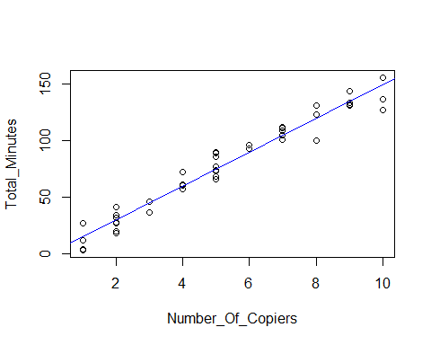
#Get the mean service time for 6 copiers serviced
Y_hat <- predict(model_3, data.frame(Number_Of_Copiers=6))
#Now get the confidence interval
CI <- predict(model_3, se.fit = TRUE, data.frame(Number_Of_Copiers=6), interval = "confidence", level = 0.90)
#Problem 2.14b
#We're getting a 90% prediction interval when 6 copiers are serviced
predict(model_3, data.frame(Number_Of_Copiers=6),interval="prediction",level=0.90)
## fit lwr upr
## 1 89.63133 74.46433 104.7983
#The interval 74.46433 <= Yh <= 104.7983 is wider than
#the confidence interval in part a and we would expect it to be.
#Problem 2.14d
#Getting the boundary values of the 90 percent confidence band of the regression line at Xh = 6
W <- sqrt(2*qf(1-0.1,2,45-2))
lower_bound <- Y_hat - W * CI$se.fit
upper_bound <- Y_hat + W * CI$se.fit
#This confidence band (86.6, 92.7) is wider than the confidence interval in part a and we would expect it to be.
Question 2.15
#Chad Huntebrinker
#Load the library and data in to R
library(readxl)
excel_data <- read_excel("Airfreight_Breakage_Data.xlsx")
#Number_Broker ~ Number_Transferred
#Fit the model
model_4 <- lm(Number_Broker~Number_Transferred,data=excel_data)
sum_of_model_4 <- summary(model_4)
#Plot to see the graph
plot(Number_Broker~Number_Transferred, data = excel_data)
abline(model_4)
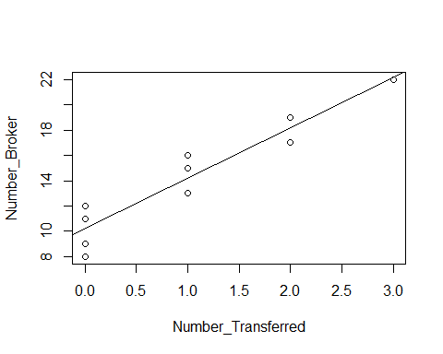
#Problem 2.15a
#Getting the mean breakage at X = 2 and 4. Also getting a 99% confidence interval at those values too.
predict(model_4, data.frame(Number_Transferred=2),interval="confidence",level=0.99)
## fit lwr upr
## 1 18.2 15.97429 20.42571
predict(model_4, data.frame(Number_Transferred=4),interval="confidence",level=0.99)
## fit lwr upr
## 1 26.2 21.22316 31.17684
#Problem 2.15d
#Getting the boundary values of the 99 percent confidence band for the regression line at X = 2 and 4.
Y_hat2 <- predict(model_4, data.frame(Number_Transferred=2))
Y_hat4 <- predict(model_4, data.frame(Number_Transferred=4))
W <- sqrt(2*qf(1-0.01,2,10-2))
CI2 <- predict(model_4, se.fit = TRUE, data.frame(Number_Transferred=2), interval = "confidence", level = 0.99)
lower_bound2 <- Y_hat2 - W * CI2$se.fit
upper_bound2 <- Y_hat2 + W * CI2$se.fit
CI4 <- predict(model_4, se.fit = TRUE, data.frame(Number_Transferred=4), interval = "confidence", level = 0.99)
lower_bound4 <- Y_hat4 - W * CI4$se.fit
upper_bound4 <- Y_hat4 + W * CI4$se.fit
#We find that both of these confidence bands are wider than the confidence
#interval in part a and we would expect that.
Question 2.28
#Chad Huntebrinker
#Load the library and data in to R
library(readxl)
excel_data <- read_excel("Muscle_Mass_Data.xlsx")
#Muscle_Mass ~ Age
#Fit the model
model_5 <- lm(Muscle_Mass~Age,data=excel_data)
sum_of_model_5 <- summary(model_5)
#Plot to see the graph
plot(Muscle_Mass~Age, data = excel_data)
abline(model_5)
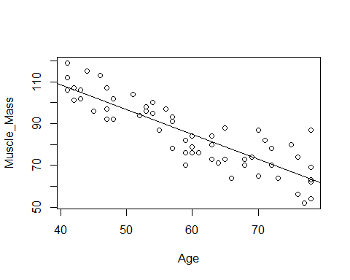
#Problem 2.28a
#Get a 95% confidence interval for the mean of the muscle mass (Y) when X = 60
predict(model_5, data.frame(Age=60),interval="confidence",level=0.95)
## fit lwr upr
## 1 84.94683 82.83471 87.05895
#We find the mean is 84.94683 with an upper bound of 87.05895 and lower bound of 82.83471
#This means that with 95% confidence we can say that the mean muscle mass is between 82.83 and 87.05
#Problem 2.28b
#Get a 95% prediction interval for the muscle mass when X = 60
predict(model_5, data.frame(Age=60),interval="prediction",level=0.95)
## fit lwr upr
## 1 84.94683 68.45067 101.443
#With the mean being 84.94683, we find the lower bound is 68.45067 and the upper bound is 101.443
#This seems to indicate the prediction interval is relatively precise
#Problem 2.28c
#Get the boundary values of the 95% confidence band for the regression line at Xh = 60
CI <- predict(model_5, se.fit = TRUE, data.frame(Age=60), interval = "confidence", level = 0.95)
W <- sqrt(2*qf(1-0.05, 2, 60-2))
lower_bound <- CI$fit[1] - W * CI$se.fit
upper_bound <- CI$fit[1] + W * CI$se.fit
#We find the confidence band is wider than the confidence interval in part a.
#Yes, we would expect that.
Question 4.27
#Chad Huntebrinker
#Load the library and data in to R
library(readxl)
excel_data <- read_excel("SENIC_Data.xlsx")
#Length_of_Stay ~ Infection_Risk
#Fit the model
model_6 <- lm(Length_of_Stay~Infection_Risk,data=excel_data)
sum_of_model_6 <- summary(model_6)
#Plot to see the graph
plot(Length_of_Stay~Infection_Risk, data = excel_data)
abline(model_6)
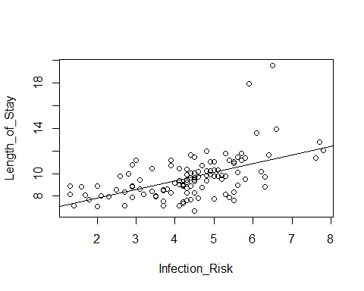
#Problem 4.27a
#1 - alpha/(2*m) [where m = 2 since we need one for B0 and one for B1]
1-0.1/4
## [1] 0.975
confint(model_6, level = 0.975)
## 1.25 % 98.75 %
## (Intercept) 5.1523372 7.521236
## Infection_Risk 0.5003816 1.020460
#We have the joint confidence interval for as 0.5003816 <= B1 <= 1.020460
#and 5.1523372 <= B0 <= 7.521236
#Problem 4.27b
#The researcher is saying that B0 should be about 7 and B1 should be about 1.
#According to Problem 2.27a, this is supported. Both B0=7 and B1=1 are in the
#confidence interval. Thus, we can say that this is true when the family confidence
#coefficient is at least 0.9 that the procedure leads to correct pairs of interval estimates.
#Problem 4.27c and d
W <- sqrt(2*qf(1-0.05,2,113-2))
B <- qt(1-0.05/8, 113-2)
B > W
## [1] TRUE
#The more efficient method should be the Working-Hotelling. The reason being that we have
#a larger value of m (m = 4) which means the Working-Hotelling will be more precise. We
#also see that the W value is less than the B value, leading us to believe that the
#Working-Hotelling method will lead to a tighter confidence limits.
#But we'll calculate using both just to see.
X.h <- c(2, 3, 4, 5)
family_con <- 1-0.05/8
# Estimation
CI.bf <- predict(model_6,data.frame(Infection_Risk = X.h), interval="confidence",level=family_con) # Adjust level
# Working-Hotelling multiplier for 95% simultaneous confidence band
# Extract standard errors of Y-hat
CI.wh <- predict(model_6,data.frame(Infection_Risk = X.h), se.fit = TRUE, interval = "confidence",
level = 0.95)
wh.LB <- CI.wh$fit[,1] - W*CI.wh$se.fit # WH lower bound
wh.UB <- CI.wh$fit[,1] + W*CI.wh$se.fit # WH upper bound
#Bonferroni:
#2: 6.994082 <-> 8.721175: dif = 1.7270924
#3: 8.011273 <-> 9.224825: dif = 1.2135524
#4: 8.937812 <-> 9.819129: dif = 0.8813172
#5: 9.665901 <-> 10.611881: dif = 0.9459808
#Working-Hotelling:
#2: 7.088991 <-> 8.626266: dif = 1.537275
#3: 8.077961 <-> 9.158137: dif = 1.080176
#4: 8.986242 <-> 9.770698: dif = 0.784456
#5: 9.717885 <-> 10.559897: dif = 0.842012

