Chad Huntebrinker’s Homework 7
Chad Huntebrinker
2024-10-28
Problem 2.23
#Chad Huntebrinker
library(readxl)
excel_data <- read_excel("Grade_Point_Average_Data.xlsx")
# GPA ~ ACT
# Fit the model and get the summary of the model
model_1 <- lm(GPA~ACT_Score,data=excel_data)
sum_of_model_1 <- summary(model_1)
sum_of_model_1
##
## Call:
## lm(formula = GPA ~ ACT_Score, data = excel_data)
##
## Residuals:
## Min 1Q Median 3Q Max
## -2.74004 -0.33827 0.04062 0.44064 1.22737
##
## Coefficients:
## Estimate Std. Error t value Pr(>|t|)
## (Intercept) 2.11405 0.32089 6.588 1.3e-09 ***
## ACT_Score 0.03883 0.01277 3.040 0.00292 **
## ---
## Signif. codes: 0 '***' 0.001 '**' 0.01 '*' 0.05 '.' 0.1 ' ' 1
##
## Residual standard error: 0.6231 on 118 degrees of freedom
## Multiple R-squared: 0.07262, Adjusted R-squared: 0.06476
## F-statistic: 9.24 on 1 and 118 DF, p-value: 0.002917
# Plot the graph just to see
plot(GPA~ACT_Score,data=excel_data)
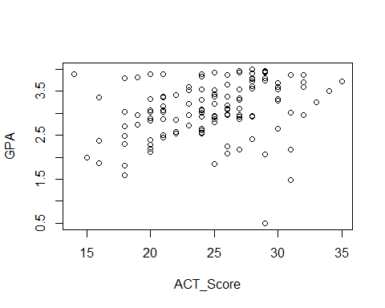
#Problem 2.23a
anova_table <- anova(model_1)
#Problem 2.23b
#MSR
anova_table$`Mean Sq`[1]
## [1] 3.587846
#MSE
anova_table$`Mean Sq`[2]
## [1] 0.3882848
#They will estimate the same quantity when the null hypothesis is true (H0: B1 = 0).
#Problem 2.23c
#H0: B1 = 0: F* <= qf(1 - 0.01, 1, 118)
#Ha: B1 != 0: F* > qf(1 - 0.01, 1, 118)
#Check to see if Ha is true:
anova_table$`F value`[1]
## [1] 9.240243
qf(1 - 0.01, 1, 118)
## [1] 6.854641
anova_table$`F value`[1] > qf(1 - 0.01, 1, 118)
## [1] TRUE
#Conclusion: B1 != 0, there is a linear association
#Problem2.23d
model_1_reduced <- lm(GPA~1,data=excel_data)
anova_table2 <- anova(model_1_reduced,model_1)
#Absolute magnitude of reduction
anova_table2$`Sum of Sq`[2]
## [1] 3.587846
#Relative reduction
anova_table2$`Sum of Sq`[2] / anova_table2$RSS[1]
## [1] 0.07262044
#It's also known as R^2 or coefficient of determination
summary(model_1)$r.square
## [1] 0.07262044
#Problem 2.23e
sqrt(anova_table2$`Sum of Sq`[2] / anova_table2$RSS[1])
## [1] 0.2694818
#r = +0.2694818
#Problem 2.23f
#In this case, r has a more clear-cut operational interpration. This is due to the answer
#of r (+0.2694818) showing that there is a slight positive linear relationship between
#the two variables. And we can see that is the case on the graph too (positive linear relationship
#between points until we get to around 27).
Problem 2.29
#Chad Huntebrinker
#Load the library and data in to R
library(readxl)
excel_data <- read_excel("Muscle_Mass_Data.xlsx")
#Muscle_Mass ~ Age
#Fit the model
model_3 <- lm(Muscle_Mass~Age,data=excel_data)
sum_of_model_3 <- summary(model_3)
#Plot to see the graph
plot(Muscle_Mass~Age, data = excel_data)
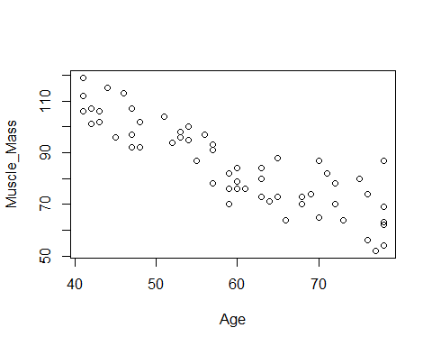
#Problem 2.29a
SSE_model_3 <- excel_data$Muscle_Mass - predict(model_3, data.frame(Age=excel_data$Age))
SSR_model_3 <- predict(model_3, data.frame(Age=excel_data$Age)) - mean(excel_data$Muscle_Mass)
plot(SSE_model_3 ~ Age, data = excel_data)
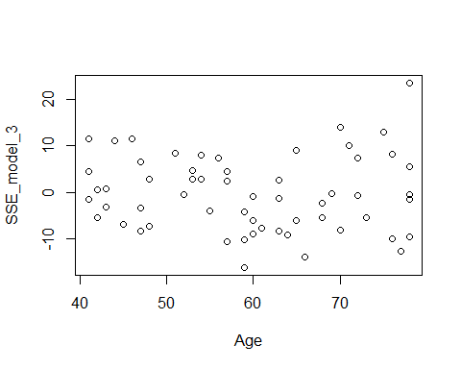
plot(SSR_model_3 ~ Age, data = excel_data)
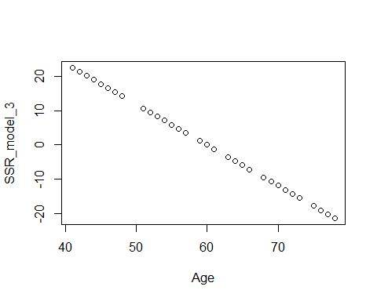
#It looks like the SSR plays a larger component of SSTO.
#That means that R^2 will be closer to 1, leading to a greater degree in linearity
#Problem 2.29b
anova_table <- anova(model_3)
#Problem 2.29c
#H0: B1 = 0: F* <= qf(1 - 0.05, 1, 58)
#Ha: B1 != 0: F* > qf(1 - 0.05, 1, 58)
#Check to see if Ha is true:
anova_table$`F value`[1]
## [1] 174.062
qf(1 - 0.05, 1, 58)
## [1] 4.006873
anova_table$`F value`[1] > qf(1 - 0.05, 1, 58)
## [1] TRUE
#Conclusion: B1 != 0, there is a linear association
#Problem 2.29d
model_3_reduced <- lm(Muscle_Mass~1,data=excel_data)
anova_table2 <- anova(model_3_reduced,model_3)
1 - anova_table2$`Sum of Sq`[2] / anova_table2$RSS[1]
## [1] 0.2499332
#0.2499332 or 24.99%
#It is relatively small
#Problem 2.29e
#R^2 = 0.7500668
anova_table2$`Sum of Sq`[2] / anova_table2$RSS[1]
## [1] 0.7500668
#r = -0.866064
sqrt(anova_table2$`Sum of Sq`[2] / anova_table2$RSS[1])
## [1] 0.866064
Problem 2.32
#Chad Huntebrinker
library(readxl)
excel_data <- read_excel("Crime_Rate_Data.xlsx")
# Fit the model and get the summary of the model
model_4 <- lm(Crime_Rate~Highschool_Diploma_Percentage,data=excel_data)
sum_of_model_4 <- summary(model_4)
sum_of_model_4
##
## Call:
## lm(formula = Crime_Rate ~ Highschool_Diploma_Percentage, data = excel_data)
##
## Residuals:
## Min 1Q Median 3Q Max
## -5278.3 -1757.5 -210.5 1575.3 6803.3
##
## Coefficients:
## Estimate Std. Error t value Pr(>|t|)
## (Intercept) 20517.60 3277.64 6.260 1.67e-08 ***
## Highschool_Diploma_Percentage -170.58 41.57 -4.103 9.57e-05 ***
## ---
## Signif. codes: 0 '***' 0.001 '**' 0.01 '*' 0.05 '.' 0.1 ' ' 1
##
## Residual standard error: 2356 on 82 degrees of freedom
## Multiple R-squared: 0.1703, Adjusted R-squared: 0.1602
## F-statistic: 16.83 on 1 and 82 DF, p-value: 9.571e-05
# Plot the graph just to see
plot(Crime_Rate~Highschool_Diploma_Percentage,data=excel_data)
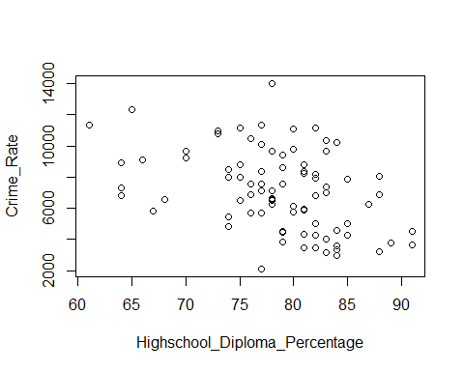
#Problem 2.32a
model_4_reduced <- lm(Crime_Rate~1,data=excel_data)
summary(model_4)
##
## Call:
## lm(formula = Crime_Rate ~ Highschool_Diploma_Percentage, data = excel_data)
##
## Residuals:
## Min 1Q Median 3Q Max
## -5278.3 -1757.5 -210.5 1575.3 6803.3
##
## Coefficients:
## Estimate Std. Error t value Pr(>|t|)
## (Intercept) 20517.60 3277.64 6.260 1.67e-08 ***
## Highschool_Diploma_Percentage -170.58 41.57 -4.103 9.57e-05 ***
## ---
## Signif. codes: 0 '***' 0.001 '**' 0.01 '*' 0.05 '.' 0.1 ' ' 1
##
## Residual standard error: 2356 on 82 degrees of freedom
## Multiple R-squared: 0.1703, Adjusted R-squared: 0.1602
## F-statistic: 16.83 on 1 and 82 DF, p-value: 9.571e-05
summary(model_4_reduced)
##
## Call:
## lm(formula = Crime_Rate ~ 1, data = excel_data)
##
## Residuals:
## Min 1Q Median 3Q Max
## -5006.2 -2090.7 -180.7 1728.3 6904.8
##
## Coefficients:
## Estimate Std. Error t value Pr(>|t|)
## (Intercept) 7111.2 280.5 25.35 <2e-16 ***
## ---
## Signif. codes: 0 '***' 0.001 '**' 0.01 '*' 0.05 '.' 0.1 ' ' 1
##
## Residual standard error: 2571 on 83 degrees of freedom
#Problem 2.32b
#1)
SSE_F <- deviance(model_4)
#2)
SSE_R <- deviance(model_4_reduced)
#3)
dfF = 82
#4)
dfR = 83
#5)
F_stat <- ((SSE_R - SSE_F) / (dfR - dfF)) / (SSE_F / dfF)
#6)
#H0: B1 = 0: F* <= qf(1 - 0.01, dfR - dfF, dfF)
#Ha: B1 != 0: F* > qf(1 - 0.01, dfR - dfF, dfF)
#Check to see if Ha is true:
F_stat
## [1] 16.83376
qf(1 - 0.01, dfR - dfF, dfF)
## [1] 6.95442
F_stat > qf(1 - 0.01, dfR - dfF, dfF)
## [1] TRUE
#Conclusion: B1 != 0, there is a linear association
#Problem 2.32c
#t-test for with alpha = 0.01 that B1 != 0
abs(sum_of_model_4$coefficients[2,3]) > qt(1 - 0.01/2, 82)
## [1] TRUE
abs(sum_of_model_4$coefficients[2,3])
## [1] 4.102897
sqrt(F_stat)
## [1] 4.102897
#Yes, they are
Problem 2.64
#Chad Huntebrinker
#Load the library and data in to R
library(readxl)
excel_data <- read_excel("SENIC_Data.xlsx")
#Length_of_Stay ~ Infection_Risk
#Fit the model
model_5 <- lm(Length_of_Stay~Infection_Risk,data=excel_data)
sum_of_model_5 <- summary(model_5)
#Length_of_Stay ~ Available_facilities_and_services
model_6 <- lm(Length_of_Stay~Available_facilities_and_services,data=excel_data)
sum_of_model_6 <- summary(model_6)
#Length_of_Stay ~ Routine_Chest_X-ray
model_7 <- lm(Length_of_Stay~`Routine_Chest_X-ray`,data=excel_data)
sum_of_model_7 <- summary(model_7)
sum_of_model_5$r.square
## [1] 0.2845623
sum_of_model_6$r.square
## [1] 0.1264072
sum_of_model_7$r.square
## [1] 0.1462924
#The largest reduction in variability with the average length of stay is Infection Risk

