Chad Huntebrinker’s Homework 9
Chad Huntebrinker
2024-11-11
Problem 8.4 and 8.5
#Chad Huntebrinker
#Load the library and data in to R
library(readxl)
excel_data <- read_excel("Muscle_Mass_Data.xlsx")
excel_data$Age.c <- excel_data$Age-mean(excel_data$Age)
#Muscle_Mass ~ Age
#Fit the model
#Problem 8.4a
model_1 <- lm(Muscle_Mass~Age,data=excel_data)
sum_of_model_1 <- summary(model_1)
plot(Muscle_Mass~Age,data=excel_data)
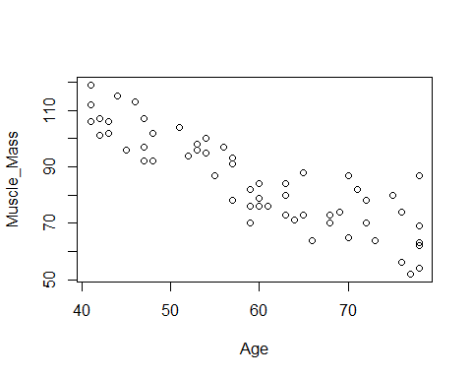
model_2 <- lm(Muscle_Mass~Age.c + I(Age.c^2),data=excel_data)
sum_of_model_2 <- summary(model_2)
sum_of_model_2
##
## Call:
## lm(formula = Muscle_Mass ~ Age.c + I(Age.c^2), data = excel_data)
##
## Residuals:
## Min 1Q Median 3Q Max
## -15.086 -6.154 -1.088 6.220 20.578
##
## Coefficients:
## Estimate Std. Error t value Pr(>|t|)
## (Intercept) 82.935749 1.543146 53.745 <2e-16 ***
## Age.c -1.183958 0.088633 -13.358 <2e-16 ***
## I(Age.c^2) 0.014840 0.008357 1.776 0.0811 .
## ---
## Signif. codes: 0 '***' 0.001 '**' 0.01 '*' 0.05 '.' 0.1 ' ' 1
##
## Residual standard error: 8.026 on 57 degrees of freedom
## Multiple R-squared: 0.7632, Adjusted R-squared: 0.7549
## F-statistic: 91.84 on 2 and 57 DF, p-value: < 2.2e-16
#The quadratic function seems like a good fit.
#Problem 8.4b
summary(model_2)
##
## Call:
## lm(formula = Muscle_Mass ~ Age.c + I(Age.c^2), data = excel_data)
##
## Residuals:
## Min 1Q Median 3Q Max
## -15.086 -6.154 -1.088 6.220 20.578
##
## Coefficients:
## Estimate Std. Error t value Pr(>|t|)
## (Intercept) 82.935749 1.543146 53.745 <2e-16 ***
## Age.c -1.183958 0.088633 -13.358 <2e-16 ***
## I(Age.c^2) 0.014840 0.008357 1.776 0.0811 .
## ---
## Signif. codes: 0 '***' 0.001 '**' 0.01 '*' 0.05 '.' 0.1 ' ' 1
##
## Residual standard error: 8.026 on 57 degrees of freedom
## Multiple R-squared: 0.7632, Adjusted R-squared: 0.7549
## F-statistic: 91.84 on 2 and 57 DF, p-value: < 2.2e-16
qf(0.95, 2, 57)
## [1] 3.158843
#H0: B1 = B11 = 0, if F_score <= 3.158843
#Ha: not B1 and B11 = 0, if F_score > 3.158843
#F-statistic: 91.84 on 2 and 57 DF
91.84 > 3.158843
## [1] TRUE
#Prove Ha is true.
#Problem 8.4c
predict(model_2, data.frame(Age.c = 48 - mean(excel_data$Age)),
interval="confidence", se.fit = TRUE, level = 0.95)
## $fit
## fit lwr upr
## 1 99.25461 96.28436 102.2249
##
## $se.fit
## [1] 1.483295
##
## $df
## [1] 57
##
## $residual.scale
## [1] 8.025521
#Problem 8.4d
predict(model_2, data.frame(Age.c = 48 - mean(excel_data$Age)),
interval="prediction", se.fit = TRUE, level = 0.95)
## $fit
## fit lwr upr
## 1 99.25461 82.9116 115.5976
##
## $se.fit
## [1] 1.483295
##
## $df
## [1] 57
##
## $residual.scale
## [1] 8.025521
#Problem 8.4e
sum_of_model_2
##
## Call:
## lm(formula = Muscle_Mass ~ Age.c + I(Age.c^2), data = excel_data)
##
## Residuals:
## Min 1Q Median 3Q Max
## -15.086 -6.154 -1.088 6.220 20.578
##
## Coefficients:
## Estimate Std. Error t value Pr(>|t|)
## (Intercept) 82.935749 1.543146 53.745 <2e-16 ***
## Age.c -1.183958 0.088633 -13.358 <2e-16 ***
## I(Age.c^2) 0.014840 0.008357 1.776 0.0811 .
## ---
## Signif. codes: 0 '***' 0.001 '**' 0.01 '*' 0.05 '.' 0.1 ' ' 1
##
## Residual standard error: 8.026 on 57 degrees of freedom
## Multiple R-squared: 0.7632, Adjusted R-squared: 0.7549
## F-statistic: 91.84 on 2 and 57 DF, p-value: < 2.2e-16
qt(0.975, 57)
## [1] 2.002465
#t* = 1.776
#H0: B11 = 0 if t* <= 2.002465
#Ha: B11 != 0, if t* > 2.002465
1.776 > qt(0.975, 57)
## [1] FALSE
#We can conclude H0 is true
#Problem 8.4f
#Y = 207.350 − 2.96432X + .0148405X^2
#Problem 8.4g
cor(excel_data$Age, excel_data$Age^2)
## [1] 0.9960939
cor(excel_data$Age.c, excel_data$Age.c^2)
## [1] -0.03835694
#Yes, the use of a centered variable is helpful here.
#Problem 8.5a
plot(sum_of_model_2$residuals~predict(model_2))
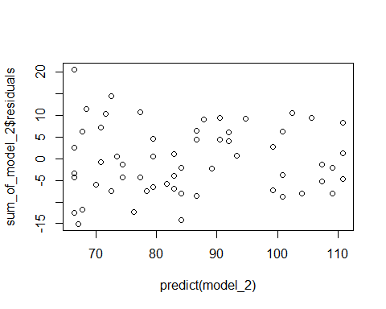
qqnorm(residuals(model_2))
qqline(residuals(model_2))
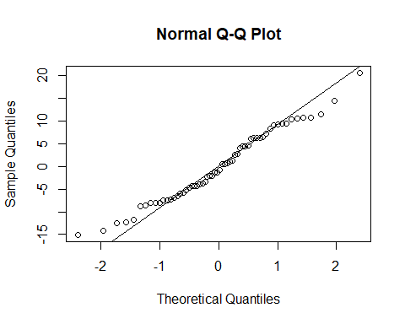
#Both of these plots seem pretty standard and no need for concern.
#Problem 8.5b
#H0: E{Y} = B0 + B1x + B11x^2, F_score ≤ 1.875188
#HA: E{Y} != B0 + B1x + B11x^2, F_score > 1.875188
reduced_model <- lm(Muscle_Mass~Age.c, data = excel_data)
model_2_residuals <- residuals(model_2)
reduced_model_residuals <- residuals(reduced_model)
#Calculate MSLF
SST <- sum((excel_data$Muscle_Mass - mean(excel_data$Muscle_Mass))^2)
SSR_reduced <- sum((predict(reduced_model) - mean(excel_data$Muscle_Mass))^2)
SSLOF <- SST - SSR_reduced
dfLOF <- length(excel_data$Muscle_Mass) - length(coef(reduced_model)) - 1
MSLF <- SSLOF / dfLOF
#Calculate MSPE
MSPE <- mean((excel_data$Muscle_Mass - predict(model_2))^2)
F_score <- MSLF / MSPE
F_score > qf(0.95, 29, 28)
## [1] FALSE
#Conclude H0
#Problem 8.5c
model_3 <- lm(Muscle_Mass~Age.c + I(Age.c^2) + I(Age.c^3), data = excel_data)
summary(model_3)
##
## Call:
## lm(formula = Muscle_Mass ~ Age.c + I(Age.c^2) + I(Age.c^3), data = excel_data)
##
## Residuals:
## Min 1Q Median 3Q Max
## -15.3671 -5.8483 -0.6755 6.1376 20.0637
##
## Coefficients:
## Estimate Std. Error t value Pr(>|t|)
## (Intercept) 82.9273444 1.5552264 53.322 < 2e-16 ***
## Age.c -1.2678894 0.2489231 -5.093 4.28e-06 ***
## I(Age.c^2) 0.0150390 0.0084390 1.782 0.0802 .
## I(Age.c^3) 0.0003369 0.0009327 0.361 0.7193
## ---
## Signif. codes: 0 '***' 0.001 '**' 0.01 '*' 0.05 '.' 0.1 ' ' 1
##
## Residual standard error: 8.087 on 56 degrees of freedom
## Multiple R-squared: 0.7637, Adjusted R-squared: 0.7511
## F-statistic: 60.34 on 3 and 56 DF, p-value: < 2.2e-16
#Y = = 82.9273 − 1.26789x + .01504x2 + .000337x3
#t_score = 0.361
#H0: B111 = 0, t_score <= 2.003241
#Ha: B111 != 0, t_score > 2.003241
qt(0.975, 56)
## [1] 2.003241
0.361 <= qt(0.975, 56)
## [1] TRUE
#Thus, we can conclude H0.
Problem 8.15 and 8.19
#Chad Huntebrinker
#Load the library and data in to R
library(readxl)
excel_data <- read_excel("Copier_Maintenance_Data.xlsx")
#Problem 8.15a & b
model_1 <- lm(Total_Minutes~Number_Of_Copiers + Type_Of_Copier,data=excel_data)
summary(model_1)
##
## Call:
## lm(formula = Total_Minutes ~ Number_Of_Copiers + Type_Of_Copier,
## data = excel_data)
##
## Residuals:
## Min 1Q Median 3Q Max
## -22.5390 -4.2515 0.5995 6.5995 14.9330
##
## Coefficients:
## Estimate Std. Error t value Pr(>|t|)
## (Intercept) -0.9225 3.0997 -0.298 0.767
## Number_Of_Copiers 15.0461 0.4900 30.706 <2e-16 ***
## Type_Of_Copier 0.7587 2.7799 0.273 0.786
## ---
## Signif. codes: 0 '***' 0.001 '**' 0.01 '*' 0.05 '.' 0.1 ' ' 1
##
## Residual standard error: 9.011 on 42 degrees of freedom
## Multiple R-squared: 0.9576, Adjusted R-squared: 0.9556
## F-statistic: 473.9 on 2 and 42 DF, p-value: < 2.2e-16
#B0 is the intercept
#B1 is one of the slopes, specifically related with the number of copiers
#B2 is the other slopes, specifically related to the copier size.
#Y = -0.9225 + 15.0461X1 + 0.7587X2
#Problem 8.15c
mean(excel_data$Number_Of_Copiers)
## [1] 5.111111
predict(model_1, data.frame(Number_Of_Copiers = 5.111111, Type_Of_Copier = 0),
interval="confidence", se.fit = TRUE, level = 0.95)
## $fit
## fit lwr upr
## 1 75.98004 72.53907 79.421
##
## $se.fit
## [1] 1.705069
##
## $df
## [1] 42
##
## $residual.scale
## [1] 9.011009
predict(model_1, data.frame(Number_Of_Copiers = 5.111111, Type_Of_Copier = 1),
interval="confidence", se.fit = TRUE, level = 0.95)
## $fit
## fit lwr upr
## 1 76.73876 72.3191 81.15842
##
## $se.fit
## [1] 2.190029
##
## $df
## [1] 42
##
## $residual.scale
## [1] 9.011009
#Problem 8.15d
#We would be interested in X1 because the service time is still impacted by the
#number of copiers even if we are interested in the effect of the type of copier (2 smaller
#copiers might have a similiar amount of service time as 1 larger one, for example).
#Problem 8.15e
temp_values <- excel_data$Number_Of_Copiers * excel_data$Type_Of_Copier
plot(Total_Minutes~temp_values, xlab = "Interaction Term", data = excel_data)
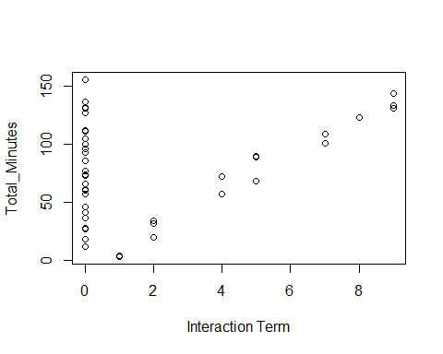
#Yes, there seems to be a pattern so a interaction term would be helpful.
#Problem 8.19a
model_2 <- lm(Total_Minutes~Number_Of_Copiers + Type_Of_Copier +
Number_Of_Copiers*Type_Of_Copier, data = excel_data)
summary(model_2)
##
## Call:
## lm(formula = Total_Minutes ~ Number_Of_Copiers + Type_Of_Copier +
## Number_Of_Copiers * Type_Of_Copier, data = excel_data)
##
## Residuals:
## Min 1Q Median 3Q Max
## -19.2072 -6.7887 -0.1708 7.1504 14.7441
##
## Coefficients:
## Estimate Std. Error t value Pr(>|t|)
## (Intercept) 2.8131 3.6468 0.771 0.4449
## Number_Of_Copiers 14.3394 0.6146 23.333 <2e-16 ***
## Type_Of_Copier -8.1412 5.5801 -1.459 0.1522
## Number_Of_Copiers:Type_Of_Copier 1.7774 0.9746 1.824 0.0755 .
## ---
## Signif. codes: 0 '***' 0.001 '**' 0.01 '*' 0.05 '.' 0.1 ' ' 1
##
## Residual standard error: 8.771 on 41 degrees of freedom
## Multiple R-squared: 0.9608, Adjusted R-squared: 0.9579
## F-statistic: 334.6 on 3 and 41 DF, p-value: < 2.2e-16
#Y = 2.8131 + 14.3394X1 - 8.1412X2 + 1.7774X1X2
#Problem 8.19b
#H0: B3 = 0, t_value <= qt(0.95, 41)
#HA: B3 != 0, t_value > qt(0.95, 41)
summary(model_2)
##
## Call:
## lm(formula = Total_Minutes ~ Number_Of_Copiers + Type_Of_Copier +
## Number_Of_Copiers * Type_Of_Copier, data = excel_data)
##
## Residuals:
## Min 1Q Median 3Q Max
## -19.2072 -6.7887 -0.1708 7.1504 14.7441
##
## Coefficients:
## Estimate Std. Error t value Pr(>|t|)
## (Intercept) 2.8131 3.6468 0.771 0.4449
## Number_Of_Copiers 14.3394 0.6146 23.333 <2e-16 ***
## Type_Of_Copier -8.1412 5.5801 -1.459 0.1522
## Number_Of_Copiers:Type_Of_Copier 1.7774 0.9746 1.824 0.0755 .
## ---
## Signif. codes: 0 '***' 0.001 '**' 0.01 '*' 0.05 '.' 0.1 ' ' 1
##
## Residual standard error: 8.771 on 41 degrees of freedom
## Multiple R-squared: 0.9608, Adjusted R-squared: 0.9579
## F-statistic: 334.6 on 3 and 41 DF, p-value: < 2.2e-16
#t_value = 1.824
#p_value = 0.0755
qt(0.95, 41)
## [1] 1.682878
#Test H0
1.824 <= qt(0.95, 41)
## [1] FALSE
#Reject H0, B3 != 0, keep it in the model.
Problem 8.37
#Chad Huntebrinker
#Load the library and data in to R
library(readxl)
excel_data <- read_excel("CDI_Data.xlsx")
#Problem 8.37
excel_data$Pop_Density <- excel_data$Total_Pop / excel_data$Land_Area
Crime_Rate <- excel_data$Serious_Crimes / excel_data$Total_Pop
Pop_Density.c <- excel_data$Pop_Density - mean(excel_data$Pop_Density)
Unemployment.c <- excel_data$Unemployment - mean(excel_data$Unemployment)
model_1 <- lm(Crime_Rate~Pop_Density.c + Unemployment.c + I(Pop_Density.c^2) +
I(Unemployment.c^2) + Pop_Density.c*Unemployment.c)
sum_of_model_1 <- summary(model_1)
plot(model_1$residuals~model_1$fitted.values)
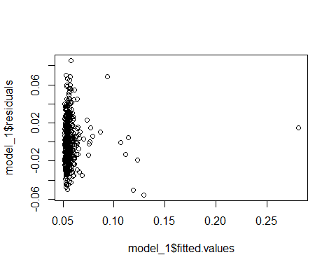
sum_of_model_1
##
## Call:
## lm(formula = Crime_Rate ~ Pop_Density.c + Unemployment.c + I(Pop_Density.c^2) +
## I(Unemployment.c^2) + Pop_Density.c * Unemployment.c)
##
## Residuals:
## Min 1Q Median 3Q Max
## -0.055642 -0.016851 -0.002889 0.014810 0.085485
##
## Coefficients:
## Estimate Std. Error t value Pr(>|t|)
## (Intercept) 5.629e-02 1.260e-03 44.662 < 2e-16 ***
## Pop_Density.c 4.585e-06 9.841e-07 4.659 4.23e-06 ***
## Unemployment.c -8.800e-05 6.276e-04 -0.140 0.8886
## I(Pop_Density.c^2) 2.698e-12 5.932e-11 0.045 0.9637
## I(Unemployment.c^2) 1.629e-04 9.541e-05 1.708 0.0884 .
## Pop_Density.c:Unemployment.c 8.334e-07 4.091e-07 2.037 0.0423 *
## ---
## Signif. codes: 0 '***' 0.001 '**' 0.01 '*' 0.05 '.' 0.1 ' ' 1
##
## Residual standard error: 0.02383 on 434 degrees of freedom
## Multiple R-squared: 0.2485, Adjusted R-squared: 0.2398
## F-statistic: 28.7 on 5 and 434 DF, p-value: < 2.2e-16
#Multiple R-squared: 0.2485, Adjusted R-squared: 0.2398
#The second-order model appears to fit the data pretty well, although there are some outliers
#in the regression function
#Problem 8.37b
#H0: p_value > 0.01, drop the quadratic and interaction terms
#Ha: p_value < 0.01, keep the quadratic and interaction terms
reduced_model <- lm(Crime_Rate~Pop_Density.c + Unemployment.c)
anova(reduced_model, model_1)
## Analysis of Variance Table
##
## Model 1: Crime_Rate ~ Pop_Density.c + Unemployment.c
## Model 2: Crime_Rate ~ Pop_Density.c + Unemployment.c + I(Pop_Density.c^2) +
## I(Unemployment.c^2) + Pop_Density.c * Unemployment.c
## Res.Df RSS Df Sum of Sq F Pr(>F)
## 1 437 0.25186
## 2 434 0.24638 3 0.005477 3.2159 0.02278 *
## ---
## Signif. codes: 0 '***' 0.001 '**' 0.01 '*' 0.05 '.' 0.1 ' ' 1
#p_value = 0.02278 > 0.01
0.02278 > 0.01
## [1] TRUE
#H0 is true, so drop those terms
#Problem 8.37c
#Problem doesn't specify whether these variables need to be centered or not.
#So, I will do both.
model_2 <- lm(Crime_Rate~Total_Pop + Land_Area + Unemployment + I(Total_Pop^2),
data = excel_data)
summary(model_2)
##
## Call:
## lm(formula = Crime_Rate ~ Total_Pop + Land_Area + Unemployment +
## I(Total_Pop^2), data = excel_data)
##
## Residuals:
## Min 1Q Median 3Q Max
## -0.05967 -0.01704 -0.00303 0.01410 0.19106
##
## Coefficients:
## Estimate Std. Error t value Pr(>|t|)
## (Intercept) 4.250e-02 3.889e-03 10.927 < 2e-16 ***
## Total_Pop 3.206e-08 3.941e-09 8.133 4.41e-15 ***
## Land_Area -5.576e-07 8.123e-07 -0.687 0.493
## Unemployment 6.824e-04 5.302e-04 1.287 0.199
## I(Total_Pop^2) -3.356e-15 5.878e-16 -5.710 2.10e-08 ***
## ---
## Signif. codes: 0 '***' 0.001 '**' 0.01 '*' 0.05 '.' 0.1 ' ' 1
##
## Residual standard error: 0.02539 on 435 degrees of freedom
## Multiple R-squared: 0.1444, Adjusted R-squared: 0.1365
## F-statistic: 18.35 on 4 and 435 DF, p-value: 6.022e-14
#Multiple R-squared: 0.1444, Adjusted R-squared: 0.1365
Total_Pop.c <- excel_data$Total_Pop - mean(excel_data$Total_Pop)
Land_Area.c <- excel_data$Land_Area - mean(excel_data$Land_Area)
model_3 <- lm(Crime_Rate~Total_Pop.c + Land_Area.c + Unemployment.c + I(Total_Pop.c^2))
summary(model_3)
##
## Call:
## lm(formula = Crime_Rate ~ Total_Pop.c + Land_Area.c + Unemployment.c +
## I(Total_Pop.c^2))
##
## Residuals:
## Min 1Q Median 3Q Max
## -0.05967 -0.01704 -0.00303 0.01410 0.19106
##
## Coefficients:
## Estimate Std. Error t value Pr(>|t|)
## (Intercept) 5.850e-02 1.229e-03 47.595 < 2e-16 ***
## Total_Pop.c 2.942e-08 3.555e-09 8.276 1.57e-15 ***
## Land_Area.c -5.576e-07 8.123e-07 -0.687 0.493
## Unemployment.c 6.824e-04 5.302e-04 1.287 0.199
## I(Total_Pop.c^2) -3.356e-15 5.878e-16 -5.710 2.10e-08 ***
## ---
## Signif. codes: 0 '***' 0.001 '**' 0.01 '*' 0.05 '.' 0.1 ' ' 1
##
## Residual standard error: 0.02539 on 435 degrees of freedom
## Multiple R-squared: 0.1444, Adjusted R-squared: 0.1365
## F-statistic: 18.35 on 4 and 435 DF, p-value: 6.022e-14
#Multiple R-squared: 0.1444, Adjusted R-squared: 0.1365
#While the coefficients are different, they both are on the lower end of the spectrum.

