chad_huntebrinker_hw2_plots

Chad Huntebrinker

2024-09-09

Problem 1.19:

#Chad Huntebrinker  
library(Hmisc)

##   
## Attaching package: 'Hmisc'

## The following objects are masked from 'package:base':  
##   
## format.pval, units

#Load data  
y_data <- c(3.897, 3.885, 3.778, 2.54,  
 3.028,  
 3.865,  
 2.962,  
 3.961,  
 0.5,  
 3.178,  
 3.31,  
 3.538,  
 3.083,  
 3.013,  
 3.245,  
 2.963,  
 3.522,  
 3.013,  
 2.947,  
 2.118,  
 2.563,  
 3.357,  
 3.731,  
 3.925,  
 3.556,  
 3.101,  
 2.42,  
 2.579,  
 3.871,  
 3.06,  
 3.927,  
 2.375,  
 2.929,  
 3.375,  
 2.857,  
 3.072,  
 3.381,  
 3.29,  
 3.549,  
 3.646,  
 2.978,  
 2.654,  
 2.54,  
 2.25,  
 2.069,  
 2.617,  
 2.183,  
 2,  
 2.952,  
 3.806,  
 2.871,  
 3.352,  
 3.305,  
 2.952,  
 3.547,  
 3.691,  
 3.16,  
 2.194,  
 3.323,  
 3.936,  
 2.922,  
 2.716,  
 3.37,  
 3.606,  
 2.642,  
 2.452,  
 2.655,  
 3.714,  
 1.806,  
 3.516,  
 3.039,  
 2.966,  
 2.482,  
 2.7,  
 3.92,  
 2.834,  
 3.222,  
 3.084,  
 4,  
 3.511,  
 3.323,  
 3.072,  
 2.079,  
 3.875,  
 3.208,  
 2.92,  
 3.345,  
 3.956,  
 3.808,  
 2.506,  
 3.886,  
 2.183,  
 3.429,  
 3.024,  
 3.75,  
 3.833,  
 3.113,  
 2.875,  
 2.747,  
 2.311,  
 1.841,  
 1.583,  
 2.879,  
 3.591,  
 2.914,  
 3.716,  
 2.8,  
 3.621,  
 3.792,  
 2.867,  
 3.419,  
 3.6,  
 2.394,  
 2.286,  
 1.486,  
 3.885,  
 3.8,  
 3.914,  
 1.86,  
 2.94)  
x_data <- c(21,  
 14,  
 28,  
 22,  
 21,  
 31,  
 32,  
 27,  
 29,  
 26,  
 24,  
 30,  
 24,  
 24,  
 33,  
 27,  
 25,  
 31,  
 25,  
 20,  
 24,  
 21,  
 28,  
 27,  
 28,  
 26,  
 28,  
 22,  
 26,  
 21,  
 25,  
 16,  
 28,  
 26,  
 22,  
 24,  
 21,  
 30,  
 27,  
 26,  
 26,  
 30,  
 24,  
 26,  
 29,  
 24,  
 31,  
 15,  
 19,  
 18,  
 27,  
 16,  
 27,  
 26,  
 24,  
 30,  
 21,  
 20,  
 30,  
 29,  
 25,  
 23,  
 25,  
 23,  
 30,  
 21,  
 24,  
 32,  
 18,  
 23,  
 20,  
 23,  
 18,  
 18,  
 29,  
 20,  
 23,  
 26,  
 28,  
 34,  
 20,  
 20,  
 26,  
 32,  
 25,  
 27,  
 27,  
 29,  
 19,  
 21,  
 24,  
 27,  
 25,  
 18,  
 29,  
 24,  
 27,  
 21,  
 19,  
 18,  
 25,  
 18,  
 20,  
 32,  
 24,  
 35,  
 25,  
 28,  
 28,  
 25,  
 22,  
 30,  
 20,  
 20,  
 31,  
 20,  
 29,  
 28,  
 16,  
 28)  
#Plot the Data  
plot(y_data ~ x_data, pch = 16, xlab = "ACT Test Scores", ylab = "GPA")  
minor.tick(ny = 1, tick.ratio = 0.25)  
  
#Fit a Linear Regression model  
lrgm <- lm(y_data ~ x_data)  
  
#Find b coefficients  
b_coefficients <- lrgm$coefficients  
  
#Add the fitted line  
abline(b_coefficients, lwd =2, lty =2, col="red")

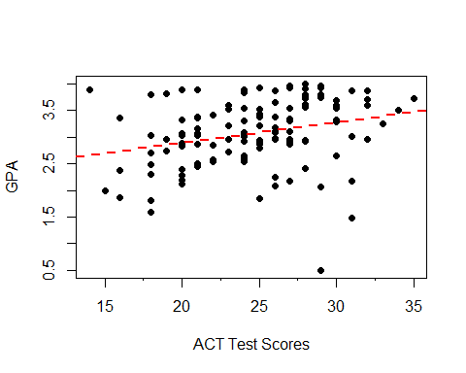

Question 1.21

#Load the data  
x_data <- c(1, 0, 2, 0, 3, 1, 0, 1, 2, 0)  
y_data <- c(16, 9, 17, 12, 22, 13, 8, 15, 19, 11)  
  
#Plot the Data  
plot(y_data ~ x_data, pch = 16, xlab = "Number of Transfers", ylab = "Number of Broken Ampules")  
minor.tick(nx = 2, tick.ratio = 0.5)  
  
#Fit a Linear Regression model  
lrgm <- lm(y_data ~ x_data)  
  
#Find b coefficients  
b_coefficients <- lrgm$coefficients  
  
#Add the fitted line  
abline(b_coefficients, lwd =2, lty =2, col="red")

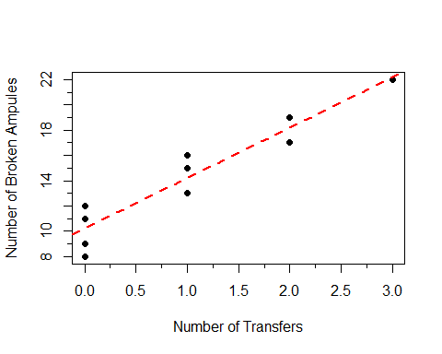

Problem 1.45

#Chad Huntebrinker  
  
#Length of Stay  
y_data <- c(7.13,8.82,8.34,8.95,11.2,9.76,9.68,11.18,8.67,8.84,11.07,8.3,12.78,  
7.58,9,11.08,8.28,11.62,9.06,9.35,7.53,10.24,9.78,9.84,9.2,8.28,  
9.31,8.19,11.65,9.89,11.03,9.84,11.77,13.59,9.74,10.33,9.97,7.84,  
10.47,8.16,8.48,10.72,11.2,10.12,8.37,10.16,19.56,10.9,7.67,8.88,  
11.48,9.23,11.41,12.07,8.63,11.15,7.14,7.65,10.73,11.46,10.42,11.18,  
7.93,9.66,7.78,9.42,10.02,8.58,9.61,8.03,7.39,7.08,9.53,10.05,8.45,  
6.7,8.9,10.23,8.88,10.3,10.79,7.94,7.63,8.77,8.09,9.05,7.91,10.39,  
9.36,11.41,8.86,8.93,8.92,8.15,9.77,8.54,8.66,12.01,7.95,10.15,  
9.76,9.89,7.14,13.95,9.44,10.8,7.14,8.02,11.8,9.5,7.7,17.94,9.41)  
  
#Infection Risk  
x1_data <- c(4.1,1.6,2.7,5.6,5.7,5.1,4.6,  
5.4,4.3,6.3,4.9,4.3,7.7,3.7,4.2,5.5,4.5,6.4,4.2,4.1,4.2,4.8,5,  
4.8,4,3.9,4.5,3.2,4.4,4.9,5,5.2,5.3,6.1,6.3,5,2.8,4.6,4.1,1.3,3.7,4.7,3,  
5.6,5.5,4.6,6.5,5.5,1.8,4.2,5.6,4.3,7.6,7.8,3.1,3.9,3.7,4.3,3.9,4.5,  
3.4,5.7,5.4,4.4,5,4.3,4.4,3.7,4.5,3.5,4.2,2,5.2,4.5,3.4,4.5,2.9,4.9,  
4.4,5.1,2.9,3.5,5.5,4.7,1.7,4.1,2.9,4.3,4.8,5.8,2.9,2,1.3,5.3,5.3,2.5,  
3.8,4.8,2.3,6.2,2.6,4.3,2.7,6.6,4.5,2.9,1.4,2.1,5.7,5.8,4.4,5.9,3.1)  
  
#Available facilities and services  
x2_data <- c(60,40,20,40,40,40,40,60,40,40,80,40,57.1,37.1,17.1,57.1,37.1,37.1,  
37.1,77.1,17.1,37.1,57.1,57.1,57.1,57.1,37.1,37.1,37.1,37.1,57.1,54.3,34.3,  
54.3,54.3,54.3,34.3,34.3,54.3,14.3,34.3,34.3,34.3,54.3,34.3,74.3,51.4,51.4,  
11.4,51.4,51.4,71.4,51.4,31.4,31.4,51.4,31.4,51.4,51.4,31.4,31.4,68.6,28.6,28.6,  
48.6,48.6,48.6,48.6,48.6,28.6,28.6,28.6,48.6,68.6,48.6,28.6,28.6,68.6,48.6,45.7,  
65.7,45.7,45.7,25.7,45.7,45.7,65.7,65.7,45.7,45.7,25.7,25.7,5.7,25.7,25.7,45.7,45.7,45.7,  
42.9,62.9,22.9,42.9,22.9,62.9,42.9,22.9,22.9,22.9,62.9,22.9,62.9,62.9,22.9)  
  
#Routine Chest X-ray  
x3_data <- c(39.6,51.7,74,122.8,88.9,97,79,85.8,90.8,82.6,122,83.8,116.9,88,76.4,  
63.6,101.8,99.2,75.9,80.9,98.9,112.6,95.9,82.3,71.1,113.1,101.3,59.2,96.1,  
103.6,102.1,72.6,56,111.7,76.1,104.3,76.5,87.9,69.1,58,92.8,94.1,78.9,  
79.1,84.8,51.5,113.7,71.9,40.4,86.9,82,42.6,97.9,105.3,56.2,73.9,75.8,  
65.7,101,97.7,59,55.9,98.1,98.3,71.6,62.8,93,95.9,87.2,87.3,88.4,56.4,  
65.7,87.5,85,80.8,86.9,77.9,76.8,88.9,56.6,92.3,61.1,47,56.9,79.8,  
79.5,88.3,90.6,73,87.5,72.5,79.5,79.8,89.7,82.5,69.5,96.9,54.9,59.2,  
80.1,108.7,92.6,133.5,58.5,57.4,45.7,46.5,116.9,70.9,67.9,91.8,91.7)  
  
#For X1, plot the Data  
plot(y_data ~ x1_data, pch = 16, xlab = "Infection Risk", ylab = "Length of Stay")  
minor.tick(nx = 2, tick.ratio = 0.5)  
#Fit a Linear Regression model  
lrgm <- lm(y_data ~ x1_data)  
#Find b coefficients  
b_coefficients <- lrgm$coefficients  
#Add the fitted line  
abline(b_coefficients, lwd =2, lty =2, col="red")

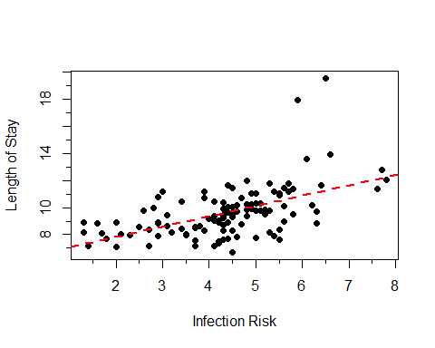

#For X2, plot the Data  
plot(y_data ~ x2_data, pch = 16, xlab = "Available facilities and services", ylab = "Length of Stay")  
minor.tick(nx = 2, tick.ratio = 0.5)  
#Fit a Linear Regression model  
lrgm <- lm(y_data ~ x2_data)  
#Find b coefficients  
b_coefficients <- lrgm$coefficients  
#Add the fitted line  
abline(b_coefficients, lwd =2, lty =2, col="green")

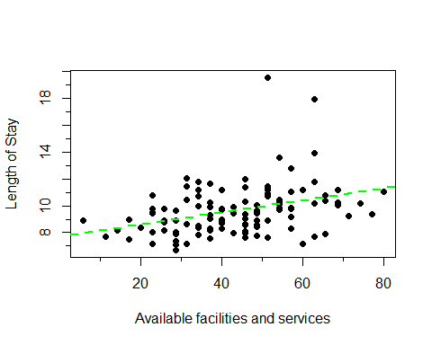

#For X3, plot the Data  
plot(y_data ~ x3_data, pch = 16, xlab = "Routine Chest X-ray", ylab = "Length of Stay")  
minor.tick(nx = 2, tick.ratio = 0.5)  
#Fit a Linear Regression model  
lrgm <- lm(y_data ~ x3_data)  
#Find b coefficients  
b_coefficients <- lrgm$coefficients  
#Add the fitted line  
abline(b_coefficients, lwd =2, lty =2, col="blue")

